**Міністерство освіти і науки України**  
**Національний технічний університет України**  
**«Київський політехнічний інститут імені Ігоря Сікорського»**  
**Факультет інформатики та обчислювальної техніки**  
**Кафедра обчислювальної техніки**

**Лабораторна робота №4**

з дисципліни  
«Об’єктно-орієнтоване програмування»

Виконав: Перевірив:

студент групи ІМ-31 Порєв В. М.  
Литвиненко Сергій Андрійович  
номер у списку групи: 11

Київ 2024

**Варіант завдання**

Ж - 12;

Динамічний об’єкт класу;

Файл Main.java.

import javafx.application.Application;

import javafx.scene.Scene;

import javafx.scene.layout.AnchorPane;

import javafx.scene.layout.BorderPane;

import javafx.stage.Stage;

import javafx.fxml.FXMLLoader;

import javafx.scene.canvas.Canvas;

public class Main extends Application {

final private String pathToView = "./resources/Main.fxml";

final private String title = "Lab 3";

static void main(String[] args) {

launch(args);

}

@Override

public void start(Stage stage) throws Exception {

final BorderPane root = FXMLLoader.load(getClass().getResource(pathToView));

final Scene scene = new Scene(root);

final var pane = (AnchorPane)((BorderPane)root.getCenter()).getCenter();

final var canvas = (Canvas)pane.getChildren().getFirst();

canvas.widthProperty().bind(pane.widthProperty());

canvas.heightProperty().bind(pane.heightProperty());

stage.setScene(scene);

pane.setPrefHeight(700);

pane.setPrefWidth(900);

stage.setTitle(title);

stage.show();

}

}

Файл resources/Main.fxml

<?xml version="1.0" encoding="UTF-8"?>

<?import javafx.scene.control.Button?>

<?import javafx.scene.control.Menu?>

<?import javafx.scene.control.MenuBar?>

<?import javafx.scene.control.MenuItem?>

<?import javafx.scene.control.RadioMenuItem?>

<?import javafx.scene.control.ToolBar?>

<?import javafx.scene.control.Tooltip?>

<?import javafx.scene.image.Image?>

<?import javafx.scene.image.ImageView?>

<?import javafx.scene.layout.AnchorPane?>

<?import javafx.scene.layout.BorderPane?>

<?import javafx.scene.canvas.Canvas?>

<BorderPane fx:id="borderPane" maxHeight="-Infinity" maxWidth="-Infinity" minHeight="-Infinity" minWidth="-Infinity" xmlns="http://javafx.com/javafx/22" xmlns:fx="http://javafx.com/fxml/1" fx:controller="controllers.MenuController">

<top>

<MenuBar id="menuBar" BorderPane.alignment="CENTER">

<menus>

<Menu mnemonicParsing="false" text="File">

<items>

<MenuItem mnemonicParsing="false" onAction="#saveAs" text="Save as..." />

<MenuItem mnemonicParsing="false" onAction="#exit" text="Close" />

</items>

</Menu>

<Menu fx:id="objectsMenu" mnemonicParsing="false" text="Objects">

<items>

<Menu mnemonicParsing="false" text="Rectangle">

<items>

<RadioMenuItem id="rectangleCenter" mnemonicParsing="false" text="From center" />

<RadioMenuItem id="rectangleCorner" mnemonicParsing="false" text="From corner" />

</items>

</Menu>

<Menu mnemonicParsing="false" text="Elipse">

<items>

<RadioMenuItem id="ellipseCenter" mnemonicParsing="false" text="From center" />

<RadioMenuItem id="ellipseCorner" mnemonicParsing="false" text="From corner" />

</items>

</Menu>

<RadioMenuItem id="cube" mnemonicParsing="false" text="Cube" />

<RadioMenuItem id="line" mnemonicParsing="false" text="Line" />

<RadioMenuItem id="line-ellipse" mnemonicParsing="false" text="Line Ellipse" />

<RadioMenuItem id="point" mnemonicParsing="false" text="Point" />

<RadioMenuItem id="brush" mnemonicParsing="false" text="Brush" />

</items>

</Menu>

<Menu mnemonicParsing="false" text="Reference">

<items>

<MenuItem mnemonicParsing="false" text="About" />

</items>

</Menu>

<Menu mnemonicParsing="false" text="Settings">

<items>

<Menu fx:id="colors" mnemonicParsing="false" onAction="#colors" text="Colors">

<items>

</items>

</Menu>

<RadioMenuItem mnemonicParsing="false" onAction="#fill" text="Fill" />

</items>

</Menu>

</menus>

</MenuBar>

</top>

<center>

<BorderPane BorderPane.alignment="CENTER">

<top>

<ToolBar BorderPane.alignment="CENTER" fx:id="toolBar">

<items>

<Button id="rectangleCenter-button" mnemonicParsing="false">

<graphic>

<ImageView fitHeight="32.0" fitWidth="32.0">

<image>

<Image url="@icons/rectangle-center.png" />

</image>

</ImageView>

</graphic>

<tooltip>

<Tooltip text="Rectangle Center" />

</tooltip>

</Button>

<Button id="rectangleCorner-button" mnemonicParsing="false">

<graphic>

<ImageView fitHeight="32.0" fitWidth="32.0">

<image>

<Image url="@icons/rectangle-corner.png" />

</image>

</ImageView>

</graphic>

<tooltip>

<Tooltip text="Rectangle Corner" />

</tooltip>

</Button>

<Button id="cube-button" mnemonicParsing="false">

<graphic>

<ImageView fitHeight="32.0" fitWidth="32.0">

<image>

<Image url="@icons/cube.png" />

</image>

</ImageView>

</graphic>

<tooltip>

<Tooltip text="Cube" />

</tooltip>

</Button>

<Button id="ellipseCenter-button" mnemonicParsing="false">

<graphic>

<ImageView fitHeight="32.0" fitWidth="32.0">

<image>

<Image url="@icons/ellipse-center.png" />

</image>

</ImageView>

</graphic>

<tooltip>

<Tooltip text="Ellipse Center" />

</tooltip>

</Button>

<Button id="ellipseCorner-button" mnemonicParsing="false">

<graphic>

<ImageView fitHeight="32.0" fitWidth="32.0">

<image>

<Image url="@icons/ellipse-corner.png" />

</image>

</ImageView>

</graphic>

<tooltip>

<Tooltip text="Elipce Corner" />

</tooltip>

</Button>

<Button id="line-button" mnemonicParsing="false">

<graphic>

<ImageView fitHeight="32.0" fitWidth="32.0">

<image>

<Image url="@icons/line.png" />

</image>

</ImageView>

</graphic>

<tooltip>

<Tooltip text="Line" />

</tooltip>

</Button>

<Button id="line-ellipse-button" mnemonicParsing="false">

<graphic>

<ImageView fitHeight="32.0" fitWidth="32.0">

<image>

<Image url="@icons/line-ellipse.png" />

</image>

</ImageView>

</graphic>

<tooltip>

<Tooltip text="Line ELlipse" />

</tooltip>

</Button>

<Button id="point-button" mnemonicParsing="false">

<graphic>

<ImageView fitHeight="32.0" fitWidth="32.0">

<image>

<Image url="@icons/point.png" />

</image>

</ImageView>

</graphic>

<tooltip>

<Tooltip text="Point" />

</tooltip>

</Button>

<Button id="brush-button" mnemonicParsing="false">

<graphic>

<ImageView fitHeight="32.0" fitWidth="32.0">

<image>

<Image url="@icons/brush.png" />

</image>

</ImageView>

</graphic>

<tooltip>

<Tooltip text="Brush" />

</tooltip>

</Button>

</items>

</ToolBar>

</top>

<center>

<AnchorPane fx:id="anchorPane" BorderPane.alignment="CENTER">

<Canvas fx:id="canvas" />

</AnchorPane>

</center>

</BorderPane>

</center>

</BorderPane>

Файл settings/Color.java

package settings;

import java.util.Map;

import javafx.scene.canvas.GraphicsContext;

import java.util.Collection;

public class Color {

static private javafx.scene.paint.Color currentColor = javafx.scene.paint.Color.BLACK;

static private Map<String, javafx.scene.paint.Color> colors = Map.of(

"black", javafx.scene.paint.Color.BLACK,

"red", javafx.scene.paint.Color.RED,

"blue", javafx.scene.paint.Color.BLUE,

"green", javafx.scene.paint.Color.GREEN,

"yellow", javafx.scene.paint.Color.YELLOW,

"purple", javafx.scene.paint.Color.PURPLE,

"pink", javafx.scene.paint.Color.PINK,

"gold", javafx.scene.paint.Color.GOLD,

"brown", javafx.scene.paint.Color.BROWN,

"light blue", javafx.scene.paint.Color.LIGHTBLUE

);

static public void setColor(final String color) {

if (!colors.containsKey(color)) return;

currentColor = colors.get(color);

}

static public void resetColor(final GraphicsContext context) {

currentColor = javafx.scene.paint.Color.BLACK;

context.setStroke(currentColor);

context.setFill(currentColor);

}

static public void applyCurentColor(final GraphicsContext context) {

context.setStroke(currentColor);

context.setFill(currentColor);

}

static public Collection<? extends String> getStringColors() {

return colors.keySet();

}

static public Collection<? extends javafx.scene.paint.Color> getColors() {

return colors.values();

}

}

Файл settings/Fill.java

package settings;

public class Fill {

private static boolean fill = false;

public static boolean getFill() {

return fill;

}

public static void setFill(final boolean flag) {

fill = flag;

}

}

Файл shapes/Shape.java

package shapes;

import javafx.scene.canvas.GraphicsContext;

import javafx.scene.paint.Color;

import java.util.List;

public abstract class Shape {

protected List<Double> coords;

public Color color = Color.BLACK;

public boolean fill = false;

public double dashes = 0;

public boolean useDashes = true;

protected void prepareContext(final GraphicsContext context) {

context.setStroke(color);

context.setFill(color);

context.setLineDashes(dashes);

}

public abstract void draw(final GraphicsContext context);

public abstract void setCoords(double x1, double y1, double x2, double y2);

public void onStart(GraphicsContext context, double x, double y) {

}

}

Файл shapes/RectangleCorner.java

package shapes;

import javafx.scene.canvas.GraphicsContext;

import java.util.List;

import java.util.ArrayList;

public class RectangleCorner extends Shape implements Rectangable {

public RectangleCorner() {

super();

coords = new ArrayList<>(List.of(0.0, 0.0, 0.0, 0.0));

}

@Override

public void draw(GraphicsContext context) {

prepareContext(context);

Rectangable.super.drawRectangle(

context,

coords.get(0),

coords.get(1),

coords.get(2),

coords.get(3),

fill

);

}

Файл shapes/RectangleCenter.java

package shapes;

public class RectangleCenter extends RectangleCorner {

@Override

public void setCoords(double x1, double y1, double x2, double y2) {

super.setCoords(2 * x1 - x2, 2 * y1 - y2, x2, y2);

}

}

@Override

public void setCoords(double x1, double y1, double x2, double y2) {

coords.set(0, Math.min(x1, x2));

coords.set(1, Math.min(y1, y2));

coords.set(2, Math.abs(x2 - x1));

coords.set(3, Math.abs(y2 - y1));

}

}

Файл shapes/Rectangable.java

package shapes;

import javafx.scene.canvas.GraphicsContext;

public interface Rectangable {

default void drawRectangle(GraphicsContext context, double x, double y, double dx, double dy, boolean fill) {

final var width = context.getLineWidth();

if (fill) context.fillRect(x, y, dx + width, dy + width);

else context.strokeRect(x, y, dx + width, dy + width);

}

}

Файл shapes/Point.java

package shapes;

import java.util.ArrayList;

import java.util.List;

import javafx.scene.canvas.GraphicsContext;

public class Point extends Shape {

public Point() {

super();

coords = new ArrayList<>(List.of(0.0, 0.0));

}

@Override

public void onStart(GraphicsContext context, double x, double y) {

this.setCoords(0, 0, x, y);

this.draw(context);

}

@Override

public void draw(GraphicsContext context) {

prepareContext(context);

final var x = coords.get(0);

final var y = coords.get(1);

final var width = context.getLineWidth();

context.fillOval(x - width, y - width, width * 2, width * 2);

}

@Override

public void setCoords(double x1, double y1, double x2, double y2) {

coords.set(0, x2);

coords.set(1, y2);

}

}

Файл shapes/LineEllipse.java

package shapes;

import java.util.ArrayList;

import java.util.List;

import javafx.scene.canvas.GraphicsContext;

public class Point extends Shape {

public Point() {

super();

coords = new ArrayList<>(List.of(0.0, 0.0));

}

@Override

public void onStart(GraphicsContext context, double x, double y) {

this.setCoords(0, 0, x, y);

this.draw(context);

}

@Override

public void draw(GraphicsContext context) {

prepareContext(context);

final var x = coords.get(0);

final var y = coords.get(1);

final var width = context.getLineWidth();

context.fillOval(x - width, y - width, width * 2, width * 2);

}

@Override

public void setCoords(double x1, double y1, double x2, double y2) {

coords.set(0, x2);

coords.set(1, y2);

}

}

Файл shapes/Line.java

package shapes;

import java.util.ArrayList;

import java.util.List;

import javafx.scene.canvas.GraphicsContext;

public class Line extends Shape implements Linable {

public Line() {

super();

coords = new ArrayList<>(List.of(0.0, 0.0, 0.0, 0.0));

}

@Override

public void draw(GraphicsContext context) {

prepareContext(context);

Linable.super.drawLine(

context,

coords.get(0),

coords.get(1),

coords.get(2),

coords.get(3)

);

}

@Override

public void setCoords(double x1, double y1, double x2, double y2) {

coords.set(0, x1);

coords.set(1, y1);

coords.set(2, x2);

coords.set(3, y2);

}

}

Файл shapes/Linable.java

package shapes;

import javafx.scene.canvas.GraphicsContext;

public interface Linable {

public default void drawLine(GraphicsContext context, double x1, double y1, double x2, double y2) {

context.strokeLine(x1, y1, x2, y2);

}

}

Файл shapes/ElipseCorner.java

package shapes;

import java.util.ArrayList;

import java.util.List;

import javafx.scene.canvas.GraphicsContext;

public class EllipseCorner extends Shape implements Ellipsable {

public EllipseCorner() {

super();

coords = new ArrayList<>(List.of(0.0, 0.0, 0.0, 0.0));

}

@Override

public void draw(GraphicsContext context) {

prepareContext(context);

Ellipsable.super.drawEllipse(

context,

coords.get(0),

coords.get(1),

coords.get(2),

coords.get(3),

fill

);

}

@Override

public void setCoords(double x1, double y1, double x2, double y2) {

final double dx = Math.abs(x2 - x1);

final double dy = Math.abs(y2 - y1);

coords.set(0, (x1 + x2 - dx) / 2);

coords.set(1, (y1 + y2 - dy) / 2);

coords.set(2, dx);

coords.set(3, dy);

}

}

Файл editors/EllipseCenter.java

package shapes;

public class EllipseCenter extends EllipseCorner {

@Override

public void setCoords(double x1, double y1, double x2, double y2) {

super.setCoords(2 * x1 - x2, 2 * y1 - y2, x2, y2);

}

}

Файл editors/Ellipsable.java

package shapes;

import javafx.scene.canvas.GraphicsContext;

public interface Ellipsable {

public default void drawEllipse(GraphicsContext context, double x, double y, double dx, double dy, boolean fill) {

final var width = context.getLineWidth();

if (fill) context.fillOval(x, y, dx + width, dy + width);

else context.strokeOval(x, y, dx + width, dy + width);

}

}

Файл editors/Cube.java

package shapes;

import java.util.ArrayList;

import java.util.List;

import javafx.scene.canvas.GraphicsContext;

public class Cube extends Shape implements Linable, Rectangable {

private static final int deltaX = 50;

private static final int deltaY = -40;

public Cube() {

super();

coords = new ArrayList<>(List.of(0.0, 0.0, 0.0, 0.0));

}

@Override

public void draw(GraphicsContext context) {

prepareContext(context);

fill = false;

final var x1 = coords.get(0);

final var y1 = coords.get(1);

final var dx = coords.get(2);

final var dy = coords.get(3);

Rectangable.super.drawRectangle(context, x1, y1, dx, dy, fill);

Rectangable.super.drawRectangle(context, x1 + deltaX, y1 + deltaY, dx, dy, fill);

Linable.super.drawLine(context, x1, y1, x1 + deltaX, y1 + deltaY);

Linable.super.drawLine(context, x1 + dx, y1, x1 + dx + deltaX, y1 + deltaY);

Linable.super.drawLine(context, x1, y1 + dy, x1 + deltaX, y1 + dy + deltaY);

Linable.super.drawLine(context, x1 + dx, y1 + dy, x1 + dx + deltaX, y1 + dy + deltaY);

}

@Override

public void setCoords(double x1, double y1, double x2, double y2) {

coords.set(0, Math.min(x1, x2));

coords.set(1, Math.min(y1, y2));

coords.set(2, Math.abs(x2 - x1));

coords.set(3, Math.abs(y2 - y1));

}

}

Файл editors/Brush.java

package shapes;

import java.util.ArrayList;

import javafx.scene.canvas.GraphicsContext;

public class Brush extends Shape {

public Brush() {

super();

coords = new ArrayList<>();

useDashes = false;

}

@Override

public void onStart(GraphicsContext context, double x, double y) {

this.setCoords(0, 0, x, y);

}

@Override

public void draw(GraphicsContext context) {

prepareContext(context);

final var size = coords.size();

if (size <= 2) return;

var prevX = coords.get(0);

var prevY = coords.get(1);

for (int i = 2; i < size; i += 2) {

final var x = coords.get(i);

final var y = coords.get(i + 1);

context.strokeLine(prevX, prevY, x, y);

prevX = x;

prevY = y;

}

}

@Override

public void setCoords(double x1, double y1, double x2, double y2) {

coords.add(x2);

coords.add(y2);

}

}

Файл editors/Editor.java

package editors;

import shapes.Shape;

import java.util.Stack;

import javafx.scene.canvas.Canvas;

import javafx.scene.canvas.GraphicsContext;

import settings.Color;

import settings.Fill;

public class Editor {

private static double lineDashes = 10;

private double startX = 0;

private double startY = 0;

private boolean drawing = false;

private static Stack<Shape> shapes = new Stack<>();

private final Canvas canvas;

private GraphicsContext context;

@SuppressWarnings("unused")

public Editor(final Canvas canvas) {

this.canvas = canvas;

context = canvas.getGraphicsContext2D();

canvas.widthProperty().addListener((event) -> {

clear();

drawAll();

});

canvas.heightProperty().addListener((event) -> {

clear();

drawAll();

});

}

public void drawAll() {

for (final var shape: shapes) shape.draw(context);

}

public void clear() {

context.clearRect(0, 0, canvas.getWidth(), canvas.getHeight());

}

public void add(final Shape shape) {

shapes.add(shape);

}

public void pop() {

if (shapes.size() > 0) shapes.pop();

}

public void onLeftButtonDown(double x, double y) {

startX = x;

startY = y;

final var shape = shapes.peek();

shape.dashes = shape.useDashes ? lineDashes : 0;

shape.color = Color.getCurrentColor();

shape.fill = Fill.getFill();

shape.onStart(context, x, y);

}

public void onMouseMove(double x, double y) {

if (drawing) clear();

else drawing = true;

shapes.peek().setCoords(startX, startY, x, y);

drawAll();

}

public void onLeftButtonUp(double x, double y) {

clear();

final var shape = shapes.peek();

shape.setCoords(startX, startY, x, y);

shape.dashes = 0;

drawAll();

drawing = false;

}

}

Файл controller/MenuController.java

package controllers;

import javafx.event.ActionEvent;

import javafx.fxml.FXML;

import javafx.scene.layout.AnchorPane;

import javafx.scene.layout.BorderPane;

import javafx.stage.FileChooser;

import javafx.stage.Stage;

import javafx.scene.canvas.Canvas;

import javafx.scene.control.Button;

import javafx.scene.control.Menu;

import javafx.scene.control.RadioMenuItem;

import javafx.scene.control.ToolBar;

import javafx.scene.image.WritableImage;

import javafx.scene.input.MouseButton;

import javafx.scene.input.MouseEvent;

import javafx.scene.control.MenuItem;

import javafx.application.Platform;

import javafx.embed.swing.SwingFXUtils;

import javafx.scene.input.KeyCode;

import java.io.IOException;

import java.util.ArrayList;

import settings.Color;

import settings.Fill;

import shapes.*;

import java.util.Map;

import javax.imageio.ImageIO;

import editors.Editor;

public class MenuController {

@FXML

private BorderPane borderPane;

@FXML

private Menu objectsMenu;

@FXML

private AnchorPane anchorPane;

@FXML

private Menu colors;

@FXML

private RadioMenuItem lastSelected = null;

@FXML

private Canvas canvas;

@FXML

private ToolBar toolBar;

private Editor editor;

private final Map<String, Class<? extends Shape>> editors = Map.of(

"rectangleCenter", RectangleCenter.class,

"rectangleCorner", RectangleCorner.class,

"ellipseCenter", EllipseCenter.class,

"ellipseCorner", EllipseCorner.class,

"line", Line.class,

"point", Point.class,

"brush", Brush.class,

"line-ellipse", LineEllipse.class,

"cube", Cube.class

);

private boolean isPrimary(final MouseEvent event) {

return event.getButton().equals(MouseButton.PRIMARY);

}

private void processEvent(final Shape shape, final RadioMenuItem item) {

anchorPane.setOnMousePressed((event) -> {

if (isPrimary(event) && item.isSelected()) {

editor.add(shape);

editor.onLeftButtonDown(event.getX(), event.getY());

}

});

anchorPane.setOnMouseDragged((event) -> {

if (isPrimary(event) && item.isSelected()) {

editor.onMouseMove(event.getX(), event.getY());

}

});

anchorPane.setOnMouseReleased((event) -> {

if (isPrimary(event) && item.isSelected()) {

editor.onLeftButtonUp(event.getX(), event.getY());

processEvent(getShape(item.getId()), item);

}

});

}

@FXML

private void exit() {

Platform.exit();

}

@FXML

private void saveAs() throws IOException {

final var stage = (Stage)borderPane.getScene().getWindow();

final var savefile = new FileChooser();

savefile.setTitle("Save File");

final var file = savefile.showSaveDialog(stage);

if (file == null) return;

final var writableImage = new WritableImage((int)canvas.getWidth(), (int)canvas.getHeight());

canvas.snapshot(null, writableImage);

final var renderedImage = SwingFXUtils.fromFXImage(writableImage, null);

ImageIO.write(renderedImage, "png", file);

}

@FXML

private void colors(final ActionEvent event) {

final var item = (MenuItem)event.getTarget();

final var text = item.getText();

Color.setColor(text);

}

@FXML

private void fill() {

final var fill = Fill.getFill();

Fill.setFill(!fill);

}

private void addColors() {

final var items = new ArrayList<MenuItem>();

for (final var color: Color.getStringColors()) {

items.addLast(new MenuItem(color));

}

colors.getItems().addAll(items);

}

private Shape getShape(final String id) {

final var constructor = editors.get(id);

try {

final var declared = constructor.getDeclaredConstructor();

final var shape = declared.newInstance();

return shape;

} catch (Exception e) {

e.printStackTrace();

return null;

}

}

@SuppressWarnings("unused")

private void addItemsEvenets(final Menu root) {

for (final var item: root.getItems()) {

if (item instanceof Menu menu) {

addItemsEvenets(menu);

continue;

}

final var selected = (RadioMenuItem)item;

final var fullPath = getFullName(selected, objectsMenu);

item.setOnAction((event) -> {

if (lastSelected != null) lastSelected.setSelected(false);

selected.setSelected(true);

lastSelected = selected;

final var window = (Stage)borderPane.getScene().getWindow();

window.setTitle(fullPath);

final var shape = getShape(selected.getId());

processEvent(shape, selected);

});

final var buttonId = selected.getId() + "-button";

final var button = (Button)toolBar.getItems().filtered((node) -> {

return node.getId().equals(buttonId);

}).getFirst();

button.setOnAction((event) -> item.fire());

}

}

@SuppressWarnings("unused")

@FXML

private void initialize() {

addColors();

addItemsEvenets(objectsMenu);

editor = new Editor(canvas);

borderPane.sceneProperty().addListener((property) -> {

final var scene = borderPane.getScene();

scene.setOnKeyPressed((event) -> {

if (event.isControlDown() && (event.getCode() == KeyCode.Z)) {

editor.pop();

editor.clear();

editor.drawAll();

};

});

});

}

private String getFullName(final MenuItem selected, final Menu root) {

final StringBuilder result = new StringBuilder(root.getText() + " -> ");

boolean find = false;

for (final MenuItem item: root.getItems()) {

if (item instanceof final Menu menu) {

final var subpath = getFullName(selected, menu);

if (subpath.length() == 0) continue;

find = true;

result.append(subpath);

break;

}

if (!item.equals(selected)) continue;

find = true;

result.append(item.getText());

break;

}

return find ? result.toString() : "";

}

}

**Діаграма наслідування**

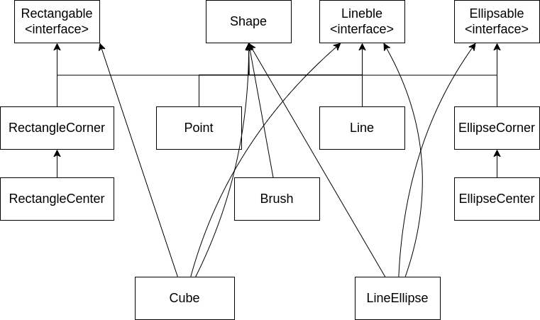

**Скріншоти виконання**

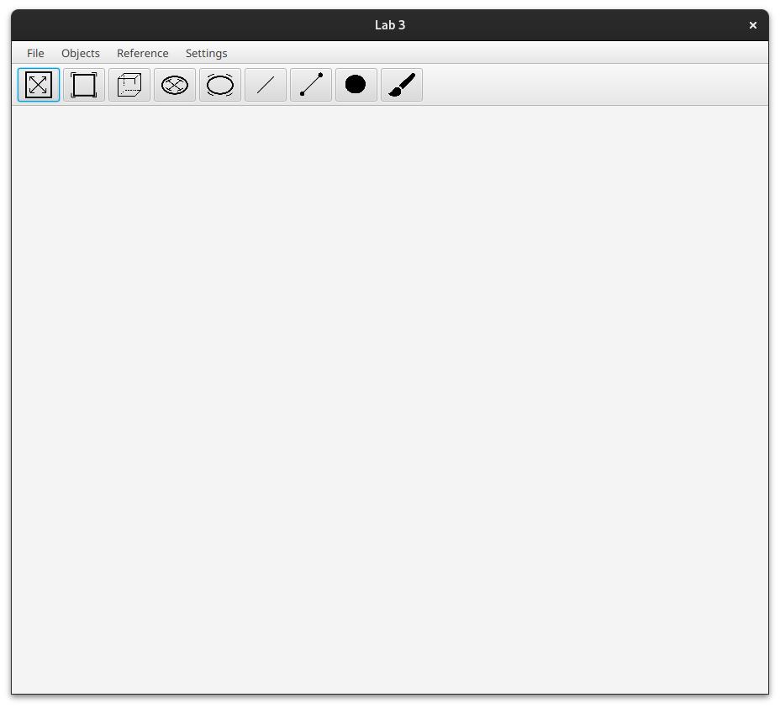

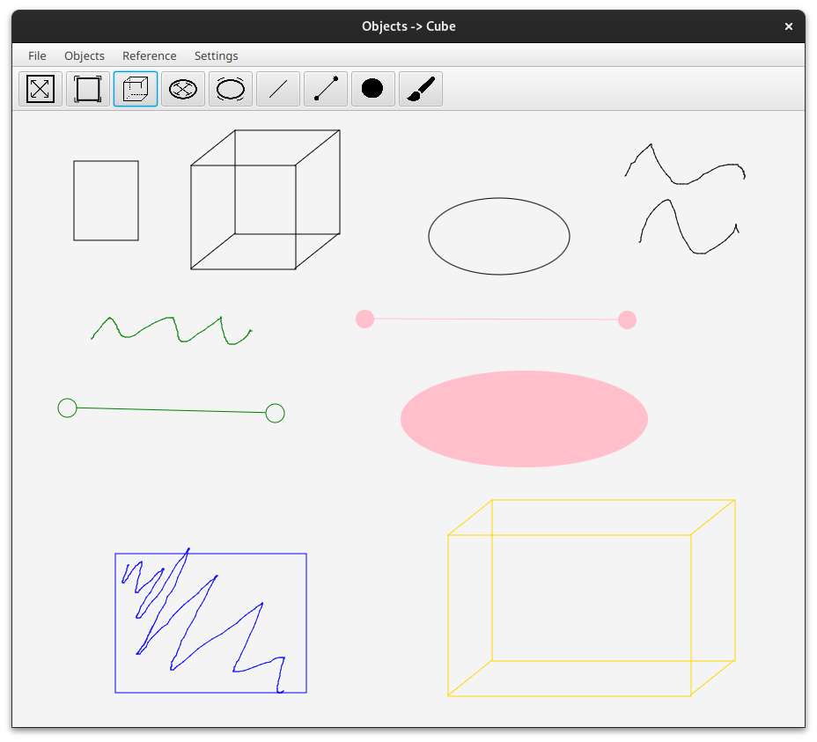

**Висновки**

Під час виконання лабораторної роботи я здобув навички використання інкапсуляції, абстрактних типів, успадкування та поліморфізму, множинного успадкування, інтерфейсів, створив простий графічний редактор та вдосконалив свої вміння програмування на Java. Протягом виконання я отримав теоретичні знання з архітектури розробки графічних додатків, та дізнався про кращі практики написання коду в об’єктно орієнтованому стилі використовуючи поліморфізм та множинне наслідування.