Stoicism

Perhaps ethics was not the fundamental question of ancient Greek philosophy. But long before the Christian religion erected the impressive structure of its ethics and morals, Socrates forever focused attention on ethics, leaving behind an unextinguishable brilliance. The death of Socrates in the year 399 BC was a momentous event that can only be described as mythical. The moment of his condemnation and execution, accepted to the point of renouncing escape, the way he faced his final hour... Everything appears imbued with that epic (and ethical) fullness that unbelievers call coincidences of chance and others call providence, which guides the favorites of the gods.

Socrates became the great reference for moral freedom in future times. He is the Socrates who, removed from all dogma and tradition and with no other government than his own person, only obeys the dictates of his conscience. With his life and death, Socrates inspired an idea of happiness within reach of any man, appealing to the spontaneous tendency for the improvement of one's own being. A culminating moment in ancient philosophical creation, those who followed him, except for Plato and Aristotle, lost the speculative and creative impulse of the pre-Socratics and formed philosophical schools that systematized and disseminated Socrates' doctrine.[***read Socrates soldier***](https://www.entreletras.eu/ensayo/socrates-soldado/)).

One of those schools, the *Cynical*, was founded by Antisthenes (444-365 BC), one of the few disciples who accompanied Socrates in his final moments. Of humble origin, he never possessed Athenian citizenship. He studied with Gorgias (460-380 BC), but was one of the many who would join Socrates. Legend attributes to him the revenge of his teacher's death by achieving the conviction of two of Socrates' accusers: Anytus, to exile, and Meletus, to death. Antisthenes, estranged from Plato,[***read Plato empiricist***](https://www.entreletras.eu/ensayo/platon-empirista/)), formed his own school on the outskirts of Athens, in the Gymnasium of Cynosarges (white dog), from where the name of his school comes from. The Cynics practiced an extreme moral rigor to the point of extravagance, and accepted the poor, women, and slaves in their classes.

The witty and even grotesque anecdotes of the Cynic philosophers are famous and still remembered, particularly those attributed to Diogenes of Sinope (412-323 BC), better known as *Diogenes the Cynic*. One of the most famous is the one that presents him as a prisoner and about to be sold as a slave, at which point his captor asked him what he knew how to do, to offer him to potential buyers. Then, Diogenes replied that he only knew how to command and that was what he knew best, so anyone who wanted to buy a master could acquire him.

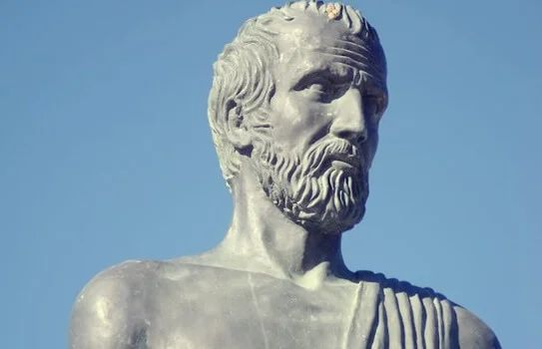

Stoicism was born from the school. *cynical* in the year 301 BC, when Zenon of Citium (336-264 BC), created his school in the "*Stoa Poikile*"(Painted Gate) of Athens. Zeno studied at the Platonic Academy and also received the influence of the Megarian school. And he was a disciple of the most prominent cynic of the second generation of that school, Crates of Thebes (368-288 BC). The first Stoicism was very close to the ideal of Cynic life. The Cynic conception of the "autarchy" (self-sufficiency) of the wise acquired the greatest importance among the Stoics. But that ideal of life taken from the Cynics would gradually be purified of eccentricities and enriched by the Stoics."