Pal Hunter
Team Members
1. Keyvan Noury (3900934113)
2. Suleyman Erten (6802970622)
3. Ali Ghahramani (9477331089)

Project description Feature description:

1) Follow Me:
Suppose you know a favorite place to go for lunch. Because you already know how to go to place you don't need to use a map application. But You decided to go to the place with your friends with a couple of cars. You want other cars to follow your car. By using GPS of the mobile device, other people would be able to see your path and follow that path.

2) Alert Zone:
Basically, the application can be planned to make alert if a friend enters to some specific environment. For example if a friend enters your city (or if a friend enters within 50 meters of you, or if a friend enters to your school's gym), the alert can be activated.. So we can have settings for different area (school, airport, country, city, bank, hospital) alerts. You can make each alert available based on your desire and your settings. User can set an option that sends message about user's location to desired friends via Facebook or cellular message.

Client (Phone) side

1) Sending User Location Data
- When application runs, the user location data will be sent over database. User can enable or disable this feature.
- While sending location data roughly every 10 seconds, metadata (location, altitude, time, angle, direction, speed) will be read from the sensors and sent to database.
- The user can press a stop button once they wish to end the recording.

2. Following Another User
- User can select any other user in his friend list to follow
- Once the follow option is selected, the path of followed user that is between 1 minute to 60 minutes time period is queried and shown on the map.
- User can follow one person at a time.
3. Enabling Alert Zone
- User can specify zones on the map.
- When other users in the friend list enters the specified zones, the user will get notification and other users will get notification or message.
- User can specify many alert zones. Other users wouldn’t see these alert zones.
- Once user enters own alert zone, it will be activated and begin to send notifications. When user leaves the alert zone it will be deactivated and remain in silent mode until user enters the zone again.

Server-side

There will be a web-server running on the server side to process requests of clients and to manipulate the database. The user interface for the server will be a web page with map API to control over the database and client applications.

1. Storing locations:
- Client applications will send location data to server and server will update the data according to timestamp and client user information.
- While updating the data in the database there will be limited space for each user. The database will be updated in such a way that the last 60 minutes data about the user will be stored.
- Another stored location data is user defined zones. Once user creates a zone, this data will be stored in database. Zones will be activated or deactivated according to user’s location instantly.
- The metadata is processed to generate spatial index information.

2. Query:
- When user selects to follow other user, client application will query about the path that belongs to followed user. The data that belongs the path will be queried on database and sent to client application.
- Once user enters in specified alert zone, current locations of other users will be queried and sent to client application to check to be processed.

Timeline

1. Before midterm
- User interface design for signing up, modifying requirements and tracking.
- Access and share some metadata (location, time, altitude) among the phones.
- Design the algorithms for spatial mapping of alert zones.
- Design a database for storing various types of data on a server.

2. After midterm
- Collect and store the rest of the metadata and preferences of users.
- Develop Mobile interface for querying and displaying the spatial and other metadata.
- Optimal spatial indexing of the data on server database.
- Optimize the interface design to reduce unhelpful visualizations in a dynamic manner.

UI mock-ups
1. Log-in
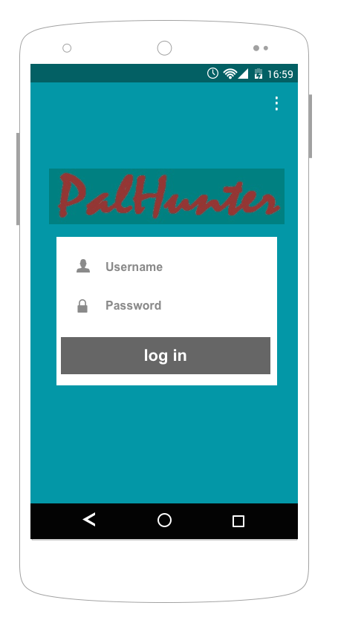

2. Overall look
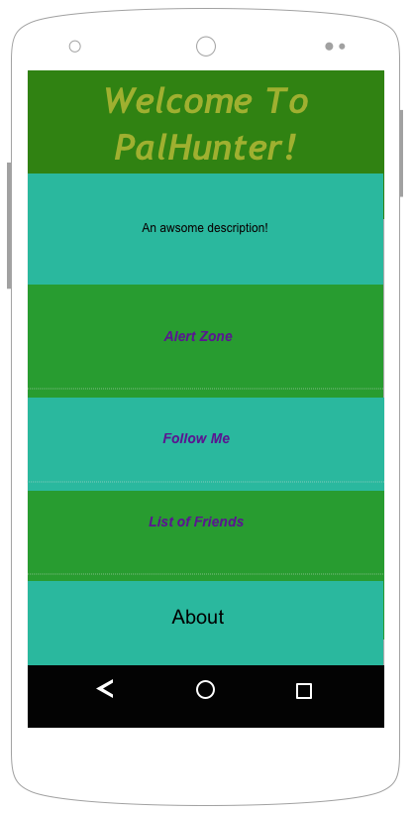
3. Alert Zone:
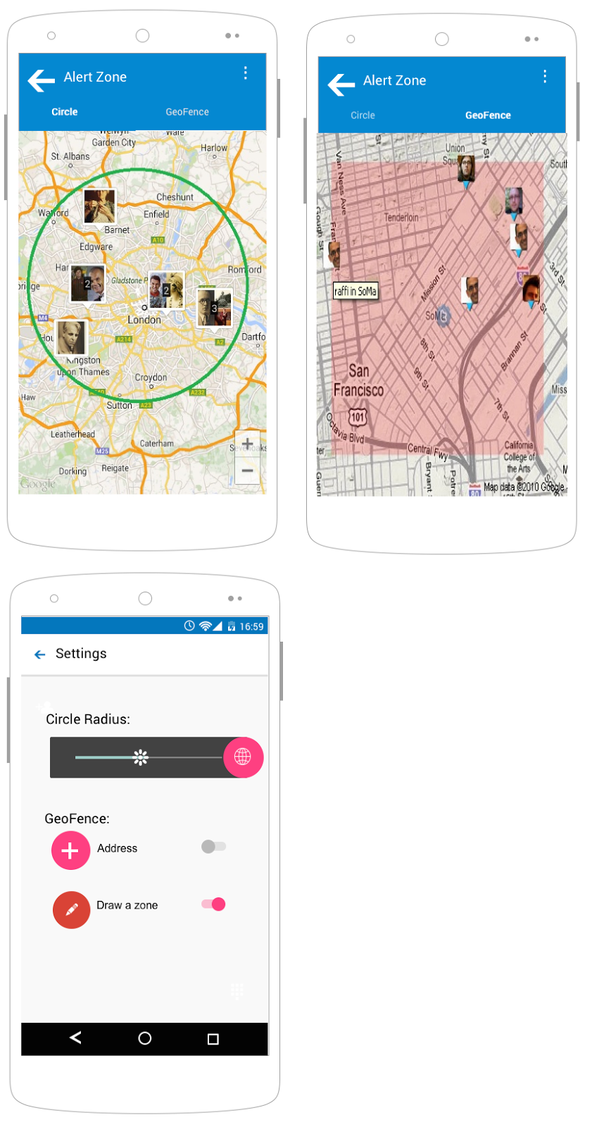
4. Follow Me:
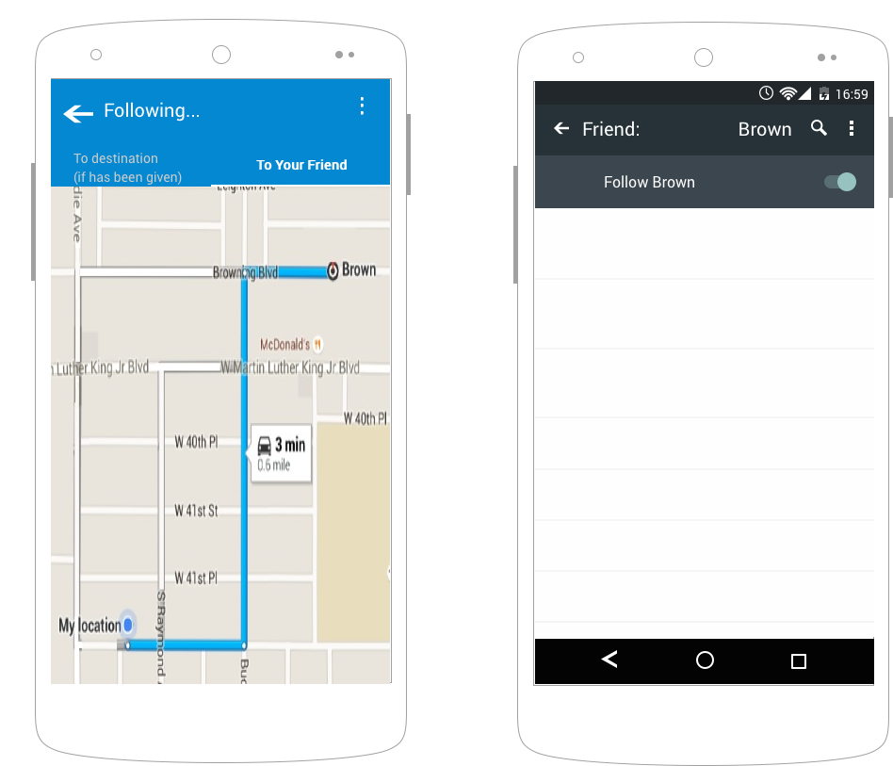
5. List of Friends:
