Pal Hunter
- Current status of the project
 | Tasks | Status (percentage of finished work) | Notes
planned to accomplish by midterm | User interface design for signing up, modifying requirements and tracking | 100 % | Screenshots of the UI can be found in Section 2.
planned to accomplish by midterm | Design a database for storing various types of data on a server. | 100 % | Our databases are located on Amazon web services (AWS) and our app directly communicates to the databases on Amazon servers. We are using PostgreSQL DB.
Tasks accomplished ahead | Access and share some metadata (location, time, altitude) among the phones | 80% | Different phones connect to our databases on Amazon server with a login ID and access to share to some metadata.
Tasks accomplished ahead | Design the algorithms for spatial mapping of alert zones. | 80% | In addition to the algorithms, the codes are also implemented.
Tasks accomplished ahead | Collect and store the rest of the metadata and preferences of users. | 80% | The database schema, design, and implementation on AWS is almost complete. The schema can be found on Section 3.
Tasks accomplished ahead | Develop Mobile interface for querying and displaying the spatial and other metadata. | 80% | The interface design for collecting user input and visualization of the results is almost done. The screenshots can be found in Section 1.
Tasks to be finished by the end of the term | Optimal spatial indexing of the data on server database. | 10% | Since we require to query many databases with many type of data, we plan to implement some query optimization to reduce the loads on our servers.
Tasks to be finished by the end of the term | Optimize the interface design to reduce unhelpful visualizations in a dynamic manner. | 10% | We plan to run several test case scenarios and integrate users feedback to improve the design.
- Screenshots of the android UI and web UI
(Login and registration)
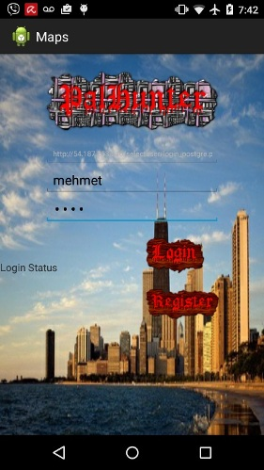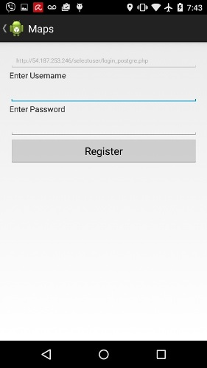
(main menu)
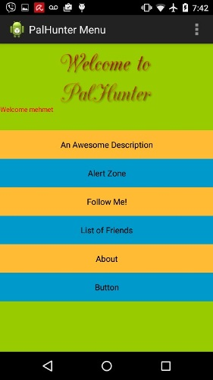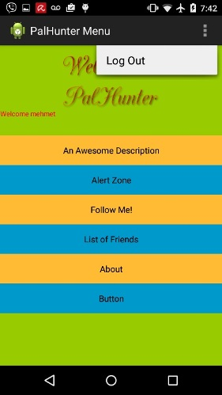
(friendlist)
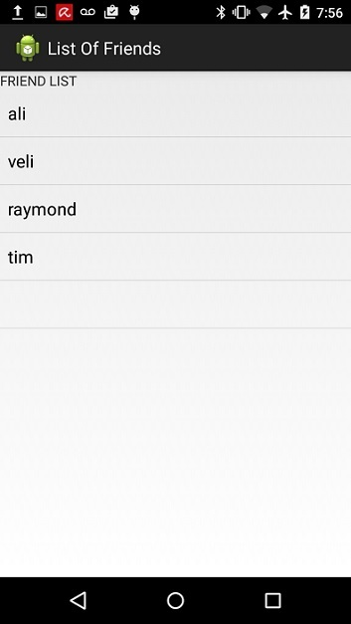
(alertzone)
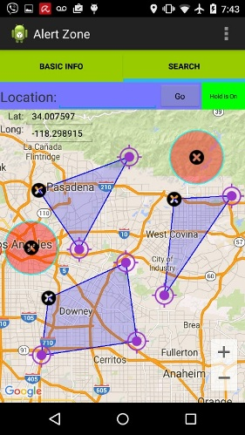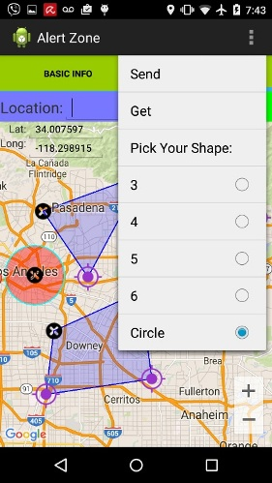

(web interface)
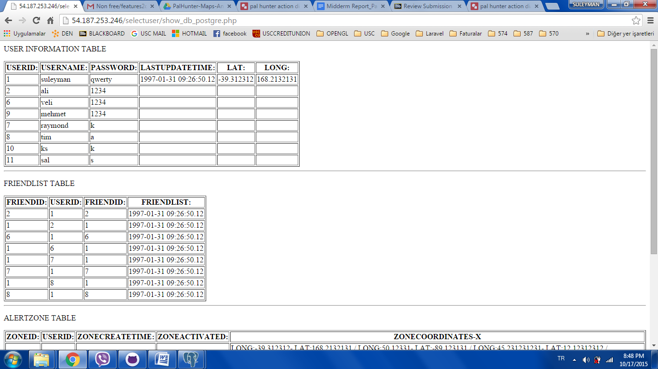

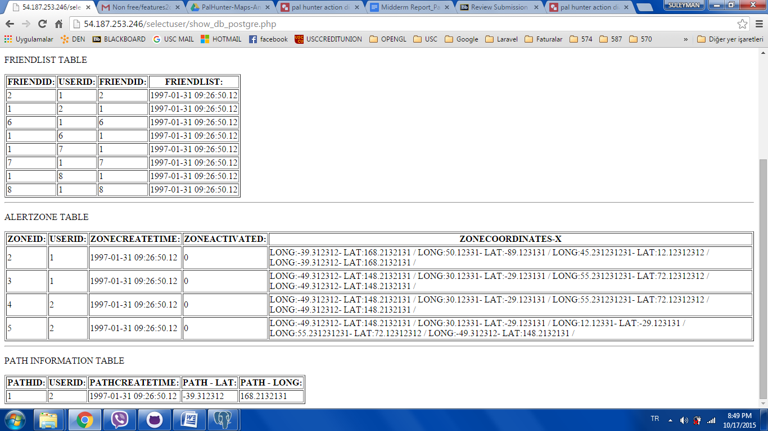

(web interface)
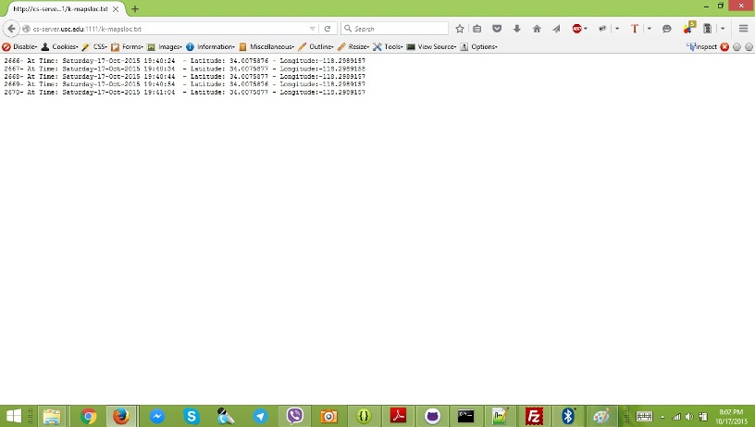
3. DB schema
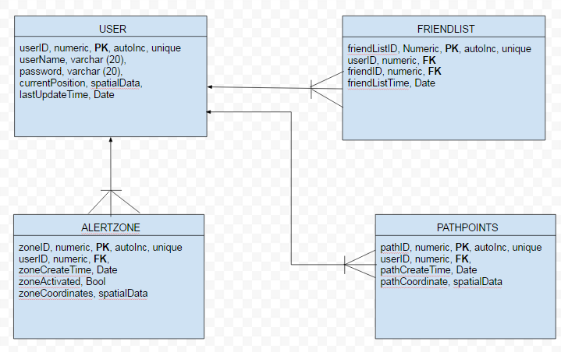
--USER TABLE
CREATE TABLE PALUSER (
USERID SERIAL PRIMARY KEY,
USERNAME VARCHAR(20) NOT NULL,
PASSWORD VARCHAR(20) NOT NULL,
CURRENTPOSITION GEOMETRY(Point, 4326),
LASTUPDATETIME TIMESTAMP
);

--creating index
CREATE INDEX PALUSER_gix
ON PALUSER
USING GIST (CURRENTPOSITION);

--FRIENDLIST TABLE
CREATE TABLE FRIENDLIST (
FRIENDLISTID SERIAL PRIMARY KEY,
USERID INT REFERENCES PALUSER(USERID),
FRIENDID INT REFERENCES PALUSER(USERID),
FRIENDLISTTIME TIMESTAMP
);

-- ALERTZONE TABLE
CREATE TABLE ALERTZONE (
ZONEID SERIAL PRIMARY KEY,
USERID INT REFERENCES PALUSER(USERID),
ZONECREATETIME TIMESTAMP,
ZONEACTIVATED INT,
ZONECOORDINATES GEOMETRY(Polygon, 4326)
);

--creating index
CREATE INDEX ALERTZONE_gix
ON ALERTZONE
USING GIST (ZONECOORDINATES);

-- PATHPOINTS TABLE
CREATE TABLE PATHPOINTS (
PATHID SERIAL PRIMARY KEY,
USERID INT REFERENCES PALUSER(USERID),
PATHCREATETIME TIMESTAMP,
PATHCOORDINATES GEOMETRY(Point, 4326)
);

--creating index
CREATE INDEX PATHPOINTS_gix
ON PATHPOINTS
USING GIST (PATHCOORDINATES);

3. Team Members:

Keyvan Noury (3900934113)
Suleyman Erten (6802970622)
Ali Ghahramani (9477331089)

