DAILY

OPERATION

SYSTEM

(DOPS)

Synopsis:

One existing salaries system for TAXI owner’s drivers, was analyzed and with focus on finding needs and requirements for new functions.

These needs and requirements were taken into account when analyzing the existing system.

It was determined that a salary system was not enough; a complete new control system was needed in order to achieve better earnings for the TAXI owners.

From the new system a prototype was developed.

The project has been developed according to the system development model (POSSUM), described in the book:

Systemudvikling og forandring ”*introduktion til for analyse og analyse.”* ISBN 8770342431  
 (System development and change – An Introduction to retrospective and prospective analysis)

The prototype is developed using various languages and is running as a service on its own physical HPC (high performance cluster)

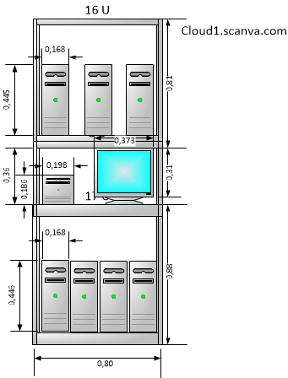The prototype and all documentation belongs to SCANVA ApS

CONTENT

1. PREFACE 3

2. INTRODUCTION 3

3. PROJECT DEFINITION 3

4. PROJECT SCOPE 3

5. PREANALYSIS 4

5.1 PROBLEMANALYSIS 4

5.1.0 PROBLEMLIST 4

5.1.1 PROBLEM HIERARCHY 6

5.1.2 INTERESTED PARTIES 6

5.1.3 Current physical system model 8

5.1.3.1 Use case diagrams 8

5.1.3.1.2 TAXI trip scenario 8

5.1.3.1.3 Owner wants to know where his vehicle is located 9

5.1.3.1.4 Owner wants supplier status 10

5.1.3.2 Dataflow diagrams 11

5.1.3.2.1 Context (current system) 11

5.1.3.2.2 Niveau 0 (Current system) 12

5.2 OBJECTIVES AND CHARACTERISTIC ANALYSIS 13

5.2.1 Hierarchy of objectives 13

5.2.2 Changing needs 14

5.2.3 Project aims 14

5.3 Change analysis 15

5.3.1 Process of change alternatives 15

5.3.2 Decision/assessment of proposed solutions 15

5.3.2.1 Sketch of new system 16

5.3.2.1.1 Context level 16

5.3.2.1.2 Level 0 (sketch of new system) 17

5.4 Task frame 18

6. ANALYSIS 20

6.1 DATA MODELING 20

6.1.1 Consideration of relevant entities 20

6.1.2 Conceptual data model Entity / Relation diagram 21

6.1.3 Role table 21

6.1.4 Extended Entity / Relation diagram 22

6.1.5 Entity classes with associated keys 23

6.2 functional modeling / system delimitation 24

6.2.1 Context ( Daily Operations System) 24

6.2.2 Level 0 (Daily operation system) 24

6.2.3 Level 1 (Daily Operations System) 25

# PREFACE

This system is a resource management system with focus on the Vehicle control. It is an end to end system covering all the aspects of controlling TAXI related services, however its base is capable of handling much more than TAXI related services.

This report will deal with the TAXI related service running on the resource management platform; it will deal with all from handling basic TAXI trips, to dispatcher service and creating salaries note for the various drivers

The report is build using the POSSUM system development model. This model is described in the book “Systemudvikling og forandring *introduktion til for analyse og analyse”****.***(System development and change – An Introduction to retrospective and prospective analysis)  
The book is written by Peter Beyer, Leif Caspersen, Knud Musaeus and Jørgen B. Svendsen.

# INTRODUCTION

The project is done by SCANVA ApS, a startup company from Nokia Denmark.  
Work on project started in former Nokia Denmark premises  
Machines and experience was available from SCANVA ApS

# PROJECT DEFINITION

Small TAXI companies, working with a TAXI dispatch central wants to improve their overall earnings, by improving how each TAXI trip is handled, also by reducing the cost for the TAXI dispatch service.   
The project is about finding the demands and requirements for the new system, and develops a prototype

# PROJECT SCOPE

Current TAXI control system is based on using taximeter’s and radio systems to communicate with dispatcher central which then gives each TAXI a trip. Each taxi has to tell which zone they are in, so that the central can find suitable customers. The price is calculated inside the TAXI cab, by the use of the taximeter.

The taximeter has several disadvantages, a lot of ways to “cheat” with the taximeter, have been found over the years, and this is a growing concern by many taxi owners and public sectors.

One growing concern by taxi owners is the actual usage of the car – who is driving it and when – how to make sure that the car is earning as much as it can during one work day – current system is NOT really helping with this

There are many things related to keeping a vehicle running and earning as much as possible and current system is focused on customer to taxi relation – This system will take existing system a step closer to giving the Taxi owner a complete taxi/salary/driver booking/vehicle handling system, in short a resource management system.

There already is a taxi salary system and that system will be changed into this one. The TAXI salary system was developed for Vagn Serup, Copenhagen TAXI, and system has been in use since 1997.

The salaries system is based on Danish salary rules; however it will be adopted to be able to handle multiple environments.

# PREANALYSIS

The external part of the system will be described with use case diagrams and the internal part of the system will be described using dataflow charts.

The use case diagrams will be divided into departments, and to make an easy overview, the system will be divided into following areas:

* Salary department
* Financial department
* Dispatcher department
* Vehicle maintenance department
* Driver booking department
* Customer service department

These are abstract departments and will be handled mostly by the system. Several owners of vehicles will make use of all these departments, each in their own scope.

This report will describe the use cases for handling a vehicle resource, with perspective from owner, driver, dispatcher and customers view

## 5.1 PROBLEMANALYSIS

### 5.1.0 PROBLEMLIST

|  |  |  |
| --- | --- | --- |
| # | i.p. |  |
| 1 | 3 | Difficult to maintain more than one owner, even though system can handle it, it should be online |
| 2 | 2 | Problems finding out how vehicle have been used during one day |
| 3 | 2 | Problems finding a good driver for vehicle |
| 4 | 2 | Difficult to find vehicles total fuel consumption |
| 5 | 2 | To many hours lost when vehicle is standing still |
| 6 | 2 | Too much money is lost on expensive repair and on various insurances |
| 7 | 2 | Too much money is lost on expensive license fee to TAXI central |
| 8 | 1 | Driver has problem finding a vehicle to use |
| 9 | 1 | Driver has problem changing from one vehicle to another |
| 10 | 2 | Owners with many vehicles have huge problems handling salaries in due time |
| 11 | 2 | Problems with mishandling of existing Taximeter |
| 12 | 3 | Problems with finding out which zone vehicle is currently in |
| 13 | 3 | Difficult in handling customer online account payment |
| 14 | 3 | Problems delivering a A to B route, from dispatcher to driver |
| 15 | 1 | Customer does NOT get an A to B detailed route on receipt of a trip |
| 16 | 1 | Customer does NOT get an estimated price before trip starts |
| 17 | 1 | Driver cannot calculate an estimated price before trip starts |
| 18 | 2 | Owner has problem with financial overview of spending’s on vehicle maintenance |
| 19 | 2 | Owner has difficulties remembering when a vehicle should undergo service |
| 20 | 2 | Owner has difficulties calculating overall fuel usage on various vehicles |
| 21 | 2 | Customer wants to book a vehicle without first downloading an app |
| 22 | 4 | Auto mechanics have problems helping owners to find free time spots for vehicle maintenance |
| 23 | 2 | Owner spends too much time entering data from vehicles into the salaries system |
| 24 | 2 | Owner has difficulties communicating with other owners about lending free drivers |
| 25 | 5 | Owner is paying a lot for starting a new vehicle as a TAXI |
| 26 | 2 | Owners vehicles is currently expensive vehicles due to endurance, needed since revenue is small |
| 27 | 1 | Every day revenue on a taxi vehicle is extremely unstable |
| 28 | 1 | Drivers phone does not connect to Internet |
| 29 | 1 | Driver have difficulties finding replacement drivers, when sick |
| 30 | 1 | Driver have difficulties driving for more than one owner, due to coordination issues |
| 31 | 2 | Owner has problems using drivers from other owners |
| 32 | 4 | Owner has problem finding best time slot for putting vehicle to service |
| 33 | 1 | Driver has problem documenting an accident or a failure on the vehicle |
| 34 | 3,7 | Customer has problem finding the vehicle he was driving in – lost some item |
| 35 | 3,7 | Customer has problem understanding what the price consists off – fees etc… |
| 36 | 3 | HPC Must be able to handle multiple requests from various driver apps |
| 37 | 3 | HPC Must be able to have redundancy in its data |
| 38 | 3 | Dispatcher has problem communicating with customer, when trip is done |
| 39 | 3 | Dispatcher has problem communicating with vehicle outside zones |
| 40 | 3 | Owners have problem learning from other owners vehicle handling experience |
| 41 | 1 | Numbers from Taximeter is difficult and time consuming to get to Owner |
| 42 | 1 | It is easy for Driver to make a mistake with the data from the vehicle |
| 43 | 1 | Owner receives sometimes less pay than what was earned |
| 44 | 2 | Vehicle drives too long with faulty parts |
| 45 | 3 | Speed limit is not being respected, which sometimes result in traffic bills |
| 46 | 2 | Nearby business have trouble getting their commercials/communication close to customer in Taxi |
| 47 | 2 | Owner has problem keeping track of price variations on fuel consumption |
| 48 | 3 | Dispatcher have problems finding vehicles close to customer, except for vehicles in zones |
| 49 | 2 | Driver have problems selling more than just driving |
| 50 | 2 | Some owners handle salaries and data for public sector in an old fashion way – future states that public sector needs its data in digital form |
| 51 | 2 | Difficult to see the economic impact of fees for credit card usage |
| 52 | 2 | Owner have difficulties keeping track of local stock – wheels, oil, etc.. |
| 53 | 2 | Owner have difficulties determining what “unused” kilometers have been used for |
| 54 | 2 | Owner has problems with revenue when vehicle needs maintenance |
| 55 | 7 | Customer cannot communicate with drivers owner |

### 5.1.1 PROBLEM HIERARCHY

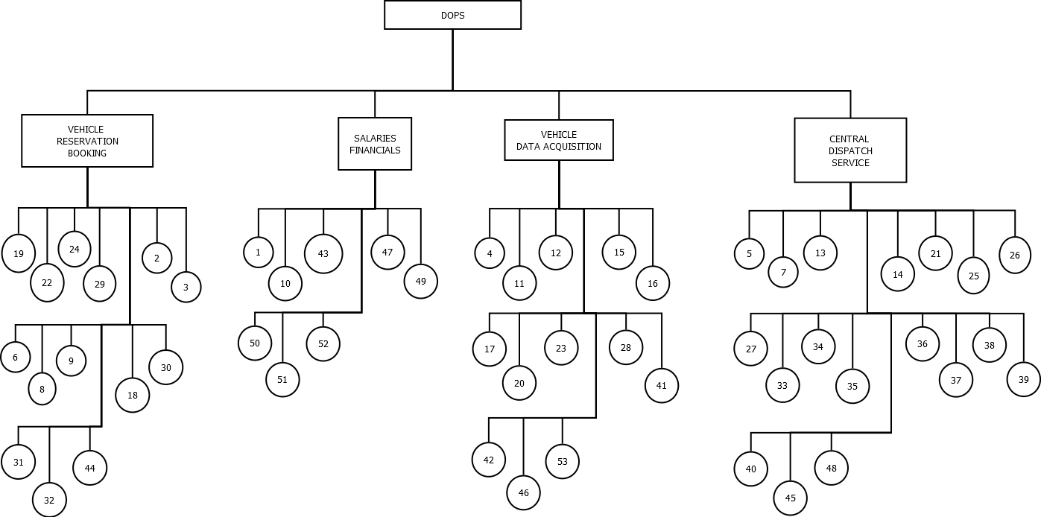

Figur 1 Problem hierarchy

### 5.1.2 INTERESTED PARTIES

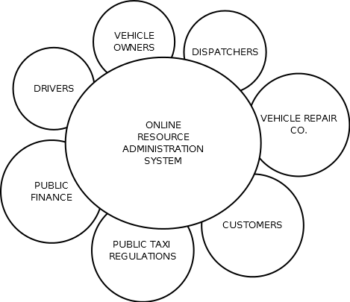

Figur 2 Interested Parties

|  |  |  |
| --- | --- | --- |
|  | Interested Party | Reference to  problem list |
| 1 | DRIVERS | 8,9,15,16,17,27,28,29,30,33,41,42,43 |
| 2 | VEHICLE OWNERS | 2,3,4,5,6,7,10,11,18,19,20,21,23,24,26,31,  44,46,47,49,50,51,52,53,54 |
| 3 | DISPATCHERS | 1,12,13,14,34,35,36,37,38,39,40,45,48 |
| 4 | VEHICLE REP. CO. | 22,32 |
| 5 | PUBLIC REGULATIONS | 25 |
| 6 | PUBLIC FINANCE |  |
| 7 | CUSTOMERS | 34,35,55 |

### 5.1.3 Current physical system model

The current system is only a salaries system, based on TAXI service handling. Future system will be covering the needs and wants of a system capable of helping with a better overview of what, where and how the individual resources are handled – this will open the system up for a wider usage, it will no longer be only TAXI service companies that can use the system.

#### 5.1.3.1 Use case diagrams

##### 5.1.3.1.2 TAXI trip scenario

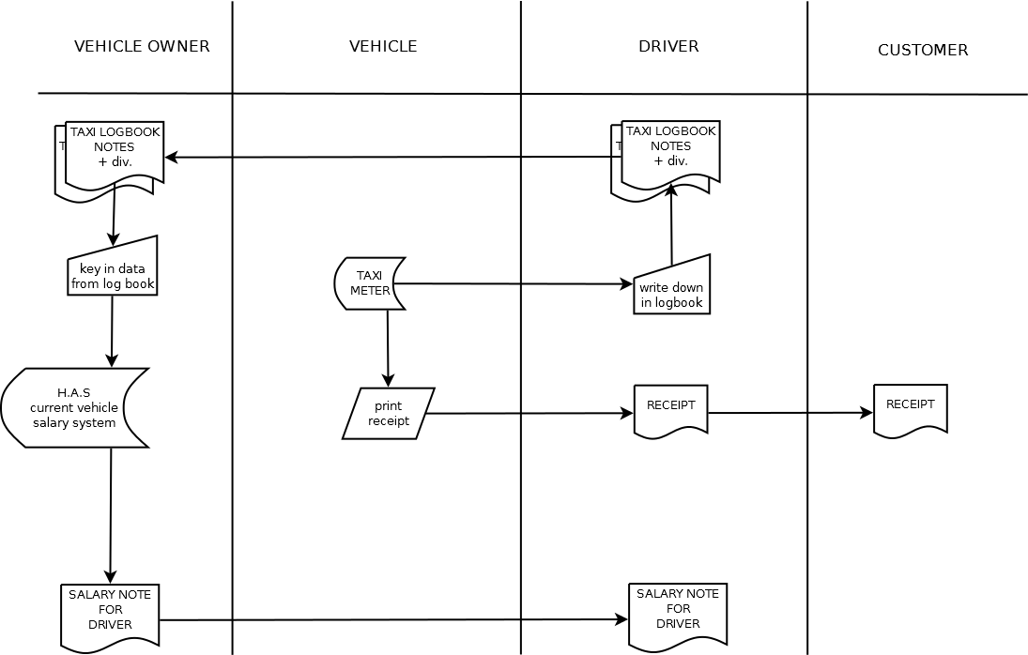

Figur 3 Taxi trip scenario

##### 5.1.3.1.3 Owner wants to know where his vehicle is located

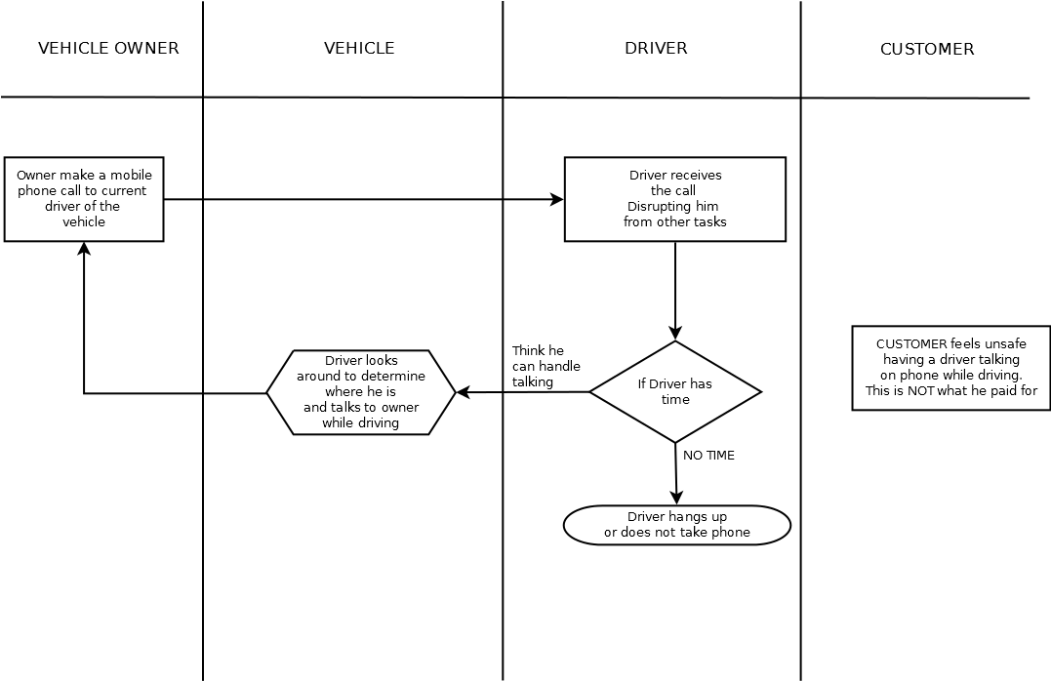

Figur 4 Owner wants vehicle status

##### 5.1.3.1.4 Owner wants supplier status

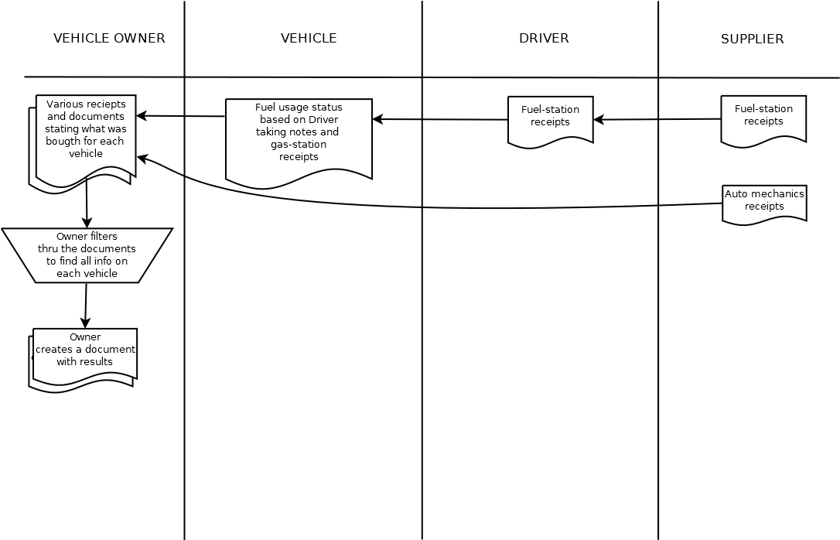

Figur 5 Owner wants supplier status

#### 5.1.3.2 Dataflow diagrams

##### 5.1.3.2.1 Context (current system)

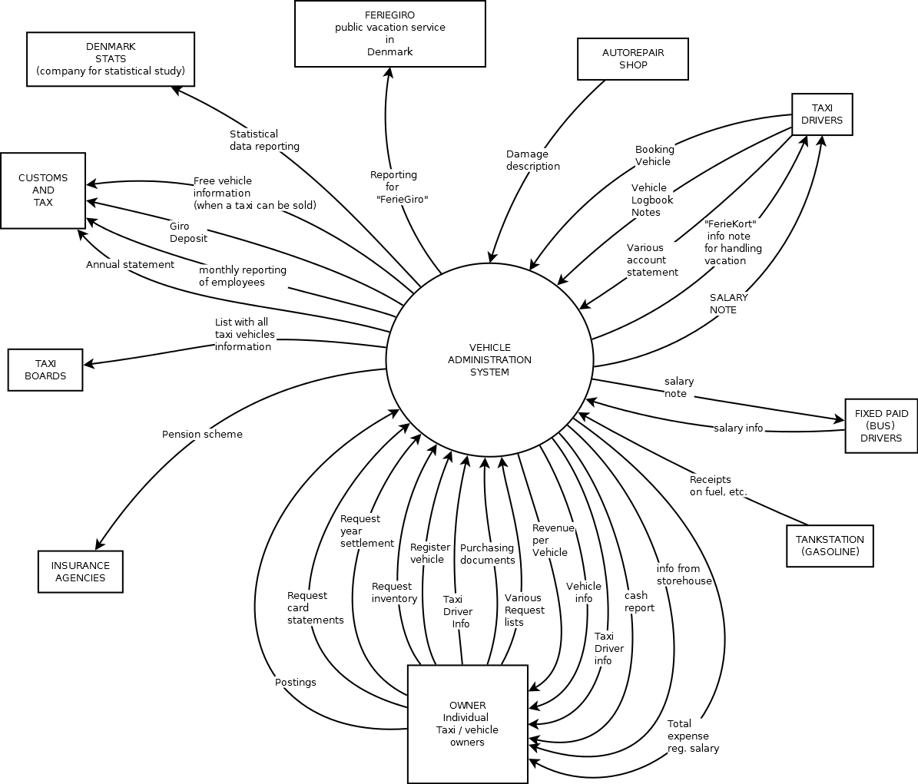

Figur 6 Context (current system)

##### 5.1.3.2.2 Niveau 0 (Current system)

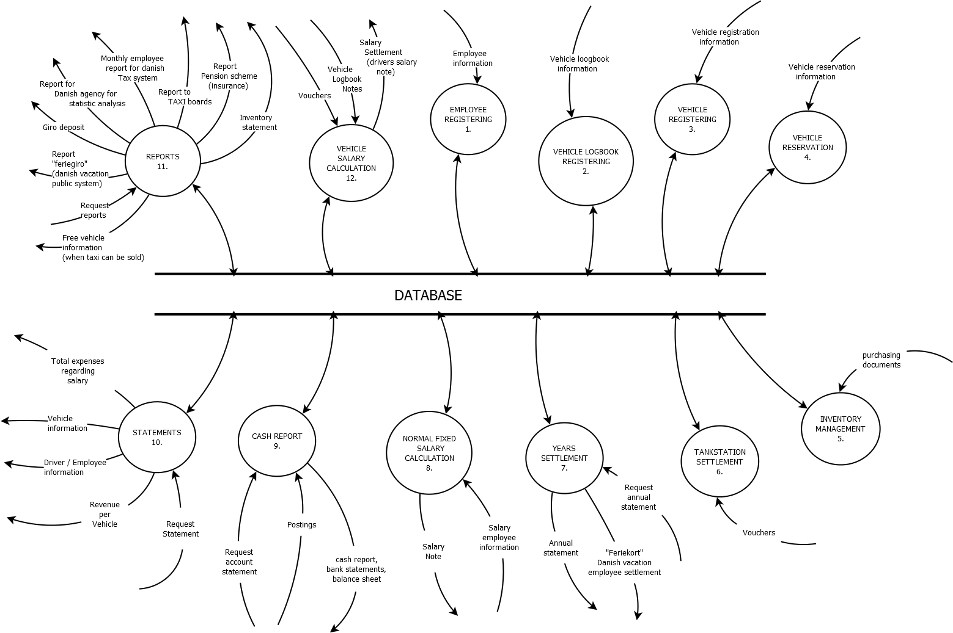

Figur 7 Niveau 0 (current system)

## 5.2 OBJECTIVES AND CHARACTERISTIC ANALYSIS

### 5.2.1 Hierarchy of objectives

Based on the old system and analysis of what is missing and what is needed, a set of objectives is found

Each vehicle owner is currently dealing with a highly changeable environment based on season and events. Each vehicles revenue depends on how many customers / trips the driver have been able to handle during one day, so in order to improve the overall revenue, a new way of managing the vehicles and drivers is needed.

The old system was running for 11 years and during that time was altered to fit public requirements to different salary issues, however the system, even though it was designed to handle more owners, It only had one owner. The system failed to reach its potential due to its implementation – it should have been an online service instead of a stand-alone PC program.

The old system had focus on employee salary and basic multiple owners of vehicles, however new system will have focus on improving the overall revenue, by improving the flexibility and resource handling of the current system. It is a major change for the system, going from salary to resource handling system.

The change is done in following main groups:

EMPLOYEES, OWNERS, DISPATCHERS, CUSTOMERS, SALARIES

Each group will have a subset of change requirements or improvements noted as (i).

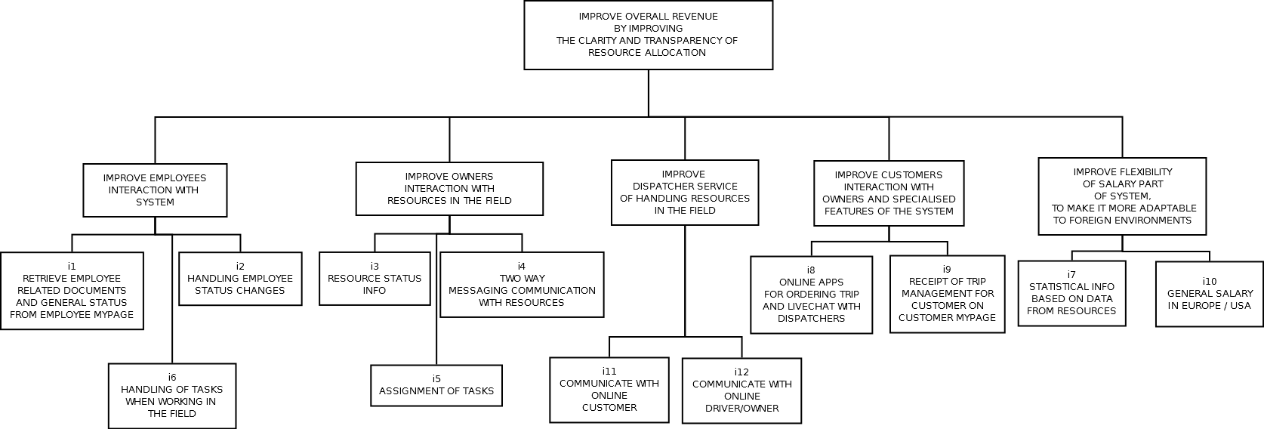

Figur 8 Hierarchy of objectives

### 5.2.2 Changing needs

|  |  |  |  |
| --- | --- | --- | --- |
| NR | Needs description | Reference to problem list | Reference to hierarchy of objectives |
| 1 | RESOURCE TASK HANDLING FEATURE |  |  |
| 2 | DISPATCHER FEATURE |  |  |
| 3 | RESOURCE OVERALL STATUS |  |  |
| 4 | SALARY INTERNATIONALIZATION |  |  |
| 5 | CUSTOMERS INTERACTION FEATURE |  |  |
| 6 | OWNER INTERACTION FEATURE |  |  |

### 5.2.3 Project aims

|  |  |  |  |  |  |  |
| --- | --- | --- | --- | --- | --- | --- |
| NR | Specification | Unit | Measuring method | Curr.  Level | Planned  Level | Reference |
| 1 | Vehicle reservation | Number of idle hours per vehicle per month | Find amount of hours with customer compared to amount of hours running idle | 1 to 14 hours idle | Less than 2 hours |  |
| 2 | Owner booking and handling drivers vehicle activities | Number of hours used creating schedules and contacting various drivers per day | Investigate how owner communicate with his employees when deciding to give them vehicle tasks – how much time is spent on that | 1-3 hours | Zero – system should handle normal vehicle handling tasks |  |
| 3 | Owner retrieve info on TAXI trips | Number of trips with customers per day  Owner spends hours retrieving this info | Current salary system is collecting info from logbook notes – salary notes then show detail on what a TAXI was doing during a shift – Owner must spend time on this for each employee | 4-12  Trips  1-2 hours per day | Maximize amount of trips during a day, based on improved interaction with dispatchers – customer allocation.  System will provide dynamic info to owner, minimizing the owners involvement | Max. revenue per day is the focus |
| 4 |  |  |  |  |  |  |
| 5 |  |  |  |  |  |  |
| 6 |  |  |  |  |  |  |

## 5.3 Change analysis

### 5.3.1 Process of change alternatives

|  |  |
| --- | --- |
| GOAL | VEHICLE RESERVATION |
|  |  |
| ALTERNATIVES: |  |
| 1 | MANUAL UPDATING PAPER LIST OF VEHICLES AVAILABLE |
| 2 |  |
| 3 |  |
| 4 |  |
|  |  |
| EXPLANATION: | Pros/Cons |
| 1 | Keeping track of all vehicles availability status, is time consuming, especially when vehicle is handled by several people |
| 2 |  |
| 3 |  |
| 4 |  |

## 5.3.2 Decision/assessment of proposed solutions

Based on the project aims and the individual change alternatives it has been decided that following solution is an acceptable future flexible solution:

TODO: indsæt forandringsalternativer beslutning

The system will be request / response driven, making the system more flexible for future alterations.  
It will be an online service with two distinct User Interfaces – one for the handheld device and one for the office desktop. The system will be touch enabled, meaning that most interaction with user will be using standard touch features, such as slide touch, double touch and single touch

### 5.3.2.1 Sketch of new system

#### 5.3.2.1.1 Context level

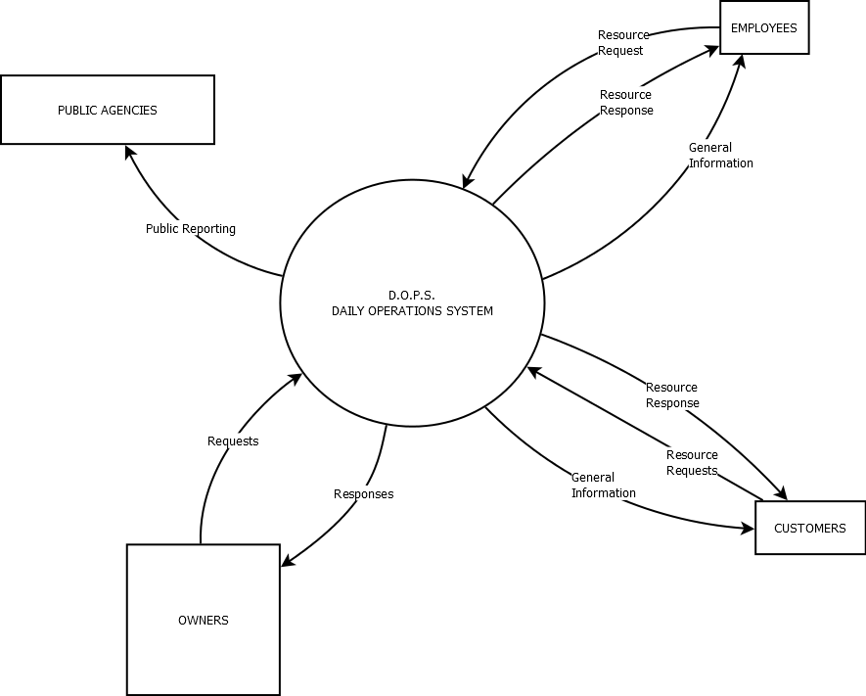

Figur 9 Context level (new system)

#### 5.3.2.1.2 Level 0 (sketch of new system)

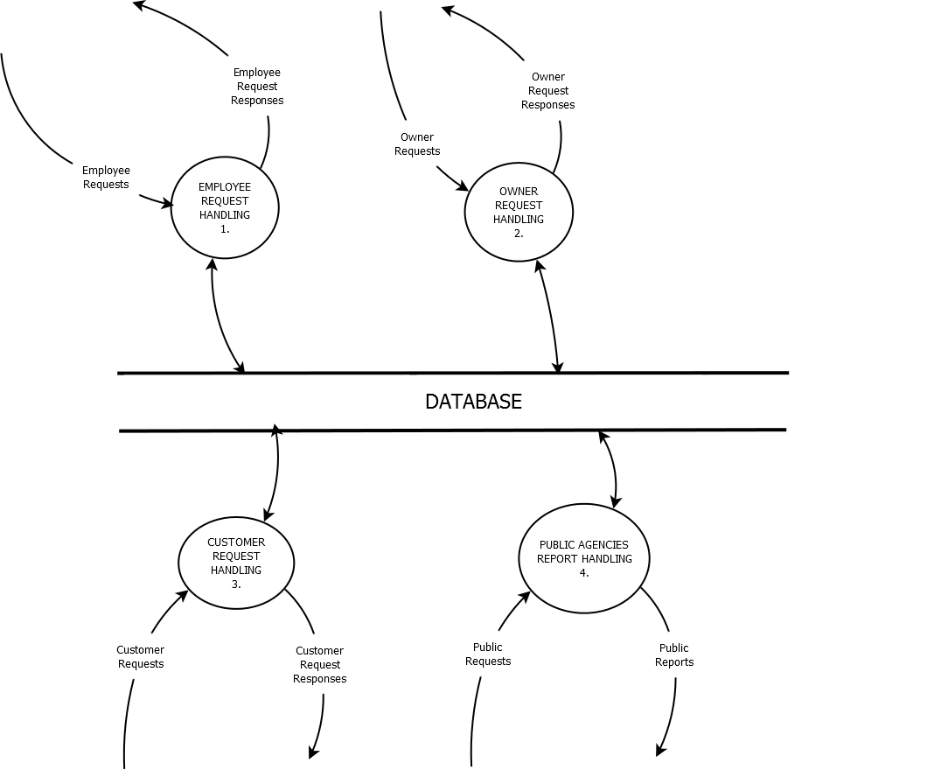

Figur 10 Level 0 (new system)

## 5.4 Task frame

In order to utilize the short amount of time before deadline, then a fixed amount of use cases was chosen to be implemented for the first version of the system.  
Below is a description of workflow for development, even after the first 10 use cases have been implemented, future implementation will follow below structure.  
It is vital that the analysis material and this document is updated for every new version of the system, so in a sense this and the following materials are living documents



Every one of above phases contain sub phases, so in order to avoid a confusing time schedule, then these sub phases is not shown.

ANALYSIS contains following sub phases:  
*Data modeling  
 development of conceptual data model  
 normalization of the data model  
 description of data elements  
Function modeling  
 dataflow diagramming  
 mini specification  
System boundaries*

DESIGN USER INTERFACE contains following sub phases:  
 *concretization of the physical appearance  
 UI Design based on 10 main use cases  
 determination of various touch/swipe  
 description of commando sequence  
 chose screen layout for handheld and desktop  
 user interface flow programming (dynamic context – using flowella tool )*

EDIT SYSTEMSPECIFICATIONS contains following sub phases:  
 *examination of the data dictionary entries   
 data dictionary consists of (dataflow one to one relation):*  Data streams, data elements, processes, records

SKELETON CONSTRUCTION contains following sub phases:  
 *structure diagramming of functions  
 SQL-Database programming  
 Test database structure and the skeleton functions*

USERINTERFACE TEST BY USER contains following sub phases:  
 *flowella working version for handheld, tested by real user – feedback written down*

CONSTRUCTION contains following sub phases:  
 *programming of functions based on structure diagrams skeleton functions and mini specs*

# ANALYSIS

## 6.1 DATA MODELING

### 6.1.1 Consideration of relevant entities

In order to achieve the best possible flexibility with regards to future changes to the system, the individual issues have been assigned to following areas

Owner  
Employee  
Resource  
Location  
Customer  
Task  
Organization  
Qualification

Every issue that occurs can be attached to one of the above areas, which means that a solution of the issue can be made based on each area.

To simplify it further:

Profile - owner, distributor, employee  
Organization   
Task - defines a goal and description to reserve resources and profiles  
Resource - location, calendar ( resource and profile each have a calendar )  
Qualification - defines  
Customer

### 6.1.2 Conceptual data model Entity / Relation diagram



Figur 11 Entity/Relation diagram

### 6.1.3 Role table

|  |  |  |  |
| --- | --- | --- | --- |
| RELATION CLASS | ENTITY CLASS | ROLE | CARDINALITY |
| Reserves | TASK  PROFILE | PLACEHOLDER  INITIATOR | N  M |
| Reserves | TASK  RESOURCE | PLACEHOLDER  TOOL | N  M |
| Assigned | ORGANIZATION  PROFILE | OWNER  EMPLOYEE | 1  M |
| Owns | CUSTOMER  TASK | OWNER  PLACEHOLDER | N  M |
| Has | PROFILE  QUALIFICATION | OWNER  LICENSE | N  M |

### 6.1.4 Extended Entity / Relation diagram



Figur 12 Extended E/R diagram

|  |  |  |
| --- | --- | --- |
| ENTITY | RELATION | ENTITY |
| TASK | Reserves | RESOURCE |
| TASK | Contains | TASK |
| PROFILE | Has | RESOURCE |
| TASK | Reserves | RESOURCE |
| ORGANISATION | Assign | PROFILE |
| RESOURCE | Has | RESOURCE ELEMENTS |
| RESOURCE ELEMENTS | Contains | RESOURCE ELEMENTS |
| RESOURCE | Has | EVENT |
| EVENT | Contains | EVENT |

The TOAST tables is to accommodate “the oversized attribute storage technique”, since most data has different protocols and is encoded as large objects, then the principle of TOAST is used.  
A toast object consists of several chunks of data, when read, then these chunks must be put together to form the actual object.

## 6.1.5 Entity classes with associated keys

|  |  |  |
| --- | --- | --- |
| Entity | Key / *Composite* key | Description |
| TASK | taskID | Contains relation to profile and |
|  | profileID | Resource – linked list of tasks |
|  | resourceID | The task type describes what the task |
|  |  | is about |
| TASKTYPE | taskTypeID | Various different tasks are |
|  |  | described in this table |
|  |  |  |
| PROFILE | profileID | A profile is a person |
|  |  | fx. Owner, Employee, |
|  |  | Customer |
|  |  |  |
| RESOURCE | resourceID | Resource is always related to a |
|  | profileID | profile |
|  |  | *Here a resource is considered a hard* |
|  |  | *resource – fx. A vehicle, a toolbox…* |
| RESOURCETYPE | resourceTypeID | Various different resource types |
|  |  | Description table for resources |
| PROTOCOLTYPE | protocolTypeID | Information about different types of |
|  |  | Protocols / codecs, fx. GPS,ZIP,PNG,... |
| RESOURCEELEMENT | resourceID | A linked list with resource elements |
|  | resourceElementID | A resource element has a protocol |
|  |  | type |
|  |  |  |
| EVENT | resourceID | An event is always related to a |
|  | eventID | resource, since it is describing what |
|  |  | a resource is doing |
|  |  |  |
| EVENTTYPE | eventTypeID | Information about event |
|  |  |  |
| PROFILETOAST | <chunk_id> |  |
| RESOURCETOAST | <chunk_id> |  |
| RESOURCETYPETOAST | <chunk_id> |  |
| RESOURCEELEMENTTOAST | <chunk_id> |  |
| EVENTTOAST | <chunk_id> |  |
| MARKER | id | Contains latitude, longitude of  resource |
| CUSTOMER | customerID | Contains customer info |

Detailed data structure diagram can be seen in the system specification.

In the old system the central part was vehicle and salary, here there is no such distinction, however a vehicle and a salary (note) can be seen as resources, so such items would be stored in the database as resources with resource elements. Having this type of perspective opens up for a more flexible system usage, the system is no longer confined to handle a fixed type of scenarios – here it is possible in the future to add more complex scenarios without changing the foundation, but simply by adding new resources

# 6.2 functional modeling / system delimitation

## 6.2.1 Context ( Daily Operations System)

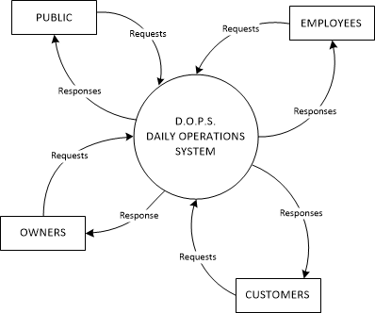

Figur 13 Context system DOPS

## 6.2.2 Level 0 (Daily operation system)

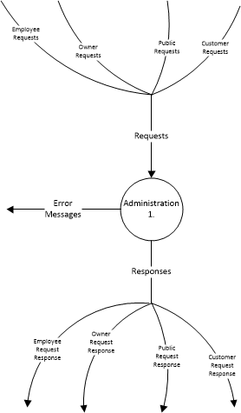

Figur 14 Level 0 system DOPS

## 6.2.3 Level 1 (Daily Operations System)

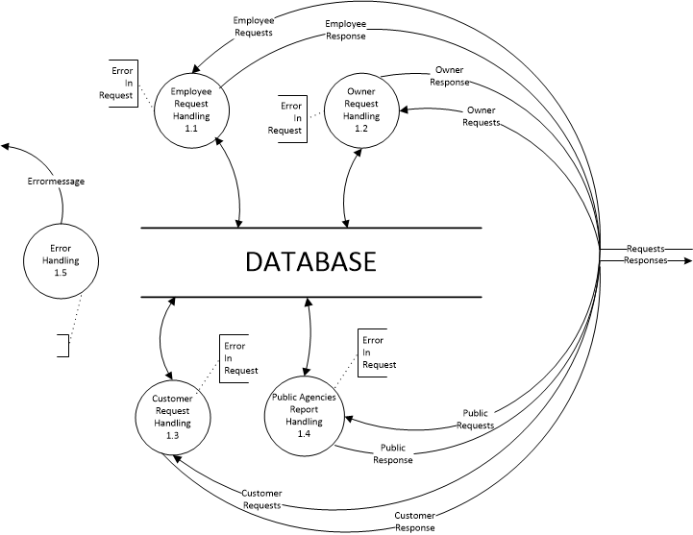

Figur 15 Level 1 system DOPS

The division of requests and responses into employee, owner, customer and public, has its origin in the way daily operations are handled. Every action in the system is on the Request/Response term

To avoid confusion, the dataflow diagrams has a pseudo-connection between error messages. This have been indicated using dashed lines. All error messages end up in error handling function and will be handled there.

Level 1 of the system represents the overall functions. The system will be delimited to contain only the absolute necessary functions

# 6.3 Design of user interface

## 6.3.1 Concretization of the physical appearance

The system consists of handheld devices and desktop touch enabled screens.  
The UI design will be in two groups :

The handheld/mobile version   
The desktop version  
  
One user scenario could be two people communicating thru the system, it could be the owner and an employee currently out in the field – owner would typically use a desktop touch enabled, when he is in the office and the employee would use a type of handheld touch enabled device when in the field.

This section will use different use cases to help build the needed UI

Figur 1 Problem hierarchy 6

Figur 2 Interested Parties 6

Figur 3 Taxi trip scenario 8

Figur 4 Owner wants vehicle status 9

Figur 5 Owner wants supplier status 10

Figur 6 Context (current system) 11

Figur 7 Niveau 0 (current system) 12

Figur 8 Hierarchy of objectives 13

Figur 9 Context level (new system) 16

Figur 10 Level 0 (new system) 17

Figur 11 Entity/Relation diagram 21

Figur 12 Extended E/R diagram 22

Figur 13 Context system DOPS 24

Figur 14 Level 0 system DOPS 24

Figur 15 Level 1 system DOPS 25