EDA

SDLG

2/25/2022

Taking a look at the dataset

billionaire.data = read.csv("C:\\Users\\Servando\\Downloads\\archive (34)\\Billionaire.csv")  
head(billionaire.data)

## Name NetWorth Country Source Rank Age  
## 1 Jeff Bezos $177 B United States Amazon 1 57  
## 2 Elon Musk $151 B United States Tesla, SpaceX 2 49  
## 3 Bernard Arnault & family $150 B France LVMH 3 72  
## 4 Bill Gates $124 B United States Microsoft 4 65  
## 5 Mark Zuckerberg $97 B United States Facebook 5 36  
## 6 Warren Buffett $96 B United States Berkshire Hathaway 6 90  
## Industry  
## 1 Technology  
## 2 Automotive  
## 3 Fashion & Retail  
## 4 Technology  
## 5 Technology  
## 6 Finance & Investments

Checking for type errors and fixing them with casting.(Data Cleaning)

require("readr")

## Loading required package: readr

#Checking types  
typeof(billionaire.data$NetWorth)

## [1] "character"

typeof(billionaire.data$Age)

## [1] "character"

#Changing types to appropiate ones  
billionaire.data$NetWorth <- as.numeric(parse_number(billionaire.data$NetWorth))  
billionaire.data$Age <- as.numeric(billionaire.data$Age)

## Warning: NAs introduced by coercion

#Changing column name  
colnames(billionaire.data)[2]<-"Net_Worth_Billions"  
#Checking dataframe  
head(billionaire.data)

## Name Net_Worth_Billions Country Source  
## 1 Jeff Bezos 177 United States Amazon  
## 2 Elon Musk 151 United States Tesla, SpaceX  
## 3 Bernard Arnault & family 150 France LVMH  
## 4 Bill Gates 124 United States Microsoft  
## 5 Mark Zuckerberg 97 United States Facebook  
## 6 Warren Buffett 96 United States Berkshire Hathaway  
## Rank Age Industry  
## 1 1 57 Technology  
## 2 2 49 Automotive  
## 3 3 72 Fashion & Retail  
## 4 4 65 Technology  
## 5 5 36 Technology  
## 6 6 90 Finance & Investments

How does the five number summary look like for net worth? What’s the standard deviation?

summary(billionaire.data$Net_Worth_Billions)

## Min. 1st Qu. Median Mean 3rd Qu. Max.   
## 1.000 1.500 2.300 4.749 4.200 177.000

sd(na.omit(billionaire.data$Net_Worth_Billions))

## [1] 9.615358

Let’s figure out how the distribution looks like.

require("ggplot2")

## Loading required package: ggplot2

require("moments")

## Loading required package: moments

Networth_billions <- billionaire.data$Net_Worth_Billions  
skewness(billionaire.data$Net_Worth_Billions)

## [1] 8.671725

ggplot ( data = billionaire.data)+geom_histogram(mapping = aes(x =Net_Worth_Billions ),binwidth = 0.5,color = "darkgreen")+ggtitle("Net Worth Frequency Distribution")

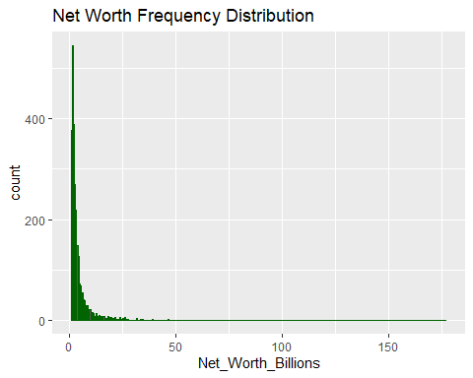 What’s the number of billionaires per industry?

require("dplyr")

## Loading required package: dplyr

##   
## Attaching package: 'dplyr'

## The following objects are masked from 'package:stats':  
##   
## filter, lag

## The following objects are masked from 'package:base':  
##   
## intersect, setdiff, setequal, union

require("wesanderson")

## Loading required package: wesanderson

by.industry <- billionaire.data %>%  
group_by(Industry) %>%  
summarise(number.of.billionaires <- n()  
)  
  
by.industry$Industry<- factor(by.industry$Industry,levels = by.industry$Industry[order(by.industry$`number.of.billionaires <- n()`)])  
par(mar=c(19,4,4,1))  
industry.plot <- ggplot(data = by.industry, aes(x = Industry, y =`number.of.billionaires <- n()` , fill =Industry ))+ geom_bar(stat = "identity") +ggtitle("Number of Billionaires by Industry") +  
 geom_text(aes(label =`number.of.billionaires <- n()` ), hjust =1 ,color = "white", size = 3.5)+  
 theme_minimal()+coord_flip()   
industry.plot + theme_bw()

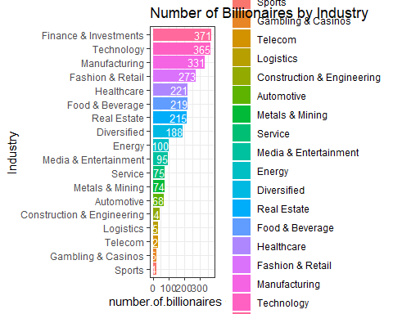

Now, let’s break it down by country.

by.country <- billionaire.data %>%  
group_by(Country) %>%  
summarise(number.of.billionaires <- n()  
)  
by.country <- by.country[order(-by.country$`number.of.billionaires <- n()`),]  
colnames(by.country)[2]<-"Number of Billionaires"  
top<- top_n(by.country,5)

## Selecting by Number of Billionaires

top$Country<- factor(top$Country,levels = top$Country[order(top$`Number of Billionaires`)])  
group.colors <-c(`United States` = "darkblue", China="Darkred",India = "Orange",Germany="Darkgreen",Russia = "purple")  
ggplot(data = top, aes(x = Country, y =`Number of Billionaires`,fill = Country ))+  
 geom_bar(stat = "identity")+ coord_flip() +ggtitle("Top 5 Countries with Most Billionaires") +  
 geom_text(aes(label = `Number of Billionaires`), hjust = -.1 , size = 3.5)+  
 theme_minimal() + scale_fill_manual(values=group.colors)

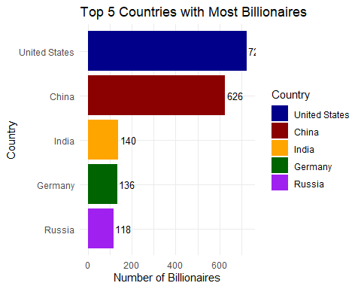

Let’s check for a correlation between age and NetWorth.

require("ggplot2")  
par(mar=c(10,6,6,1))  
ggplot(billionaire.data) + geom_point(mapping = aes(x = Age , y = Net_Worth_Billions ,color=Industry))+  
 ggtitle("Correlation Between Net Worth and Age by Industry")

## Warning: Removed 79 rows containing missing values (geom_point).

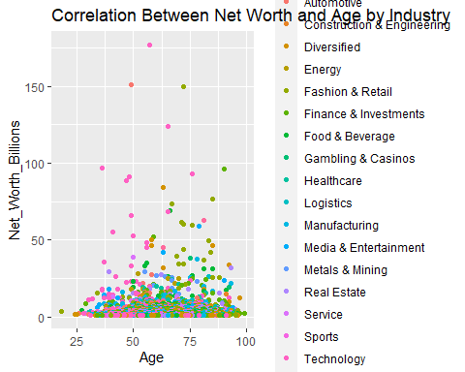 Let’s look at the five number summary of the billionaires’ age.

summary(billionaire.data$Age)

## Min. 1st Qu. Median Mean 3rd Qu. Max. NA's   
## 18.00 54.00 63.00 63.11 73.00 99.00 79

Now, Let’s compare the age of billionaires of the 5 industries with most billionaires

five.industries <- billionaire.data %>% filter(Industry == c("Finance & Investments","Technology","Manufacturing","Fashion & Retail","Healthcare"))  
  
agesplot <- ggplot(data = five.industries , mapping = aes(x=reorder(Industry,Age,FUN=median), y = Age, fill = Industry)) +  
 geom_boxplot() +  
 coord_flip()  
  
agesplot

## Warning: Removed 6 rows containing non-finite values (stat_boxplot).

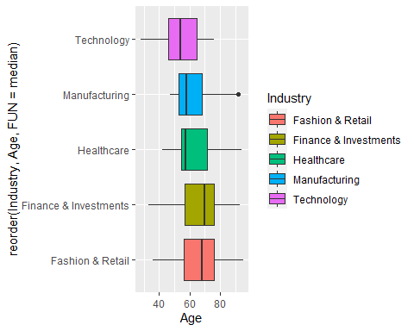 Now, let’s see how that comparison it’s like for net worth

ggplot(data = five.industries , mapping = aes(x=reorder(Industry,Net_Worth_Billions,FUN=median), y = Net_Worth_Billions, fill = Industry)) +  
 geom_boxplot() +  
 coord_flip()

