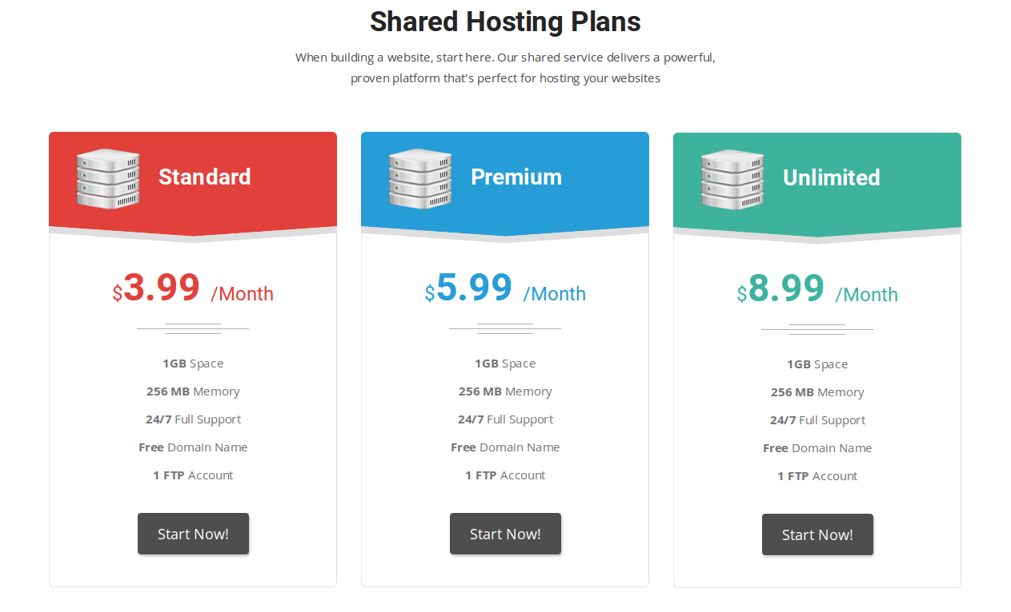
Price Plan for Internet POS (headline for this section)

RESTAURANT POS

Table Layouts /Orders

Takeaway Orders

Inventory and Stocks

Intelligent Reporting

No device limitation

IPAD/TABLET/PC

£30 PCM

RESTAURANT ECOMMERCE

GPRS Printer Integrated

Card Payment/ Paypal /Cash

Intelligent Dashboard

Dynamic Table Booking

Offline marketing System

Social media monitoring

£35 PCM

ECOMMERCE & POS

Total control of business

Integrated Marketing

Detail business reports

Competitive advantage

Grow Fast. Increase Sales

£50 PCM

Testiomnial: Copy from www.restaurantAutomation .co.uk

Update : Address , Phone number

Update Logo : Restaurant Automation, Order Pin, Service ON, Worldpay, MCAfee
Change Get Started today to “Request Demo” and change this line “You may contact us for any kindly of query regarding web hosting or domain we will deal you and welcome you on priority.”
to
You may contact us for any kindly of query regarding Point of Sale or E-commerce or both we will deal you and welcome you on priority.

