Beebuk Manifesto
- Create Accounts
  - GoDaddy: https://godaddy.com
  - CloudFlare: https://cloudflare.com
  - Github: https://github.com
  - Vercel: https//:vercel.com
  - builder.io: https://builder.io
  - Shopify: https://shopify.com
  - PayPal: https://paypal.com

- Create related charts for user actions iteractions of app
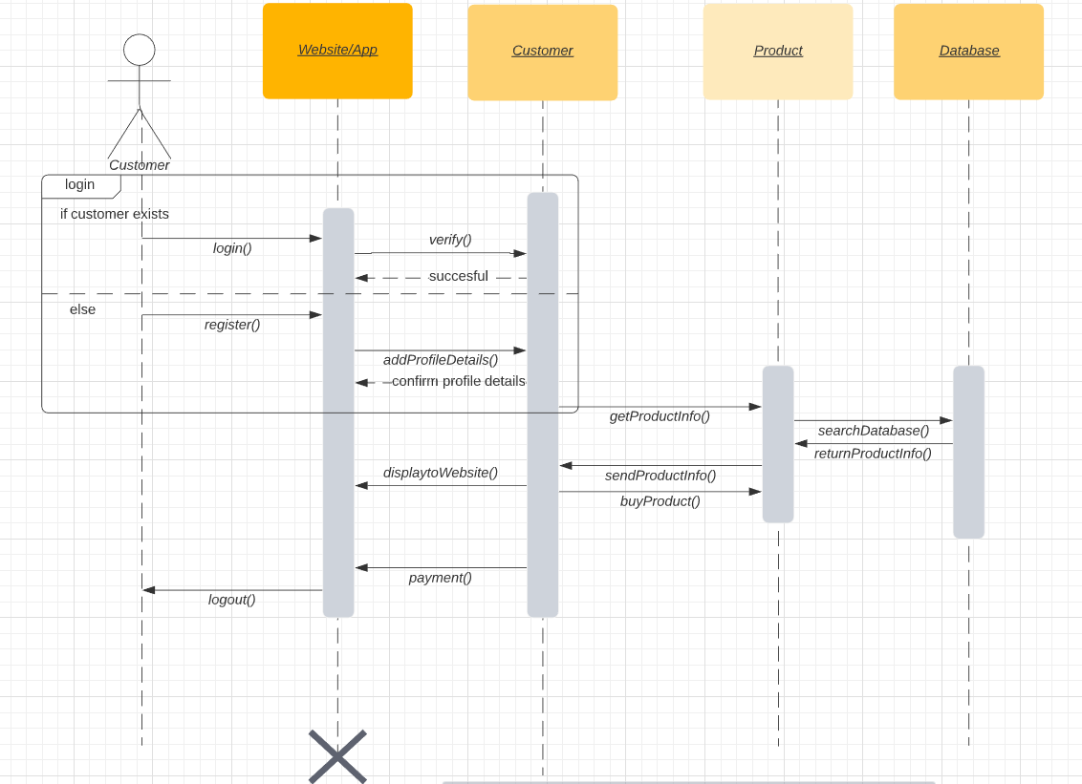
- Create MVP
  - Can navigate website
  - Can register an account
  - Can add users into services list
  - Can mark users to use for service
  - Can make online payment directly from the platform

