Срок до 19.10.2021

Развернуть две виртуальные машины:

1) Ubuntu 20.04(latest) **(ОК)**

2) Centos 8.2.2004 (latest)**(ОК)**

3) произвести минимальную настройку **(ОК)**

* + Environment:
    - Generate your SSH private key (if do not have yet) **(ОК)**
  + VM
    - Prepare Virtual Machine with the Ubuntu 20 LTS and the CentOS 8**(ОК)**
    - Make some initial configuration:
      * Change hostnames

внес изменения в *etc*/hostname и *etc*/hosts

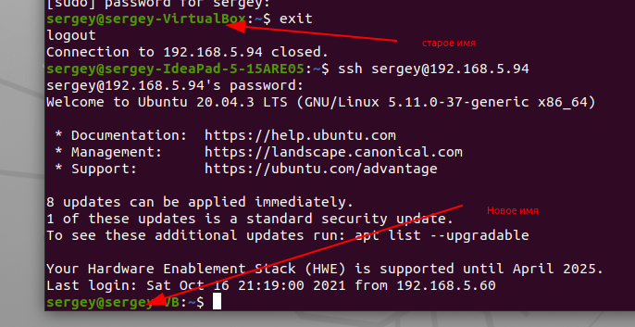

* + - * Change timezone**(ОК)**

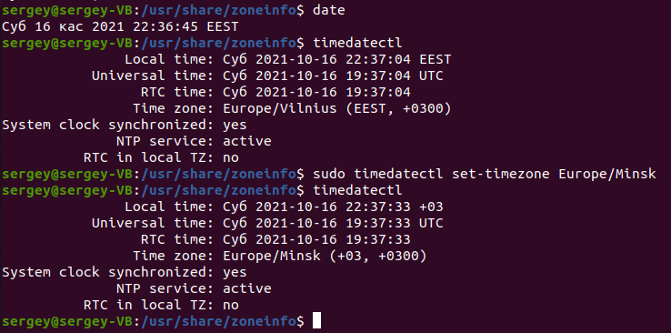

* + - * Set MOTD (Message of the Day) customised for each VM**(ОК)**

создаем файл *etc*/motd, пишем туда что хотим

при подклчнии по ssh видим что написали:

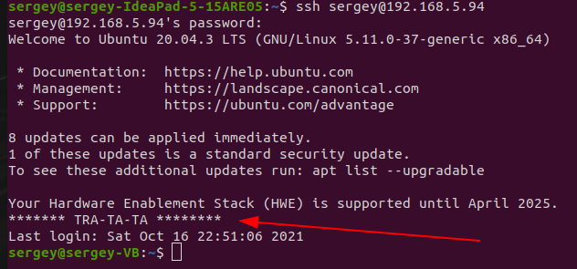

* + - Connect to Virtual Machines using SSH key **(ОК)**
    - Disable password login via SSH on Virtual Machines

После подключения через ключ автоматом не требует пароль. Но почему-то под убунту из хостовой машины в виртуальную не захотело без пароля (а наоборот безпроблем – для экперимента). В Центос подключилось без пароля по ключу.

4) Сделать снапшоты

* + - Create a VM snapshot for one of the VM **(ОК)**
    - Restore a VM using this snapshot **(ОК)**
    - *Load OS in the recovery mode and observe the log information **(на ubuntu не получилось вообще (((**

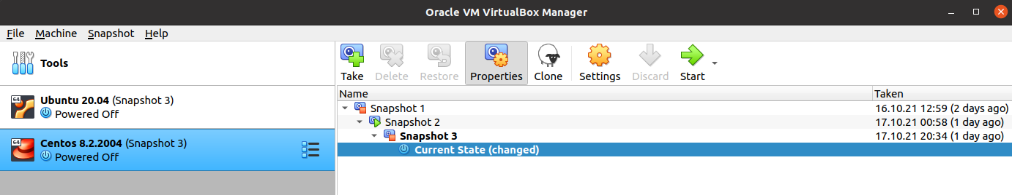

5) Определить точную версию ядра.(**ОК)**

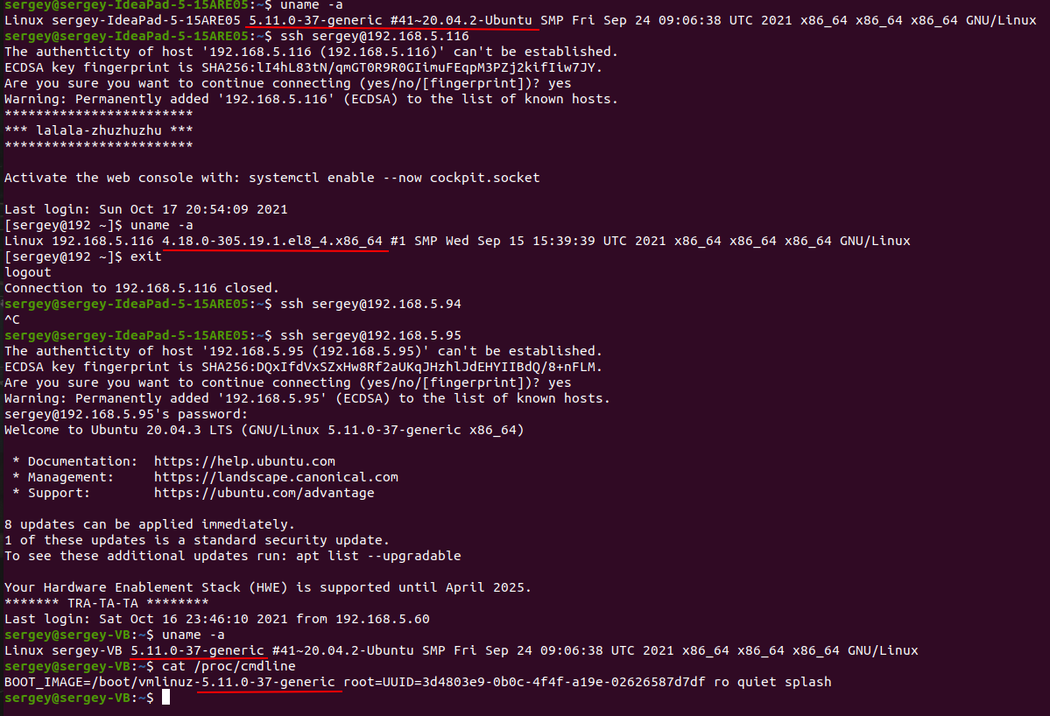

6) Вывести список модулей ядра и записать в файл **(OK)**

lsmode > имяфайла (у меня файл spisok111):

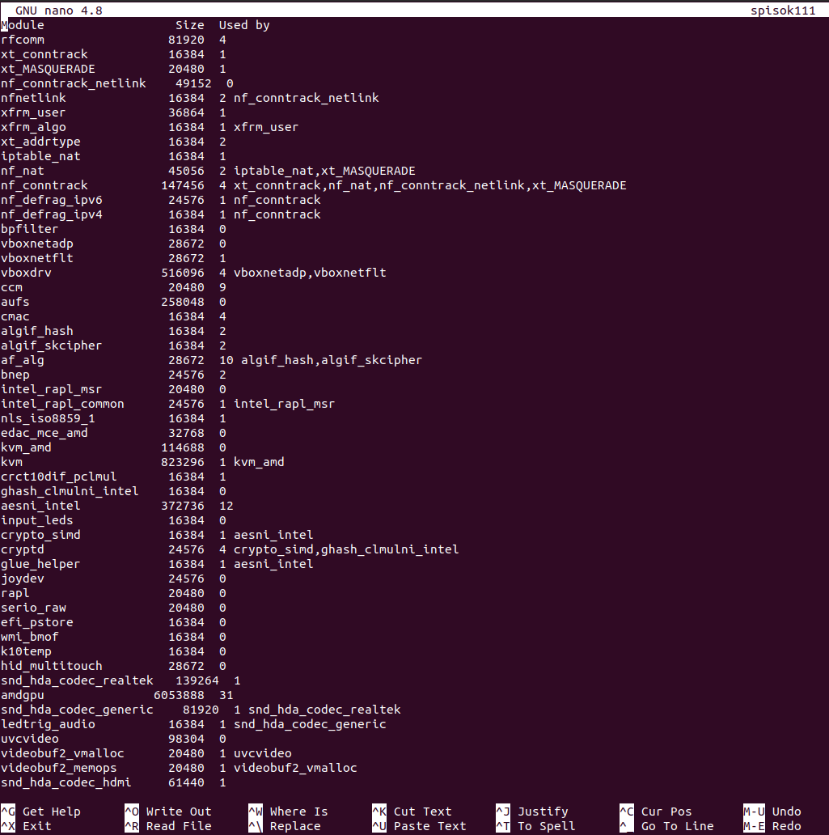

7) Просмотреть информацию о процессоре и модулях оперативной памяти (на виртуалках и на хостовой машине). **(ОК)**

(lshw):

host:

*-cpu

product: AMD Ryzen 3 4300U with Radeon Graphics

vendor: Advanced Micro Devices [AMD]

physical id: 1

bus info: cpu@0

size: 2262MHz

capacity: 2700MHz

width: 64 bits

RAM

*-memory

description: System Memory

physical id: 1

slot: System board or motherboard

size: 8GiB

*-bank:0

description: Row of chips DDR4 Synchronous Unbuffered (Unregistered) 3200 MHz (0,3 ns)

product: M471A5244CB0-CWE

vendor: Samsung

physical id: 0

serial: 00000000

slot: DIMM 0

size: 4GiB

width: 64 bits

clock: 3200MHz (0.3ns)

*-bank:1

description: Row of chips DDR4 Synchronous Unbuffered (Unregistered) 3200 MHz (0,3 ns)

product: M471A5244CB0-CWE

vendor: Samsung

physical id: 1

serial: 00000000

slot: DIMM 0

size: 4GiB

width: 64 bits

clock: 3200MHz (0.3ns)

CENTOS:

*-cpu

product: AMD Ryzen 3 4300U with Radeon Graphics

vendor: Advanced Micro Devices [AMD]

physical id: 1

bus info: cpu@0

version: 23.96.1

width: 64 bits

RAM (lshw -class memory)

*-memory

description: System memory

physical id: 1

size: 2GiB

UBUNTU

*-cpu

product: AMD Ryzen 3 4300U with Radeon Graphics

vendor: Advanced Micro Devices [AMD]

physical id: 2

bus info: cpu@0

width: 64 bits

RAM

*-memory

description: System memory

physical id: 1

size: 4GiB

8) Получить информацию о жестком диске (на виртуалках и на хостовой машине).**(ОК)**

HOST

*-storage

description: Non-Volatile memory controller

product: SK hynix

vendor: SK hynix

physical id: 0

bus info: pci@0000:02:00.0

version: 00

width: 64 bits

clock: 33MHz

capabilities: storage pm msi msix pciexpress nvm_express bus_master cap_list

configuration: driver=nvme latency=0

resources: irq:43 memory:fd500000-fd503fff

*-nvme0

description: NVMe device

product: SKHynix_HFM256GDHTNI-87A0B

physical id: 0

logical name: /dev/nvme0

version: 11010C00

serial: CY07N044710307M0X

configuration: nqn=nqn.2014.08.org.nvmexpress:1c5c1c5cCY07N044710307M0X SKHynix_HFM256GDHTNI-87A0B state=live

*-namespace

description: NVMe namespace

physical id: 1

logical name: /dev/nvme0n1

size: 238GiB (256GB)

capabilities: gpt-1.00 partitioned partitioned:gpt

configuration: guid=94b27fa2-3f2d-474d-969d-6286c99c44ea logicalsectorsize=512 sectorsize=512

*-volume:0

description: Windows FAT volume

vendor: mkfs.fat

physical id: 1

logical name: /dev/nvme0n1p1

logical name: /boot/efi

version: FAT32

serial: a692-aad0

size: 510MiB

capacity: 511MiB

capabilities: boot fat initialized

configuration: FATs=2 filesystem=fat mount.fstype=vfat mount.options=rw,relatime,fmask=0077,dmask=0077,codepage=437,iocharset=iso8859-1,shortname=mixed,errors=remount-ro name=EFI System Partition state=mounted

*-volume:1

description: EXT4 volume

vendor: Linux

physical id: 2

logical name: /dev/nvme0n1p2

logical name: /

version: 1.0

serial: dcaa63f2-22a8-45c1-84c6-48571e6dde47

size: 237GiB

capabilities: journaled extended_attributes large_files huge_files dir_nlink recover 64bit extents ext4 ext2 initialized

configuration: created=2021-10-04 21:39:37 filesystem=ext4 lastmountpoint=/ modified=2021-10-17 20:49:30 mount.fstype=ext4 mount.options=rw,relatime,errors=remount-ro mounted=

CENTOS

*-disk

description: ATA Disk

product: VBOX HARDDISK

vendor: VirtualBox

physical id: 0.0.0

bus info: scsi@1:0.0.0

logical name: /dev/sda

version: 1.0

serial: VB62dd59f8-0aa4fe3b

size: 25GiB (27GB)

capabilities: partitioned partitioned:dos

configuration: ansiversion=5 logicalsectorsize=512 sectorsize=512 signature=e864c4c2

*-volume:0

description: Windows FAT volume

vendor: mkfs.fat

physical id: 1

bus info: scsi@1:0.0.0,1

logical name: /dev/sda1

version: FAT32

serial: ef80-1491

size: 510MiB

capacity: 512MiB

capabilities: primary bootable fat initialized

configuration: FATs=2 filesystem=fat

*-volume:1

description: Extended partition

physical id: 2

bus info: scsi@1:0.0.0,2

logical name: /dev/sda2

size: 9725MiB

capacity: 9725MiB

capabilities: primary extended partitioned partitioned:extended

*-logicalvolume

description: EXT4 volume

vendor: Linux

physical id: 5

logical name: /dev/sda5

version: 1.0

serial: 3d4803e9-0b0c-4f4f-a19e-02626587d7df

size: 9725MiB

capacity: 9725MiB

capabilities: journaled extended_attributes large_files huge_files dir_nlink 64bit extents ext4 ext2 initialized

configuration: created=2021-10-14 00:26:16 filesystem=ext4 lastmountpoint=/ modified=2021-10-14 01:01:02 mounted=2021-10-14 01:01:02 state=clean

*-volume:2

description: EXT4 volume

vendor: Linux

physical id: 3

bus info: scsi@1:0.0.0,3

logical name: /dev/sda3

logical name: /boot

version: 1.0

serial: da303de6-1529-4c27-ba90-dc0dfd52e240

size: 1GiB

capacity: 1GiB

capabilities: primary journaled extended_attributes large_files huge_files dir_nlink recover 64bit extents ext4 ext2 initialized

configuration: created=2021-10-16 12:28:14 filesystem=ext4 lastmountpoint=/boot modified=2021-10-17 21:29:47 mount.fstype=ext4 mount.options=rw,seclabel,relatime mounted=2021-10-17 21:29:47 state=mounted

*-volume:3

description: Linux LVM Physical Volume partition

physical id: 4

bus info: scsi@1:0.0.0,4

logical name: /dev/sda4

serial: nM4Lnb-CwC9-JbNh-41SO-lim5-ijgg-FgJY8m

size: 14GiB

capacity: 14GiB

capabilities: primary multi lvm2

UBUNTU

*-disk

description: ATA Disk

product: VBOX HARDDISK

vendor: VirtualBox

physical id: 0.0.0

bus info: scsi@2:0.0.0

logical name: /dev/sda

version: 1.0

serial: VB62dd59f8-0aa4fe3b

size: 10GiB (10GB)

capabilities: partitioned partitioned:dos

configuration: ansiversion=5 logicalsectorsize=512 sectorsize=512 signature=e864c4c2

*-volume:0 UNCLAIMED

description: Windows FAT volume

vendor: mkfs.fat

physical id: 1

bus info: scsi@2:0.0.0,1

version: FAT32

serial: ef80-1491

size: 510MiB

capacity: 512MiB

capabilities: primary bootable fat initialized

configuration: FATs=2 filesystem=fat

*-volume:1

description: Extended partition

physical id: 2

bus info: scsi@2:0.0.0,2

logical name: /dev/sda2

size: 9725MiB

capacity: 9725MiB

capabilities: primary extended partitioned partitioned:extended

*-logicalvolume

description: EXT4 volume

vendor: Linux

physical id: 5

logical name: /dev/sda5

logical name: /

version: 1.0

serial: 3d4803e9-0b0c-4f4f-a19e-02626587d7df

size: 9725MiB

capacity: 9725MiB

capabilities: journaled extended_attributes large_files huge_files dir_nlink recover 64bit extents ext4 ext2 initialized

configuration: created=2021-10-14 00:26:16 filesystem=ext4 lastmountpoint=/ modified=2021-10-17 21:08:37 mount.fstype=ext4 mount.options=rw,relatime,errors=remount-ro mounted=2021-10-17 21:08:38 state=mounted

9) Добавить в виртуальную машину второй сетевой интерфейс (вывести информацию о нем в виртуалках) (**ОК)**

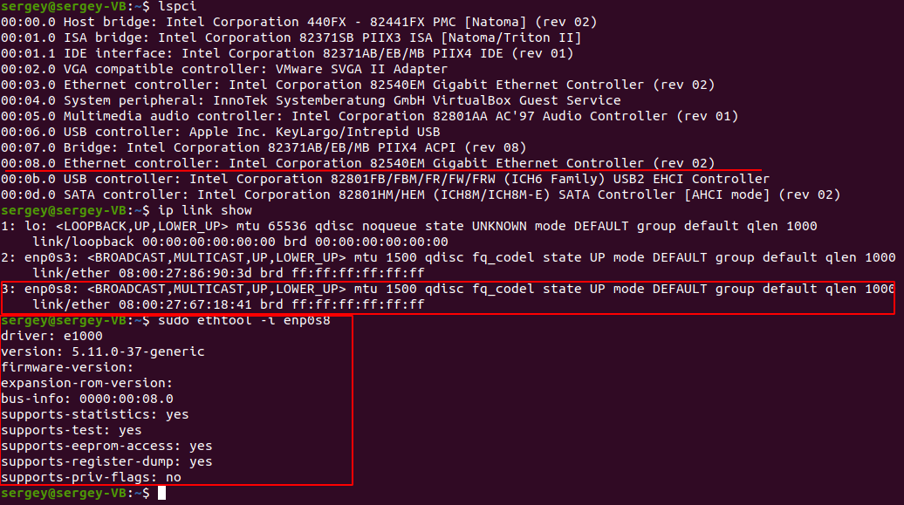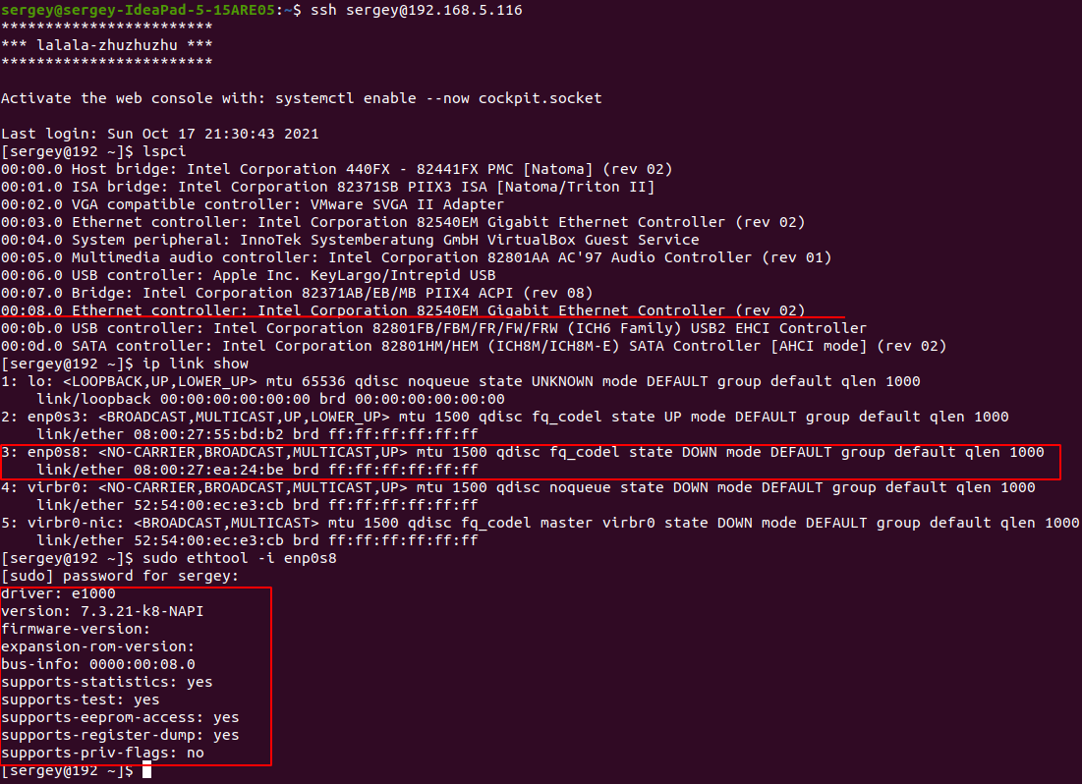

10) Вывести инфо о PCIEx (**ОК)**

HOST (lspci)

00:00.0 Host bridge: Advanced Micro Devices, Inc. [AMD] Renoir Root Complex

00:00.2 IOMMU: Advanced Micro Devices, Inc. [AMD] Renoir IOMMU

00:01.0 Host bridge: Advanced Micro Devices, Inc. [AMD] Renoir PCIe Dummy Host Bridge

00:02.0 Host bridge: Advanced Micro Devices, Inc. [AMD] Renoir PCIe Dummy Host Bridge

00:02.2 PCI bridge: Advanced Micro Devices, Inc. [AMD] Renoir PCIe GPP Bridge

00:02.4 PCI bridge: Advanced Micro Devices, Inc. [AMD] Renoir PCIe GPP Bridge

00:08.0 Host bridge: Advanced Micro Devices, Inc. [AMD] Renoir PCIe Dummy Host Bridge

00:08.1 PCI bridge: Advanced Micro Devices, Inc. [AMD] Renoir Internal PCIe GPP Bridge to Bus

00:08.2 PCI bridge: Advanced Micro Devices, Inc. [AMD] Renoir Internal PCIe GPP Bridge to Bus

00:14.0 SMBus: Advanced Micro Devices, Inc. [AMD] FCH SMBus Controller (rev 51)

00:14.3 ISA bridge: Advanced Micro Devices, Inc. [AMD] FCH LPC Bridge (rev 51)

00:18.0 Host bridge: Advanced Micro Devices, Inc. [AMD] Renoir Device 24: Function 0

00:18.1 Host bridge: Advanced Micro Devices, Inc. [AMD] Renoir Device 24: Function 1

00:18.2 Host bridge: Advanced Micro Devices, Inc. [AMD] Renoir Device 24: Function 2

00:18.3 Host bridge: Advanced Micro Devices, Inc. [AMD] Renoir Device 24: Function 3

00:18.4 Host bridge: Advanced Micro Devices, Inc. [AMD] Renoir Device 24: Function 4

00:18.5 Host bridge: Advanced Micro Devices, Inc. [AMD] Renoir Device 24: Function 5

00:18.6 Host bridge: Advanced Micro Devices, Inc. [AMD] Renoir Device 24: Function 6

00:18.7 Host bridge: Advanced Micro Devices, Inc. [AMD] Renoir Device 24: Function 7

01:00.0 Network controller: Realtek Semiconductor Co., Ltd. RTL8822CE 802.11ac PCIe Wireless Network Adapter

02:00.0 Non-Volatile memory controller: SK hynix Device 1339

03:00.0 VGA compatible controller: Advanced Micro Devices, Inc. [AMD/ATI] Renoir (rev c4)

03:00.1 Audio device: Advanced Micro Devices, Inc. [AMD/ATI] Device 1637

03:00.2 Encryption controller: Advanced Micro Devices, Inc. [AMD] Family 17h (Models 10h-1fh) Platform Security Processor

03:00.3 USB controller: Advanced Micro Devices, Inc. [AMD] Renoir USB 3.1

03:00.4 USB controller: Advanced Micro Devices, Inc. [AMD] Renoir USB 3.1

03:00.5 Multimedia controller: Advanced Micro Devices, Inc. [AMD] Raven/Raven2/FireFlight/Renoir Audio Processor (rev 01)

03:00.6 Audio device: Advanced Micro Devices, Inc. [AMD] Family 17h (Models 10h-1fh) HD Audio Controller

04:00.0 SATA controller: Advanced Micro Devices, Inc. [AMD] FCH SATA Controller [AHCI mode] (rev 81)

04:00.1 SATA controller: Advanced Micro Devices, Inc. [AMD] FCH SATA Controller [AHCI mode] (rev 81)

CENOS

00:00.0 Host bridge: Intel Corporation 440FX - 82441FX PMC [Natoma] (rev 02)

00:01.0 ISA bridge: Intel Corporation 82371SB PIIX3 ISA [Natoma/Triton II]

00:02.0 VGA compatible controller: VMware SVGA II Adapter

00:03.0 Ethernet controller: Intel Corporation 82540EM Gigabit Ethernet Controller (rev 02)

00:04.0 System peripheral: InnoTek Systemberatung GmbH VirtualBox Guest Service

00:05.0 Multimedia audio controller: Intel Corporation 82801AA AC'97 Audio Controller (rev 01)

00:06.0 USB controller: Apple Inc. KeyLargo/Intrepid USB

00:07.0 Bridge: Intel Corporation 82371AB/EB/MB PIIX4 ACPI (rev 08)

00:08.0 Ethernet controller: Intel Corporation 82540EM Gigabit Ethernet Controller (rev 02)

00:0b.0 USB controller: Intel Corporation 82801FB/FBM/FR/FW/FRW (ICH6 Family) USB2 EHCI Controller

00:0d.0 SATA controller: Intel Corporation 82801HM/HEM (ICH8M/ICH8M-E) SATA Controller [AHCI mode] (rev 02)

UBUNTU

00:00.0 Host bridge: Intel Corporation 440FX - 82441FX PMC [Natoma] (rev 02)

00:01.0 ISA bridge: Intel Corporation 82371SB PIIX3 ISA [Natoma/Triton II]

00:01.1 IDE interface: Intel Corporation 82371AB/EB/MB PIIX4 IDE (rev 01)

00:02.0 VGA compatible controller: VMware SVGA II Adapter

00:03.0 Ethernet controller: Intel Corporation 82540EM Gigabit Ethernet Controller (rev 02)

00:04.0 System peripheral: InnoTek Systemberatung GmbH VirtualBox Guest Service

00:05.0 Multimedia audio controller: Intel Corporation 82801AA AC'97 Audio Controller (rev 01)

00:06.0 USB controller: Apple Inc. KeyLargo/Intrepid USB

00:07.0 Bridge: Intel Corporation 82371AB/EB/MB PIIX4 ACPI (rev 08)

00:08.0 Ethernet controller: Intel Corporation 82540EM Gigabit Ethernet Controller (rev 02)

00:0b.0 USB controller: Intel Corporation 82801FB/FBM/FR/FW/FRW (ICH6 Family) USB2 EHCI Controller

00:0d.0 SATA controller: Intel Corporation 82801HM/HEM (ICH8M/ICH8M-E) SATA Controller [AHCI mode] (rev 02)

11) Удалить сеть в модуле ядра в виртуальной машине. И убрать из автозапуска по умолчанию службу сети. (**ОК)**

sudo modprobe -r e1000 - сеть на виртуальной машине пропала напрочь (нет никаких адаптеров)

sudo modprobe -i e1000 все адаптеры вернулись обратно

Убираем из автозагрузки службу сети:

sudo systemctl disable network-manager.service



после перезагрузки сеть не появилась

12) Изменить режим запуска по умолчанию ОС. (на виртуалках Ubuntu и Centos(**ОК)**

UBUNTU:

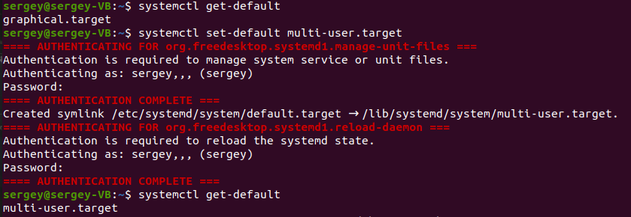

CENTOS:

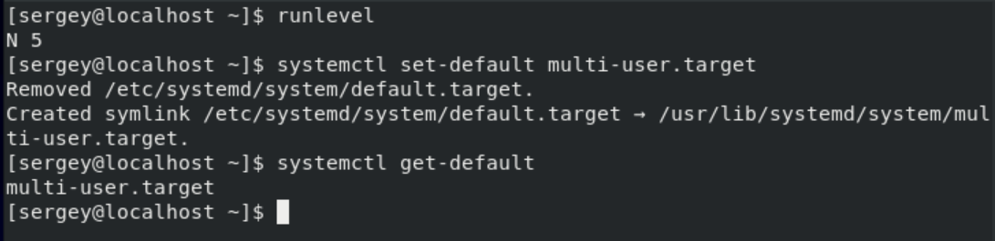

И в том и в другом случае после перезагрузки графика исчезла