

Authors: Sergey Nabatov, Nikita Rozov, Olexandr Shchukhlyi

Date: 29 November 2020

Professor: Matteo Rossi

**Requirement Analysis and Specification Document**

**Deliverable:** RASD

**Title:** Requirement Analysis and Verification Document

**Authors:** Nabatov Sergey, Rozov Nikita, Shchukhlyi Olexandr

**Version:** 1.1

**Date:** 29-November-2020

**Download page:** https://github.com/serynabatov/NabatovRozovShchukhlyi

**Copyright:** Copyrights 2017, S. Nabatov, N. Rozov, O. Shchukhlyi - All rights reserved

Contents

1 Introduction 3

1.1 Purpose 3

1.1.1 General Purpose 3

1.1.2 Goals 3

1.2 Scope 3

1.2.1 World Phenomena: 4

1.2.2 Shared phenomena: 4

1.3 Definitions, Acronyms, Abbreviations 5

1.3.1 Definitions 5

1.3.2 Acronyms 5

1.3.3 Abbreviations 5

1.4 Revision History 5

1.5 Reference Documents 5

1.6 Document Structure 5

2 Overall Description 6

2.1 Product perspective 6

2.2 Product functions 9

2.2.1 Booking management 9

2.2.2 Location management 10

2.2.3 Arrival/departure management 10

2.2.4 Others 10

2.3 User characteristics 10

2.4 Assumptions, dependencies and constraints 10

3 Specific requirements 12

3.1 External interface requirements 12

3.1.1 User interfaces 12

3.1.2 Hardware user interfaces 15

3.1.3 Software interfaces 15

3.2 Functional requirements 16

3.2.1 Common User 16

3.2.2 Prioritized User 23

3.2.3 Privilege User 26

3.2.4 Requirements 30

4 Formal Analysis Using Alloy 32

4.1 Alloy Code 32

4.2 World generated 37

4.3 Alloy results 38

5 Effor spent 38

5.1 Nikita Rozov 38

5.2 Oleksandr Shchukhlyi 38

5.3 Sergey Nabatov 38

6 References 39

List of Figures List of Tables

# Introduction

## Purpose

### General Purpose

The current world was faced with a pandemic of COVID-19. That virus is extremely infectious and is transmitted by airdrome droplets. So, the government and people should organize some restrictions to prevent the mass spreading of coronavirus.

One of the most visited places in the real-world is shops and stores. They cannot be closed because people have to purchase essential goods, such as food. So, there should be a way to provide a low chance of transmitting the virus to new people. As the World Health Organization established the maximum range of the effective virus spreading (1.5 meters) it could be used to estimate the optimal flow in the store concerning the security. However, it makes another trouble: people who are waiting outside a store making a crowd enhancing the chance of obtaining and spreading the virus.

### Goals

G1: The system should provide customers with a reasonably precise estimation of the waiting time and should alert them taking into account the time they need to get to the shop from the place they currently are;

G2: To give people opportunity to stay in queue remotely to avoid crowds in stores and in real queues.

G3: Stores should have the possibility to hand out “tickets” on the spot;

G4: The system should allow customers to book a visit to the supermarket to optimize quantity of people in it by time of their visit, and category of products which they want to purchase;

Additional goals for the group of 3 members:

G5: The system (application and “tickets” on the spot) should include alternative slots (for another day), suggest to the customer the location of the nearest “safe” store based on his location;

G6: The system should allow the third party to get the statistical information to perform better management of the store.

## Scope

The service ‘‘Clup’’ (stands for Customers line up) gives the possibility to plan your visit to a shop with coordination with the management of a store (call them the third side). The application creates a virtual queue instead of a real one, helping to avoid crowds. Also, the system enables the personnel of the management to monitor a situation in a store. For including a store into the application, the manager should accommodate the service with information about areas of a store and departments (to calculate the maximum people flow).

Clup allows customer three options: to simply stand in the queue (the shortest waiting time), to book your visit for the time/day chosen by you, and to accept a token from a machine right outside a store (of course it is not recommended, but in case of not knowing about the application it is the only way). After picking any option users could enter a supposed time of a visit and choose the goods categories, to balance human flow between departments to get the best efficiency.

The location of a customer is getting by GPS, the location of the store is provided by the manager of the shop.

If the user is choosing the first option, the service shows him/her an estimated time of waiting and an estimated time of walking/driving to a store. After coming to a shop customer scans the QR code and if the time for a visit is not expired (came not more than some minutes late) user could go in and start to buy what he/she needs. The application also has an additional feature which will give the possibility to detect customers who not wearing masks it happens when the server gets the data from entering the store. If the user does not have a mask, he will be banned for some time. After exiting from the store user is popping out from the virtual queue.

The second option adding the notification feature to the first one. So, a customer gets the message when the planned visit time is coming. The rest functionality is inherited from the first option.

If a person is using a mobile device to stand in queue/book a visit he can see a load of stores to choose the one with the minimum waiting time/people flow. Also, it is possible to cancel a booking if a user changed his/her mind.

The third option presumes that a customer does not know about mandatory using the application to get in a store. So, when a person comes, he got a ticket with the time of a visit. This request is adding to the queue such as it will be a request from the first option. To visit/leave the store a customer has to scan his ticket before arrival/departure.

### World Phenomena:

* Stores are located at different places;
* Departments are located differently at each store;
* Stores and departments come in different sizes;
* Users can visit different stores and various departments in every store;
* Users purchase various products;
* Users choose basket based on the number of products they want to purchase;
* Users go from home to the store.

### Shared phenomena:

* Booking;
* User arrival time;
* User departure time;
* The wearing mask fact;
* Store and department area;
* Customer queue

A diagram containing world phenomena and shared phenomena is shown in Figure 1:

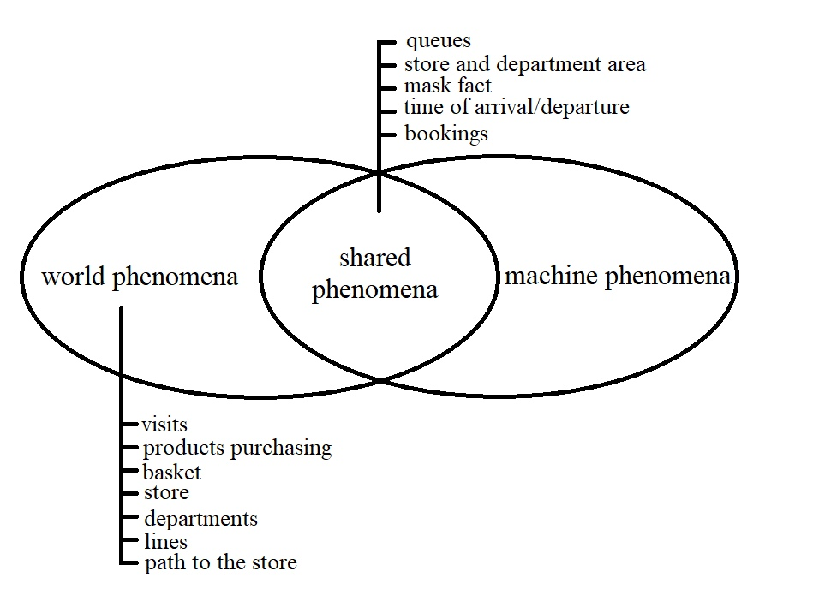

Figure 1 – diagram of world phenomena & shared phenomena

## Definitions, **Acronyms**, Abbreviations

### Definitions

### **Acronyms**

**UML** – Unified Modeling Language.

### Abbreviations

## Revision History

## Reference Documents

## Document Structure

# Overall Description

## Product perspective

As a result, an entirely new mobile app will be developed that uses Yandex maps as additional service. Tracking the user's location will be performed with the help using the built-in sensors of the mobile device. Yandex Map API is responsible for displaying available stores and building the path to them.

The detailed architecture of the program and its interaction with third-party API will be described below.

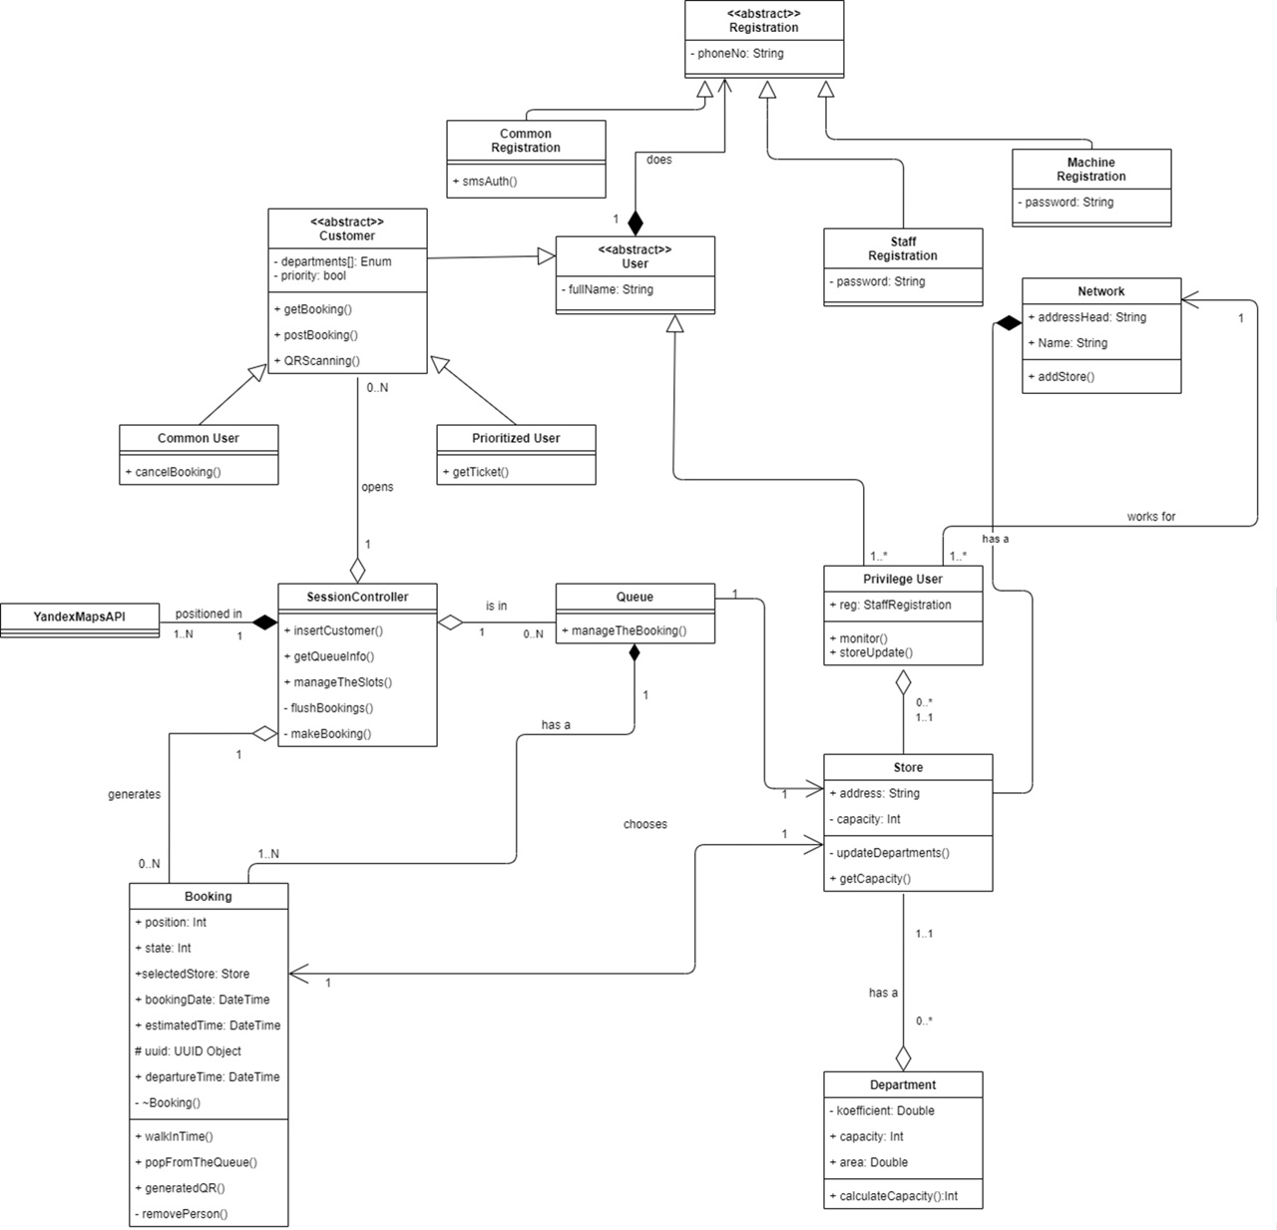

Figure 2 – Class diagram

As can be seen in the screenshot, the entry point of the program can be considered as the *Registration*, which is divided into two branches: the end-user registration and staff registration. Class *Customer*, after inheriting the qualities of the *User* Class, also can be divided into two parts: the one group of people who will use the application - *CommonUser*, with the consequent possibility of canceling reservations online, and the second group *PrioritizedUser*, which will receive its ticket to the queue upon arrival at the store. The *SessionController* class, which controls the process of Queuing in general, uses the *GeoController* class, which provides functionality for tracking the user position and building a route to the selected store. The *YandexAPI* library is responsible for the rest of the map functionality. The *SessionController* class contains a key *makeBooking* method that implements the logic of introducing a new user to the queue, storing more detailed information, such as the selected store and the capacity of its departments, the user’s state (going to the store, making purchases, leaving the store), and generating a QR code that is necessary needed for going to the store. User’s position data is transmitted via a mobile device; therefore, it is important to grant the appropriate rights to use the app. The Queue class stores an array of all bookings for the store. The purpose of the *Store* and *Department* classes is to prevent congestion and create a more efficient distribution of incoming people, to do this, we need to have additional information about the store itself that the owner provides. Let us say the user selects priority departments, and we know their capacity, which will help us calculate the approximate number of customers for each department. The *PriviligeUser* class is the store staff that can access the app and its advanced settings. The Network class groups stores of a single registered trademark. It is worth noting that the above functionality is performed on the server-side.

Using a state diagram, it is possible to describe system behavior more accurately. For example, Figure 3 shows the creation of a connection session to authenticate users via SMS.

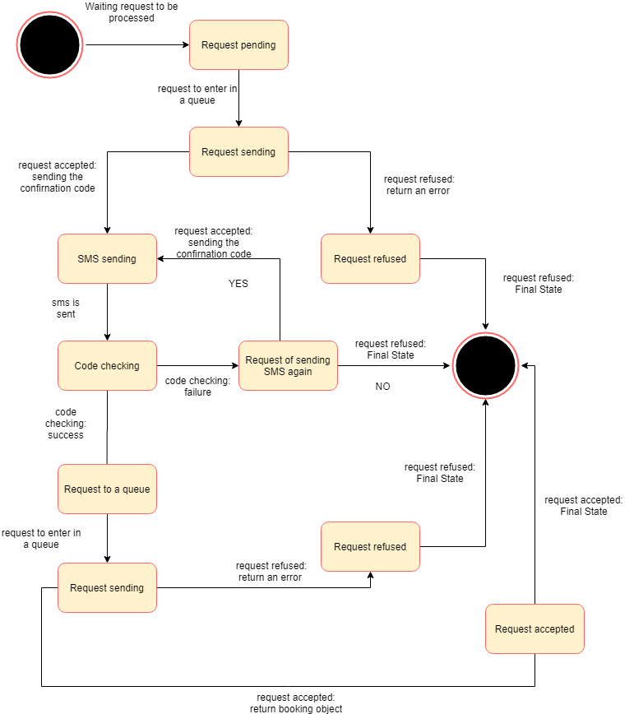

Figure 3 - State diagram

*Figure 4* shows the step-by-step authorization of a Prioritized user (who books the queue, being physically in the store).

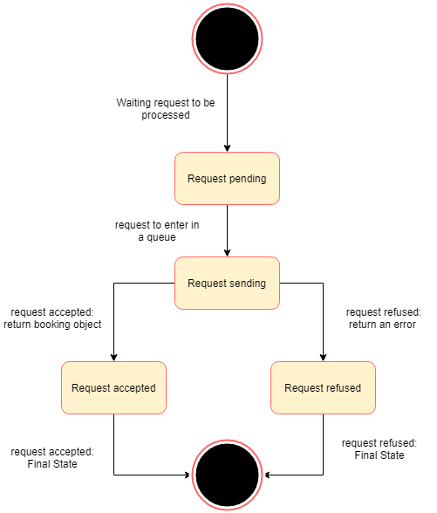

Figure 4 – State diagram

It is important to show the authorization process by store employees, what is observed in *Figure 5.*

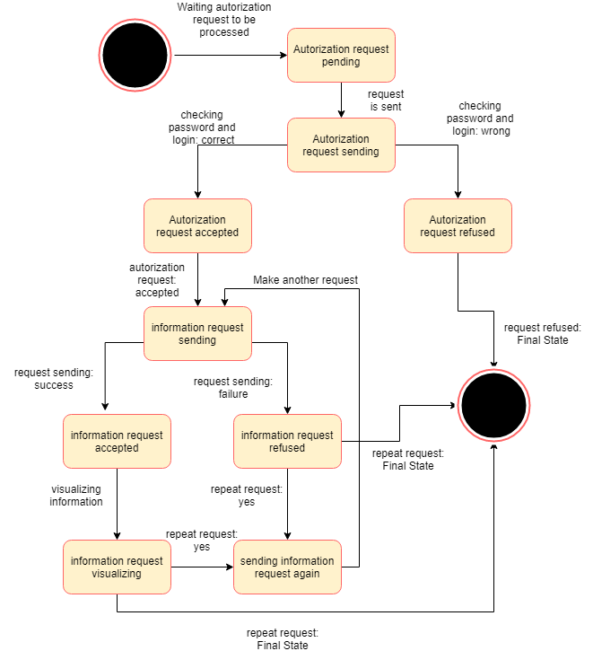

Figure 5 – State diagram

## Product functions

The following section contains the main functions that software will perform. As said earlier, there are additional features available for the personnel staff, but here will be displayed just the general functions.

### Booking management

The most exciting thing about this product function is the opportunity of the customer - to not register. The system will provide SMS authentication and GPS location that will be enough to unambiguously define the user. The STB will not collect any personal data about users other than their phone number and their names (this feature is optional, if the user doesn’t like to be called by his name via notifications, it’s his choice). The system also will provide the tickets in place because not every human got his phone or could install an app. If the user could not get to the store in the estimated time, he will get the notification reminding him that either he is just late but he goes to the store or he forgot about the store and he had to get a new booking. By the way, the user can plan his booking, he can choose every available slot in the timetable, or he can book as quickly as possible. The user can pick any store that is available. Every user can cancel the booking without any sanctions given to him. While performing a booking the user could also enter the data about departments he is going to visit the store, this action will be very helpful to preserve his own health and the others. The STB will process the data given by the user and return the solution that will help him not to be infected or not infect the others.

### Location management

To reduce the possibility of a queue, the system will monitor the location of the user and will provide him the shortest path to the selected store. It can be obtained by using GPS to retrieve the current location of the user. The STB uses the shortest path but the maximum estimated time because the system couldn’t know about the personal characteristics of the users.

### Arrival/departure management

The arrival and departure of the user will be checked via QR code. When the user arrives at the store and his booking is still active then his QR code will be valid. The customer scan QR code and the STB starts the countdown because some users have entered the information about the departments they are going to visit, otherwise the system supposes that the time they will spend at the store will be distributed uniformly. When user time comes to an end, there will be a notification either via mobile phone. At the departure moment, the user scans the QR code again and the system supposes that the customer visit ends.

### Others

The administration of the store must enter the system the store specifications i.e. its size, the departments' location, etc. On-site tickets are also handled by the store staff. The tickets given by the staff will have priority over the booking via app since the users are already in the store and they are more likely to get sick than the users that use a booking option. The administration of the store will be able to collect information about a human flow which is going through a store, to evaluate human load in different periods.

## User characteristics

The following points describe the general characteristics that may influence usability. Hence, the actors are the following:

1. Common User: a person that book a visit from home. To do that, this person must enter the system his phone number and enable geolocation for the app. This user has access to the basic functionality i.e. the booking, choosing a store, and departments in its store.

2. Privilege User: a personnel staff of the store. It has access to the technical information and can enter the metadata about the store i.e. store size, its departments, and their sizes.

3. Prioritized User: a person that book a visit via machine. This person doesn’t need to provide his phone number or anything, but he has to get a ticket from the machine. He will get a higher priority than other users in the queue.

## Assumptions, dependencies and constraints

[D1] - Registration is via the phone number.

[D2] - The device must have stable access to the Internet to establish a user status and queue calculation.

[D3] - The user goes to the selected shop according to the notification on the mobile device.

[D4] - The user should follow the rules that will be notified on the device (i.e. social distance, the presence of a mask, allocated time for purchase).

[D5] - People who cannot use the device should easily integrate into the queue by registering on the spot.

[D6] - The customer will enter/exit the store using a QR code.

[D7] - Store owners will have access to an expanded version of the app for more control and tracking of the flow of customers.

[D8] – The user should denote the supposed departments to visit.

[D9] – Store owner must specify the area of the shop and departments.

[D10] – The ticket given by machine will contain information about the customer arrival/departure time and QR code.

[D11] – The user is going to the store by shortest path.

[D12] – If the user is late more than 10 minutes (according to his/her appointed time) he/she is removing from the queue.

[D13] – It is possible to cancel the booking if user plans are changed.

[D14] – The location of the user is obtained by GPS. The locations of the stores are retrieved by API.

For the personal use of the application, the user must have a mobile phone or a tablet, if he doesn’t want to install the app or he doesn’t have the phone/tablet, then he can use the store machine. Again, in case of personal use the device must match the following characteristics: 2G/3G/4G/802.11 (a/b/g/n/ac) Internet connection, it is welcomed if this device had GPS function enabled.

The device of common use must be connected to a permanent power supply. Device of common use must have the touch screen to provide a communication interface, also it must have facilities to print tickets.

For the personnel staff access, there must be any device (a PC, a laptop, a tablet, etc.) that has a stable connection to the Internet. Also, the application uses the Yandex Maps API that provides more lightweight architecture.

# Specific requirements

## External interface requirements

### User interfaces

To represent the approximate concept and interface of the program, the first mockups are shown below.

#### User verification by sending an SMS to the specified number

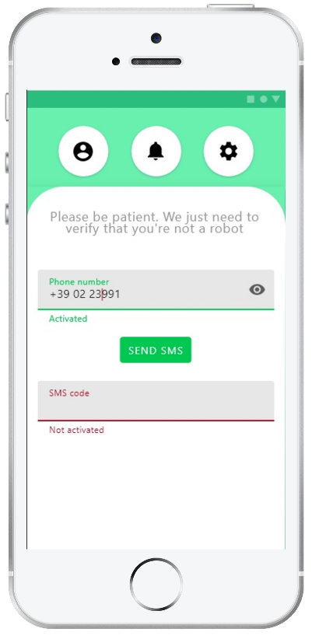

Figure 6 – CLup: customer verification

#### **Display and selection of the nearest available stores of the user**

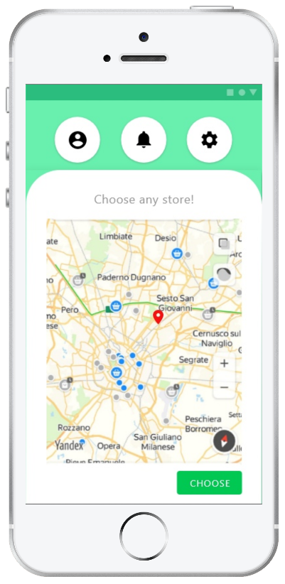

Figure 7 – CLup: store choosing

#### **Selecting the appropriate store visit dates**

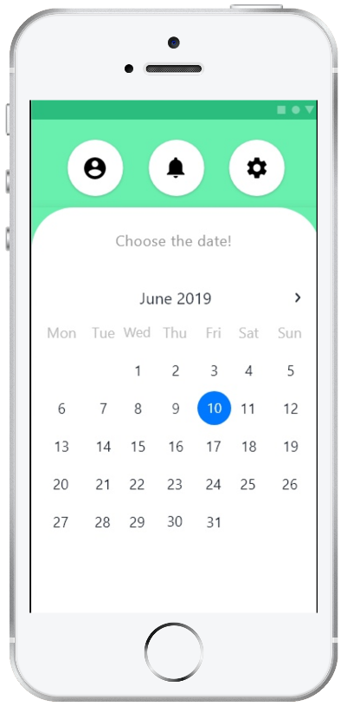

Figure 8 – CLup: date choosing

#### Selecting the appropriate store visit time

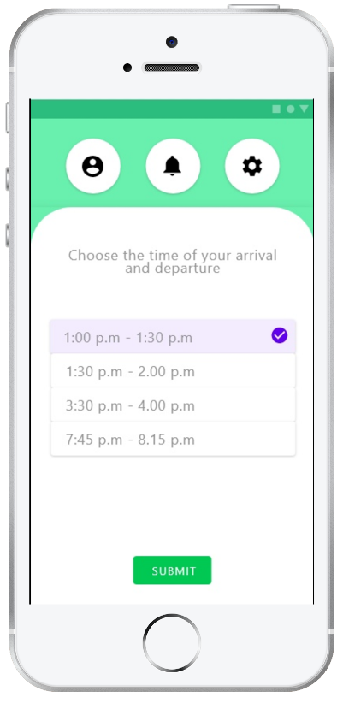

Figure 9 – CLup: time choosing

#### Selection of prospective departments to visit

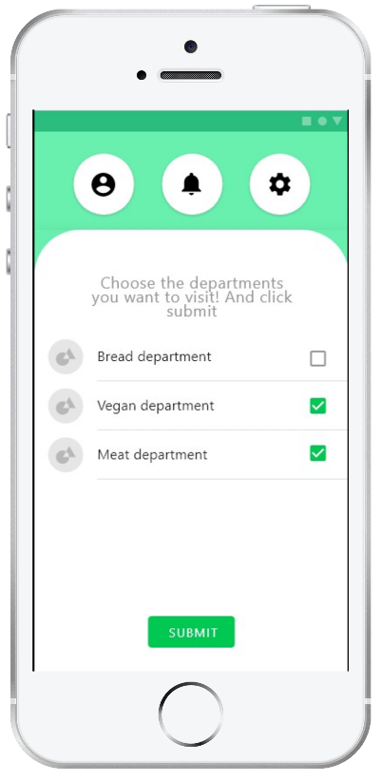

Figure 10 – CLup: department choosing

#### Generate the QR code required for entering and exiting

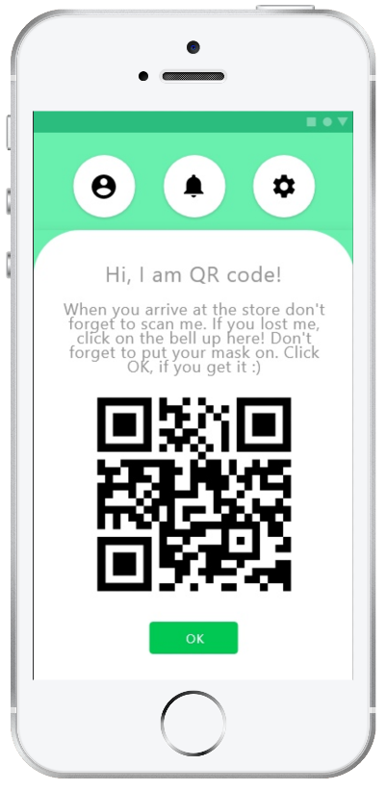

Figure 11 – CLup: QR code generation

#### Building a route to the selected store

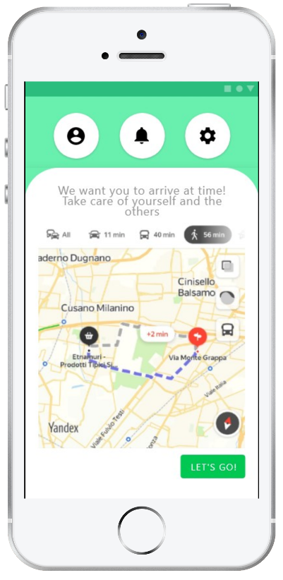

Figure 12 – CLup: built route

### Hardware user interfaces

For third parties, it is important to have the following equipment:

* registration terminal for entering the queue and receiving a ticket with a QR code
* General information Board that displays all the numbers of customers waiting in line and their estimated time to enter
* a tableau at the employee's workplace (can be a computer that is authorized with the store's account), which contains all information about queue management

### Software interfaces

The system does not provide any API to external applications, but it uses some proven services and ready-made functionality for stable performance.

* Yandex Maps API

Yandex Maps API is a set of services that allow to use Yandex map up-to-date information such as public transport schedules, traffic jams, reconstruction in a project. In our case, as mentioned, it is used to lay out the route and display the stores available in the area and their additional information such as opening hours, load, approximate waiting time.

* Calendar and alert system

Planning a trip to the store is not possible without a calendar and specifying the exact time of arrival. After viewing the available dates and time of booking, the user assigns the most comfortable one for them. For convenience, it is recommended using a notification system about planned visit

* QR code reading/generation

An important attribute of the program is the QR code. It is generated on the server side after the request to visit the store is confirmed. It is used to enter and exit the store after scanning by the staff

## Functional requirements

### Common User

**Scenario 1**

Because of the pandemic Hazel does not want to endanger her own life and lives of the others, and she does not leave the home. But using food delivery services soon became too expensive for her. And she started to look for the other ways to get food supplies, so as an active app user she downloaded and installed CLup. This service helped her to get to the store, buy all the supplies she needed and reduce contact with people to a minimum.

**Use case diagram**

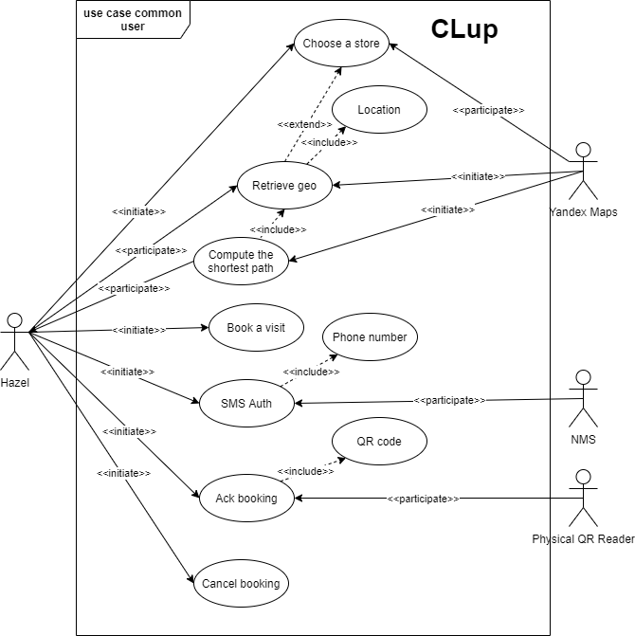

Figure 13 – Use case diagram: Common User

**Use cases**

|  |  |
| --- | --- |
| Name | Choose a Store |
| Actor | Hazel, Yandex Maps |
| Entry conditions | 1. Hazel has opened the application on her device  2. (Optionally) She could turn on the geo location |
| Events flow | 1. Hazel chooses a store on the map  2. Hazel clicks on the “Choose” button  3. The app saves the data |
| Exit conditions | Hazel has chosen the store where she would buy the supplies |
| Exceptions | 1. Hazel forgot to turn on the Internet connection, so she would get the Connection Error  2. Hazel has chosen the store that is closed this time, then the app would display the closed store status |

|  |  |
| --- | --- |
| Name | Location |
| Actor | Hazel |
| Entry conditions | Hazel has opened the application on her device |
| Events flow | 1. The app displays the geolocation banner that asks the user to turn on the geolocation  2. Hazel approves or rejects  3. The app saves the data |
| Exit conditions | Hazel approved or rejected the usage of geolocation by this service |
| Exceptions | 1. Unavailability of Yandex Maps API Servers |

|  |  |
| --- | --- |
| Name | Retrieve geo |
| Actor | Yandex maps, Hazel |
| Entry conditions | 1. Hazel has opened the application on her device  2. The location must be approved |
| Events flow | 1. Yandex maps retrieve Hazel geo position  2. Yandex maps display Hazel geo position on the map |
| Exit conditions | 1. Yandex Maps API has retrieved geo position |
| Exceptions | 1. Unavailability of Yandex Maps API Servers |

|  |  |
| --- | --- |
| Name | Compute the shortest path |
| Actor | Yandex maps, Hazel |
| Entry conditions | 1. Hazel has opened the application on her device  2. The location must be approved  3. Yandex maps must retrieve Hazel geo position |
| Events flow | 1. Yandex maps retrieve Hazel geo position  2. Hazel has chosen the store  3. Yandex maps return the shortest path to this store |
| Exit conditions | 1. Yandex Maps API calculated the shortest path |
| Exceptions | 1. Unavailability of Yandex Maps API Servers  2. Unexpected road works or accidents |

|  |  |
| --- | --- |
| Name | Book a visit |
| Actor | Hazel |
| Entry conditions | 1. Hazel has opened the application on her device  2. Hazel has chosen the store |
| Events flow | 1. Hazel chooses the departments she wants to visit  2. Hazel chooses the date and the time of the visit  3. Hazel enters the phone number  4. Hazel clicks “Send SMS” button |
| Exit conditions | 1. The booking has been done |
| Exceptions | 1. The Internet Connection is lost  2. The occurrence of “Nonrepeatable Read” |

|  |  |
| --- | --- |
| Name | SMS Auth |
| Actor | Hazel, NMS |
| Entry conditions | 1. Hazel has opened the application on her device  2. Hazel has chosen the store  3. Hazel has finished choosing the booking entry data  4. Hazel has entered her phone number |
| Events flow | 1. Hazel verifies the SMS code  2. Hazel gets the QR code acting as a ticket to the store  3. Hazel clicks “Ok” button |
| Exit conditions | 1. The user successfully authenticated |
| Exceptions | 1. The Internet Connection is lost  2. Hazel has not got the QR code  3. Hazel has not got the SMS code |
| Name | Ack booking |
| Actor | Hazel, Physical QR reader |
| Entry conditions | 1. Hazel has booked a visit  2. Hazel has arrived to the store |
| Events flow | 1. Hazel scans the QR code when she arrives  2. Hazel scans the QR code when she leaves |
| Exit conditions | 1. Hazel leaves the store |
| Exceptions | 1. Hazel did not arrive at the store  2. Hazel accidently scans the QR code twice (maybe even thrice) |
| Special Requirements | 1. Hazel receives a reminder notification 15 minutes before the estimated arrival at the store |

|  |  |
| --- | --- |
| Name | Cancel booking |
| Actor | Hazel |
| Entry conditions | 1. Hazel has booked a visit |
| Events flow | 1. Hazel goes to the account tab  2. Hazel cancels the visit |
| Exit conditions | 1. The booking has been canceled |
| Exceptions | 1. The Internet connection is lost |

**Sequence diagrams**

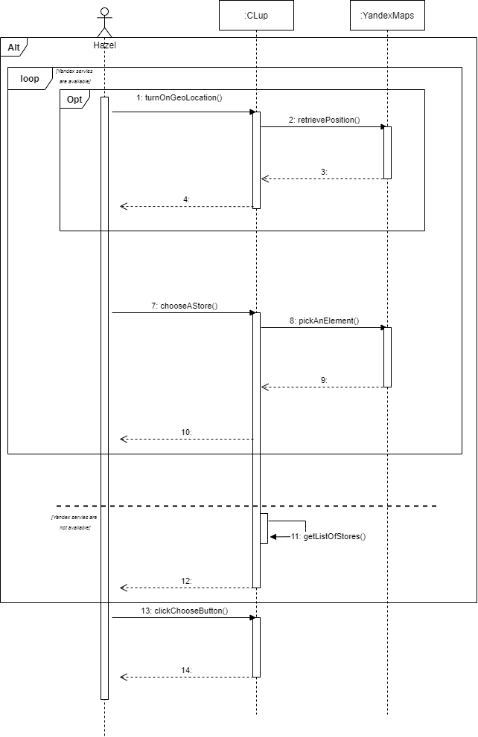

Figure 14 –Sequence Diagram: Choose A Store

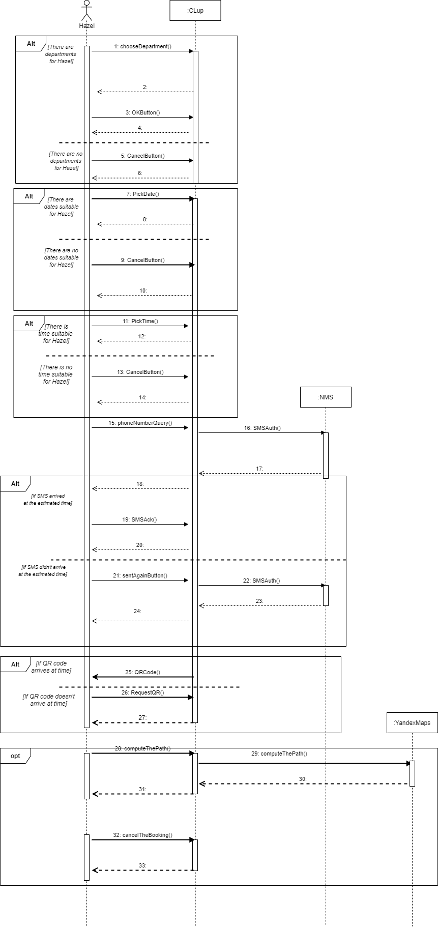

Figure 15 – Sequence Diagram: Book A Visit

### Prioritized User

**Scenario 2**

Alexander is an elderly Afghanistan veteran, but the pandemic knocked him down. He has lost all the joys of his life: he could not see his relatives and he couldn’t even go to the store without the risk of getting sick. He does not have a smartphone, and new technologies seem too complicated for him. So, Alexander goes to the store and he sees some machine giving tickets. Thanks to the presence of this machine the risks of getting sick for him have decreased.

**Scenario 3**

Julie is a student and as every young person, she does not like planning. Walking along the embankment (yes, she does not want to observe self-isolation) she realized that she would like to have a snack. So, she goes to the nearest store and books a visit via the machine using the "CLup" service. This service will help the people concerning their health to minimize the risk of illness.

**Use case diagram**

The machine & QR scanner is the one device. This division was made in the diagram just to make it clear that the QR scanner is embedded into the machine.

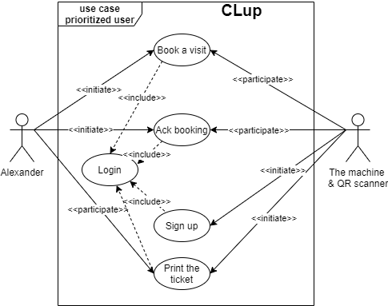

Figure 16 – Use case diagram: Prioritized User

|  |  |
| --- | --- |
| Name | Book a visit |
| Actor | Alexander, the machine & QR scanner |
| Entry conditions | 1. Alexander is in the store and near the machine  2. Machine has been registered in the system |
| Events flow | 1. Alexander clicks the button “book a visit”  2. The machine shows the QR code and Alexander click “Ok” |
| Exit conditions | The booking has been done |
| Exceptions | 1. There is no available slots the next hour |
| Special Requirements | 1. Availability of a consultant to help and control the flow of people |

|  |  |
| --- | --- |
| Name | Ack booking |
| Actor | Alexander, the machine & QR scanner |
| Entry conditions | 1. Alexander has booked a visit  2. Alexander has arrived at the store |
| Events flow | 1. Alexander scans the QR code when he arrives  2. Alexander scans the QR code when he leaves |
| Exit conditions | 1. Alexander leaves the store |
| Exceptions | 1. Alexander did not arrive at the store  2. Alexander accidently scans the QR code twice (maybe even thrice) |

|  |  |
| --- | --- |
| Name | Sign up |
| Actor | The machine & QR scanner, staff personal |
| Entry conditions | 1. The machine has turned on |
| Events flow | 1. Personnel staff enters the required data to register the machine in the system |
| Exit conditions | 1. The machine has been registered |
| Exceptions | 1. The Internet connection is lost  2. The serial number doesn’t exist |

|  |  |
| --- | --- |
| Name | Login |
| Actor | The machine & QR scanner, staff personal |
| Entry conditions | 1. The machine has turned on |
| Events flow | 1. Personnel staff inputs the serial number of the machine |
| Exit conditions | 1. The machine has been logged in |
| Exceptions | 1. The Internet connection is lost  2. The serial number doesn’t exist  3. Power failure |

|  |  |
| --- | --- |
| Name | Print the ticket |
| Actor | The machine & QR scanner, Alexander |
| Entry conditions | 1. The visit has been booked |
| Events flow | 1. The machine prints the ticket |
| Exit conditions | 1. Alexander has got the ticket |
| Exceptions | 1. The ink is out  2. The Internet connection is lost  3. Out of print paper  4. The user loses the received ticket |

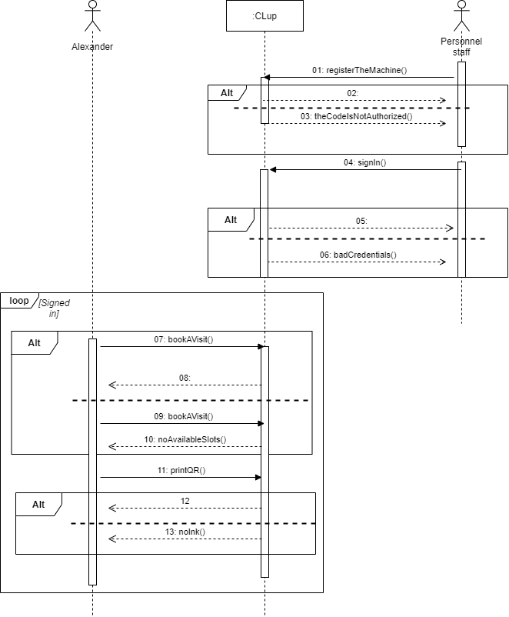

Figure 17 - Sequence Diagram: Book A Visit via the machine

### Privilege User

**Scenario 4**

Working in a store during the pandemic is a big risk, Dave figured it out the hard way. He had COVID-19, and when he getting on his feet, he decided to secure the store in which he works as a manager. So, his choice fell on the CLup because he does not need to recruit couriers, it will help him to save some money at this difficult time. All he needs to do is to estimate the number of people for each department and in line at the cash register and provide this data to the system.

**Scenario 5**

Jimmy is the store owner, and as every businessman he wants to get profit. But in nowadays the profit is not high, because of the pandemic. So, Jimmy thought about getting his store safer for every customer. But he wants to analyze the possibilities to increase profit without endangering his customers. The CLup provides the analytic services such safe way.

**Use case diagram**

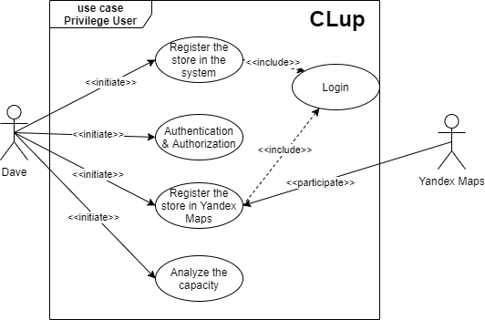

Figure 18 – Use case diagram: Privilege User

|  |  |
| --- | --- |
| Name | Authentication & Authorization |
| Actor | Dave |
| Entry conditions | Dave has opened PC and started the app |
| Events flow | 1. Dave chooses the “Create” option  2. Dave enters login, password and phone number  3. Dave chooses the “OK” button  4. The system saves it |
| Exit conditions | 1. Dave is authenticated and authorized as a manager  2. System saves the data |
| Exceptions | 1. He inputs incorrect data (not correct phone number, long login, not strong password)  2. The session was interrupted for technical reasons |

|  |  |
| --- | --- |
| Name | Login |
| Actor | Dave |
| Entry conditions | Dave has signed in |
| Events flow | 1. Dave chooses the “Sign in” option  2. Dave enters login, password  3. Dave chooses the “OK” button |
| Exit conditions | Dave is logged in |
| Exceptions | 1. He inputs incorrect data (a login or a password)  2. The session was interrupted for technical reasons |

|  |  |
| --- | --- |
| Name | Register the store in the store system |
| Actor | Dave |
| Entry conditions | Dave has logged in |
| Events flow | 1. Dave enters the name of the store  2. Dave enters the address of the store  3. Dave inputs the personnel staff of the store and authorizes them to register the machines  4. Dave inputs the area of the store  5. Dave inputs the number of the departments and their area  6. Dave inputs the number of cash registers  7. Dave clicks “Ok” button  8. The system saves the information about this store |
| Exit conditions | The system has the information about the store. Dave logs out |
| Exceptions | 1. He inputs invalid data  2. He misprints some data and wants to correct it  3. The session was interrupted for technical reasons |

|  |  |
| --- | --- |
| Name | Register the store in Yandex Maps |
| Actor | Dave, Yandex Maps |
| Entry conditions | Dave has logged in |
| Events flow | 1. Dave creates the mark on Yandex Maps  2. Dave enters the name, address and the description of the store  3. Dave marks the store as active in the system  4. The system saves the information |
| Exit conditions | The store and its description are displayed on Yandex maps |
| Exceptions | 1. He inputs invalid mark  2. He misprints some data and wants to correct it  3. He enter invalid name or address  4. He forgot to mark the store as active  5. The session was interrupted for technical reasons |

|  |  |
| --- | --- |
| Name | Analyze the capacity (flow) |
| Actor | Jimmy |
| Entry conditions | Jimmy has logged in |
| Events flow | 1. Jimmy chooses the store in the list of his stores.  2. Jimmy clicks the button “Analyze”  3. He could do every manipulation with data |
| Exit conditions | Jimmy has observed the necessary information |
| Exceptions | 1. There is no data for the chosen store yet.  2. He entered the incorrect settings for modelling |

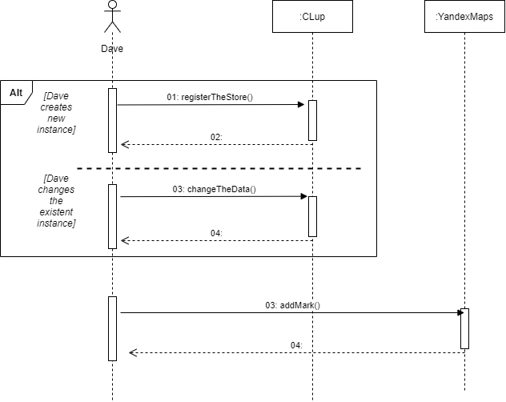

Figure 19 – Sequence Diagram: Register the store in the system

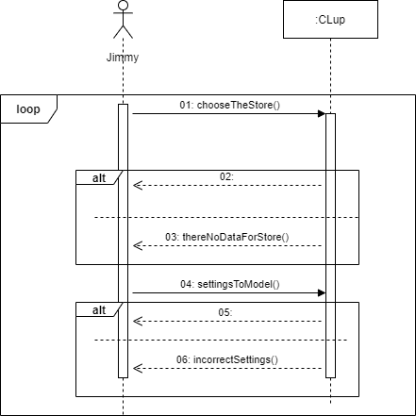

Figure 20 – Sequence Diagram: Analyzing

### Requirements

**G1: The system should provide customers with a reasonably precise estimation of the waiting time and should alert them taking into account the time they need to get to the shop from the place they currently are.**

[D2] - The device must have stable access to the Internet to establish a user status and queue calculation.

[D3] – The user goes to the selected shop according to the notification on the mobile device.

[D11] – The user is going to the store by shortest path.

[D12] – If the user is late more than 10 minutes (according to his/her appointed time) he/she is removing from the queue.

[D14] – The location of the user is obtained by GPS. The locations of the stores are retrieved by API.

R1: The system should allow users to go to the store by shortest path calculated by Yandex Maps.

R2: The all information about visit (arrival/departure time, the selected departments) should be analyzed by system, to estimate the time of waiting more precisely.

**G2: To give people opportunity to stay in queue remotely to avoid crowds in stores and in real queues.**

[D1] – Registration is via the phone number.

[D4] - The user should follow the rules that will be notified on the device (i.e. social distance, the presence of a mask, allocated time for purchase).

[D6] - The customer will enter/exit the store using a QR code

[D8] – The user should denote the supposed departments to visit.

[D9] – Store owner must specify the area of the shop and departments.

[D12] – If the user is late more than 10 minutes (according to his/her appointed time) he/she is removing from the queue.

[D13] – It is possible to cancel the booking if user plans are changed.

R3: The system should send the data of the visit to the server to organize the queue correctly.

R4: The system should provide concurrency to insert multiple request in short period of time in correct order.

R5: The system should balance the human flow in the store by analyzing the departments and store capacity.

R6: The system generates QR codes by UUID, telephone number/device id and suggested time of the visit.

**G3: Stores should have the possibility to hand out “tickets” on the spot.**

[D2] - The device must have stable access to the Internet to establish a user status and queue calculation.

[D5] - People who cannot use the device should easily integrate into the queue by registering on the spot.

[D6] - The customer will enter/exit the store using a QR code.

[D8] – The user should denote the supposed departments to visit.

[D10] – The ticket given by machine will contain information about the customer arrival/departure time.

[D12] – If the user is late more than 10 minutes (according to his/her appointed time) he/she is removing from the queue.

R7: The system should distinguish users of mobile phones and local devices to prioritize the second ones in the queue.

R8: QR readers should be installed at the entrance and exit of the store sending data of arrival and departure time to system.

R9: The machine should be authorized and logged in the system by the manager of the store.

**G4: The system should allow customers to book a visit to the supermarket to optimize quantity of people in it by time of their visit, and category of products which they want to purchase.**

[D1] - Registration is via the phone number.

[D3] - The user goes to the selected shop according to the notification on the mobile device.

[D6] - The customer will enter/exit the store using a QR code.

[D8] - The user should denote the supposed departments to visit.

[D9] - Store owner must specify the area of the shop and departments.

[D12] - If the user is late more than 10 minutes (according to his/her appointed time) he/she is removing from the queue.

[D13] - It is possible to cancel the booking if user plans are changed.

R10: The system automatically extends the queue if the user books a visit for particular date and time.

R11: CLup service appeals to NMS to provide the authentication of the user.

**G5: The system (application and “tickets” on the spot) should include alternative slots (for another day), suggest to the customer the location of the nearest “safe” store based on his location.**

[D3] - The user goes to the selected shop according to the notification on the mobile device.

[D5] - People who cannot use the device should easily integrate into the queue by registering on the spot.

[D6] - The customer will enter/exit the store using a QR code.

[D9] - Store owner must specify the area of the shop and departments.

R12: The system should provide algorithms to assess the stores human flow.

**G6: The system should allow the third party to get the statistical information to perform better management of the store.**

[D5] - People who cannot use the device should easily integrate into the queue by registering on the spot.

[D6] - The customer will enter/exit the store using a QR code.

[D7] - Store owners will have access to an expanded version of the app for more control and tracking of the flow of customers.

[D9] - Store owner must specify the area of the shop and departments.

R13: The staff of the store have to login into the system to obtain statistic to manage the store in a better way.

R14: The system provides to the store owner only statistical information with embedded in the system instruments for visualization.

# Formal Analysis Using Alloy

## Alloy Code

This section is devoted to the critical moments of the system described with the help of Alloy anotation. In addition to system entities, special attention is paid to structural constraints such as:

* Every store must have a Network
* There is no two Networks have the same store
* It cannot happen that some users have identical Phone no
* A queue can't hang

To make sure that the constraints are correct, the alloy compiler analyzes the world models and the corresponding assertion.

**abstract** **sig** Bool **{}**

**one** **sig** True **extends** Bool **{}**

**one** **sig** False **extends** Bool **{}**

// MAC-address

**one** **sig** MAC **{}**

**sig** DateTime **{**

year: **one** **Int,**

month: **one** **Int,**

day: **one** **Int,**

hour: **one** **Int,**

minute: **one** **Int**

**}** **{**

// these values are just for modeling

year >= **0** **and**

month >= **0** **and** month =< **4** **and**

day >= **1** **and** day =< **6** **and**

hour >= **0** **and**

minute >= **0**

**}**

// in our case we suppose that UUID version 1defined as in RFC 4122

// so model it as the combination of MAC and datetime

**sig** UUID **{**

dt: **one** DateTime**,**

mac: **one** MAC

**}**

**sig** Location **{**

lat: **one** **Int,**

lon: **one** **Int**

**}** **{**

// the values are for modeling

lat >= **-3** **and** lat =< **3**

**and** lon >= **-6** **and** lon =< **6**

**}**

**sig** PhoneNo **{}**

**sig** Password **{}**

**sig** FullName **{}**

**sig** Address **{}**

**sig** Brand **{}**

**sig** Registration **{**

phoneNo: **one** PhoneNo**,**

**}**

**sig** StaffRegistration **extends** Registration **{**

password: **one** Password**,**

**}**

**abstract** **sig** User **{**

fullName: **one** FullName**,**

**}**

**sig** PrivilegeUser **extends** User **{**

reg: **one** StaffRegistration**,**

store: **some** Store

**}**

**abstract** **sig** Customer **extends** User **{**

departments: **set** Department**,**

regC: **one** Registration**,**

control: **set** SessionController

**}**

**sig** MachineReq **{}** //

**sig** CommonUser **extends** Customer **{**

priority: **one** False

**}**

**sig** PrioritizedUser **extends** Customer **{**

priority: **one** True

**}**

**sig** Network **{**

name: **one** Brand**,**

addressHead: **one** Address**,**

stores: **some** Store**,**

staff: **some** PrivilegeUser

**}**

**sig** Store **{**

address: **one** Address**,**

capacity: **one** **Int,**

deps: **some** Department

**}** **{**

// the value for modeling

capacity >= **1** **and** capacity =< **6**

**}**

**sig** Department **{**

koef: **one** **Int,**

capacity: **one** **Int,**

area: **one** **Int**

**}** **{**

// the value for modeling

koef >= **0** **and** koef =< **3** **and**

capacity >= **1** **and** capacity =< **2** **and**

area >= **0** **and** area =< **3**

**}**

**sig** SessionController **{**

queue: **some** Queue**,**

**}**

**sig** Queue **{**

books: **some** Booking**,**

store: **one** Store

**}**

**sig** Booking **{**

position: **one** **Int,**

// state indicates delete, create, enter, left

state: **one** **Int,**

selectedStore: **one** Store**,**

bookingDate: DateTime**,**

estimatedTime: DateTime**,**

uuid: UUID**,**

departureTime: DateTime**,**

**}** **{**

// estimatedTime in booking must be equal to difference between departureTime

// and bookingDate

// departureTime = bookingDate + estimatedTime

position >= **0** **and** position =< **3** **and**

state >= **0** **and** state =< **3**

**}**

// fact. Networks HQ are not in the same address

// we suppose we work with big shop networks like Auchan or 7-11

**fact** NoNetworkSameHQAddress **{**

**all** **disj** n1**,** n2 : Network **|** n1 != n2 **implies** n1**.**addressHead != n2**.**addressHead

**}**

// There is no two Networks have the same store

// but two or more stores in different networks may have the same address

**fact** NoNetworkHasTheSameStore **{**

**all** **disj** n1**,** n2: Network **|** n1 != n2 **implies** n1**.**stores != n2**.**stores

**}**

// fact. Every store must have a network

**fact** EveryStoreMustHaveANetwork **{**

**all** s : Store **|** **one** n: Network **|** s **in** n**.**stores

**}**

// fact. We think it's not good to have the same Network stores share the same address

**fact** NoStoreNetworkShareTheSameAddress **{**

**all** **disj** s**,** s': Store **|** **one** n: Network **|** s **in** n**.**stores **and** s' **in** n**.**stores **implies** s**.**address != s'**.**address

**}**

// fact. PhoneNo are unique if user are not staff

**fact** PhoneNoUnique **{**

**all** r**,** r': Registration **|** r != r' **implies** r**.**phoneNo != r'**.**phoneNo

**}**

// fact Passwords are unique

**fact** PassUnique **{**

**all** r**,** r': StaffRegistration **|** r != r' **implies** r**.**password != r'**.**password

**}**

// fact two users can't have the same registration

// There are some users in fact that are staff and customers at the same time

// Because as we saw earlier the functionality differs

**fact** RegistrationUnique **{**

// exclude the prioritizeduser; think about this one. It's not so obvious as you thought

**all** u**,** u': User **|** u != u' **implies** u**.**reg != u'**.**reg **or** u**.**regC != u'**.**regC

**}**

// fact users can't have the same username

**fact** UsernameUnique **{**

**all** u**,** u' : User **|** u != u' **implies** u**.**fullName != u'**.**fullName

**}**

// fact PrivilegeUser must work in the Network

**fact** NetworkStaff **{**

**all** n : Network **|** **all** p:PrivilegeUser **|** p **in** n**.**staff

**}**

// fact story capacity must be more than departments

//fact StoreIsBiggerThanDepartments {

// all s : Store | all d : Department | d in s.deps implies sum s.d.capacity <= s.capacity

//}

// fact every store must have departments (delete the hanging departmens)

**fact** DepartmentStore **{**

**all** d : Department **|** **one** s: Store **|** d **in** s**.**deps

**}**

// fact the controller is only one. It emulates the real controller

// a person that regulates the flow

**fact** ControllerTheOne **{**

**all** c: Customer **|** **one** s: SessionController**|** s **in** c**.**control

**}**

// fact queue can't hang

**fact** QueueToController **{**

**all** q: Queue **|** **one** s: SessionController **|** q **in** s**.**queue

**}**

// fact booking can't hang

**fact** BookToQueue **{**

**all** b: Booking **|** **one** q: Queue **|** b**.**selectedStore = q**.**store **implies** b **in** q**.**books

**}**

// fact Queues are unique

**fact** UniqueQueue **{**

**all** **disj** q**,** q': Queue **|** q != q' **implies** q**.**store != q'**.**store

**}**

// uuid are unique

**fact** UUIDUnique **{**

**all** **disj** b1**,** b2 : Booking **|** b1 != b2 **implies** b1**.**uuid != b2**.**uuid

**}**

**pred** show() **{**

**#**PrivilegeUser = **2**

**#**Department = **5**

**#**CommonUser = **2**

**#**SessionController = **1**

**#**PrioritizedUser = **1**

//#Booking = 1

**#**Store = **3**

**#**Queue = **2**

**}**

**run** show **for** **10**

## World generated

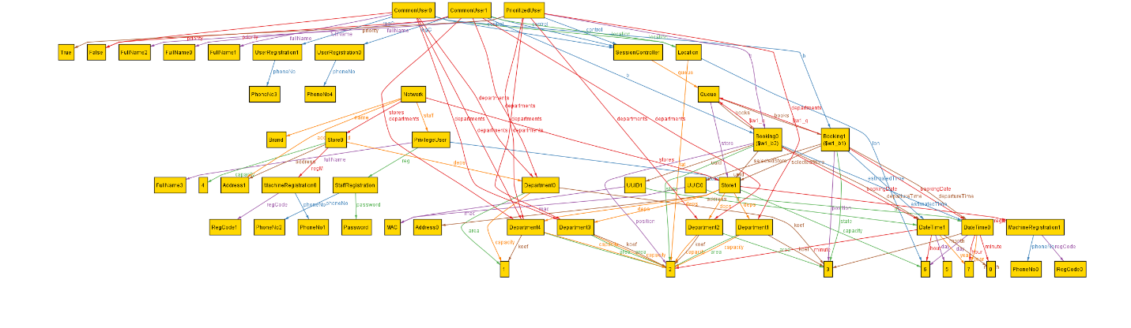

Figure 21 – Alloy: World generated

## Alloy results

The following is the result of the above code:

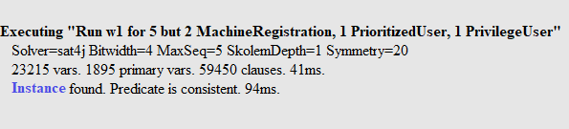

Figure 22 – Alloy – Executing result

# Effor spent

## Nikita Rozov



## Oleksandr Shchukhlyi



## Sergey Nabatov



# References

* Standard on requirement engineering - ISO/IEC/IEEE 29148
* Yandex.maps API - <https://yandex.ru/dev/maps/>
* Project’s diagrams were made with - <https://app.diagrams.net/>
* Alloy documentation - https://alloytools.org/