Smart Refrigerator

This project will constitute a prototype “Smart Refrigerator” system which will monitor grocery items purchased by the user in order to reduce food waste and facilitate efficient shopping habits.

Steven Strapp
ses6498@rit.edu

Ben Reeves
bpr5171@rit.edu

Dustin Stroup
dxs2847@rit.edu

Overview
Needs Statement
The New York Times reports that an average American family of four will account for over 120 pounds of food waste per month and that 27% percent of all food available will be lost to waste [1]. In addition, other resources are lost due to inefficient shopping practices; forgetting common items and special trips made for recipe ingredients. A system is required for shoppers to both ensure their purchases are used before expiration and to assist in planning of grocery shopping trips.
Objective Statement
The objective of this project is to design a prototype that will allow a user to scan in food items in order to reduce waste and improve shopping efficiency. The system will remind the user about items nearing their expiration date and track the frequency of purchased items. From this frequency calculation the system will suggest typical shopping lists. A mobile phone application will provide an interface to the unit to view or create shopping lists and to query inventory.
Brief Description
A UPC scanner will be used to identify items added or removed from the refrigerator's inventory; a database of UPC codes will translate from the scanned code to item description. Two databases will be maintained, one linking UPD codes to product descriptions and expiration dates and another to store items currently checked into the refrigerator. A central processing platform on the base station will be used to decode UPC information and store and interact with the databases. This platform will provide a web interface accessible both via a large convenient display on the main unit and also using a mobile interface. The display on the main unit will also a user to both check current inventory with expiration dates and to provide additional information when adding or removing items. Both the base station and mobile interfaces can also be used to display and modify suggested shopping lists. The mobile application will interact with the same web interface but will provide a similar interface optimized for smaller displays. The system will continually estimate the frequency that particular items are purchased and will use this information combined with the expiration dates and purchase dates to suggest shopping lists.

A high level system diagram isolating components is shown below in Figure 1.
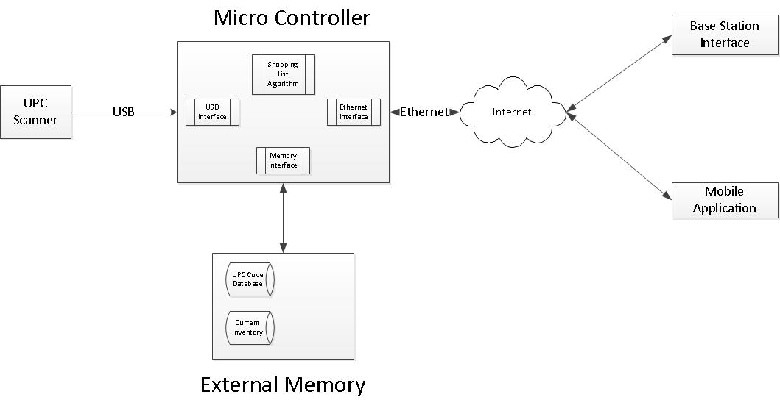
Figure 1: High Level System Diagram

Requirements Specification
Customer Needs
- The system should provide an intuitive, easy to use graphical interface.
- The system should require minimal user input.
- The system should be able to scan product codes.
- The system should be able identify a scanned product code quickly.
- The system should provide secure remote access.
- The system should record product expiration dates.
- The system should report items nearing expiration.
- The system should provide access to the current inventory.
- The system should provide a method to create and edit shopping lists.
- The system should recommend shopping lists based on buying habits.
- The system should function as an add-on to an existing refrigerator or pantry.
Engineering Specifications
Customer Need | Engineering Requirement | Justification
2,3,4 | - An off-the-shelf UPC scanner should be used to input items. | A UPC scanner can read product codes with a single click.
4 | - An internal UPC code database should be used to associate codes with items. | An internal database will remove delays associated with an internet look-up.
1,5,8 | - The system should be internet enabled and provide a web interface. | By providing a web interface any other internet-connected device can access the system.
5 | - Remote access should be authenticated with user name and password. | User names and passwords are standard for access control.
2,6 | - An internal database will store default recommended expiration estimates for common categories of items. | Inferring expiration dates based on item category helps minimizes user input. It is well known how long some products take to expire.
1,6 | - The user interface will provide a method for updating default expiration estimates. | Default estimates will not account for condition of product on arrival and may need to be updated.
1,7 | - Interface will provide a visual indication to the user when items are within a user-defined margin of expiration. | The goal of the system is to reduce waste due to expiration.
1,8 | - From both the base station and mobile application the user will be able to view an inventory list. | The user needs access to the current inventory in order to use items and shop effectively.
9,10 | - A database will be devoted to storing recommend shopping lists produced by the system. | User may wish to retain generic shopping lists for future use.
10 | - Recommended shopping lists will reflect purchasing history and expiration dates of current inventory. | Recommendation policy must suggest items relevant to the user in order to be useful.
9 | - Custom shopping lists, created either from the base station or the mobile interface, can be added to shopping list database. | Inefficient shopping practices can be prevented by storing shopping lists and the system can not anticipate all required items.
11 | - System will be self-contained and no modifications will be required to existing appliances. | Similar systems are commercially available but require costly replacement of existing appliances.

Concept Selection
Evaluation of Existing Systems
Many refrigerator systems are current available which offer integrated displays and internet connectivity. LG, Electrolux, and Samsung all offer refrigerators with large LCD displays that offer access to calendar applications, recipes, weather forecasts, and music and photo sharing services. The principle shortcoming of these devices is the elevated price and the need to completely replace existing appliances. As a more affordable alternative, tablet mounts are available for refrigerators as well.
However, these systems do not offer tracking of the refrigerators contents and do not attempt to reduce waste or improve efficiency. LG demonstrated in April, 2011 a “Smart Fridge” with goals closer to the proposed system. The sensors and algorithms used were not disclosed but the product objective is similar, tracking user purchases and providing a mobile interface to the refrigerator’s contents while shopping [2]. Our system will provide a much more inexpensive alternative and will be more flexible; the system proposed will not be limited to strictly refrigerators and can be used as an add-on to an existing system.

Concepts Considered and Chosen
Many of the system design choices are easily derived from the engineering requirements; a UPC scanner with a standard USB interface is a clear choice for input of product codes and a mobile application is an obvious interface choice for a system catering to an on-the-go shopper. However, the choice of implementation platform and main base station display presents more alternatives. Expiration date recognition is also a potential shortcoming of the system; ideally image processing could be employed to read in expiration dates. However, the difficulty and computational complexity of applying image processing significantly extends the scope of the project and places additional performance constraints on the processing platform used. An evaluation of different expiration date recognition systems are tabulated in Figure 2, below.

 | Entirely User Input | Predictive Strategy with User Override | Image to Text Recognition
Accuracy | +++ | - | +++
Processing Power Required | +++ | + | ---
Ease of Use | --- | + | +++
Feasibility | +++ | +++ | -
Figure 2: Comparison of Expiration Date Systems

Ease of Use is one of the most critical system requirements, which eliminates a system relying completely on input from the user. However, feasibility and limiting processing performance required are important secondary objectives. Accuracy is critical to the goal of reducing waste due to expiration but there is inherently some variability even in reported expiration dates and image processing presents too much additional scope and requirements in exchange for marginal gains. As long as the predictive system learns from user input and anticipates that items will be purchased in different conditions, this scheme should be sufficient.

