BACnet Testing Laboratory

VTS 3 User’s Guide and Reference

Revised September 2003

Table of Contents
Chapter 1: Introduction to VTS 3 1
Overview of VTS 1
What is VTS? 1
Who Uses VTS? 1
What does VTS do? 1
Requirements for Testing with VTS 1
Obtaining and Installing VTS 3 1
Requirements: 1
To Install VTS 3: 1
To Install WinPCap: 2
Troubleshooting 2
Running VTS 2
Chapter 2: Configuring VTS 3 3
The VTS Workspace 3
Device Configuration 4
Port Configuration 6
Name Configuration 9
How to Test Your Configuration 10
Using Multiple Workspaces 10
Creating a New Workspace 11
Switching Between Workspaces 11
Sharing Workspaces 11
Chapter 3: Manually Sending BACnet Packets 12
When To Send Packets Manually 12
The Send Menu 12
The Send Dialog 14
Switching Between Packet Types 15
Starting With a Blank Packet 16
Chapter 4: Viewing Packets 17
Packet Views 17
The Packet List 17
The Detail View 18
The Hex View 19
Highlighting the Hex View From the Detail View 19
Saving Packets 20
Switching Log Files 20
Determining the Current Log File 21
Printing Packets 21
Chapter 5: Running VTS Scripts 22
Requirements for Script Testing 22
What is an EPICS? 22
How to Create/Edit an EPICS 22
How to Load an EPICS 22
How to Run a Script 23
Opening a Script File 23
The Script Window 23
Checking Script Syntax 25
Configuring a Script 26
Running a Script 26
Checking Results 28
Chapter 6: Script Standards 30
Parameter Scripts 30
Parameter Setup 31
Body Scripts 32
The Test Body 34
Master Scripts 34
Script Constructs 34
Sending and Expecting Packets 34
Cases 34
Chapter 7: Script Development 35
Sending Packets 35
Common Components Error! Bookmark not defined.
Data Link Components 36
Network Layer Components 40
Application Layer Components 41
Data Components 36
Chapter 8: Script Keyword Glossary Error! Bookmark not defined.
Chapter 9: VTS/BACnet Reference and Glossary 44

Chapter 1: Introduction to VTS 3

Overview of VTS

What is VTS?
VTS 3 is a test tool for BACnet that was developed by the Building and Fire Research Laboratory of N.I.S.T. The program and the source code are in the public domain.

Who Uses VTS?
VTS is the primary tool used by the BACnet Testing Laboratory (BTL) to test BACnet devices for compliance to the BACnet standard (ANSI/ASHRAE Standard 135).
VTS can also be used by manufacturers to pretest their devices before submitting them to the BTL for testing.

What does VTS do?
VTS 3:
- generates BACnet compliant service messages,
- detects and decode BACnet compliant service messages, and
- runs scripts to generate, receive and respond to BACnet compliant service messages

Requirements for Testing with VTS
In order to test a device, the following basic components are needed:
The latest version of VTS 3, correctly installed on a PC (installation instructions are below). This constitutes the Testing Device (TD).
The device being tested, known as the Implementation Under Test (IUT), which must be on the same BACnet inter-network as the TD.
For testing with scripts, a formal description of the IUT called an Electronic Protocol Implementation Conformance Statement (EPICS) must be on the TD machine (see below).

Obtaining and Installing VTS 3

Requirements:
- Windows NT or Windows XP standard system requirements.
- A web browser, such as Netscape or Internet Explorer
- A PKZip-compatible application, such as WinZip.

To Install VTS 3:
- Download the latest version of VTS3 from http://sourceforge.net/projects/vts. Depending on the version, the install file will be called something like “vts-3.4.2-win32.zip”
- Save the file to a known location on your local hard drive (e.g. your desktop).
- Extract the files in the Zip archive to a folder on your local hard drive (e.g. C:\Program Files\VTS)
- (Optional) To create a shortcut to VTS, drag the file ‘VTS.exe’ from the folder created in step 3 to your Windows Desktop. A shortcut titled “Shortcut to VTS.exe” will be created.
You can also drag the file to the Start button on the taskbar. A Start Menu command titled “Shortcut to VTS.exe” will be created.
VTS 3 is now installed. However, in order to use any data link layer other than IP (e.g. Ethernet), VTS 3 needs ‘helper’ files from a package called WinPCap.

To Install WinPCap:
(NOTE: WinPCap only needs to be installed once; if you are reinstalling or upgrading VTS 3 and WinPCap is already on your system, skip these steps!)
- In the folder created in step 3 above, double-click the file called “WinPcap_3_0.exe”
- Follow the installation instructions to install WinPCap.

Troubleshooting
?? EDIT: Need content here

Running VTS
To run VTS 3:
- If you created a Desktop shortcut (in step 4 of the “To Install VTS” section), double-click the shortcut to start VTS.
- If you created a Start Menu command, click Start, then click the menu item to start VTS.
- Otherwise, use Windows Explorer to open the folder into which you extracted the VTS package and double-click on “VTS.exe”

Chapter 2: Configuring VTS 3
This chapter assumes that VTS has been successfully installed, as described in Chapter 1: Introduction to VTS 3.

The VTS Workspace
The collection of settings VTS uses to communicate with an IUT is called its workspace. The workspace includes information about the local device, communication ports and remote devices. Multiple workspaces can be created, to make it easier to use VTS to test multiple IUTs with different capabilities.
Three major components define the VTS workspace:
- Device: Device definitions allow users to use VTS to simulate BACnet devices. Each Device definition must define a local DEVICE object (for full details of the DEVICE object, see the BACnet standard (ASHRAE/ANSI Standard 135-2001), clause 12). The DEVICE object defines certain communication parameters; VTS uses these parameters to define how it initiates and responds to messages.
Other standard BACnet objects can also be created in each Device definition, in order to simulate a full-featured BACnet device.
- Port: A port is a connection point to a communication medium, such as Ethernet or the Internet Protocol (IP). In order to communicate over a medium, VTS must have a Port defined for that medium.
- Name: A Name is a user pseudonym for a BACnet address. The address can be a unicast address (a specific device), or a broadcast address. A Name defined in VTS can be used in scripts and in manual tests in place of the address that it represents.
The configuration of each of these components is described below.

Device Configuration
To configure a local device object for VTS:
- In the Edit menu, click ‘Devices…’ (see Figure 1)
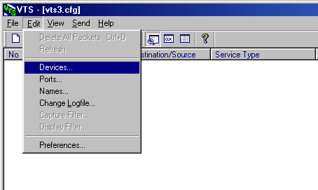
Figure 1: “Devices…” command
The Device Configuration dialog will appear (see Figure 2).
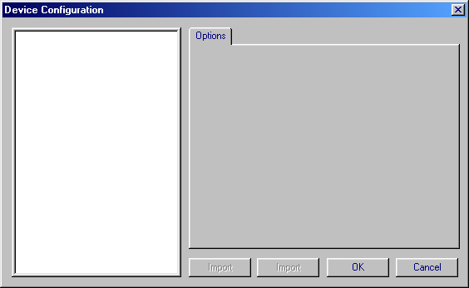
Figure 2: Empty Device Configuration dialog
- Right-click in the white window at the left of the dialog box. A context menu will appear (see Figure 3).
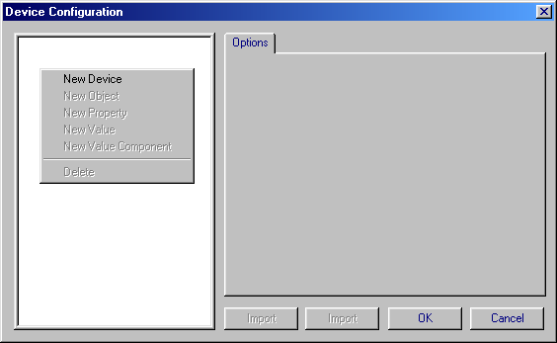
Figure 3: Context menu for creating a new device object
- Click on “New Device”. A tree containing a Device icon will appear in the white window at the left of the dialog box, the “Options” tab will become a “Device” tab, and several options will appear in it (see Figure 4).
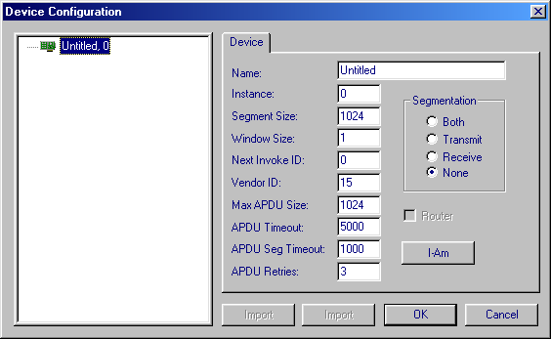
Figure 4: New device object to be completed
- Fill in the Device information as appropriate for the test(s) that you will be running. Note that VTS will behave as described in the configuration. For instance, if you need segmentation enabled for a particular test, segmentation must be enabled in the Device configuration.
- If other objects are required, right-click in the window at the left of the dialog and click “New Object” to create one. Fill in the property values as needed, using the “New Property” and “New Value” commands in the same context menu.

Port Configuration
NOTE: In order for VTS to be able to communicate with an IUT, a Port entry MUST refer to a Device object. Be sure to set up a Device (see previous section) before setting up a Port.
To configure a Port:
- In the Edit menu, click ‘Ports…’ (see Figure 5)
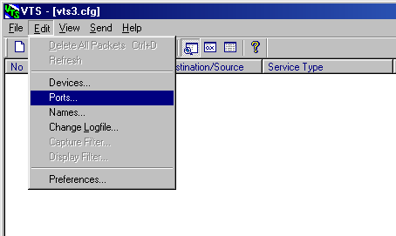
Figure 5: “Ports…” command
The Port Configuration dialog will appear (see Figure 6).
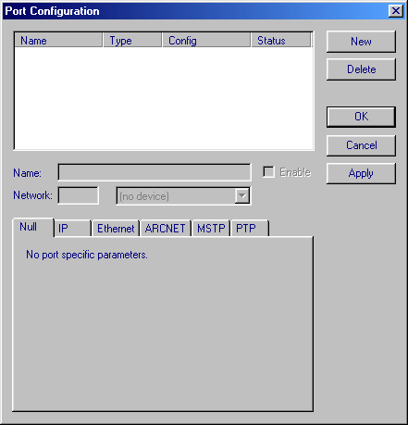
Figure 6: The Port Configuration dialog
- To create a new Port configuration, click the “New” button. A new port entry will be created with the name “Untitled” (see Figure 7)
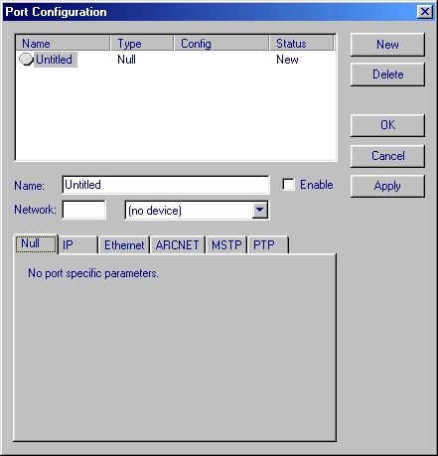
Figure 7: Creating a new Port configuration
- Make up a name for the Port (e.g. “Eth”) and enter it into the Name: field.
- Enter the correct Network number into the Network: field.
- Enter the associated local Device object (see the DEVICE) section, above.
- To allow the port to communicate, click the Enable checkbox
- Click on the correct medium from the tabs at the bottom of the Port Configuration dialog (IP, Ethernet, ARCNET, MSTP and PTP) and fill in the appropriate information. See Figure 8 for an example of a completed Ethernet entry.
NOTE: When picking the medium, choose the one that the PC is attached to, not (necessarily) one to which your IUT is attached, as it may be on a remote segment of a different medium.
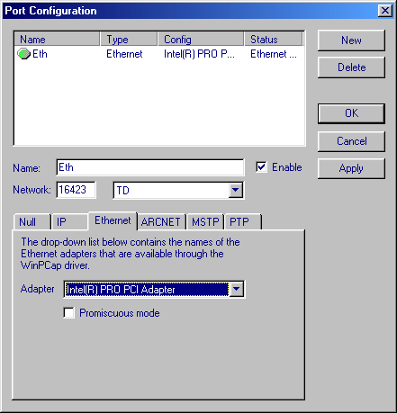
Figure 8: Example of a completed Port configuration

Name Configuration
NOTE: A Name entry specifies the physical (MAC) address and the local Port for a BACnet destination. Be sure to set up a Port for the device (see previous section) before setting up a Name.
Names can be applied to:
- the local device (the TD, which must have a Name entry)
- remote devices (e.g. the IUT, which must have a Name entry also)
- a local or remote broadcast
To set up a Name entry:
- In the Edit menu, click “Names…” (see Figure 9Error: Reference source not found)
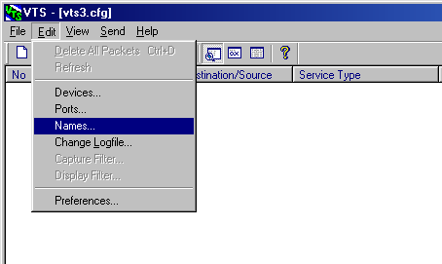
Figure 9: "Names..." command
The ‘Names’ dialog will appear (see Figure 10)
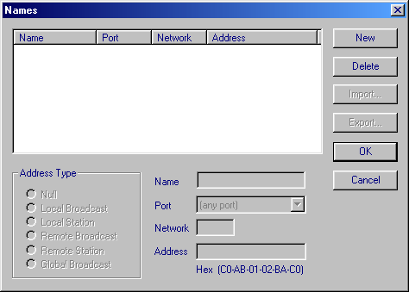
Figure 10: The ‘Names’ dialog
- Click “New”. An untitled Name entry will be created (see Figure 11).
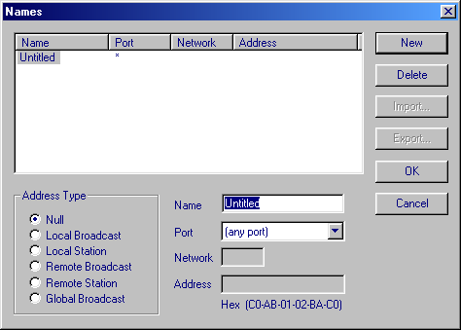
Figure 11: New Name entry
- Give the entry a name. Remember, you must create an entry for the device being tested and it must be named “IUT”. VTS will create an entry for itself (named “TD”).
- Choose an Address Type for the Name. The available types are:
- Null: No type chosen. Use this when you aren’t sure what Address Type is appropriate and want to fill it in later
- For Individual Devices:
  - Local Station: Any specific device on the local network.
  - Remote Station: Any specific device on a network other than the TD’s local network.
- For Broadcasts:
  - Local Broadcast: Packets are sent to all devices on the local network
  - Remote Broadcast: Packets are sent to all devices on the specified network
  - Global Broadcast: Packets are sent to all devices on all reachable networks
- Choose a Port. If no Port is configured (see “Port Configuration,” above), the only choice available will be “(any port)”
- If the Address Type is Remote Broadcast or Remote Station, specify the remote network number in the “Network” field
- If the Address Type is Remote Station, specify the remote device’s address in the Address field. There may be restrictions on the number of bytes in an address, depending on the Port type (e.g., Ethernet addresses must be 6 bytes long). VTS will validate the length of the address you enter, but not the address itself.

How to Test Your Configuration
The most direct way to ensure your configuration works is to send a simple packet. Sending packets is described in Chapter 3.

Using Multiple Workspaces
Different workspaces can be created with different sets of configurations, to allow testers to test IUT under different simulated conditions. Each workspace is stored on disk as a file with the extension “.cfg” (for ‘configuration’).
When you start VTS for the first time, a default configuration file is created, called vts3.cfg.
For working with multiple workspaces, the “File” menu has a “Workspace” submenu (see Figure 12).
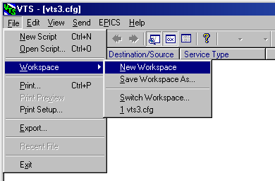
Figure 12: The "Workspace" submenu of the "File" menu.

Creating a New Workspace
To create a new workspace:
- Save the default workspace with a new name using the “Save Workspace As…” command (see Figure 12). Do not make any changes to the VTS configuration before proceeding to step 2!
- Create a new workspace using the “New Workspace” command.
- VTS will pop up a warning dialog, saying that the default workspace “vts3.cfg” already exists and asking if you wish to replace it with a new workspace. Since you have just saved that workspace with a new name (in Step 1), click ‘Yes’.

Switching Between Workspaces
There are 2 ways to switch to a different workspace:
- Use the ‘Switch Workspace…” command (see Figure 12). An ‘Open File’ dialog will appear with which you can choose a workspace file.
- Choose a workspace file from the numbered list at the bottom of the “Workspace” submenu (Figure 12 has a single entry in the list: “1 vts3.cfg” – the default workspace).

Sharing Workspaces
Once a workspace has been created, configured and saved, it can be shared among different users. This allows different testers to have the same workspace configuration without having to re-enter all of the same configuration information over and over again. In addition to saving time and labour, this also helps ensure that no settings are overlooked when duplicated.
When sharing a workspace, both the configuration file and at least one associated packet log (for details on saving packet logs, see the Saving Packets section in Chapter 4) must be distributed together.

Chapter 3: Manually Sending BACnet Packets
This chapter assumes that VTS has been configured, as described in Chapter 2: Configuring VTS 3, and that an IUT is placed on a reachable network segment.
There are two ways that a tester can use VTS to test a BACnet device:
- Running a pre-written set of instructions – called a script – that VTS interprets one instruction at a time. VTS also uses scripts, where possible, to verify test results.
- Manually sending BACnet messages one packet at a time and visually examining return packets to verify test results.
This chapter explains how to use VTS manually.

When To Send Packets Manually
Manual operation is best used to:
- Verify a VTS configuration (i.e. ensure VTS can communicate with an IUT)
- Run quick tests that would take more time to run with a script
- Find devices on the network
- Debug test scripts

The Send Menu
To send packets with VTS, use the Send menu (see Figure 13).
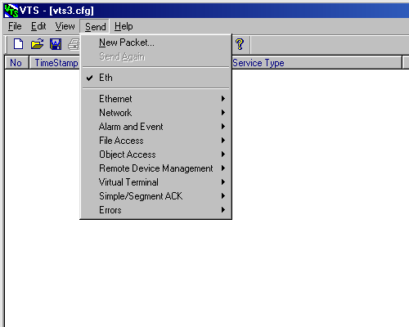
Figure 13: Send menu
Typically, testers send specific types of packet, such as Read-Property. To create packets, the Send menu has an entry for each Network or Application packet, in the groupings defined in clauses 6 and 13-17 of the BACnet standard, plus additional groups for Acknowledgements and Errors.
To choose a specific packet type, click the Send menu, then the appropriate group, and finally the specific packet type. See Figure 14 for an example of choosing a Read-Property packet, in the Object Access group.
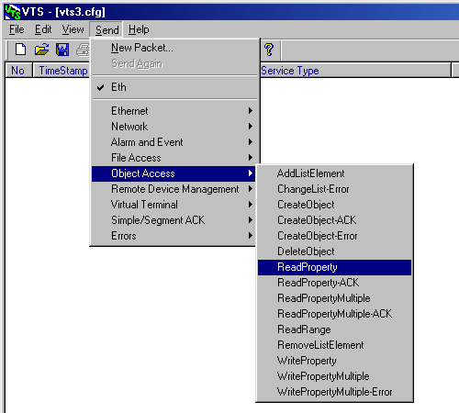
Figure 14: Choosing a Read-Property packet with the Send menu
You will notice that there is an item on the Send menu corresponding to each Port that has been configured (see the section called “Port Configuration” in Chapter 2). Use this command as another way to choose which Port is enabled.
The “New Packet…” command in the Send menu is described below, in the section titled “Starting With a Blank Packet.”

The Send Dialog
All of the commands in the Send menu open the Send dialog. The Send dialog allows a user to create (and send) any valid (or even invalid) BACnet packet.
When a packet type is chosen from the Send menu, the Send dialog will appear, with tabs for each layer of the packet (e.g. physical, data link, network). On each tab are appropriate fields to be filled in for each layer.
Some fields in each packet, and in each layer, are required. If the packet is incomplete, the ‘Send’ button will be disabled and the Status box at the bottom left of the Send dialog will indicate what information is missing from the currently selected tab.
Figure 15 shows an incomplete Send dialog for the Read-Property packet. The Object ID field, which is required for this packet type, is blank in the “ReadProperty” tab. The Status window shows the error.
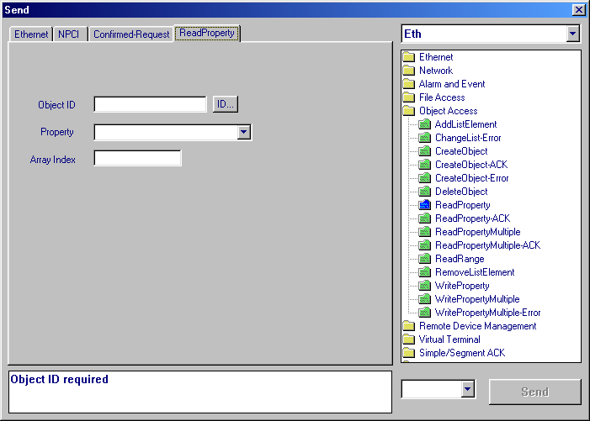
Figure 15: Send dialog for Read-Property packet
When all required fields in all the layers of the packet are filled in correctly, the status window shows the hex code for the packet. Figure 16 shows a completed Send dialog for a Read-Property packet.
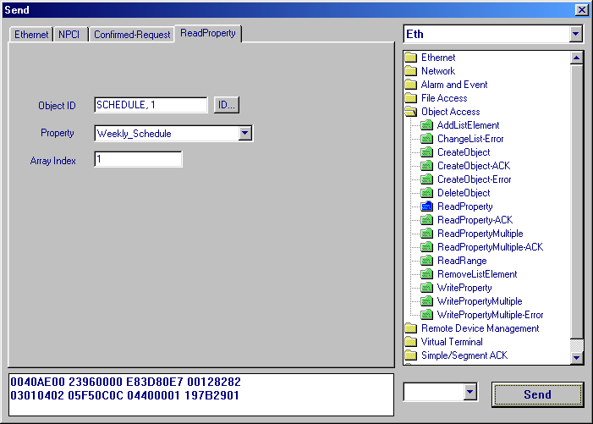
Figure 16: Completed Send Dialog for ReadProperty Service
Once your packet is complete and correct, send it by clicking the “Send” button at the bottom right of the dialog.

Switching Between Packet Types
A tester may wish to send many different packet types in succession. In this case, it is not necessary to close and re-open the Send dialog for each packet type. To change to a new service:
- Double-click on the appropriate file folder icons at the right hand side of the dialog (which correspond to the groups in the Send menu). A tree will open with a list of all the packet types in that group.
- Click on the new packet type. The tabs in the Send dialog will change accordingly.

Starting With a Blank Packet
It is also possible to create a packet “from scratch” with the Send dialog. To do so, choose the “New Packet…” command in the Send menu, and a blank Send dialog will appear (see Figure 17).
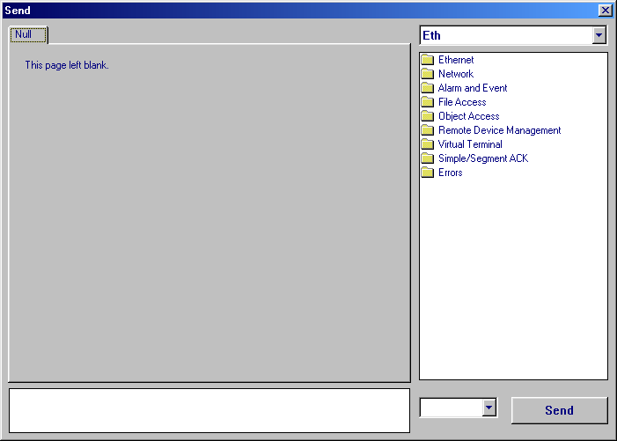
Figure 17: Blank Send dialog. Note that an Ethernet Port (called “Eth”) is enabled.
There are 2 ways to build a packet with the blank Send dialog. One is just to enter raw hexadecimal data into the lower left window of the Send dialog. However, only do this if you really know what you’re doing.
The other method is to follow the directions in the “Switching Between Packet Types” section, above.

Chapter 4: Viewing Packets
This chapter assumes that the user knows how to send packets with VTS, as described in Chapter 3: Manually Sending BACnet Packets, and that an IUT is placed on a reachable network segment.
VTS is able to act as a network ‘sniffer’ (a program that detects and decodes network traffic). The sniffer capability of VTS is limited in that it only decodes and displays BACnet packets. This allows testers to see a device’s response to a particular packet, in order to determine the results of the test being conducted.
VTS captures packets automatically on all enabled Ports (see the “Configuring Ports” section in Chapter 2).

Packet Views
There are three panes in VTS that display the captured packets: the Packet List, the Detail View and the Hex View (see Figure 18). Each pane gives a different view of the network traffic and together, they provide a comprehensive view of all BACnet communication.
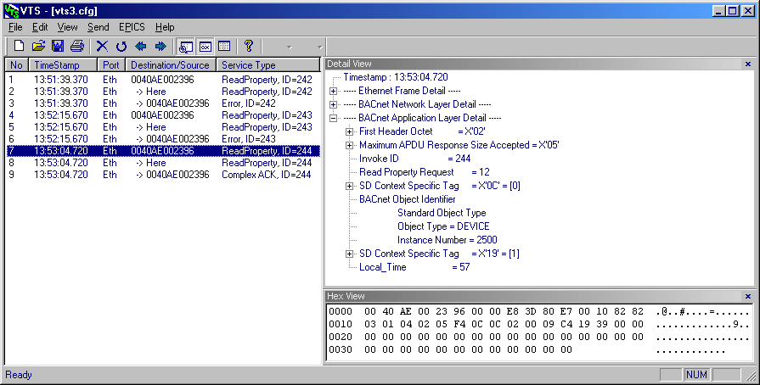
Figure 18: The Three Packet Views available in VTS

The Packet List
The Packet List is the main window in VTS and, as its name implies, is a list of all of the packets that VTS has captured.
For each packet, the following information is displayed:
- Packet Number: a sequential number indicating the order in which the packets were captured
- Time Stamp: the time at which the packet was captured (based on the PC’s clock)\
- Port: the Port (see Chapter 2) on which the packet was captured
- Destination/Source: the address or Name (see Chapter 2) of the device from/to which the packet was sent
- EDIT: Find out what the arrows mean! -
- Service Type: the BACnet Service Type of the Packet (e.g. ReadProperty or Who-Is-Router-To-Network)

The Detail View
The Detail View provides a byte-by-byte breakdown of a single packet’s data and decodes its semantic meaning. The semantic meaning of a piece of data in the packet is translation from a simple hexadecimal value (e.g. X’0A’) to a meaningful term (such as CreateObject service, or File object type).
The Detail View divides a packet into the various network layers that comprise that packet. See Figure 19 for an example.
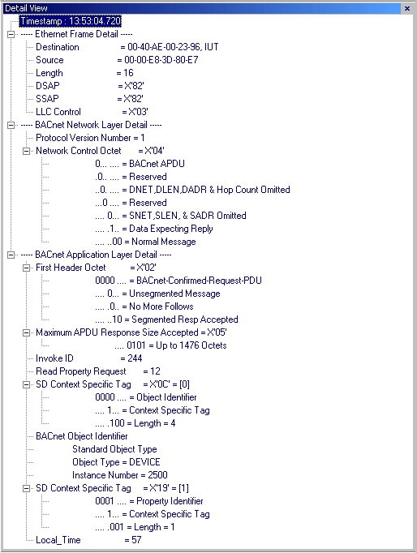
Figure 19: Detail View of a ReadProperty Packet
As Figure 19 shows, the Detail View breaks down packets in a tree format. Each main branch of the tree represents one network layer, in this case Ethernet, BACnet Network Layer and BACnet Application Layer. Other layers could include the BACnet Master-Slave/Token Passing (MS/TP) protocol or the Internet Protocol (IP).
Each piece of data in each network layer (such as Destination, Source, and Protocol Version) is a ‘leaf’ on the tree. Some entries within each layer break down into sub-branches, such as the Network Control Octet or data tags.
By examining the Ethernet layer of the packet, a tester can determine that:
- a device at address 00-00-E8-3D-80-E7 sent the packet to a device at address 00-40-AE-00-23-96 (both addresses are in the Ethernet layer)
By examining the BACnet Network Layer of the packet, a tester can determine that:
- the packet is a BACnet APDU, and
- the packet was not routed from another network (source address information omitted) nor is it to be routed to another network (destination address information omitted)
By examining the BACnet Application Layer of the packet, a tester can determine that:
- the packet is a Confirmed Request, of type ReadProperty, and
- the property being requested is the LocalTime property of the Device object (instance number 2500)
Note that the value of each octet is given (e.g. “57”), as well as the semantic meaning (“Local_Time”).
Data tags are shown as their hexadecimal value (e.g. X‘19’) and broken down into tag number, class and length/type (for details on BACnet tagging, see Chapter 20 of the BACnet standard).
To enable or disable the Detail View, click on the View menu and choose “Detail View”. The menu item will be checked when the Detail View is enabled.

The Hex View
The Hex View shows the raw hexadecimal octets of a single packet, in rows of 16 octets. To the right of each row, the Hex View displays the ASCII character (if any) of each byte. Any byte that doesn’t correspond to a standard ASCII character is indicated with a dot.
Figure 20 shows the Hex View for the same packet shown in Figure 19.
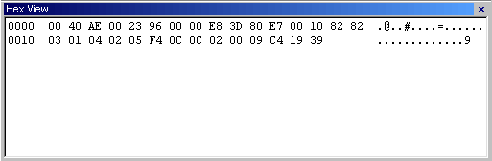
Figure 20: Hex View of the Same ReadProperty Packet
To enable or disable the Hex View, click on the View menu and choose “Hex View”. The menu item will be checked when the Hex View is enabled.

Highlighting the Hex View From the Detail View
It is possible to use the Detail View to highlight certain octets or groups of octets in the Hex View, to see how certain parts of the data are encoded.
To use this feature:
- Ensure both the Detail View and Hex View panes are enabled (see the above 2 sections for how to do this).
- Click the field whose hex data you want to highlight.
In the Hex View, the hex data representing the chosen data will be surrounded with a red box.
Figure 21 shows the packet from Figure 19 with a BACnet Object Identifier highlighted.
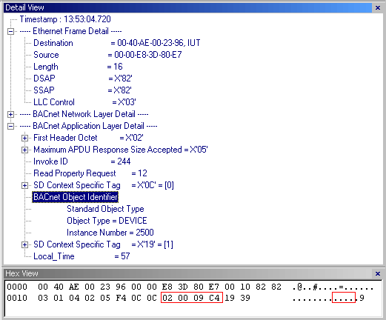
Figure 21: The Same ReadProperty Packet Showing a Highlighted Field

Saving Packets
VTS stores all captured packets (known as the packet log) in a file with the extension “.vpk”.
During the course of testing, a tester may want to save a certain set of captured packets for later review or to demonstrate the behaviour of an IUT. For this reason, VTS allows users to create multiple packet log files, though only one log file can be used at a time.

Switching Log Files
To switch to a different log file:
- Under the “Edit” menu, choose “Change Logfile …”. A file picker dialog will appear (see Figure 22).
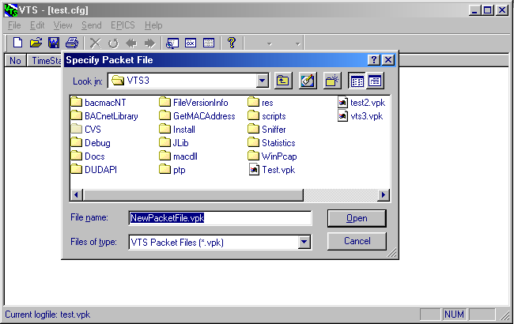
Figure 22: Specify Packet File dialog for switching log files
- Either:
  - create a new log file by entering a new file name in the “File name:” box,
OR
  - open an existing log file (to review its packets), either by clicking on it or entering its name in the “File name:” box.
  - Click ‘Open’.

Determining the Current Log File
To determine the current log file being used, follow just the first step for ‘Switching Log Files’. The name of the current log file will be displayed in the status bar of the main VTS window (see Figure 22).

Printing Packets
Not yet included in the most recent build reporting functionality.

Chapter 5: Running VTS Scripts
This chapter assumes that VTS is configured to communicate with an IUT, as described in Chapter 2: Configuring VTS 3, and that pre-written scripts are available.
A script is a file containing a sequential set of instructions. A tester can use VTS to run scripts in order to perform tests, rather than creating and sending all test packets manually with the Send dialog (see Chapter 3).
Script testing works best for repetitive tests or for tests with long or complicated sequences of steps. However, every VTS script must be customized to fit the particular device being tested and it may take longer to configure a script than it would to run a manual test. In these cases, testers should run the tests manually.

Requirements for Script Testing
Besides VTS itself and a device to be tested, a tester requires the following in order to perform script testing:
- one or more pre-written scripts
- an Electronic Protocol Information Conformance Statement (EPICS)
NOTE: an EPICS is only required for scripts that refer to it. Scripts without EPICS references (for instance, scripts that test certain Device Management BIBBS) can be run without generating and loading an EPICS.

What is an EPICS?
An EPICS is a plain text computer file that contains a detailed description of an IUT, including (but not limited to):
- communication parameters (e.g. maximum packet sizes),
- BACnet limitations (e.g. supported BACnet services), and
- a list of the device’s objects and their properties.

How to Create/Edit an EPICS
The description of an EPICS file and instructions for generating one are beyond the scope of this document. Refer to Chapter 4 in the document “Method of Test for Conformance to BACnet” (ASHRAE Standard 135.1-2003).

How to Load an EPICS
To load an EPICS into VTS:
- On the EPICS menu, choose the “Load EPICS…” command. An Open File dialog appears.
- Select the EPICS file you want to use and click “Open” (or press Enter).
NOTE: VTS will assume that an EPICS is in the same folder as its workspace file (see Using Multiple Workspaces on page 10, for details on Workspace files), so putting your EPICS files in that folder will save you some time.
- VTS will parse the EPICS file and report any errors. If VTS reports no errors, it successfully loaded the EPICS; otherwise, you will need to edit your EPICS and repeat these steps until all errors are eliminated.

How to Run a Script

Opening a Script File
There are three ways to open a script:
- The keyboard shortcut ‘Ctrl + O’
- The ‘Open File’ button:
- File menu, “Open script…” command.
Any of these will cause an Open File dialog to appear. Choose the script file you want to run and click “Open” (or press Enter).
NOTE: VTS maintains a Recent File List, in which it remembers the last several scripts that were used. To open one of these, click the script you want.
The script window will open (see Figure 23).
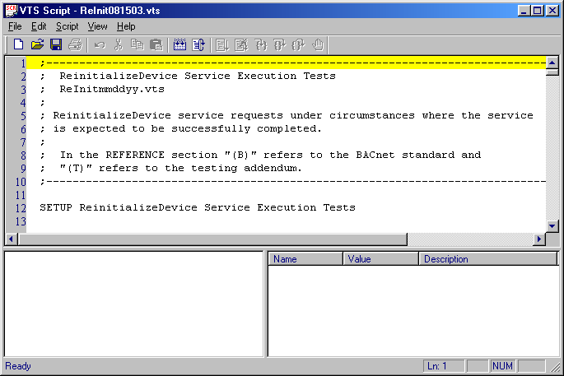
Figure 23: VTS Script Window

The Script Window
As you can see in Figure 23, the VTS script window has 3 panes, each representing the script in a different way. They are:
- Script Text
- Test Components
- Parameters

Script Text
The script text is in the pane at the top of the Script Window. This pane is a simple text editor in which to write and edit scripts. A yellow highlight bar indicates the line currently being edited. The editor has standard editing features, such as text select, copy/cut, and paste.

Test Components
The Test Components pane is at the lower left of the Script Window. It provides a graphical Tree depiction of the individual components of a script (except for the Setup section; see the Parameters section, below). The script components that are depicted are:
- Section
- Test (within a Section)
- Dependency (within a Test)
- Reference (within a Test)
- Packets (within a Test)
See Figure 24 for an example of a filled Test Components pane:
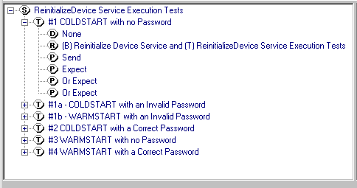
Figure 24: Example of a Test Components pane
In the Test Components tree, different components (Sections, Tests, Dependencies, References and Packets) are indicated with a small circle containing the first letter of that component type (Sections are indicated with a small circle containing an ‘S’, etc.)
To expand or collapse the components of the tree, either:
- click on the small box at the left containing a ‘+’ (to expand) or ‘-‘ (to collapse) or
- double-click on the item.
In Figure 24, the script has a single Section and six Tests, one of which is expanded and which contains an (empty) Dependencies section, a Reference and 4 Packets, 1 to send and a choice of three to expect.

Navigating Scripts with the Test Components Window
The Test Components window can be used to navigate the script text itself. To do this, double-click on any component in the Test Components window. The cursor in the Script Text pane will move to the corresponding line in the script. NOTE: double-clicking the item will also cause it to expand or collapse, if it can.

Parameters
The Parameters pane is at the lower right of the Script Window. It shows the names and current values of all script parameters defined in the Setup section of the Script. See Figure 25.
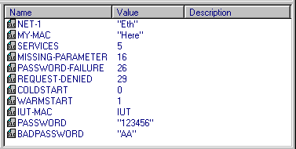
Figure 25: Example of a Parameters pane

Comments
Script comments are not included in any graphical representation of the test and can only be viewed in the Script Text pane of the Script Window.

Checking Script Syntax
Users should have VTS check the syntax of a script when first loading it. You should do this even if the script has been used before and you know that it is correct, because checking the syntax also loads the script Parameters and Test Components into their respective panes.
You must have VTS check the script syntax before you run the script; VTS will not run it until it has checked the syntax.
If you edit a script after the syntax is checked and before running it, you must have VTS check it again or your changes will not take effect, even if you save the script file.
To have VTS check the script syntax, use either:
- the Check Syntax button: , or
- the ‘Check Syntax’ command in the Script menu of the Script Window
NOTE: Checking script syntax ensures that all required script constructs (Setup, Section, Test, etc) are present and that parameter values can be parsed. Syntax checking does not check for correct formation of Packets.

Configuring a Script
Before running a Script, all its parameters (found in the Setup portion) must be configured to match local conditions (e.g. local MAC addresses, passwords, object restrictions (if any), etc).
The configuration can either be long-term – editing the script to change the parameter values – or short-term – changing the current value of one or more parameters, using the Script Window Parameters pane.

Changing Parameter Values
To change the value of a parameter:
- Double click the parameter’s name in the Parameter pane of the Script Window.
A Script Parameter Update dialog will appear (see Figure 26)
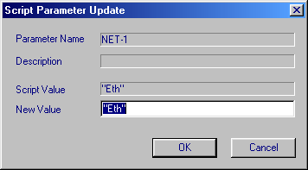
Figure 26: Dialog to Change Values of Script Parameters
- Enter the new value of the Parameter and click ‘OK’ or press Enter.
The value of the parameter, as shown in the Parameters pane will change to the new value.

Resetting Parameter Values
To return all parameter values to those specified in the script:
- click the Reset button , or
- click the ‘Reset’ command in the ‘Script’ menu

Running a Script
VTS allows users to run either entire scripts or, if a script contains multiple Tests, a single Test within a script.
To run a script or Test:
- Choose a script component to run, by clicking on it in the Test Components pane. You can run either an entire script Section or a single test (shown in Figure 27).
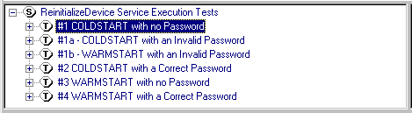
Figure 27: Test Component Pane with a Single Test Selected to Run
- Run the test(s) by:
  - pressing F5,
  - clicking the Run Test button , or
  - clicking the ‘Run’ command in the ‘Script’ menu.
NOTE: The ‘Run’ command will either read “Run all tests” or “Run <test name>”, where <test name> is the name of a highlighted test. To use Figure 27 as an example, the menu command will read “Run #1 COLDSTART with no Password”

Manually Controlling Tests
In addition to running an entire script or Test at once, it is possible to run a Test one step at a time and, if the tester wishes, to force each component to pass or fail. To do so:
- Choose a Test to step through, as in step 1 above.
NOTE: The Script Window only supports stepping through individual Tests, not entire scripts.
- For each step in the test, you can:
  - Execute the step normally by:
    - pressing F6,
    - clicking the ‘Single Step’ button , or
    - clicking the ‘Step’ command in the ‘Script’ menu.
NOTE: As with the “Run” command, the ‘Step’ command will read “Step <test name>”, where <test name> is the name of a highlighted test. However, the name will only appear in the menu BEFORE you start the test.
  - Skip the step and force it to PASS by:
    - clicking the ‘Bypass with PASS’ button , or
    - clicking the ‘Step Pass’ command in the ‘Script’ menu.
  - Skip the step and force it to FAIL by:
    - clicking the ‘Bypass with FAIL’ button , or
    - clicking the ‘Step Fail’ command in the ‘Script’ menu.
  - Resume normal (full) script execution by:
    - pressing F5,
    - clicking the Run Test button , or
    - clicking the ‘Resume’ command in the ‘Script’ menu.
  - End (and FAIL) the test by:
    - pressing F8,
    - clicking the ‘Force Fail’ button , or
    - clicking the ‘Kill’ command in the ‘Script’ menu.

Checking Results
For a quick check on the results of running a script, the Test Components pane indicates the success or failure of individual tests. Sections, Tests and Sent or Expected packets that pass are highlighted in green. Failed Packets, Tests and Sections are highlighted in red. Note that all Tests in a Section must pass for the Section to pass. See Figure 28 for an example.
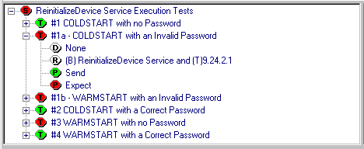
Figure 28: Test Component Pane Showing Passed and Failed Components

Script Messages
The Test Component pane can only show the Pass/Fail result of a test. However, running a script generates more detailed messages, which are displayed in the main VTS window.
Messages are logged in the VTS Packet List window and each message can be viewed individually in the Detail View (see Chapter 4: Viewing Packets for more information about these displays). Figure 29 shows a typical script message:
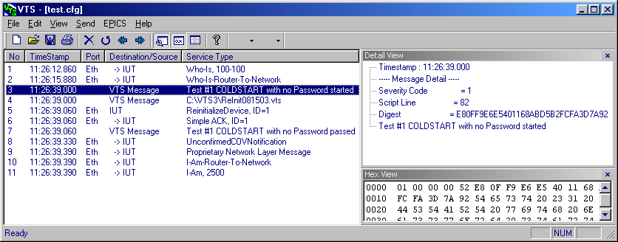
Figure 29: Sample Script Message
A Script Message has a number of parts:
- Timestamp: indicates when the Script Window sent the message
- Severity Code, which can be 1, 2 or 3, with the following meanings:
      - A test was started or stopped
      - A user manually stepped through (and, optionally, forced to pass or fail) a test step
      - A script statement failed (which does NOT necessarily mean that a test failed; the statement may have been conditional)

Failed Sends
Because the Script syntax checker doesn’t check packet formation, you may not know that there is a malformed packet in a script until the Script Window fails to send it. If a packet fails to be sent, the Script Window will look something like Figure 30.
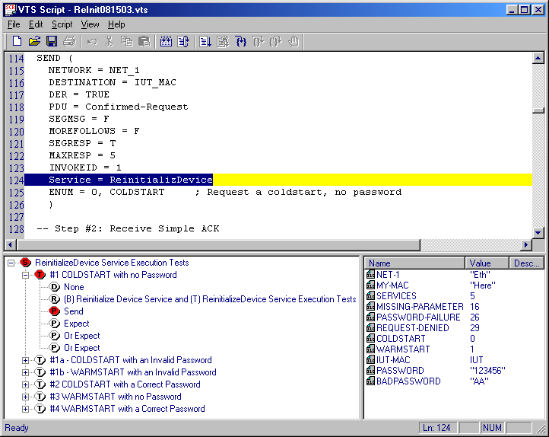
Figure 30: Failed Send Packet Statement
When this happens, the Script Window will generate a message indicating the general problem and the line number of the script where the error occurred, so that a user can quickly find the error and fix it. See Figure 31 for an example of a packet error message.
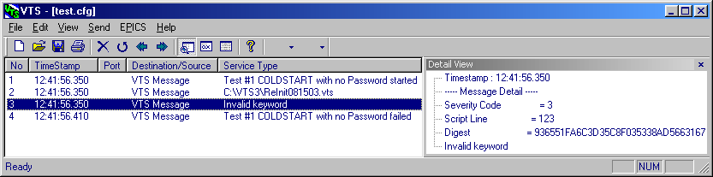
Figure 31: Script Message with Send Packet Error Details

Chapter 6: Script Standards
This chapter assumes that readers are familiar with, and have access to, the BACnet specification and Test Standard (ASHRAE 135 and 135.1) and the BACnet Testing Laboratory (BTL) documentation package for testers. It also assumes that the reader is comfortable running scripts as described in Chapter 5: Running VTS Scripts.
In order to make scripts usable and maintainable by many different testers and pre-testers, script developers should use common, accepted standards and conventions. Those defined by BTL for the development of VTS scripts are described in this chapter.

Parameter Scripts
As of September 2003, scripts are in two parts: body and parameters. The body of the script consists of the test itself – the packets sent and expected, the checks of object values or device status, etc. – and remains constant.
The parameters portion of the script consists of variable data: MAC and routing information for the testers local network, plus any variables (such as property identifiers, enumerations, error codes, etc) that are required in the body of the script.
The parameters and body are separated not only logically but physically – each is in its own file. The Parameters file is associated with the Body using the VTS INCLUDE keyword, which is described more fully later.
Figure 32 shows a parameter definition script for testing the Reinitialize-Device COLDSTART service with no password.
-------------- S C R I P T V E R S I O N I N F O -----------------------
;
; Version 0.1 2003-09-23 Wilson Fowlie - Sample Parameter Script for VTS usage guide
;
---------------------- S C R I P T H E A D E R ------------------------------
;
; Script: DM-9.27.1.1P-Rev0.1.vts
; Test: ASHRAE 135.1 - 9.27.1.1 COLDSTART with no Password
;
; Purpose: To verify the correct execution of the ReinitializeDevice request service
; procedure when a COLDSTART is attempted and no password is provided.
;
----------------- S C R I P T P A R A M E T E R S ---------------------------

SETUP

NET_1 = "Eth" -- Local network

MY_MAC = "TD" -- MAC address of the TD
IUT_MAC = IUT -- Address of IUT

---------------------- S C R I P T B O D Y ----------------------------------
INCLUDE "DM-9.27.1.1B-Rev0.1.vts"
Figure 32: A Parameter Definition script for a test of the BACnet Reinitialize Device Service
The parameter script has four areas, each with a heading:
- Version Information of the script, consisting of:
  - the revision number of the script,
  - the date that the script was created
  - the script writer’s name
  - a comment describing the script revision
Note that all of the lines in this area (and the next) start with a semi-colon. The VTS script executor ignores any part of a line following a semi-colon as a COMMENT EDIT: reference keyword in next chapter that is not executed as part of the script.
- Script Header, consisting of:
  - the name of the script file, which MUST be of the form:
    - <BIBB Area>-<TestNumber>-Rev<rev>.vts, where:
      - <BIBB Area> is the acronym of the main BACnet Interoperability Building Block (BIBB) section of which the test is a part (such as AE for Alarm & Event Management, DM for Device Management, etc).
      - <TestNumber> is the test number from either the Test Standard (ASHRAE 135.1) or the BTL Specified Tests
      - <Rev> is the script revision number in the form <Major>.<Minor> (e.g. 1.3)
  - the details of the test, including:
    - the document in which the test is found
    - the name and number of the test
  - a short description of the purpose of the test.
- Parameter Setup, which declares the parameters that will be used in the body of the test. There is more detail about this area of this script below.
- Body, which simply uses the VTS keyword INCLUDE EDIT: reference keyword to bind this Parameter script to the correct Body script file. The important thing to remember for this area is that the name of the file to be INCLUDEd must be enclosed in quotation marks. Also note that the lines in this area (and the Parameter Setup area above it) are not comment lines – they are read and executed by the VTS.

Parameter Setup
The Parameter Setup area of the Parameter script file is the file’s reason for existing. All of the parameters required by a Body script must be declared here, before the Body script is INCLUDEd. The Parameter Setup area always follows the same format.

SETUP Keyword
The first item is the SETUP EDIT: reference keyword construct. The SETUP command tells VTS that the following lines will declare script parameters.
The SETUP keyword can be by itself or can have text associated with it; for example:
SETUP ReinitializeDevice With COLDSTART

No quotes or other punctuation is required; however, any text associated with SETUP must be on the same line as the SETUP keyword itself. If you want to use multiple lines to describe the SETUP, use comments for following lines.

Parameter Declarations
Most VTS users will not need to declare parameters; rather, they will be configuring pre-written scripts and modifying existing parameters to values that are appropriate for their own testing environment. However, it’s good to understand how parameters are declared, so we’ll take a quick look at them.
Parameters are declared in the format shown in Figure 33:
<Parameter-name> = <Initial Value> -- <Parameter description>
[; <Additional description>]
Figure 33: Format of Parameter declaration.

Parameter Name
The parameter name must contain only alphabetical characters, numerical characters and underscores (“_”). It may not contain spaces or special characters such as quotation marks, mathematical operators, etc.
Parameter names should be very descriptive, to make sure that the parameter’s use is clear and to make the Body scripts as readable as possible.
Examples of good, valid parameter names can be found in the script in Figure 32.

Parameter Value
Parameters can be initialized with any valid value of any primitive BACnet data type (NULL, Boolean, Unsigned, Integer, etc). For details on how to form the various types, see the section of Chapter 7: Script .

Parameter Description
The description should be clear and complete enough that a user does not need to refer to the Body script file to understand what to enter into the parameter.
The parameter description is a comment, but the comment symbol is a double hyphen ("--") instead of a semi-colon. When the script parser finds a comment using the double hyphen symbol (or the COMMENT keyword), it associates that comment with the most recently declared parameter, and the VTS Script Window will display that comment in the Parameters pane, next to its associated parameter.
While the first line of the description should use the double-hyphen comment style, any further comments, on following lines, should use the semi-colon comment style (as in Figure 33). This doesn’t make a difference in the behaviour of script execution or parameter display; however, it serves as a reminder that the first line of the description should be as explanatory as possible, as it is the one that will be seen most.

Body Scripts
The Body is the part that does the actual work of the test: sending packets, receiving responses and checking them to determine the pass or fail status of the test. Like Parameter scripts, Body scripts have a particular format. Figure 34 shows a very simple Body script. It is the same ReinitializeDevice COLDSTART With No Password test that the Parameter script in Figure 32 is for.
-------------- S C R I P T V E R S I O N I N F O -----------------------
;
; Version 0.1 2003-09-23 Wilson Fowlie - Sample Parameter Script for VTS usage guide
;
---------------------- S C R I P T H E A D E R ------------------------------
;
; Script: DM-9.27.1.1B-Rev0.1.vts
; Test: ASHRAE 135.1 - 9.27.1.1 COLDSTART with no Password
;
; Purpose: To verify the correct execution of the ReinitializeDevice request service
; procedure when a COLDSTART is attempted and no password is provided.
;
---------------------- S C R I P T B O D Y ----------------------------------

COLDSTART = 0 -- ColdStart constant
; Defined in the ReinitializeDevice service in Chapter 21 of the standard

SECTION 9.27.1.1 COLDSTART with no Password

TEST #1

-------------------------- S T E P 1 ----------------------------------------
--
-- TRANSMIT ReinitializeDevice-Request,
-- 'Reinitialized State of Device' = COLDSTART
--

SEND (
NETWORK = NET_1
DESTINATION = IUT_MAC
DER = TRUE
PDU = Confirmed-Request
SEGMSG = F
MOREFOLLOWS = F
SEGRESP = T
MAXRESP = 5
INVOKEID = 1
Service = ReinitializeDevice
ENUM = 0, COLDSTART ; Request a ColdStart, no password
)

-------------------------- S T E P 2 ----------------------------------------
--
-- (RECEIVE BACnet-Simple-ACK-PDU
-- CHECK (Did the IUT perform a COLDSTART reboot?)) |
-- (RECEIVE BACnet-Error-PDU,
-- Error Class = SECURITY,
-- Error Code = PASSWORD_FAILURE) |
-- (RECEIVE BACnet-Error-PDU,
-- Error Class = SERIVCES,
-- Error Code = MISSING_REQUIRED_PARAMETER)
--

EXPECT (
Network = NET_1
Destination = MY_MAC
DER = FALSE
PDU = SimpleAck
Service = ReinitializeDevice
)

OR (
NETWORK = NET_1
DER = FALSE
PDU = Error
Error-Choice = ReinitializeDevice
ENUM = 4 ; Error class: Security
ENUM = 26 ; Error code: Password Failure
)

OR (
NETWORK = NET_1
DER = FALSE
PDU = Error
Error-Choice = ReinitializeDevice
ENUM = 5 ; Error class: Services
ENUM = 16 ; Error code: Missing Required Parameter
)

------------------ E N D O F T H E S C R I P T ----------------------
Figure 34: Body script for a test of the BACnet Reinitialize Device Service
The Body script has three main areas. The first two are the same as the first two of the Parameter script: the Version Information and the Script Header. Note that the information in these sections may not necessarily be the same, as the two scripts may be developed or modified independently.

The Test Body
The third area of the Body script is the body of the test itself. This should be written so that what is happening is absolutely clear. Follow these guidelines (compare to the script in Figure 34 for examples):
- If there are any parameters that will not be changed by a tester (e.g. a constant that is easier to read as text than as a number), declare them at the top of the script before any SECTION or TEST constructs.
- Start the body with a SECTION EDIT: reference keyword command that identifies the Test Standard (ASHRAE 135.1) or BTL test (see the BTL Specified Tests document included in the BTL pre-testing documentation package) that the script implements.
- The test steps (from 135.1 or BTL Specified Tests) should be in comments that precede the script statements that implement the test step.
- If there are many steps in a test insert the TEST EDIT: reference keyword construct to define stopping points that allow the tester to step through the execution of the test (as described in the Manually Controlling Tests section of Chapter 5: Running VTS Scripts).

Master Scripts
Master Scripts contain several INCLUDE statements, each referring to a Parameter script (each of which in turn, of course, INCLUDEs a Body script). Master scripts allow testers to automate the running of many possibly interdependent scripts, saving testing time and effort (and after all, what are computers for?).
Like Parameter and Body scripts, Master Scripts should have Version and Header areas that show the script’s history, purpose, etc., so that the scripts are usable by multiple users.
When multiple tests are run in sequence, some may be dependent on the results of previous tests. In this case, use the DEPENDENCIES EDIT: reference keyword construct to indicate to VTS (and other users of a script) which tests are prerequisites of other tests. Note that the DEPENDENCIES keyword must be declared inside a TEST construct.

Script Constructs

Sending and Expecting Packets
SEND keyword
EXPECT keyword
Comparators (describe use here, refer to Forming Packets, Data Components – below – for syntax)
AND and OR keywords.
AFTER and BEFORE keywords – don’t work yet

Cases
In some tests, what to do in a particular step may depend on the result of the previous step.

Chapter 7: Script Development
This chapter assumes that readers are familiar with, and have access to, the BACnet standard (ASHRAE 135), and with BTL’s standards of script development, as described in Chapter 6: Script Standards.
This chapter assembles all of the information relevant to developing scripts from other sources (Thesis.doc, GDThesis.doc and VTSScripting.html et al), so that script writers don’t have to consult three different documents.
This chapter explains the ‘nuts and bolts’ of writing scripts – the components involved in sending and receiving packets, checking results and changing behaviour based on conditions of the device or received packets.

Defining Packets

SEND and EXPECT
Sending a packet is the most basic function of a VTS script. To send a packet, use the SEND EDIT: reference keyword construct. Figure 35 shows an example of a DeviceCommunicationControl packet being sent:
SEND (
NETWORK = NET_1
DESTINATION = IUT_MAC
PDU = Confirmed-Request
SEGMSG = F
MOREFOLLOWS = F
SEGRESP = T
MAXRESP = 5
INVOKEID = 1
SERVICE = DeviceCommunicationControl
ENUM = 1, 1 ; Disable request
) ; No password
Figure 35: SENDing a DeviceCommunicationControl packet
A packet’s content is specified with one field per line. All packet parameters, in all network layers (data link, virtual link, network and application), are combined into a single structure, with no differentiation or separation between layers. However, a script developer could put blank lines between packet components for readability or to emphasize certain key elements.
Receiving a packet is also a very common task. To specify a packet to be received, use the EXPECT EDIT: reference keyword construct, as shown in Figure 36:
EXPECT (
NETWORK = NET_1
Destination = MY_MAC
PDU = SimpleAck
SERVICE = DeviceCommunicationControl
)
Figure 36: EXPECTing a DeviceCommunicationControl Acknowledgement packet

Packet Parameters
There are many parameters available for forming packets; they are listed below and divided by general category. Note that some parameter keywords have multiple versions (e.g. PDU and PDU-TYPE); these are noted where appropriate.
The data components (NULL, Boolean, etc) are shown first as they are the most commonly used. After that, the network parameters are given in the order that they usually appear.
All parameters are encoded the same way:
<DataType> [<Operator>] [<Tag>,] <Value>, where:
  - DataType is NULL, BOOLEAN, etc.
  - Operator is one of “=”, “==”, “<”, “<=”, “>”, “>=”, “<>”, “!=” or “>>” discussed below. If no operator is included, “=” is assumed.
  - Tag is a context tag number. If it is not supplied, an application tag is assumed. A tag is only included when encoding Data (i.e. not for standard fields such as NETWORK, DESTINATION, etc.).
  - Value is the formatted value of the parameter. It can be:
    - a standard definition as defined below, or
    - a reference to a property defined in the EPICS (see the What is an EPICS? section in Chapter 5: Running VTS Scripts), which is defined as a property name between two braces, as in this example:
REAL = {AI.Present-Value} EDIT: Is this correct?

Packet Parameter Operators
SEND and EXPECT have identical construction, with one exception. In EXPECT packets, the Operator (the “=” sign, in the above examples) can be any one of several, to indicate that a particular value is expected (“=” or “==”), that a particular value is invalid (“!=” or “<>”) or that a value should be less than (“<”), less than or equal to (“<=”), greater than (“>”) or greater than or equal to (“>=”) a value.
NOTE: if no operator is supplied, VTS will assume the “=” operator.
Figure 37 shows a SEND/EXPECT pair that uses a “<=” operator:
SEND (
NETWORK = NET_1
PDU = Confirmed-Request
SEGMSG = F
MOREFOLLOWS = F
SEGRESP = T
MAXRESP = 5
INVOKEID = 1
SERVICE = ReadProperty
OBJECTIDENTIFIER = 0, AI, 1 ; Analog Input 1
PROPERTYIDENTIFIER = 1, Present-Value
) ; No array index

EXPECT (
NETWORK = NET_1
PDU = ComplexAck
SEGMSG = F
MOREFOLLOWS = F
INVOKEID = 1
SERVICE = ReadProperty
OBJECTIDENTIFIER = 0, AI, 1 ; Analog Input 1
PROPERTYIDENTIFIER = 1, Present-Value
REAL <= 3, 100.0 ; Any value less than 100 is valid
)
Figure 37: A SEND/EXPECT Pair in Which the EXPECT Statement Uses a “<=” Operator

Assignment Operator
It is also possible, with the EXPECT command, to assign a value to a script parameter using the script parameter operator ">>". The syntax is the same as with a normal parameter, but instead of specifying a value, a Script Parameter name (which must have been declared in the SETUP area, as discussed in Chapter 6: Script Standards) is specified instead. __ shows an example:
EXPECT (
NETWORK = NET_1
PDU = ComplexAck
SEGMSG = F
MOREFOLLOWS = F
INVOKEID = 1
SERVICE = ReadProperty
OBJECTIDENTIFIER = 0, AI, 1 ; Analog Input 1
PROPERTYIDENTIFIER = 1, Present-Value
REAL >> 3, AI_VALUE ; The AI_VALUE parameter now holds the value received in the
; ReadProperty response
)
Figure 38: An EXPECT Packet Which Assigns a Value to a Script Parameter Using the “>>” Operator

Data Parameters
All BACnet primitive types can be encoded. Open and Close tags can also be encoded and using them, any structure of arbitrary complexity can be built.

Primitive Types

NULL
Has no value. Any operator is ignored. If a tag number is included, it should NOT have a comma after it.
NOTE: This means that the most common encoding is simply the word NULL by itself

BOOLEAN
Values can be any of: T, TRUE, Y, YES; F, FALSE, N, NO
Alternate keyword BOOL can be used.

UNSIGNED (~8, ~16, ~32)
Values may be specified using decimal, hexadecimal, octal or binary encoding. The following are all valid ways to specify the number 13:
13, 0x0D, &x0D, x'D', 0o15, &o15, o’15’, 0b1101, &b1101, b'1101'
Alternate keywords UNSIGNED8, UNSIGNED16 and UNSIGNED32 can be used.

INTEGER
Value encoding is identical to UNSIGNED type.

REAL
Values may specified in a number of common forms, as follows:
12.3, -23.4, 3e4, 4.5e6, 5.6e-7, -6.7e-8
Alternate keyword SINGLE can be used.

DOUBLE
Value encoding is identical to REAL type.

OCTETSTRING
The most common representation is strings of hexadecimal characters, with each pair representing a single octet, as: x’4F6374657420537472696E67’
Values may also be specified in decimal, octal or binary form.

CHARACTERSTRING
Character strings can be encoded in two different ways:
- As a character string (most common): "Character String"
- As an octet string (as described in the OCTETSTRING type)
A character string encoding can also specify a character set. If it is specified, the character set appears immediately before the character string itself (after any operator or tag number) and can be any of:
    - IBM or MICROSOFT or DBCS or IBM-MICROSOFT-DBCS
    - JIS or JIS-C-6226
    - UCS-4 or ISO-10646-UCS-4
    - UCS-2 or ISO-10646-UCS-2
    - ISO-8859-1
If no character set is specified, ASCII (ANSI X3.4) is assumed.
If a character set is specified, VTS does NOT automatically translate between the ASCII in the script file and the specified character set. The script writer must translate the string and encode it as an OCTETSTRING.
Alternate keyword CHARSTRING can be used.

BITSTRING
Values can be specified in one of two ways:
- As a binary value; e.g. B'101101'
- As a series of True (T) or False (F) values; e.g. T, F, T, T, F, T

ENUMERATED
VTS doesn’t have a mechanism to translate the names of enumerated values, so they must be specified as integers. However, the enumeration type and name should be included in an associated comment.
Example: ENUMERATION = 5; BACnetEngineeringUnits - Volts
Alternatively, script parameters (see the Parameter Setup section in Chapter 6: Script Standards) can be defined to create named constants corresponding to enumeration values (for an example of this, see Figure 34 in Chapter 6: Script Standards).
Alternate keyword ENUM can be used.

DATE
Values are specified as: <day-of-week> <Month>/<Day>/<Year>, where:
    - Day-of-week is the name of any day of the week (SUNDAY, MONDAY, etc)
    - Month, Day and Year are integers (1-12, 1-31 and 1900-2154, respectively)
NOTE: any component of the value can be substituted with an asterisk ("*"), which means that that component of the date is unspecified.

TIME
Values are specified as: <hour>:<minute>:<second>:<hundredths>, with all components being integers (valid ranges are 0-23, 0-59, 0-59 and 0-99, respectively).
NOTE: any component of the value can be substituted with an asterisk ("*"), which means that that component of the date is unspecified.

OBJECTIDENTIFIER
Values are specified as: <object-type>, <object-instance>, where:
    - object-type is a standard object type (see below) or (if a proprietary type is specified) an integer
    - object-instance is an integer (valid range 0-4194302)
The standard object types and allowable abbreviations for them are:
ANALOG-INPUT (AI)
ANALOG-OUTPUT (AO)
ANALOG-VALUE (AV)
BINARY-INPUT (BI)
BINARY-OUTPUT (BO)
BINARY-VALUE (BV)
CALENDAR (CAL)
COMMAND (COM)
DEVICE (DEV)
EVENT-ENROLLMENT (EVE)
FILE
GROUP
LOOP
MULTI-STATE-INPUT (MI)
MULTI-STATE-OUTPUT (MO)
NOTIFICATION-CLASS (NC)
PROGRAM (PRO)
SCHEDULE (SCH)
AVERAGING (AVG)
MULTI-STATE-VALUE (MSV)
TREND-LOG (TR)
LIFE-SAFETY-POINT
LIFE-SAFETY-ZONE
Alternate keyword OBJECT can be used.

Special Types
There are some instances of certain data types that are used often enough to justify special encoding.

DEVICEIDENTIFIER
Values are specified as: <device-instance>, which is an integer.
Alternate keyword DEVICE can be used.

PROPERTYIDENTIFIER
Values are specified as: <property-name>, which is a standard property name (see the BACnet Standard).
Alternate keyword PROPERTY can be used.

Structural Components
These data types allow building of complex data types such as SEQUENCEs and CHOICEs (see the BACnet Standard).

OPENINGTAG

CLOSINGTAG
Both of these components are specified as <keyword> <operator> <tag-number>, where:
    - keyword is OPENINGTAG or CLOSINGTAG (or alternates; see below)
    - operator is a standard comparative operator as described above ("=", etc.)
    - tag-number is the context tag-number as specified in the BACnet standard.
Alternate keywords OPEN, OPENTAG, CLOSE or CLOSETAG can be used.

Data Link Parameters
These components specify values of components in the Data Link layer.

NETWORK
The port on which to send or expect a packet.
The value is specified as a string containing the name of a Port specified in the VTS workspace (see the Port Configuration section in Chapter 2: Configuring VTS 3). Example:
NETWORK = "Ethernet" ; "Ethernet" is defined in the Ports configuration
NOTE: If only one active Port is configured, the NETWORK parameter may be omitted

DA
The Destination Address for the packet (which may be the address of VTS, if EXPECTing the packet). The value is specified as any of:
    - BROADCAST
    - LOCALBROADCAST
    - a character string specifying a defined Name
    - an Octet String defining a physical address
NOTE: The DA parameter may be omitted in a SEND statement ONLY IF a Name called “IUT” has been specified in the workspace (see the Name Configuration section in Chapter 2: Configuring VTS 3).

SA
The Source Address for the packet (which may be the address of VTS, if SENDing the packet). The value is specified in the same way as DA.

LSAP
Link Service Access Point. EDIT: Is this still used?

Network Layer Components

VERSION
The BACnet version number.
This parameter may be omitted, in which case VTS will use a default value of 1.

DNET/DADR
Destination Network and Address for routing purposes.
The Network number is specified as an integer.
The Address is specified as an Octet String.
These parameters may be omitted. If either (or both) of these parameters is included, the correct bit will automatically be set in the Network Protocol Control Information.

SNET/SADR
Source Network and Address for routing purposes.
The value is specified as with DNET/DADR.
These parameters may be omitted. If either (or both) of these parameters is included, the correct bit will automatically be set in the Network Protocol Control Information.

HOP COUNT
Number of times the message has been routed. The value is specified as an Integer.
This parameter may be omitted. If it is omitted and is required (as it is when the DNET and/or DADR are included), VTS will use a default value of 255.

MESSAGE
The Network Layer message (if applicable). Can be one of the following (abbreviations given in brackets):
WHO-IS-ROUTER-TO-NETWORK (WHOS-RTN)
I-AM-ROUTER-TO-NETWORK (IM-RTN)
I-COULD-BE-ROUTER-TO-NETWORK (I-CLD-BE-RTN)
REJECT-MESSAGE-TO-NETWORK (REJ-MTN)
ROUTER-BUSY-TO-NETWORK (RBTN)
ROUTER-AVAILABLE-TO-NETWORK (RATN)
INITIALIZE-ROUTING-TABLE (IRT)
INITIALIZE-ROUTING-TABLE-ACK (IRT-ACK)
ESTABLISH-CONNECTION-TO-NETWORK (ECTN)
DISCONNECT-CONNECTION-TO-NETWORK (DCTN)
This parameter may only be omitted if the packet is an Application Layer packet, in which case

PRIORITY
The packet priority given to the port for ordering packets.
The value is specified as an Integer (valid range 0-3).
This parameter may be omitted. If it is omitted, VTS will use a default value of 1 (Normal).
NOTE: VTS3 doesn’t prioritize outgoing packets, but sends them on a first-come-first-served basis.

DER
The Data Expecting Reply parameter, indicating whether a reply is expected.
The value is specified as a Boolean.

VENDORID
The Vendor Identification number.
The value is specified as an unsigned integer.

NLDATA
This parameter allows the script writer to send arbitrary data in a packet.
The value is specified as an Octet String.

Application Layer Components
These parameters are only used when an Application Layer packet (e.g. Read-Property) is being sent or expected.

DESTINATION
This is the destination of a packet in a SEND command. It is specified in the same format as the DA parameter described above.

ROUTER
EDIT: Is this still used? It’s in Thesis.doc, but not the new HTML file.

PDU[-TYPE]
The type of PDU (Protocol Data Unit) being sent. Valid choices are:
CONFIRMED-REQUEST
UNCONFIRMED-REQUEST
SIMPLEACK
COMPLEXACK
SEGMENTACK
ERROR
REJECT
ABORT
This parameter is required for all Application Layer packets.

SEGMSG
Whether or not this packet is part of a segmented message. The value is specified as Boolean.
This parameter is required for all CONFIRMED-REQUEST and SEGMENTACK packets.

MOREFOLLOWS
Whether or not this is the last packet in a segmented message. The value is specified as Boolean.
This parameter is required for all CONFIRMED-REQUEST and SEGMENTACK packets, even if they are not segmented.

SEGRESP
Whether or not a segmented response will be accepted by the sending device. The value is specified as Boolean.
This parameter is required for all CONFIRMED-REQUEST packets.

MAXSIZE
Encoding of the maximum packet size accepted by the sending device. Valid values are 50, 128, 206, 480, 1024, and 1476. VTS will translate the value into the appropriate code number.
The alternate keywords MAXRESPONSE or MAXRESP can be used.
This parameter is required for all CONFIRMED-REQUEST packets.

INVOKEID
The packet’s Invoke Identifier. The value is specified as an unsigned integer (valid range 0-255)
This parameter is required for all Application Layer packets.

SEQUENCENR
Sequence Number of a segmented message. The value is specified as an unsigned integer (valid range 0-255). EDIT: is that range correct?
This parameter is required for all SEGMENTACK packets, and all CONFIRMED-REQUEST and COMPLEXACK packets, even if they are not segmented.

WINDOWSIZE
The maximum number of message segment packets that can be accepted before a SEGMENTACK is required. The value is specified as an unsigned integer (valid range 1-15). EDIT: is that range correct?
This parameter is required for all CONFIRMED-REQUEST and COMPLEXACK packets, even if they are not segmented.

SERVICE
The specific Application Layer service being requested (or responded to). Valid values depend on the PDU type.
For CONFIRMED-REQUEST packets, valid service values are:
ACKNOWLEDGEALARM, CONFIRMEDCOVNOTIFICATION, CONFIRMEDEVENTNOTIFICATION, GETALARMSUMMARY, GETENROLLMENTSUMMARY, SUBSCRIBECOV, ATOMICREADFILE, ATOMICWRITEFILE, ADDLISTELEMENT, REMOVELISTELEMENT, CREATEOBJECT, DELETEOBJECT, READPROPERTY, READPROPERTYCONDITIONAL, READPROPERTYMULTIPLE, WRITEPROPERTY, WRITEPROPERTYMULTIPLE, DEVICECOMMUNICATIONCONTROL, CONFIRMEDPRIVATETRANSFER, CONFIRMEDTEXTMESSAGE, REINITIALIZEDEVICE, VTOPEN, VTCLOSE, VTDATA, AUTHENTICATE, REQUESTKEY
For UNCONFIRMED-REQUEST packets, valid service values are:
I-AM, I-HAVE, UNCONFIRMEDCOVNOTIFICATION, UNCONFIRMEDEVENTNOTIFICATION, UNCONFIRMEDPRIVATETRANSFER, UNCONFIRMEDTEXTMESSAGE, TIMESYNCHRONIZATION, WHO-HAS, WHO-IS
For acknowledgement packets (SIMPLEACK, COMPLEXACK, etc.), valid values depend on the service being acknowledged.
This parameter is required for all Application Layer packets.

ERROR
Error that occurred in attempting to respond to an Application Layer packet. Values are specified as two enumerated values representing the Error Class and Error Code. See the BACnet Standard for specific codes.
This parameter is required for all ERROR packets.

REJECT-REASON
The reason that a packet is being rejected. Valid values are:
OTHER
BUFFER-OVERFLOW
INCONSISTENT-PARAMETERS
INVALID-PARAMETER-DATA-TYPE
INVALID-TAG
MISSING-REQUIRED-PARAMETER
PARAMETER-OUT-OF-RANGE
TOO-MANY-ARGUMENTS
UNDEFINED-ENUMERATION
UNRECOGNIZED-SERVICE
This parameter is required for all REJECT packets.

ABORT-REASON
The reason that a service is being aborted. Valid values are:
OTHER
BUFFER-OVERFLOW
INVALID-APDU-IN-THIS-STATE
PREEMPTED-BY-HIGHER-PRIORITY-TASK
SEGMENTATION-NOT-SUPPORTED
This parameter is required for all ABORT packets.

ALDATA
Like NLDATA (see above), this parameter allows the script writer to send arbitrary data in a packet.
The value is specified as an Octet String.

Chapter 8: VTS/BACnet Reference and Glossary
This chapter could use some content. At this writing, it’s rather … ‘discontented.’
EDIT: Put something here or get rid of this chapter.

