## **Raspberry PI Z W**

OS Installation

* Prerequisite
  + 8GB minimum SD card required to install the OS.
  + Download and install Raspberry PI Imager from <https://www.raspberrypi.com/software/>
  + Local copy of “**2022-01-28-raspios-bullseye-32bit-lite.img**” or latest from <https://www.techspot.com/downloads/6930-raspberry-pi-os.html#google_vignette>
  + Launch Raspberry PI Imager
    - Select customer image selector ( to select the local “.img” files)

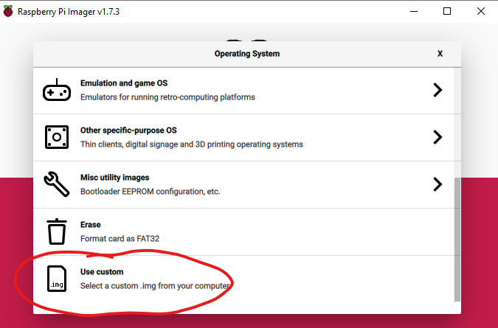

* + - Select the img file

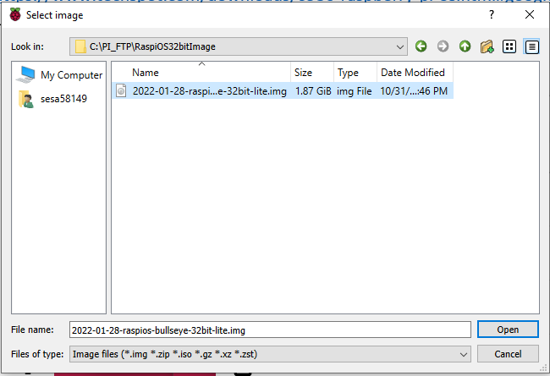

* + - Choose the memory drive (SD card inserted in the laptop)

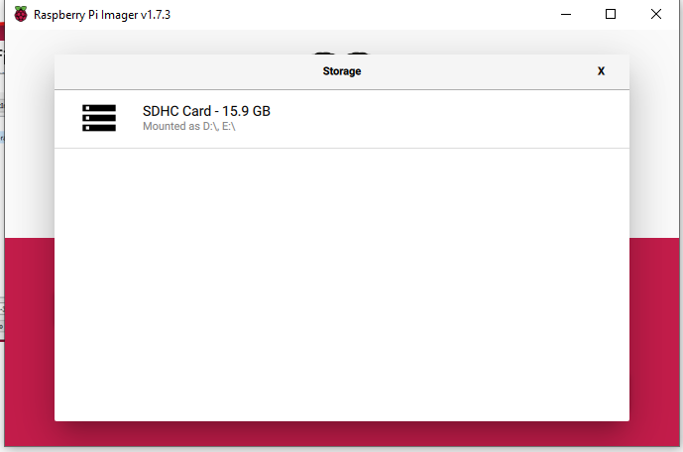

* + - Host setting ( Host name, DHCP, SFTP, SSH, USER and password) configuration
      * Click setting button

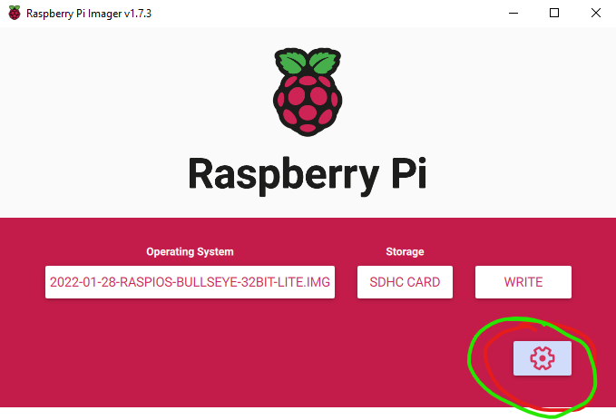

Select the option which you want to configure

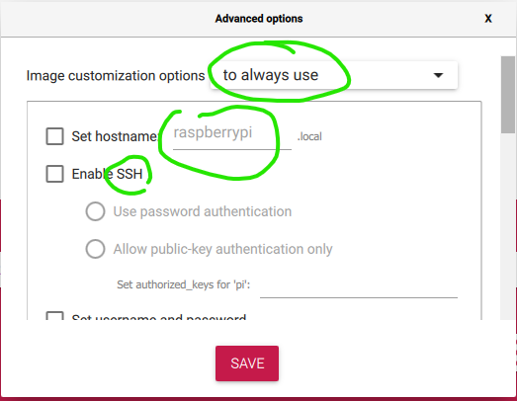

* + - Write the OS on SD card

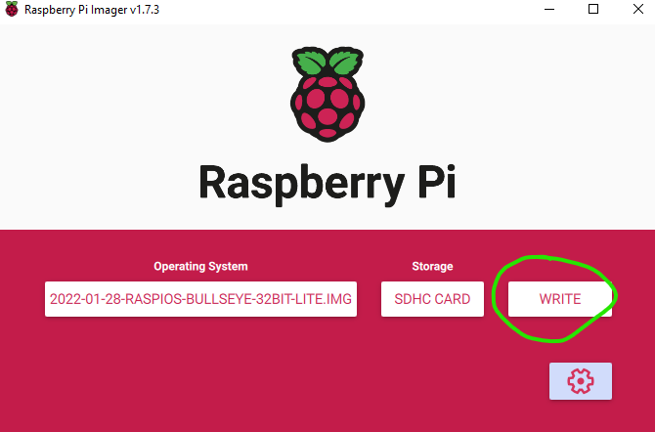

* + - Remove the SD card from Laptop and insert into the SD card slot of the Raspberry pi board.

Software Installation

1. Paho MQQT client installation
   1. Run “sudo apt-get update” to get the latest versions
   2. Check whether **Python3** is installed by executing “python3 - - version” install the python3 in case it is not installed by command “sudo apt install python3”
   3. Install **paho-mqtt** package for mqtt client by command “sudo pip3 install paho-mqtt” make sure pip3 is installed if not then use command “sudo apt-get install python3-pip” in case pip3 is not installed.
   4. Check the paho-mqtt package installed by command “ pip3 list” it will list all the pip package installed in the device.
2. Install other missing python package using pip3 command “sudo pip3 install **pack_name**”

KSHome **App installation**

1. Clone source code from git repo <https://github.com/sesa58149/SmartHomeSolution.git>
2. Enter into the folder shown in below screenshot

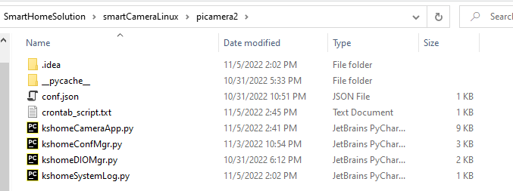

1. Connect to the raspberry pi board using sftp from your pc.
2. Create a folder under /home/”userID”/app in the raspberry module.
3. Transfer all “.py file” to the raspberry pi under app folder
4. Edit the con.json file if needed and transfer this as well to raspberry pi module’s app folder
5. To start the application at reboot edit the crontab script by command “sudo crontab -e” and copy the line of the crontab_script.txt file to the crontab script.
6. To run crontab need to log into the raspberry pi over ssh

Enabling and Disabling Raspberry OS Feature to save energy

2. USB AND ETHERNET

To shut off power for USB ports and Ethernet type the following into the

Raspberry Pi Terminal and press enter.

echo &#39;1-1&#39; | sudo tee /sys/bus/usb/drivers/usb/unbind

To turn the power back on for USB ports and Ethernet type the following into the

Raspberry Pi Terminal and press enter.

echo &#39;1-1&#39; | sudo tee /sys/bus/usb/drivers/usb/bind

3. WIFI AND BLUETOOTH

Disabling WiFi not only lower the overall power usage but also improves security

for your Raspberry Pi. There are a number of ways to do this. The easiest way is

to utilise the program | rfkill |. Type the following into the terminal and press enter

for each line. Then on reboot it will be disabled.

sudo apt install rfkill

sudo rfkill block wifi

If you want to re-enable WiFi simply type the following into the terminal.

sudo rfkill unblock wifi

Disable Bluetooth

Internal

sudo rfkill block bluetooth

If you want to re-enable Bluetooth simply type the following into the terminal.

sudo rfkill unblock Bluetooth

4. DISABLE HDMI

Whenever you are remotely accessing the Raspberry Pi using SSH or running it

headless then likely there will be no need to run anything through the onboard

HDMI ports. This means you can disable power to these ports which will give a

small improvement to battery life (~20mA). Type the following into the terminal to

disable power to the HDMI ports. As soon as you press enter it will be disabled.

sudo /opt/vc/bin/tvservice -o

If you want to re-enable HDMI connection simply type the following into the

terminal.

sudo /opt/vc/bin/tvservice -p