Assignment 6
Non Linear Dynamics

Shubham Agarkar
2014A7PS085G

Lorenz system simulation:

Parameters: sigma = 10
b = 2.6667
r = 85 (for the second set of observations it is 42.5)
X_i = 0
Y_i = 8
Z_i = 5

Iterations : 10000
Step size : 0.001

Results:

Z vs X

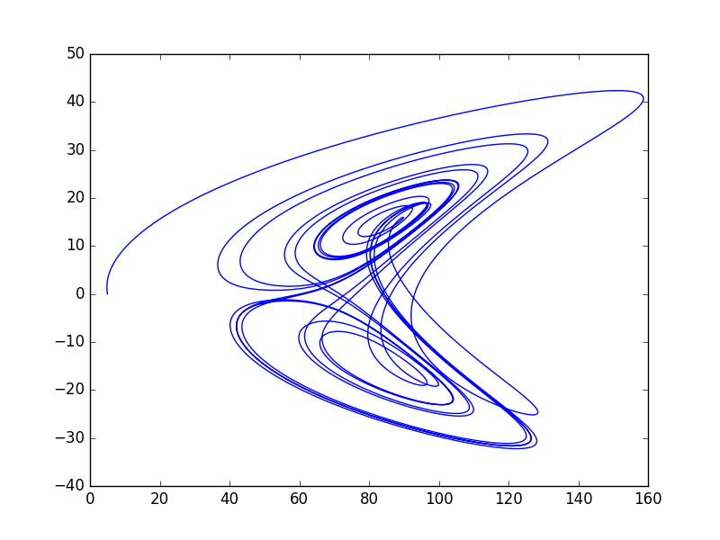

We are seeing the strange attractor appearing and so the system oscillates between the branches chaotically(Aperiodicity not conclusively determined here)

Z vs Y

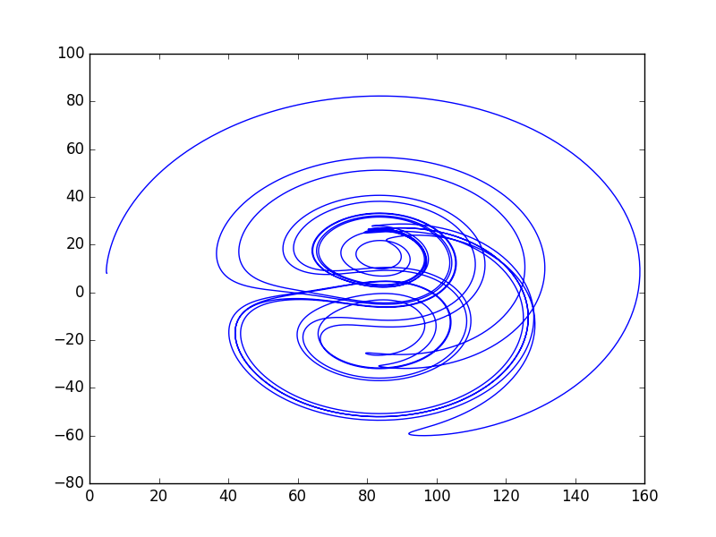
The same system is now projected on the Z-Y plane and we see the
chaotic behaviour again

Z vs t

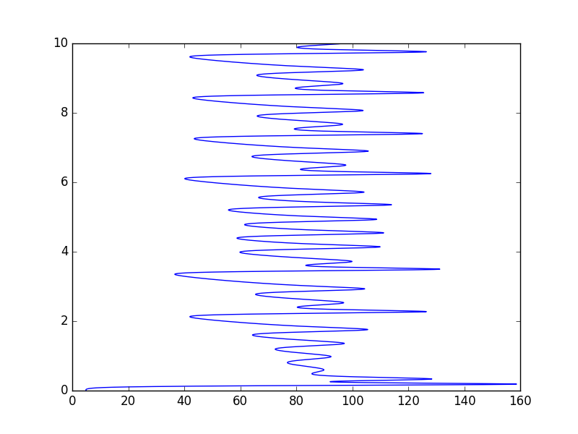

Z seems to be oscilatting between certain extreme values but the period of oscillation is not fixed

Parameter r changed to value 42.5

Z vs X

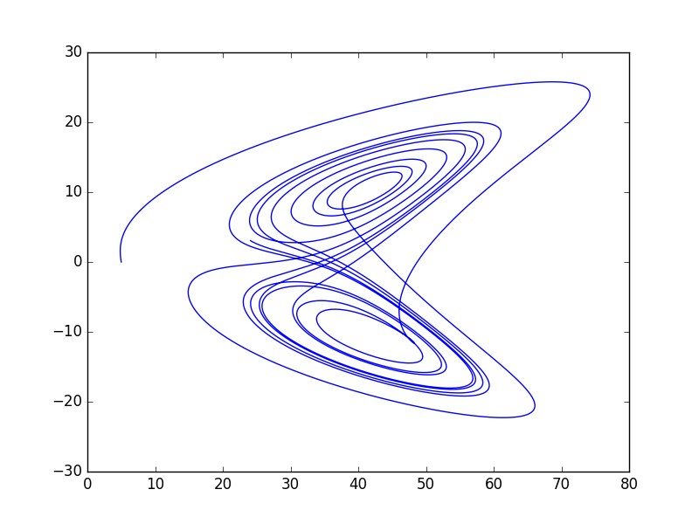

Similar dynamics to the system at r = 85

Z vs Y

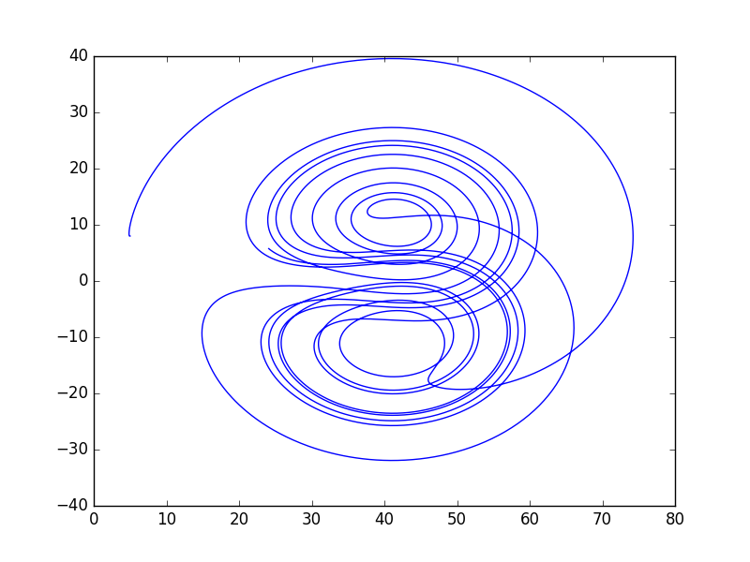

Again the plot shows chaotic oscillations between two branches of an attractor

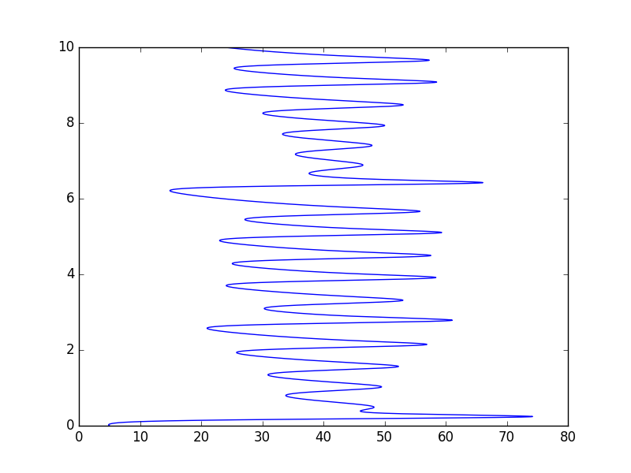
Z vs t

Z oscillates aperiodically wrt t

Python3 Code:

Extra Libraries : matplotlib

import matplotlib.pyplot as plt

n = 10000
step = 0.001
sigma = 10
# python doesn't treat 085 as 85 and throws error
# r is 85 for the first set of observations and 42.5 for the second
r = 85
b = 2.6667

X_i = 0.0
Y_i = 8.0
Z_i = 5.0

X = [0.0]*n
Y = [0.0]*n
Z = [0.0]*n
t = [0.0]*n

i=0
X[0] = X_i
Y[0] = Y_i
Z[0] = Z_i

while i < n-1:
X[i+1] = X[i] + step*sigma*(Y[i] - X[i])
Y[i+1] = Y[i] + step*(X[i]*(r-Z[i]) - Y[i])
Z[i+1] = Z[i] + step*(X[i]*Y[i]-b*Z[i])
t[i+1] = t[i] + step
# print(t[i],X[i],Y[i],Z[i])
i+=1

# Call any one of the following 3 statements at a time
plt.plot(Z,X)
plt.plot(Z,Y)
plt.plot(Z,t)
plt.show()

