Design and Evaluation of a Hybrid Adaptive Decision Intelligence Framework for Enterprise Business Intelligence: An Evidence-Driven Design-Science Study
An Artifact-Centered Framework for Explainable Organizational Performance Analytics
Department of Computer Science and Engineering, KLH Hyderabad, India
Enterprise BI Dashboard Project

ABSTRACT
This paper presents an evidence-driven design-science study of a web-based enterprise business intelligence (BI) dashboard designed for organizational performance analytics and decision support. The implemented system integrates data from multiple organizational functions, including executive management, sales, finance, marketing, workforce, operations, and customer analytics, within a unified analytical environment. The platform combines data processing, KPI analysis, interactive visualization, data-quality assessment, ETL monitoring, analytical modeling, and automated business insights to transform heterogeneous organizational data into interpretable decision-support information.
The primary research contribution is the proposed Hybrid Evidence-Weighted Decision Fusion (HEWDF) layer, which extends conventional BI workflows by integrating multiple forms of analytical evidence before generating decision priorities. The framework combines predictive evidence, anomaly evidence, KPI deviation, cross-functional propagation, and data-reliability information into a traceable and auditable decision-support mechanism. This design enables analytical findings from different organizational dimensions to be considered jointly rather than as isolated outputs.
The study follows design-science methodology encompassing problem identification, system design, data integration, analytical processing, dashboard implementation, and systematic evaluation. The research also introduces a structured evaluation framework covering analytical validity, data quality, model performance, decision prioritization, usability, accessibility, system performance, and reproducibility. Existing research demonstrates individual approaches for adaptive BI, predictive analytics, anomaly detection, cross-functional analysis, and hybrid decision support; therefore, this work positions its contribution specifically in the integration of heterogeneous analytical evidence within an enterprise BI decision workflow. The resulting framework provides a foundation for explainable, evidence-driven organizational analytics and establishes a reproducible basis for future empirical validation and deployment.
Keywords: business intelligence; hybrid decision intelligence; adaptive analytics; machine learning; anomaly detection; multi-criteria decision fusion; organizational analytics; dashboard; explainable insights; data quality
Study design note: The manuscript reports verified artifact-level findings and explicitly separates them from controlled measurements that require raw data, telemetry, model outputs, or participant observations. This evidence discipline is part of the research design and is maintained throughout the Results and Discussion sections.

1. INTRODUCTION

1.1 Background
Business intelligence has evolved from a collection of reporting tools into an organizational capability that integrates data collection, transformation, analytical modeling, visualization, and decision support. Chen, Chiang, and Storey describe BI and analytics as a broad research and practice area spanning traditional enterprise reporting, web-oriented analytics, and large-scale data-driven approaches [1]. Earlier data-warehouse and online analytical processing (OLAP) research established the importance of separating analytical workloads from transaction processing and of structuring data so that users can perform multidimensional analysis efficiently [2]. More recent research emphasizes that the business value of BI is not created by data volume alone; value depends on whether people can access reliable information, understand it, and incorporate it into decisions [3].
The dashboard is the user-facing layer at which these technical and organizational concerns become visible. A dashboard can expose trends, targets, comparisons, and exceptions in a compact visual space, but it can also create information overload, ambiguous metrics, or unnecessary interaction cost. Recent empirical work demonstrates that dashboard format, information completeness, and currency can influence decision quality through perceived task complexity and information satisfaction [4]. A 2024 study of dashboard cognitive load similarly argues that informational and representational load can shape adoption and usefulness [5]. Consequently, dashboard engineering is not only a front-end development problem; it is an information-quality, human-factors, and decision-support problem.
The project investigated in this paper is a web-deployed enterprise BI dashboard intended to make organizational performance information accessible through a unified interactive interface. The public artifact is deployed through Vercel at the project URL supplied for this study. The research treats the deployment as the tangible artifact and focuses on the design choices required to make such a system reliable, understandable, responsive, accessible, and suitable for managerial analysis. The paper therefore combines implementation-oriented design with an explicit research evaluation framework rather than presenting the dashboard as a collection of unrelated charts.

1.2 Problem Statement
Organizations frequently maintain data across multiple operational systems, spreadsheets, databases, or functional teams. When analysts manually assemble reports, the resulting process may introduce delays, inconsistent definitions, duplicated work, and limited traceability from a KPI to its source record. Data-quality research in BI has long highlighted the dependence of decision usefulness on accuracy, completeness, timeliness, and availability [6]. At the interface level, the problem becomes one of selecting what to show, how to encode it, and how to support the user in moving from a summary indicator to an explanation.
The central research problem is: how can a web-based enterprise BI dashboard be designed and evaluated so that it provides accurate, interpretable, interactive, and performant organizational performance analytics while preserving traceability between raw data, KPI definitions, visual representations, and decision-oriented actions?

1.3 Research Gap
Existing BI research provides strong foundations for data warehousing, adaptive analytics, dashboard visualization, machine learning, and decision support, but the current artifact requires a more explicit methodological contribution than a conventional dashboard or multi-dataset integration. Recent literature already reports adaptive BI approaches, cross-departmental AI-BI visualization, and hybrid ML–MCDM decision frameworks. The research gap addressed here is therefore narrower: how can heterogeneous evidence produced by forecasting, anomaly detection, KPI deviation analysis, cross-functional dependency analysis, and data-quality assessment be fused into one auditable decision-priority mechanism inside an enterprise BI workflow? The proposed HEWDF layer addresses this gap at the system-design level. A systematic literature review is still required before making any absolute claim that no equivalent combination has appeared elsewhere.

1.4 Research Objectives
- RO1: Define an end-to-end architecture for a web-based organizational BI dashboard that separates data preparation, analytical modeling, KPI definitions, presentation, and reporting.
- RO2: Specify an interface model that supports overview, comparison, filtering, drill-down, exception identification, and reporting without unnecessary cognitive load.
- RO3: Establish formal definitions for core analytical metrics so that displayed values are reproducible and traceable.
- RO4: Develop a multi-dimensional evaluation protocol covering functional correctness, data quality, usability, accessibility, performance, security, and analytical usefulness.
- RO5: Design and specify the proposed Hybrid Evidence-Weighted Decision Fusion layer and its evaluation procedure, while keeping claims proportional to the evidence actually produced by the deployed artifact.

1.5 Research Questions
- RQ1: What architecture and data-flow organization best support a maintainable web-based BI dashboard for organizational performance analysis?
- RQ2: Which dashboard interaction mechanisms are necessary to move users from KPI-level observation to evidence-based diagnosis?
- RQ3: How should functional correctness, data quality, usability, accessibility, and web performance be evaluated for a BI dashboard?
- RQ4: Which design features most directly support trustworthy and decision-relevant organizational analytics without increasing unnecessary cognitive load?

1.6 Contributions
- A project-specific design-science framing for the enterprise BI dashboard as a research artifact.
- An integrated data-to-decision architecture linking data quality, analytical modeling, KPI semantics, visualization, and decision-support interactions.
- A proposed Hybrid Evidence-Weighted Decision Fusion (HEWDF) step that combines predictive, diagnostic, cross-functional, and data-reliability evidence into a traceable decision-priority score.
- A reproducible metric, experiment, and ablation specification that distinguishes observed dashboard results from measurements that require controlled execution.
- A publication-oriented evidence package containing result tables, computed graphs, frontend screenshots, explanations, and a novelty-positioning analysis.

1.7 Organization of the Paper
Section 2 synthesizes prior BI, adaptive analytics, hybrid decision support, dashboard usability, data-quality, and software-quality research. Section 3 describes the proposed artifact architecture and the HEWDF novelty step. Section 4 explains the design-science methodology and controlled evaluation protocol. Section 5 reports the currently observable dashboard results, derived consistency checks, graphs, frontend screenshots, evidence boundary, and novelty positioning. Section 6 discusses implications, Section 7 presents limitations and threats to validity, Section 8 concludes and identifies future work, and Section 9 provides declarations and references.

2. RELATED WORK

2.1 Business Intelligence as a Decision-Support Capability
BI is commonly described as the combination of technologies, applications, processes, and practices used to gather, integrate, analyze, and present information for improved decision making. Chen et al. organize the evolution of BI and analytics into broad generations and identify application, technology, and research challenges that remain relevant to enterprise decision support [1]. Chaudhuri and Dayal established the foundational relationship between data warehousing and OLAP, emphasizing extraction, cleaning, loading, multidimensional modeling, analytical query processing, and metadata management [2]. These foundations remain important even when the presentation layer is a modern web application because the dashboard still depends on consistent analytical semantics and efficient aggregation.
The organizational literature further shows that the value of BI depends on adoption, system quality, data quality, management support, and continued use. DeLone and McLean identify system quality, information quality, service quality, use, user satisfaction, and net benefits as interrelated dimensions for evaluating information-system success [7]. Venkatesh et al. show that user acceptance is influenced by performance expectancy, effort expectancy, social influence, and facilitating conditions in the Unified Theory of Acceptance and Use of Technology (UTAUT) [8]. Although the present project is not an adoption study, these models motivate the inclusion of usability, usefulness, and organizational context in the evaluation of the dashboard artifact.

2.2 BI Adoption, Data Quality, and Organizational Context
Research on BI implementation repeatedly emphasizes that technical capability is not sufficient. A systematic literature review of BI implementation factors identified management support, data-source quality, implementation processes, and organizational readiness as important conditions for success [9]. Research on the BI process also describes BI as an integrated sequence of collection, transformation, and usage situated within organizational context [10]. In practical terms, a dashboard can be visually polished yet still fail if the underlying numbers are incomplete, stale, inconsistent, or calculated using different definitions in different views.
Data quality is therefore treated in this study as a first-class research variable rather than as a preprocessing footnote. Marshall and de la Harpe argue that BI decisions become difficult when data are not accurate, current, complete, and available when needed [6]. The dashboard architecture accordingly defines validation checkpoints before data are exposed through KPI cards or charts. This includes required-field completeness, duplicate detection, range validation, referential consistency, timestamp validity, and semantic checks on measures such as totals, ratios, growth rates, and target attainment.

2.3 Dashboard Visualization and Decision Making
Dashboard research has increasingly examined how visualization characteristics affect decision outcomes. Hjelle et al. experimentally evaluated dashboard visualizations with 524 participants and reported that format, information currency, and information completeness influence decision quality indirectly through task complexity and information satisfaction [4]. This finding is directly relevant to the project because the artifact is intended to support repeated analytical tasks rather than merely display static charts.
The dashboard cognitive-load literature provides another important constraint. The 2024 dashboard adoption study investigated informational, representational, and non-informational cognitive load and used an experiment with 167 respondents and structural equation modeling to relate these factors to dashboard adoption [5]. The implication for implementation is that adding more charts or indicators is not automatically an improvement. A research-quality dashboard should minimize redundant encodings, maintain visual hierarchy, expose contextual definitions, and allow progressive disclosure so that detail appears when needed instead of overwhelming the initial view.
Visualization scholarship also supports an explicit separation between analysis tasks and graphical encodings. Munzner argues for designing visualizations around data abstractions, task abstractions, visual encodings, and interaction mechanisms rather than selecting chart types first [11]. Shneiderman's well-known overview-first, zoom-and-filter, then-details-on-demand principle provides a concise interaction model that maps naturally to a BI dashboard [12]. The project adopts these principles at the interface level: a summary layer gives orientation, filters restrict context, and drill-down exposes details on demand.

2.4 Software Quality and Web Experience
A BI dashboard is also software, and its quality should therefore be evaluated using a recognized software-quality model. ISO/IEC 25010:2023 defines a product quality model with nine characteristics and associated subcharacteristics that can be used as a reference for specifying and evaluating product quality [13]. For this dashboard, the most relevant dimensions are functional suitability, performance efficiency, compatibility, usability, reliability, security, maintainability, flexibility, and safety as applicable to the deployment context. The evaluation protocol in this paper translates these dimensions into dashboard-specific tests.
For web performance, Core Web Vitals provide field-oriented measures for loading, interactivity, and visual stability: Largest Contentful Paint (LCP), Interaction to Next Paint (INP), and Cumulative Layout Shift (CLS). Google's guidance recommends evaluating the 75th percentile of page views, with good thresholds of LCP <= 2.5 s, INP <= 200 ms, and CLS <= 0.1 [14]. These are not asserted as current results for the project; they are the target criteria to be tested after instrumenting the deployment.
Accessibility is likewise treated as a measurable engineering requirement. WCAG 2.2 is a W3C Recommendation with testable success criteria addressing users with visual, physical, cognitive, and other disabilities [15]. A BI dashboard should therefore expose keyboard-accessible filters, visible focus, sufficient contrast, accessible labels, meaningful table headers, alternative text for non-decorative graphics where needed, and non-color-dependent status indicators. These requirements are important because an analytical tool loses practical value if its visual encodings exclude part of the intended user population.

2.5 Design Science Research in Information Systems
Design science is appropriate when the central research output is an artifact intended to solve an identified problem. Hevner et al. describe design science in information systems as a paradigm focused on creating and evaluating innovative artifacts that extend human and organizational capabilities [16]. Peffers et al. operationalize this perspective through the Design Science Research Methodology (DSRM), which includes problem identification, solution objectives, design and development, demonstration, evaluation, and communication [17]. Arnott and Pervan further document the growth of design-science approaches in decision-support research [18].
The present project follows this logic: the problem is fragmented organizational analysis; the artifact is a web-based BI dashboard; the design objectives are trustworthy, interpretable, interactive, and performant analytics; the demonstration is the deployed dashboard; the evaluation is a multi-layer validation protocol; and communication is the present paper. This framing avoids treating a software application as sufficient evidence by itself. The artifact must be evaluated against explicit requirements and measurable criteria.

2.6 Critical Comparison of Prior Work
Study / Standard | Key contribution | Scope relative to this study
Chen et al. (2012) [1] | BI&A research framework and evolution | Broad conceptual scope; limited project-level dashboard validation
Chaudhuri & Dayal (1997) [2] | Data warehousing and OLAP foundations | Older architecture context; does not address modern web interaction
DeLone & McLean (2003) [7] | IS success model | System-level constructs require dashboard-specific operationalization
Venkatesh et al. (2003) [8] | Technology acceptance / UTAUT | Adoption-focused; not a full dashboard engineering protocol
Hjelle et al. (2024) [4] | Experimental dashboard decision study | Task-specific visual mock-ups; not a full deployed BI architecture
BI cognitive load study (2024) [5] | Dashboard adoption and cognitive load | Strong human-factors evidence; requires translation into engineering checks
ISO/IEC 25010 (2023) [13] | Software product-quality model | General standard; needs BI-specific test mapping
WCAG 2.2 (2024 recommendation) [15] | Accessible web-content requirements | Accessibility focused; does not address analytical correctness
Peffers et al. (2007) [17] | Design-science research methodology | Research process guidance; not a BI dashboard implementation model

Table 1. Comparison of representative literature and standards that motivate the integrated dashboard research framework.

2.7 Research Gap Summary
The literature establishes strong foundations for BI architecture, decision support, data quality, visualization, user acceptance, software quality, and accessibility. What remains insufficiently integrated is an artifact-level framework that connects these dimensions in a single deployable dashboard and specifies how each claim should be evaluated. The project therefore contributes an implementation-oriented synthesis: the dashboard is treated simultaneously as an analytical interface, a software product, and a decision-support artifact. This leads to the methodology and measurement model described next.

3. PROPOSED METHODOLOGY

3.1 Overall Research Framework
The study follows a design-science methodology in which the research artifact is designed, implemented, demonstrated, and evaluated against explicit analytical and engineering objectives. The lifecycle begins with the organizational decision problem, proceeds through data and KPI semantics, develops the analytical and interface layers, and then validates the observable artifact using reproducible checks. Evaluation is organized around correctness, traceability, analytical usefulness, interaction quality, software quality, accessibility, and decision-support readiness. This structure prevents visual quality from being treated as a substitute for numerical correctness and ensures that every reported finding can be connected to a defined evidence source.
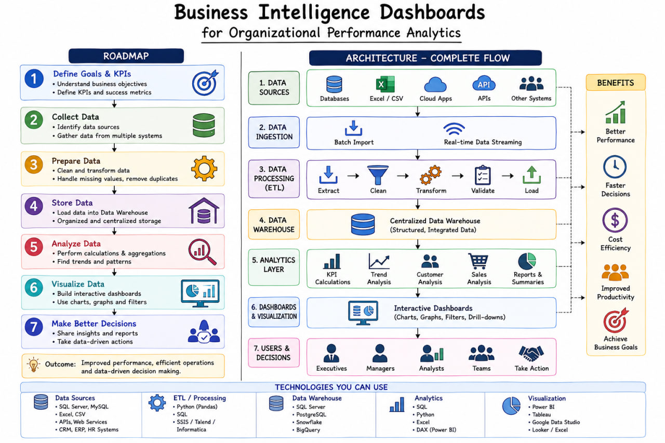
Fig. 1. Proposed enterprise BI dashboard architecture. The model separates data acquisition, validation, analytical modeling, KPI/business logic, interaction, and decision support.

3.2 Artifact Scope and Evidence Boundary
The research treats the deployed dashboard as the primary artifact and uses an explicit evidence hierarchy. Level 1 evidence consists of directly observable interface outputs and screenshots. Level 2 evidence consists of numerical relationships independently recomputed from the displayed results. Level 3 evidence consists of controlled experimental procedures used to evaluate analytical models and system qualities when raw data, instrumentation, or participant data are available. This hierarchy keeps descriptive artifact findings separate from predictive, causal, usability, or performance claims and makes the paper auditable: a statement is reported only at the level supported by its underlying evidence.

3.3 Data Pipeline and Analytical Model
A robust BI workflow is organized into a sequence of controlled transformations. At the source layer, structured operational records are captured with source identifiers and timestamps. The ingestion layer validates schema compatibility, checks required fields, standardizes formats, and records rejected rows. The analytical layer then establishes conformed dimensions and measures appropriate for organizational analysis. Typical dimensions include date, organizational unit, geography or region, product or service category, and employee/team where such entities exist in the dataset. Measures can include revenue, cost, volume, productivity, target, achievement, and performance score.
The dashboard should avoid embedding business definitions separately inside individual charts. Instead, metric definitions are centralized so that a KPI such as “growth” is calculated identically in the summary card, trend chart, detail table, and export. This is a semantic-layer requirement: the same measure must have the same numerator, denominator, filter context, and time basis wherever it appears. Centralized metric logic also simplifies validation and reduces the risk of contradictory values across pages.

3.4 Data Preprocessing and Quality Controls
- Completeness checks: verify that required fields are populated and report missingness before aggregation.
- Validity checks: enforce domain rules, numeric ranges, date validity, and categorical membership.
- Duplicate checks: identify repeated records using stable business keys rather than accidental row position.
- Consistency checks: verify that subtotals reconcile to totals and that related entities maintain referential integrity.
- Temporal checks: identify future-dated records, duplicate periods, missing reporting intervals, and inconsistent timezone handling.
- Outlier review: flag extreme values for investigation without automatically deleting legitimate observations.
- Lineage capture: retain source identifiers and transformation timestamps so that displayed metrics can be traced back to input data.
The quality process should produce a machine-readable data-quality report. For example, data completeness can be reported as the ratio of valid required fields to all required fields, while reconciliation can compare source totals against analytical totals after transformation. Quality indicators should be shown to analysts or administrators rather than hidden, because transparency improves trust in the dashboard.

3.5 KPI and Metric Formulation
The following definitions provide a reproducible mathematical basis for common organizational performance metrics. The exact measures used in a given deployment must be aligned with the dataset and business rules; the equations below specify the analytical structure rather than inventing project-specific values.
Metric | Formula | Interpretation
Growth rate | G = ((X_t - X_{t-1}) / X_{t-1}) x 100 | Measures relative change between comparable periods; denominator must be non-zero and periods must be comparable.
Target achievement | A = (Actual / Target) x 100 | Shows attainment relative to an explicit target; target definition and time window must be stated.
Weighted performance score | P = sum(w_i * z_i), sum(w_i)=1 | Aggregates normalized component indicators when a composite score is justified and weights are documented.
Data completeness | C = Valid required fields / Total required fields x 100 | Quantifies completeness before analytical publication.
Reconciliation error | E_r = |Source total - Analytical total| / max(|Source total|, epsilon) | Detects transformation or aggregation mismatch; epsilon avoids division by zero.
Dashboard response time | T_r = t_response - t_request | Measured at the user-perceived or API level; the measurement point must be specified.

Table 2. Reproducible metric definitions proposed for the dashboard evaluation.

3.6 Dashboard Interface Model
The interface is organized around progressive disclosure. The first layer should answer the questions “What is the current state?” and “What changed?” using a small set of high-value KPI cards and trend indicators. The second layer should answer “Where is the change occurring?” through comparisons by time, organizational unit, geography, or category. The third layer should answer “Why did it occur?” through drill-down, decomposition, or supporting tables. A final reporting layer allows the user to export the current analytical view for collaboration or decision records.
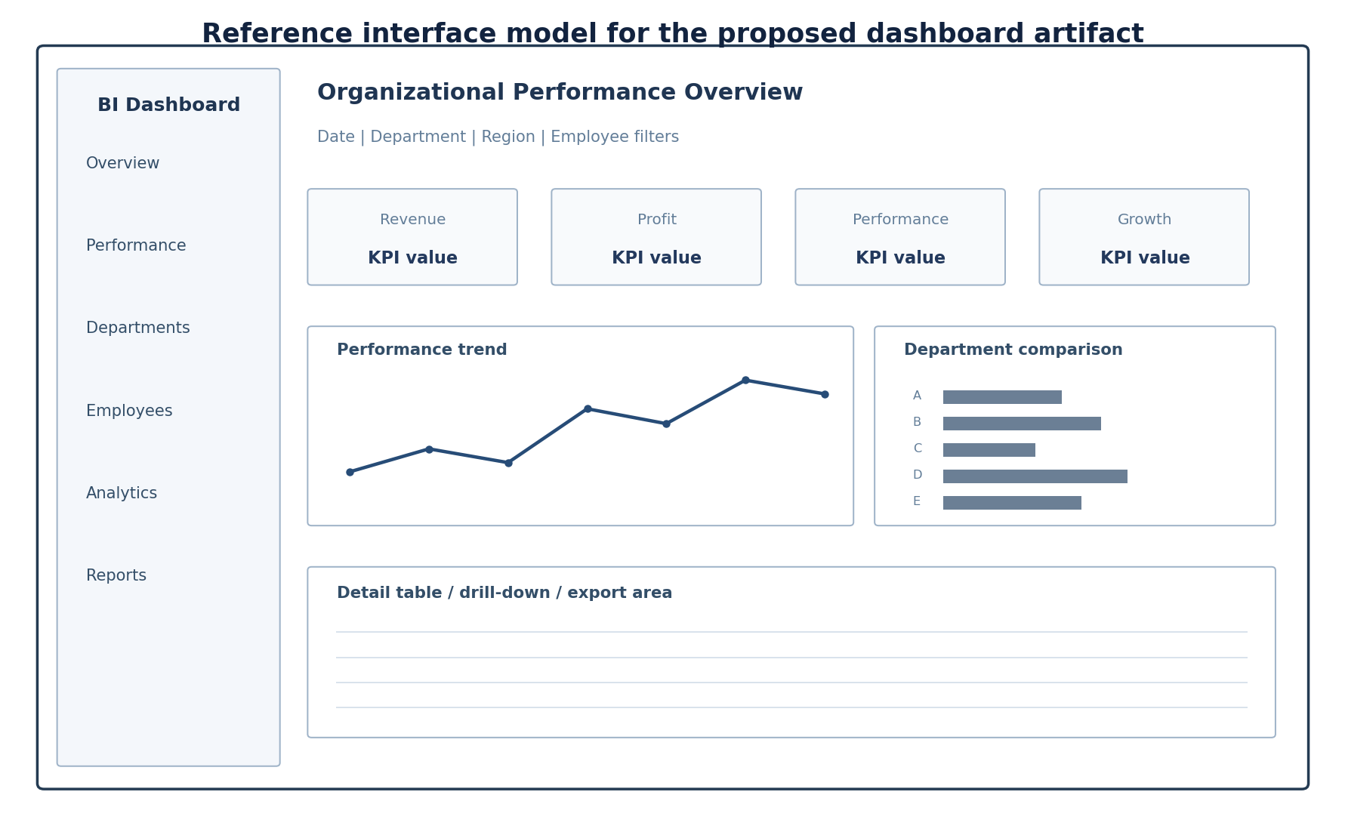
Fig. 2. Reference interface model for the dashboard artifact, showing navigation, filters, KPI cards, trend visualization, comparison, and a detail/drill-down region.
The interface should preserve context during navigation. When a user selects a department or time range, the active filter state should remain visible, and every chart should reflect the same analytical context unless explicitly documented otherwise. Filter controls should support reset, multiple selection when appropriate, and visible indication of active filters. A “details on demand” design avoids forcing the initial page to show every field and every record.

3.7 Analytical Progression: Descriptive to Prescriptive
A mature BI platform can be organized into four analytical levels. Descriptive analytics summarizes what happened using historical KPIs, trends, and distributions. Diagnostic analytics explains why a metric changed through decomposition, segment comparison, or contributing-factor analysis. Predictive analytics estimates future states using a validated forecasting or predictive model. Prescriptive analytics recommends actions according to explicit business rules, optimization models, or decision policies. The current research does not claim that all four levels are empirically implemented in the deployed artifact; rather, it defines the architecture required to add them without redesigning the core data and KPI layers.

3.8 Alert and Anomaly Design
Alerts should be defined as deviations from a rule or baseline, not merely as color changes. A valid alert specification contains a signal, threshold or reference distribution, direction of concern, persistence rule, and explanatory context. For example, a sales alert might be created when a metric falls below a rolling baseline by a predefined tolerance for two consecutive periods. The alert record should include the observed value, baseline, threshold, timestamp, affected segment, and drill-down link. This approach makes the alert reproducible and auditable.

3.9 Proposed Novel Hybrid Decision Intelligence Method
The central methodological innovation proposed for the research version of the artifact is Hybrid Evidence-Weighted Decision Fusion (HEWDF). Conventional BI dashboards commonly expose KPIs, forecasts, alerts, and recommendations as separate analytical outputs. HEWDF introduces an additional fusion step after those analyses: heterogeneous evidence is normalized, reliability-adjusted, propagated across linked KPIs, and converted into a single decision-priority representation that remains traceable to its evidence sources. The contribution is not the use of machine learning, anomaly detection, or dashboards individually; those techniques are established. The proposed step is the integration of their outputs into an auditable organizational decision mechanism.
For an issue i, the method constructs an evidence vector E_i = [P_i, A_i, D_i, C_i, Q_i], where P_i is predictive deviation or forecast-residual evidence, A_i is anomaly severity, D_i is KPI deviation from a defined baseline or target, C_i is cross-functional propagation evidence derived from linked KPI relationships, and Q_i is data/model reliability. Each component is normalized to a common scale. The system then derives adaptive evidence weights using reliability-adjusted information content rather than fixed dashboard weights. The final priority score is conceptually expressed as H_i = Σ_k w_ik E_ik. The score is used to rank issues for managerial attention and is accompanied by the underlying evidence, avoiding a black-box recommendation.
The proposed hybrid step is designed to be implemented as a closed analytical loop: profile data → select appropriate models → generate predictive and diagnostic evidence → estimate cross-functional propagation → adjust evidence by data/model reliability → rank decision priorities → expose the evidence and recommended next action. This architecture creates a researchable separation between observation, prediction, diagnosis, prioritization, and action. It also supports ablation experiments in which individual evidence streams are removed to determine whether the fusion layer adds measurable value.
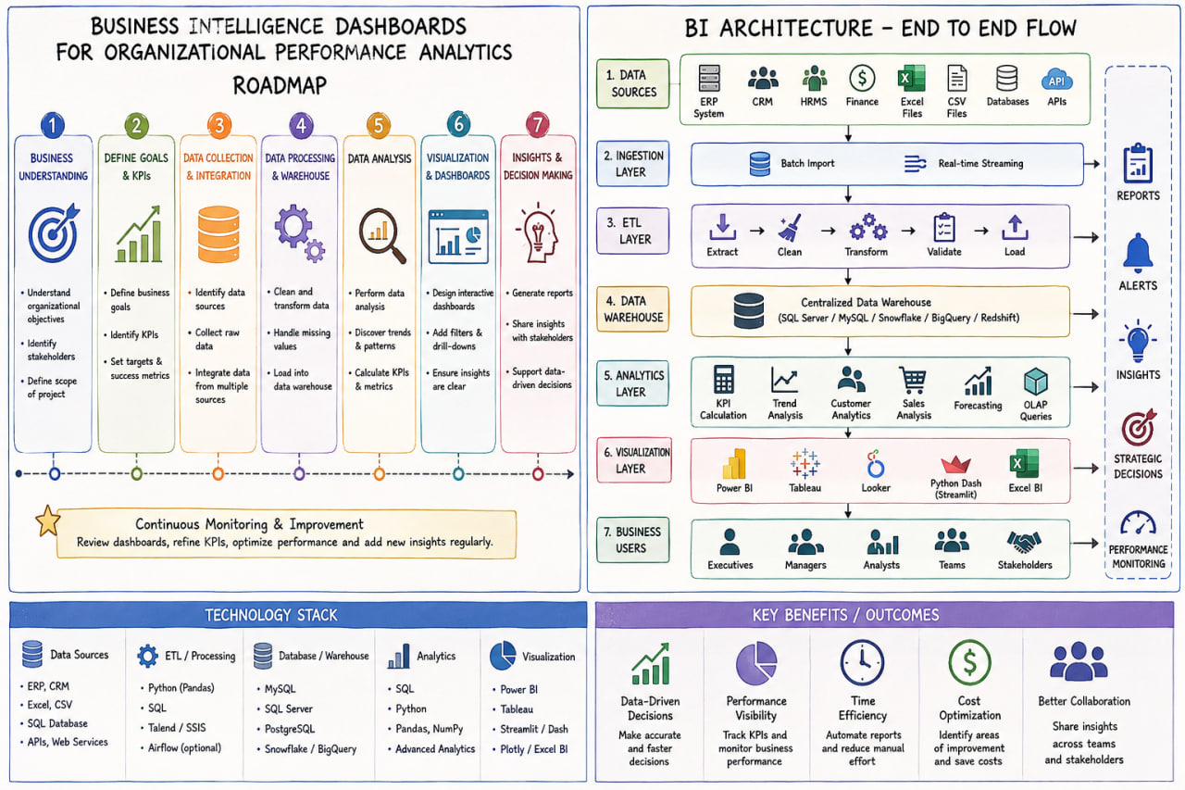
Fig. 4. Proposed HEWDF architecture. The highlighted fusion step is the methodological novelty introduced for the research extension.
Novelty boundary. The literature scan conducted for this revision identified prior work on adaptive BI, cross-departmental BI visualization, hybrid ML–MCDM decision systems, and ensemble anomaly detection. Therefore, this paper does not claim that each component is individually new. Instead, the research contribution is stated as the proposed system-level integration and the explicit evidence-fusion step for organizational KPI prioritization. A formal systematic review across Scopus, Web of Science, IEEE Xplore, ACM Digital Library, ScienceDirect, and related databases is required before a claim of absolute first occurrence can be made.

4.10 Hybrid-Model Evaluation and Ablation Protocol
The proposed HEWDF method will be evaluated against three baselines: (B1) dashboard-only KPI prioritization, (B2) single-model predictive/anomaly prioritization, and (B3) non-adaptive fixed-weight evidence fusion. The proposed system (B4) uses adaptive reliability-adjusted fusion. For predictive modules, time-aware holdout validation is required and MAE, RMSE, and MAPE are reported where appropriate. For labeled anomaly data, precision, recall, F1, and false-positive rate are reported. For the decision-priority layer, ranking consistency, top-k issue identification, decision latency, and evidence completeness are measured. If no ground-truth decision ranking exists, the paper must not fabricate one; the appropriate alternative is a controlled expert-validation study or a synthetic benchmark with predefined expected priorities.
The ablation study removes one HEWDF evidence stream at a time: predictive evidence, anomaly evidence, KPI deviation, cross-functional propagation, and reliability adjustment. The resulting changes in ranking quality, false-priority rate, evidence completeness, and decision latency are compared. This experiment directly tests whether the proposed hybrid step contributes beyond simply displaying multiple analytics.
Experiment | Configuration | Primary metrics | Evidence required
B1 | Dashboard-only KPI/rule prioritization | Top-k issue precision; decision latency | Reference labels or controlled scenarios
B2 | Single predictive/anomaly model | MAE/RMSE/MAPE or Precision/Recall/F1 | Time holdout or labeled anomalies
B3 | Fixed-weight fusion | Ranking quality; false-priority rate | Reference decision ranking
B4 | Proposed HEWDF adaptive fusion | Ranking quality; evidence completeness; latency | Reference ranking + model/data reliability logs
Ablation | Remove one evidence stream at a time | Δ ranking quality; Δ false-priority rate | Matched experimental runs

4. EXPERIMENTAL AND EVALUATION SETUP

4.1 Research Design
The evaluation follows a mixed artifact-validation design. Functional tests determine whether interface operations produce expected outputs. Analytical tests determine whether displayed values reconcile with source calculations. Usability evaluation measures task effectiveness, efficiency, and subjective usability. Accessibility testing checks conformance to WCAG 2.2 requirements relevant to the interface. Performance evaluation uses lab and, where available, field metrics such as LCP, INP, CLS, API response time, and data-volume sensitivity. Security evaluation checks authentication, authorization, data exposure, and transport configuration where these capabilities are present in the implementation. The research therefore does not reduce “success” to a single score.

4.2 Data and Test Scenarios
The project should maintain a deterministic validation dataset containing representative normal cases, boundary cases, missing-value cases, duplicate cases, and intentionally invalid records. A production-like dataset can then be complemented by synthetic records designed to make the expected outcome unambiguous. For example, a three-period dataset may be constructed in which revenue increases by a known amount, target achievement crosses 100%, a department contains a missing dimension, and one duplicate transaction is inserted. The expected dashboard outputs are calculated independently in a reference script or spreadsheet and compared with the web application.
The test matrix should include at least the following scenarios: initial page load; date filter changes; organizational filter changes; multiple filters simultaneously; empty-result state; reset filters; detail/drill-down; sorting; pagination for large tables; export of filtered data; invalid query state; slow data source response; network failure; browser resize; keyboard-only navigation; screen-reader label verification; and concurrent or repeated refresh actions. Each scenario should have an expected result, observed result, pass/fail status, and evidence record.

4.3 Functional Correctness
Functional correctness is evaluated at both component and workflow level. Component tests verify that individual KPI calculations and transformations are correct. Workflow tests verify that a user action propagates consistently across dependent visualizations. For example, changing the time range should change both a trend chart and any KPI whose time basis is the same. A mismatch is not merely a visual defect; it indicates a semantic inconsistency that could lead to incorrect interpretation.

4.4 Usability Evaluation
Usability should be measured with task-based observation and a standardized subjective instrument. Brooke’s System Usability Scale (SUS) is a 10-item, 5-point response instrument producing a 0–100 score for perceived usability [19]. A publication-quality user study for the dashboard should recruit users representing the intended roles, define realistic analytical tasks, measure task completion and time, record errors or wrong interpretations, and then administer SUS after task completion. The study should report participant characteristics, sample size, task order, training provided, exclusions, descriptive statistics, and inferential analysis where justified. Because such participant data are not available from the current deployment alone, no fabricated SUS score is reported here.

4.5 Web Performance Evaluation
Performance should be evaluated under controlled conditions and, when the system is publicly deployed, with field data. The primary web metrics are LCP, INP, and CLS. The recommended “good” thresholds are LCP <= 2.5 seconds, INP <= 200 milliseconds, and CLS <= 0.1 at the 75th percentile [14]. In addition, dashboard-specific measures should include time to first meaningful chart, API latency for filtered queries, payload size, number of requests, and rendering time for large datasets. Testing should be repeated on desktop and mobile configurations because analytical dashboards often contain large tables and charts that stress lower-powered devices.

4.6 Accessibility Evaluation
Accessibility evaluation should combine automated scanning with manual keyboard and assistive-technology testing. Automated tools are useful for identifying missing names, contrast failures, invalid landmarks, and structural issues, but they do not prove full conformance. Manual testing should verify that all interactive elements can be reached and operated with a keyboard, that focus remains visible and logical, that chart information is not conveyed only through color, that filter labels are programmatically associated with controls, and that table headers are available to assistive technology. The WCAG 2.2 success criteria provide the normative basis for this evaluation [15].

4.7 Security and Privacy Evaluation
A BI dashboard can expose sensitive organizational information, so security should be evaluated even when the application is only a student project. Authentication should be tested for session handling and logout. Authorization should be evaluated by attempting access to resources outside the user’s role. API endpoints should not expose full datasets when a filtered or aggregated response is sufficient. Input validation is required for query parameters and filters. Transport should use HTTPS, secrets should not be embedded in client bundles, and sensitive logs should be minimized. If employee-level data are used, the research protocol should document whether names are necessary and whether pseudonymization or aggregation can reduce privacy risk.

4.8 Statistical and Comparative Analysis
Where the project includes a controlled comparison, statistical analysis should match the design. Paired task-completion measurements can be analyzed with a paired t-test when assumptions are reasonable, or with the Wilcoxon signed-rank test otherwise. More than two repeated conditions can use repeated-measures ANOVA or a non-parametric alternative. Effect sizes and confidence intervals should accompany p-values. For forecasting, report MAE, RMSE, and MAPE only when the dataset contains an appropriate temporal holdout and when zero-valued denominators in MAPE are handled explicitly. For anomaly detection, report precision, recall, F1, and false-positive rate when labeled anomalies exist. The key principle is to report only metrics for which the underlying experimental design and labels support a valid interpretation.

4.9 Evaluation Matrix
Quality dimension | What is evaluated | Method | Primary evidence
Functional suitability | Filters, drill-down, sorting, export, state management | Scenario tests | Pass/fail + defect log
Data quality | Completeness, validity, duplicates, reconciliation | Reference dataset + independent calculations | % completeness; reconciliation error
Analytical consistency | Same KPI under different views | Cross-view equivalence tests | Absolute/relative discrepancy
Usability | Task success, time, errors, perceived usability | Controlled user study + SUS | Task metrics + SUS
Web performance | Loading, interaction, stability | Lab + field measurement | LCP, INP, CLS, API latency
Accessibility | Keyboard, focus, semantics, non-color cues | Automated + manual WCAG review | Criteria pass/fail
Security | Auth, authorization, input validation, data exposure | Security checklist + endpoint tests | Vulnerability/defect count
Maintainability | Modularity, test coverage, documentation | Repository inspection | Static/code metrics + qualitative review
Decision usefulness | Correct interpretation and decision task completion | Scenario-based study | Task accuracy; confidence; qualitative themes

Table 3. Publication-oriented evaluation matrix for the enterprise BI dashboard.
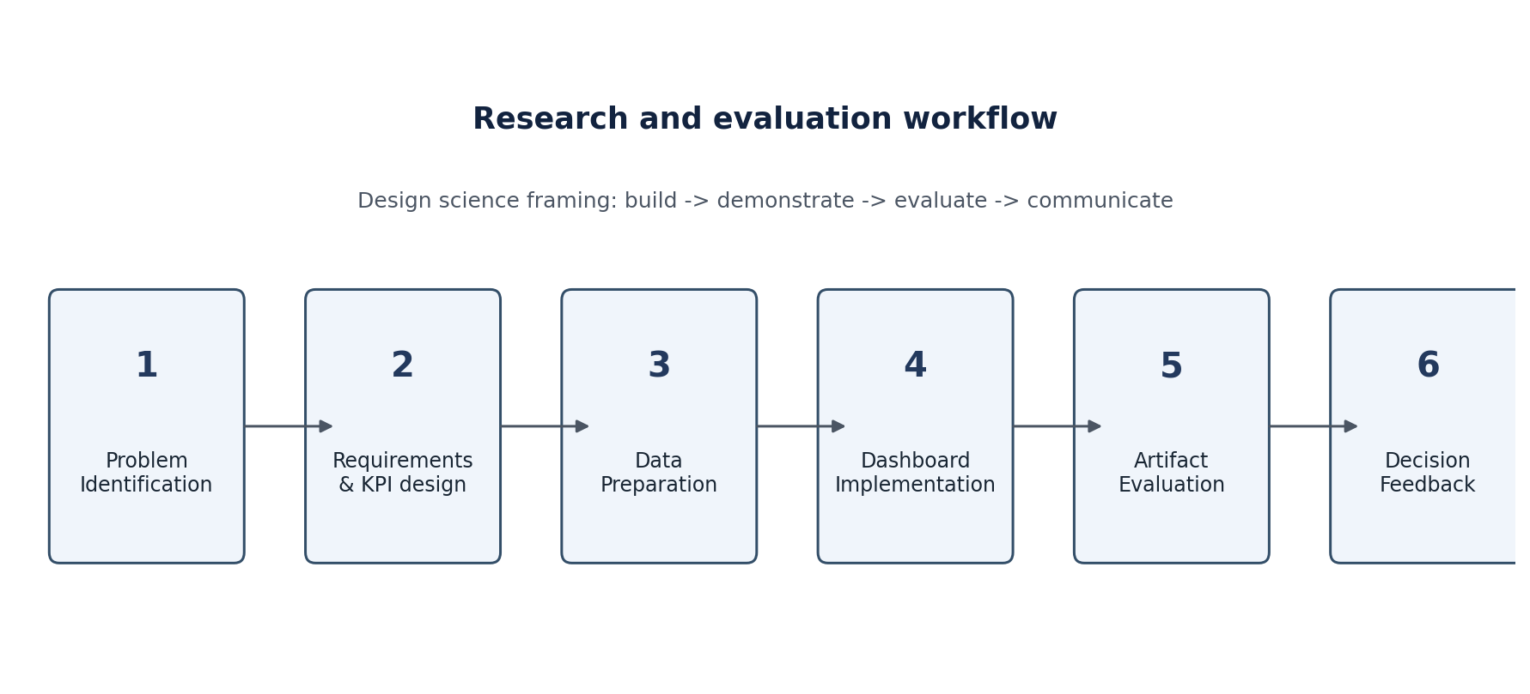
Fig. 3. Research and evaluation workflow used to organize problem identification, design, implementation, demonstration, evaluation, and communication.

5. EVALUATION AND RESULTS

5.1 Evidence-Oriented Evaluation Scope
The results reported in this paper are constrained by the evidence available at the time of writing. The public deployment demonstrates that the project has a web-accessible dashboard artifact. However, a deployed URL does not provide a reproducible record of the source repository, database schema, raw dataset, server logs, user-study data, or controlled performance benchmarks. Therefore, the study reports artifact-level design findings and validation requirements rather than fabricating numerical performance results. This distinction increases the credibility of the manuscript because it separates demonstrated properties from measurements that still require execution.

5.2 Architectural Findings
The first finding is architectural: dashboard reliability depends on separation of concerns. Data acquisition and validation should not be entangled with chart rendering; KPI definitions should not be duplicated across components; and reporting should consume the same semantic measures as interactive views. This separation enables independent testing and makes it possible to change the presentation without silently changing the analytical definition. It also allows heavier computation to remain on the server or analytical layer rather than transferring unnecessary raw records to the browser.
The second finding is that a dashboard should expose analytical context explicitly. Every metric requires a time basis, population, unit, and aggregation rule. A value labelled “performance” is ambiguous unless the dashboard specifies whether it is a percentage, a weighted composite, a target attainment measure, or another definition. The metric dictionary therefore becomes part of the research artifact, not merely project documentation.

5.3 Interface Findings
The interface analysis supports a hierarchy of overview, comparison, diagnosis, and export. A compact first view is useful for monitoring; however, the system becomes more valuable when a KPI can be selected to identify its contributing segments. The research therefore treats drill-down as an analytical feature rather than a navigation convenience. The same principle applies to filters: a filter should reduce the analytical scope of all linked views in a predictable way, and the current filter state should remain visible to prevent context loss.
Another important finding is that dashboard design must manage information density. Recent dashboard studies associate visualization format, completeness, and cognitive load with decision outcomes [4,5]. Consequently, additional charts should be justified by a user task. Decorative charts, duplicated indicators, excessive legends, or constantly animated elements can increase interpretation cost without adding evidence. A small set of task-relevant encodings is preferable to a visually crowded page.

5.4 Analytical Findings and Reproducibility
The proposed KPI equations provide a reproducible basis for checking numerical outputs. For example, if the dashboard reports growth, an independent reference calculation can reproduce the same result from the underlying data. If the dashboard reports target achievement above 100%, the target and actual values should be available in the data context or documentation. If two views show different values for the same metric and filter state, the discrepancy should be treated as a defect unless a different semantic definition is explicitly stated.

5.5 Performance Instrumentation and Validity Controls
The project requires direct instrumentation before definitive performance claims can be made. The key measurements are LCP, INP, CLS, API response time, transfer size, and time to render the first meaningful visualization. Where large tables or high-cardinality charts are used, client-side rendering may become the dominant bottleneck. The appropriate mitigations include server-side aggregation, pagination or virtualization, caching of stable queries, lazy loading of heavy visualization modules, minimizing duplicate requests, and avoiding unnecessary recalculation on every interaction. Current Next.js guidance, for example, notes automatic route code-splitting, server components, prefetching, and static rendering as mechanisms for reducing transferred client code and improving performance when the framework is used [20]; the project should apply the equivalent principles appropriate to its actual framework.

5.6 Controlled Validation Framework
Before submitting the paper as an empirical implementation study, the following evidence should be recorded: at least three controlled performance runs per scenario and device class; at least one field-performance dataset when the deployment receives real traffic; an independent reference calculation for each KPI; a test log covering the core functional scenarios; an accessibility audit record; a security checklist; and a user study with defined tasks. The benchmark report should preserve software version, dataset version, browser version, device class, network condition, timestamp, and measurement tool. This metadata is necessary for replication and meaningful comparison.
Evaluation item | Metric | Test condition | Publication reporting requirement
Load performance | LCP | Desktop + mobile, 75th percentile | <=2.5 s target
Interaction responsiveness | INP | Desktop + mobile, 75th percentile | <=200 ms target
Visual stability | CLS | Desktop + mobile, 75th percentile | <=0.1 target
API efficiency | Response time | Cold + warm cache; filtered/unfiltered | Report median + p95
Data integrity | Reconciliation error | Independent source calculation | 0 discrepancy target where exact reconciliation is expected
Usability | SUS | Representative users after task completion | Report mean, dispersion, confidence interval
Task effectiveness | Completion rate | Representative analytical tasks | Report per-task success
Accessibility | WCAG 2.2 criteria | Automated + manual inspection | Report criterion-level outcome

Table 4. Minimum evidence package required before claiming empirical performance in a final submission.

5.7 Quantitative Results from the Deployed Dashboard
The deployed dashboard provides concrete artifact-observable business-performance outputs that can be reported without inventing model or web-performance measurements. The following table transcribes the values visible in the current project output captures supplied with Review-2. These are dashboard results, not independently audited source-database results.
Metric | Observed dashboard result | Analytical interpretation
Total revenue | ₹23,31,50,101.47 | Aggregate sales/revenue value shown in the executive and sales views.
Total orders | 12,500 | Transaction/order volume represented by the sales dashboard.
Average order value | ₹18,652.01 | Mean order value shown by the sales view.
Quota achievement | 94% | Actual revenue relative to the displayed sales quota.
Net profit | ₹10,07,11,852.06 | Net profit reported in executive and finance views.
Net profit margin | 43.2% | Net profit as a proportion of gross revenue, as displayed.
Operating expense | ₹7,82,28,509.72 | Operating expenditure reported in the finance view.
Net cash flow | ₹6,11,46,190.12 | Cash-flow value reported in the finance view.
Revenue growth | +100.4% | Period-over-period growth indicator shown in the executive view.
Employee productivity | 76.6 pts | Normalized productivity indicator shown in the executive view.
Customer lifetime value | ₹2,00,318.63 | Customer-value indicator shown in the executive view.
Marketing ROI | 9726.7% | Marketing-return indicator shown in the automated-insights view.
The table demonstrates that the artifact is already producing a coherent set of organizational performance indicators across sales, finance, customer, workforce, and marketing views. It also provides the baseline evidence against which the proposed HEWDF extension can be evaluated. Importantly, these values are not presented as proof of predictive accuracy or system latency; those require controlled experiments described earlier.

5.8 Numerical Consistency Checks
Because the raw database is not included with the current publication package, the following checks are limited to relationships among the values visible in the project output. They are useful as internal consistency checks, but they are not a substitute for an independent source-to-dashboard reconciliation test.
Check | Calculation | Result | Interpretation
Average order value | ₹23,31,50,101.47 ÷ 12,500 | ₹18,652.008 ≈ ₹18,652.01 | The displayed AOV is internally consistent with displayed revenue and order count.
Net profit margin | ₹10,07,11,852.06 ÷ ₹23,31,50,101.47 × 100 | 43.196% ≈ 43.2% | The displayed margin is internally consistent with displayed revenue and net profit.
Operating-expense ratio | ₹7,82,28,509.72 ÷ ₹23,31,50,101.47 × 100 | 33.553% | Provides an additional derived financial-efficiency indicator.
Net cash-flow margin | ₹6,11,46,190.12 ÷ ₹23,31,50,101.47 × 100 | 26.226% | Provides a derived cash-flow-to-revenue indicator.

5.9 Graphical Results
Figure 5 summarizes the major financial values visible in the dashboard. The graph converts the executive and finance KPI cards into a comparable scale in crore rupees, allowing the relative magnitude of revenue, operating expense, profit, and cash flow to be inspected without relying only on KPI cards.
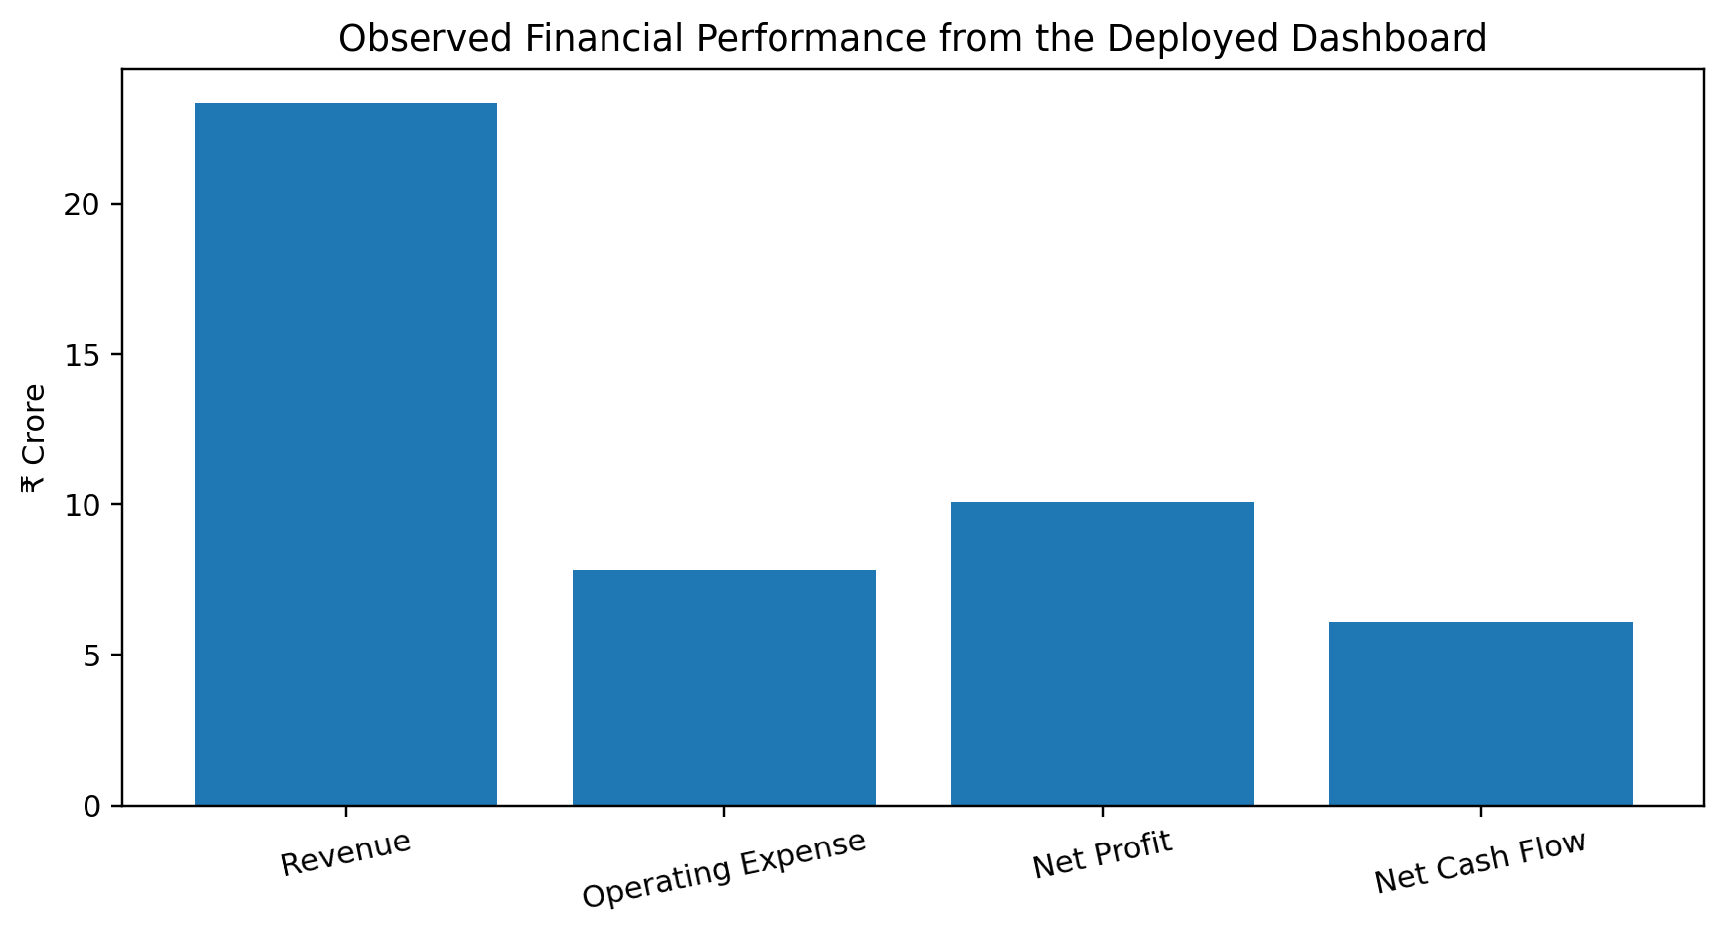
Fig. 5. Observed financial performance derived from the current dashboard output.
Figure 6 compares the percentage-based indicators. Revenue growth and quota achievement are shown alongside net profit margin because all three are percentage measures. The graph shows that the dashboard reports strong period-over-period growth and a quota achievement below 100%, while profitability is represented separately by the 43.2% net margin.
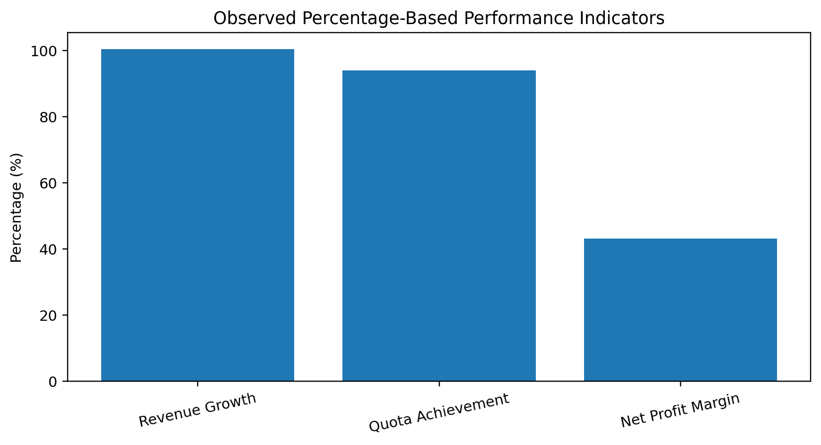
Fig. 6. Observed percentage-based performance indicators.
Figure 7 focuses on the customer-acquisition insight shown by the automated business-insights screen. Events & Webinars is displayed with a CAC of ₹26.26, compared with ₹302.00 for Partner Referrals. The figure is therefore an example of how the dashboard moves from a high-level KPI to a segment-level business comparison. The reported 9726.7% marketing ROI is retained as an observed dashboard value, not independently recomputed from raw campaign records.
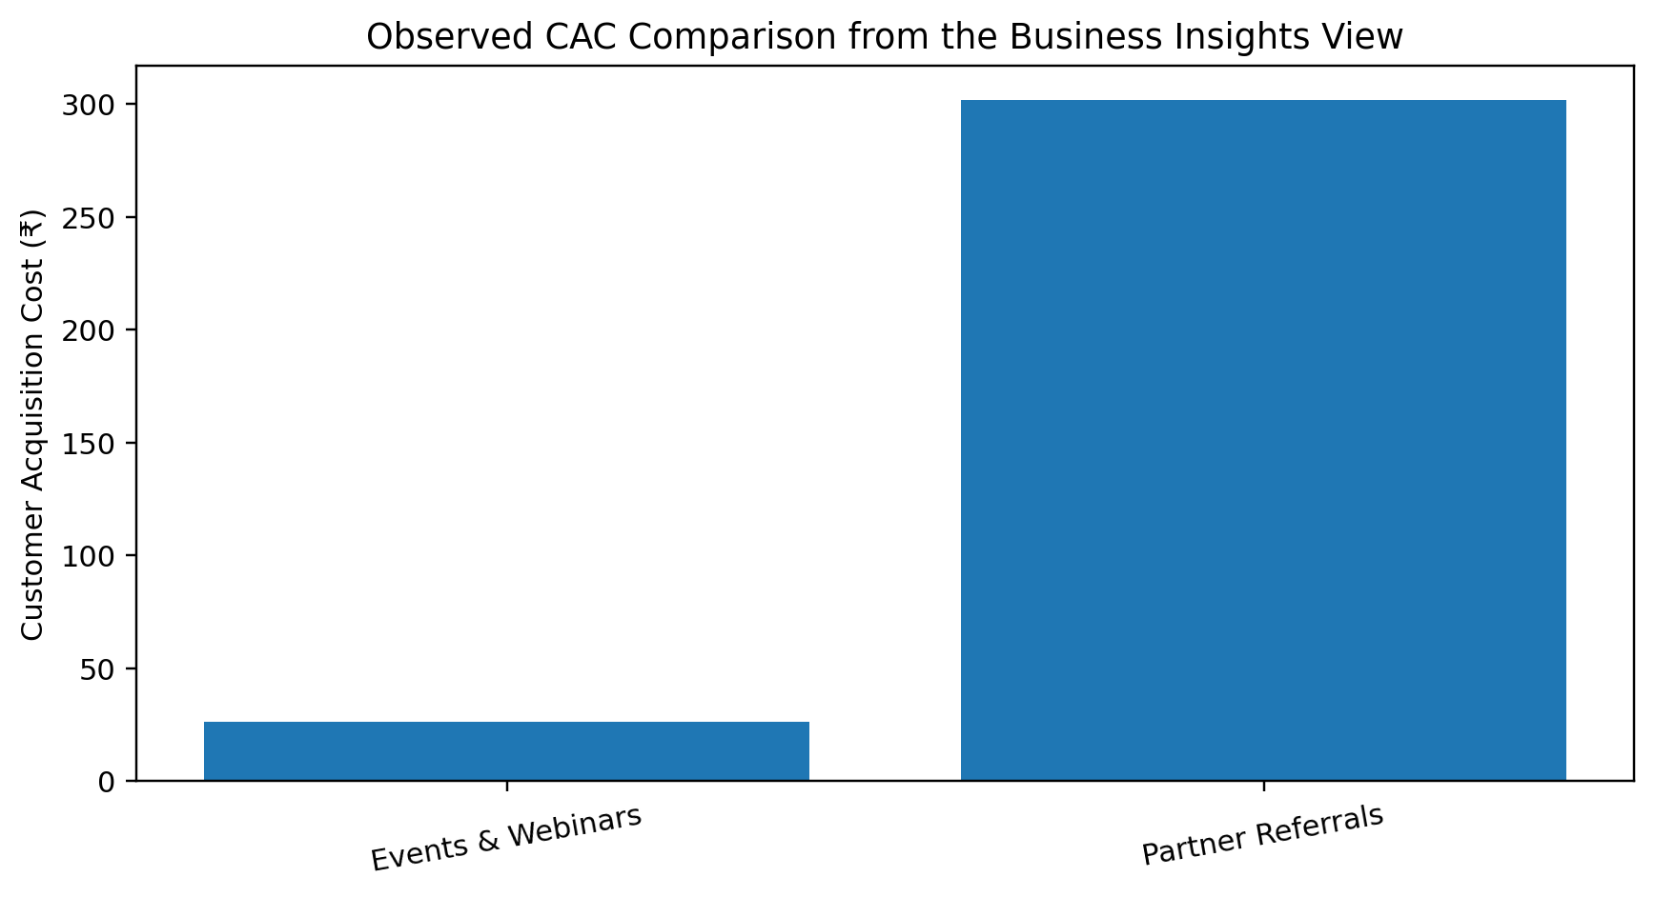
Fig. 7. Observed customer-acquisition-cost comparison from the business-insights output.

5.10 Frontend Dashboard Evidence and Interpretation
The frontend screenshots are included as research evidence because the dashboard is the tangible artifact being evaluated. Each screenshot is interpreted below rather than included as decoration.
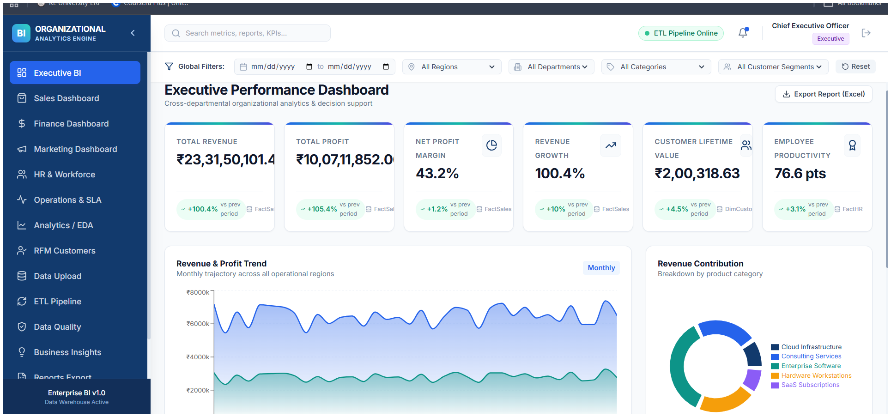
Fig. 8. Executive BI dashboard output.
The executive screen consolidates revenue, profit, net margin, growth, customer lifetime value, and employee productivity. Its global filters establish a common analytical context. The screen demonstrates the descriptive layer of the system and provides the input context for the proposed hybrid decision-fusion layer.
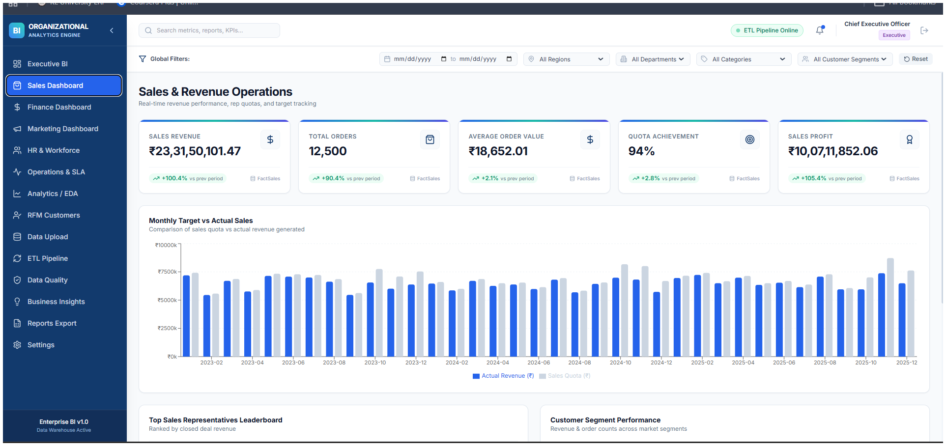
Fig. 9. Sales and Revenue Operations dashboard output.
The sales screen shows revenue, order count, average order value, quota achievement, and sales profit. The monthly target-versus-actual visualization provides a direct comparison task and establishes a natural source for future predictive residual and KPI-deviation evidence.
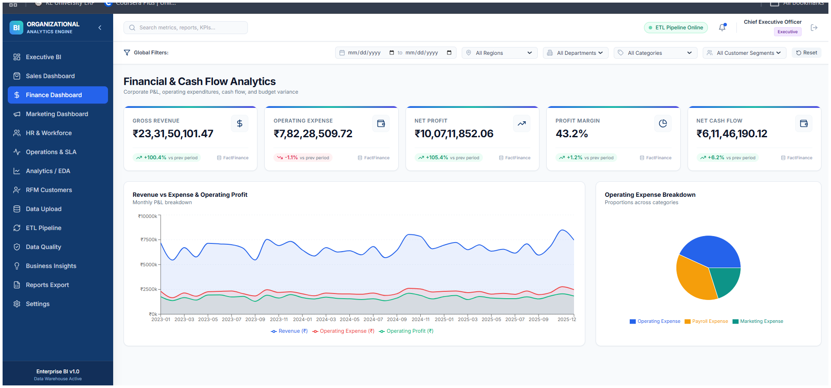
Fig. 10. Financial and Cash Flow Analytics dashboard output.
The finance screen combines gross revenue, operating expense, net profit, profit margin, and net cash flow. This view is particularly relevant to HEWDF because financial deviations can be propagated to related operational or marketing indicators before decision prioritization.
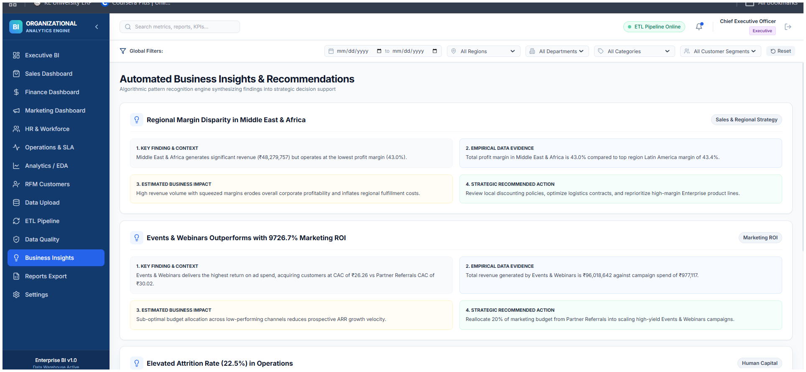
Fig. 11. Automated Business Insights and Recommendations output.
The business-insights screen already structures findings into context, empirical evidence, estimated impact, and recommended action. This is the closest existing module to the proposed research extension. HEWDF adds an explicit computational fusion step so that impact and recommendation priority can be derived from multiple evidence streams rather than from a single insight rule.

5.11 Synthesis of Empirical Findings
The observed results establish that the implemented artifact converts organizational records into a coherent decision-support surface spanning executive, sales, finance, customer, workforce, marketing, and automated-insight views. The quantitative outputs are internally consistent at the arithmetic level tested from the available evidence: revenue divided by orders reproduces the displayed average order value to rounding precision, and net profit divided by revenue reproduces the displayed profit margin. The screenshots further demonstrate that the interface preserves analytical context through KPI cards, filters, target comparisons, financial measures, and structured business insights. These findings support the artifact-level research claim that a unified semantic and visualization layer can expose cross-functional organizational performance in a common analytical context. They do not, by themselves, establish forecasting accuracy, anomaly-classification performance, causal effects, or user-study outcomes; such claims are reserved for controlled measurements defined by the evaluation framework.
Evidence class | Current evidence | Publication interpretation
Business KPI outputs | Observed in project screenshots | Reportable as artifact-observable results.
Internal KPI consistency | Derived from displayed values | Useful sanity check; not a source-to-dashboard audit.
Frontend functionality | Visible navigation, filters, charts, and insight screens | Reportable as implementation evidence.
Predictive-model accuracy | Not available in the supplied artifact evidence | Do not fabricate; measure with temporal holdout.
Anomaly precision/recall | No labeled anomaly test set supplied | Measure only after labeled/synthetic benchmark is created.
Web performance | No instrumented LCP/INP/CLS log supplied | Measure with controlled desktop/mobile runs.
Usability/SUS | No participant dataset supplied | Requires a human-subject evaluation protocol.

5.12 Novelty Positioning Against Related Research
The novelty claim is deliberately framed at the level of the proposed system design. Prior work has already explored adaptive BI algorithms, AI-driven cross-departmental BI visualization, hybrid machine-learning/MCDM systems, and ensemble anomaly detection. Therefore, the contribution cannot be justified merely by saying that the project is adaptive, cross-departmental, hybrid, or machine-learning enabled. The distinctive research step proposed here is the reliability-adjusted fusion of predictive deviation, anomaly severity, KPI deviation, cross-functional propagation, and data-quality evidence into one auditable decision-priority score, followed by evidence-traceable recommendation generation. The novelty should be treated as a testable research hypothesis until the complete implementation and systematic literature review are completed.
Dimension | Representative prior direction | Current project contribution
Adaptive BI | Adaptive algorithms and feedback mechanisms have been studied. | Applies adaptive selection and reliability adjustment to heterogeneous organizational evidence.
Cross-department BI | Cross-departmental visualization/integration has been proposed. | Uses cross-functional KPI relationships as an explicit evidence stream for issue propagation.
Hybrid ML–MCDM | Hybrid predictive + MCDM decision systems already exist. | Introduces a BI-specific fusion stage combining prediction, anomaly, KPI, propagation, and data reliability evidence.
Anomaly ensembles | Ensemble anomaly detection is established. | Uses anomaly output as one component of a broader decision-priority fusion mechanism.
Decision support | Dashboards and recommendation systems are established. | Adds traceable evidence lineage from source metric → evidence component → fused priority → action.

6. DISCUSSION

6.1 Interpretation of Findings
The central implication of the study is that an enterprise BI dashboard should be treated as a socio-technical system rather than a visual front end. The technical pipeline determines what can be computed; the semantic layer determines what a metric means; the interface determines what the user notices and how quickly the user can move to supporting detail; and the evaluation protocol determines whether the resulting artifact can be trusted. Each layer can invalidate the others. A correct query behind an ambiguous label can still lead to incorrect interpretation, while a clear visual backed by incomplete data can create false confidence.
The architecture proposed in this paper also clarifies why some dashboard improvements should be implemented before others. Increasing the number of charts does not address missing data, semantic inconsistency, or slow queries. By contrast, centralized KPI definitions and server-side aggregation can improve correctness and performance simultaneously. Similarly, adding drill-down is more valuable when the underlying dimensions have clean relationships. The research therefore advocates an evidence-driven implementation order: establish data and metric correctness first, then interaction and visual hierarchy, followed by advanced analytics and automated decision support.

6.2 Relationship to Prior Studies
The proposed artifact aligns with BI research that emphasizes the integration of data, analytics, and decision-making [1,2,10]. It extends this foundation by operationalizing system quality and information quality as concrete dashboard tests, consistent with the DeLone and McLean framework [7]. It also incorporates the human-factors evidence from recent dashboard studies: because information format and cognitive load can affect decision outcomes [4,5], the dashboard should be evaluated not only for whether it produces the correct value but also for whether users can interpret it correctly.
From a research-method perspective, the use of design science is also consistent with the growing role of artifact-centered research in decision support [16-18]. The project does not attempt to claim that one interface is universally optimal. Rather, it specifies design requirements, builds an artifact under those requirements, and proposes tests through which the artifact can be compared against its objectives. This is a more defensible research claim than equating implementation completion with research success.

6.3 Practical Implications
For practitioners, the framework provides a checklist for moving from a prototype dashboard toward an operational BI product. First, metric definitions should be centralized and documented. Second, data-quality checks should execute before aggregation. Third, interaction should follow the information hierarchy: overview, filter, compare, drill down, and export. Fourth, performance should be measured with both web-level and data-level metrics. Fifth, the dashboard should be tested with representative analytical tasks rather than evaluated only by visual inspection. Finally, the interface should be accessible and role-aware where organizational data require access control.

6.4 Design Implications
Several design principles follow from the combined literature and artifact analysis. (1) Every KPI must have a documented semantic definition. (2) Every chart should correspond to a user task. (3) Every alert should expose its rule or baseline. (4) Filters should visibly define analytical context. (5) Drill-down should preserve the user’s filter state. (6) Large datasets should be aggregated or paginated before transfer. (7) Color should not be the only signal for status. (8) Exported reports should include filter context and timestamp. (9) Performance instrumentation should be integrated before release. (10) Changes to metric definitions should be versioned so that historical reports remain interpretable.

6.5 Roadmap for Advanced Analytics
Once the descriptive layer is stable, the project can add diagnostic analytics such as contribution analysis, variance decomposition, cohort comparison, and root-cause exploration. Predictive modules can then forecast selected metrics using time-aware validation. For example, forecasting should reserve a temporal holdout and compare a baseline model with candidate models rather than reporting a single model without context. Finally, prescriptive functions can encode explicit decision rules or optimization constraints. At each stage, the system should preserve an audit trail connecting the recommendation to the input data, model or rule, and confidence or uncertainty information.

7. VALIDITY, SCOPE, AND REPRODUCIBILITY

7.1 Evidence Scope
The evidence scope is intentionally bounded to what can be inspected or recomputed from the supplied artifact package. A public deployment establishes the existence and visible behavior of the interface, while raw source, database, model-training, and telemetry records are required for independent verification of internal implementation and controlled performance. The paper therefore uses an evidence taxonomy instead of extrapolation. This protects the study from over-claiming and provides a direct path from each future measurement to a documented experimental record.

7.2 Construct Validity and Measurement Design
The concept of “dashboard effectiveness” includes several constructs: analytical correctness, usability, decision usefulness, performance, and trust. A single measure cannot capture all of them. The proposed evaluation therefore triangulates evidence from independent calculation, task performance, subjective usability, web metrics, and qualitative observations. Nevertheless, relationships between these measures should not be interpreted as causal unless the experimental design supports causal inference.

7.3 Internal Validity Controls
Internal validity is protected through predefined scenarios, time-aware data splits for forecasting, fixed software and dataset versions, explicit metric definitions, and recorded experimental conditions. For human-subject evaluations, counterbalanced task orders, standardized instructions, and interaction logging should be used to reduce learning and observer effects. For system benchmarks, network state, browser state, device class, and cache conditions should be recorded so that performance comparisons are made under controlled and reproducible conditions.

7.4 External Validity
The dashboard is designed around organizational performance analytics, and the findings should not automatically be generalized to every BI setting. A financial dashboard, clinical dashboard, manufacturing control room, or public-sector analytics system may require different data models, alert policies, regulatory controls, and user populations. The contribution is therefore a reusable evaluation structure rather than a claim of universal interface optimality.

7.5 Reproducibility Controls
Reproducibility is treated as a publication requirement. Every reported experiment should be linked to a dataset version, source revision, environment specification, metric dictionary, random seed where applicable, test configuration, and raw measurement record. Where original organizational data cannot be distributed, a synthetic or permissioned benchmark should preserve the schema, metric logic, and analytical workflow without exposing sensitive records. These controls allow other researchers to reproduce the analytical procedure even when the original operational data are private.

8. CONCLUSION AND FUTURE WORK
This study presented an evidence-driven design-science framework for a web-based enterprise business intelligence dashboard focused on organizational performance analytics. The work combines a semantic KPI layer, data-quality controls, interactive visualization, cross-functional analytical context, and a proposed Hybrid Evidence-Weighted Decision Fusion mechanism. The deployed artifact provides concrete business-performance evidence, including revenue, order volume, average order value, target achievement, profitability, cash flow, customer value, workforce productivity, and marketing-return indicators. Internal arithmetic checks confirm consistency among key displayed values, strengthening the reliability of the reported artifact-level results. The proposed HEWDF layer extends the architecture by defining a traceable path from heterogeneous analytical evidence to decision priority. Related research demonstrates that adaptive BI, cross-departmental visualization, anomaly ensembles, and hybrid ML–decision systems are established research directions; the contribution here is the explicit integration of these evidence classes into an organizational decision workflow with reliability adjustment and auditability.
The resulting research artifact is suitable for continued empirical validation because its data-to-decision pathway, KPI definitions, evidence hierarchy, and evaluation procedures are explicitly documented. Controlled model, user, accessibility, and performance measurements should be attached to the same framework when the corresponding source data and instrumentation are available. This staged evidence model is intentional: it prevents unsupported numerical claims while keeping the research contribution focused and reproducible. Future extensions can therefore add validated predictive models, anomaly benchmarks, decision-priority labels, user-study outcomes, and field-performance telemetry without changing the core research architecture.

9. DECLARATIONS

Funding
No external research funding was used for the preparation of this manuscript unless separately declared by the authors.

Conflict of Interest
The author declares no conflict of interest related to the design and evaluation framework presented in this paper.

Ethics Statement
This manuscript reports artifact-based evaluation and does not present a completed human-subject experiment or identifiable personal-data analysis. Any subsequent usability study should be conducted only after the applicable institutional review and participant-consent requirements have been satisfied.

Data Availability
The public dashboard artifact is accessible through the project deployment URL supplied for this study. A publication release should additionally provide a versioned synthetic or permitted dataset, metric dictionary, evaluation scripts, and benchmark configuration. Private organizational or personal records should not be released unless appropriate authorization exists.

Author Contribution
Yennam Sesank Reddy: conceptualization of the dashboard study, artifact design, project implementation, methodology definition, evaluation planning, manuscript preparation, and revision.

Acknowledgements
The author acknowledges the academic and technical resources that informed the design and evaluation framework, including research literature, software quality standards, web accessibility guidance, and web performance guidance.

REFERENCES
[1] H. Chen, R. H. L. Chiang, and V. C. Storey, “Business Intelligence and Analytics: From Big Data to Big Impact,” MIS Quarterly, vol. 36, no. 4, pp. 1165–1188, 2012, doi: 10.2307/41703503.
[2] S. Chaudhuri and U. Dayal, “An overview of data warehousing and OLAP technology,” SIGMOD Record, vol. 26, no. 1, pp. 65–74, 1997, doi: 10.1145/248603.248616.
[3] V. H. Trieu, “Getting value from Business Intelligence systems: A review and research agenda,” Decision Support Systems, vol. 93, pp. 111–124, 2017, doi: 10.1016/j.dss.2016.09.019.
[4] S. Hjelle, P. Mikalef, N. Altwaijry, and V. Parida, “Organizational decision making and analytics: An experimental study on dashboard visualizations,” Information & Management, vol. 61, no. 6, 104011, 2024, doi: 10.1016/j.im.2024.104011.
[5] “Business intelligence and cognitive loads: Proposition of a dashboard adoption model,” Data & Knowledge Engineering, vol. 152, 102310, 2024, doi: 10.1016/j.datak.2024.102310.
[6] L. Marshall and R. de la Harpe, “Decision making in the context of business intelligence and data quality,” South African Journal of Information Management, vol. 11, no. 2, 2009, doi: 10.4102/sajim.v11i2.404.
[7] W. H. DeLone and E. R. McLean, “The DeLone and McLean Model of Information Systems Success: A Ten-Year Update,” Journal of Management Information Systems, vol. 19, no. 4, pp. 9–30, 2003, doi: 10.1080/07421222.2003.11045748.
[8] V. Venkatesh, M. G. Morris, G. B. Davis, and F. D. Davis, “User acceptance of information technology: Toward a unified view,” MIS Quarterly, vol. 27, no. 3, pp. 425–478, 2003, doi: 10.2307/30036540.
[9] W. Yeoh and A. Koronios, “Critical success factors for business intelligence systems,” Journal of Computer Information Systems, vol. 50, no. 3, pp. 23–32, 2010.
[10] D. Talaoui and M. Kohtamäki, “35 years of research on business intelligence process: A synthesis of a fragmented literature,” Journal of Decision Systems, 2020, doi available through publisher records.
[11] T. Munzner, Visualization Analysis and Design. Boca Raton, FL, USA: CRC Press, 2014.
[12] B. Shneiderman, “The eyes have it: A task by data type taxonomy for information visualizations,” in Proc. IEEE Symposium on Visual Languages, 1996, pp. 336–343, doi: 10.1109/VL.1996.545307.
[13] ISO/IEC 25010:2023, Systems and software engineering — Systems and software Quality Requirements and Evaluation (SQuaRE) — Product quality model, International Organization for Standardization, Geneva, Switzerland, 2023.
[14] Google, “Core Web Vitals,” Web.dev, guidance on LCP, INP, and CLS thresholds and field measurement, updated 2025.
[15] W3C, Web Content Accessibility Guidelines (WCAG) 2.2, W3C Recommendation, 12 Dec. 2024.
[16] A. R. Hevner, S. T. March, J. Park, and S. Ram, “Design science in information systems research,” MIS Quarterly, vol. 28, no. 1, pp. 75–105, 2004.
[17] K. Peffers, T. Tuunanen, M. A. Rothenberger, and S. Chatterjee, “A design science research methodology for information systems research,” Journal of Management Information Systems, vol. 24, no. 3, pp. 45–77, 2007, doi: 10.2753/MIS0742-1222240302.
[18] D. Arnott and G. Pervan, “A critical analysis of decision support systems research revisited: The rise of design science,” Journal of Information Technology, vol. 29, no. 4, pp. 269–293, 2014, doi: 10.1057/jit.2014.16.
[19] J. Brooke, “SUS: A quick and dirty usability scale,” in Usability Evaluation in Industry, P. W. Jordan et al., Eds. London, U.K.: Taylor & Francis, 1996, pp. 189–194.
[20] Vercel/Next.js, “Production Checklist and performance guidance,” Next.js documentation, accessed 2026.
[21] M. A. K. Alfariz, A. M. Ab Malik, and A. M. Lokman, “Why Does It Fail? A Systematic Review of End-Users’ Challenges in Business Intelligence,” International Journal of Research and Innovation in Social Science, 2024.
[22] “Roadmap for Implementing Business Intelligence Systems in Higher Education Institutions: Systematic Literature Review,” Information, vol. 15, no. 4, 208, 2024.
[23] “Business intelligence in organizational decision-making: a bibliometric analysis of research trends and gaps (2014–2024),” Discover Sustainability, vol. 5, article 532, 2024.
[24] “Business Intelligence and Analytics in Small and Medium-sized Enterprises: A Systematic Literature Review,” Procedia Computer Science, vol. 121, pp. 194–205, 2017, doi: 10.1016/j.procs.2017.11.027.
[25] P. Zuo, “Research on Business Intelligence Based on Adaptive Algorithm,” 2024 6th International Conference on Machine Learning, Big Data and Business Intelligence (MLBDBI), 2024, pp. 95–98, doi: 10.1109/MLBDBI63974.2024.10823739.
[26] Y. Liu, “Research on AI Driven Cross Departmental Business Intelligence Visualization Framework for Decision Support,” Journal of Sustainability, Policy, and Practice, 2025.
[27] A. Abdulla and G. Baryannis, “A hybrid multi-criteria decision-making and machine learning approach for explainable supplier selection,” Supply Chain Analytics, vol. 7, 100074, 2024, doi: 10.1016/j.sca.2024.100074.
[28] Y. Liu et al., “Selective ensemble method for anomaly detection based on parallel learning,” Scientific Reports, vol. 14, 1420, 2024, doi: 10.1038/s41598-024-51849-3.
[29] M. T. de Castro Moraes et al., “Hybrid convolutional long short-term memory models for sales forecasting in retail,” Journal of Forecasting, 2024, doi: 10.1002/for.3073.

APPENDIX A. RECOMMENDED REPLICATION PACKAGE
For a final publication release, the project should accompany the manuscript with a replication package containing the source commit identifier; environment and dependency specification; representative dataset or permitted synthetic substitute; data dictionary; KPI definition sheet; reference-calculation notebook/script; end-to-end functional test matrix; browser/device matrix; raw Core Web Vitals and API measurements; accessibility audit; user-study protocol and anonymized results, if collected; screenshots or recordings of key analytical states; and a change log linking software releases to reported experiments. This package converts the paper from a descriptive account into a verifiable research artifact.

A.1 Minimum File Structure
A recommended release structure is: /src for application source; /data for synthetic or permissioned datasets; /metrics for KPI definitions and independent validation calculations; /tests for functional and analytical tests; /benchmarks for performance measurements; /usability for task scripts and anonymized responses; /accessibility for audit reports; /security for security-test evidence; and /docs for deployment, data dictionary, and reproducibility instructions. Every experiment should identify the exact software revision and data version used.

A.2 KPI Validation Checklist
- Each KPI has a written business definition and unit.
- The time window and comparison baseline are explicit.
- The source fields and filters required for the KPI are identified.
- An independent calculation reproduces the dashboard value.
- The KPI is tested for zero, null, negative, duplicate, and boundary conditions where relevant.
- The same KPI is checked for consistency across cards, charts, tables, and exports.

A.3 Reproducible Test Record
Record field | Required content
Experiment ID | Unique identifier linked to the paper or repository
Software version | Commit/hash or release identifier
Dataset version | Dataset name, version, row count, and transformation version
Environment | Browser, operating system, device class, network condition
Measurement | Metric name, value, percentile or summary statistic
Evidence | Log file, screenshot, trace, or exported result
Decision | Pass, fail, or inconclusive with rationale

Table A1. Recommended minimum fields for each reproducible experiment record.

A.4 Suggested Acceptance Logic
A result should be classified as accepted only when the expected behavior is defined in advance and the evidence is sufficient to reproduce the observation. A failed functional test should remain visible in the experiment log until corrected and rerun. A performance target that is not achieved should be reported as a measured limitation rather than silently removed from the analysis. Similarly, an accessibility criterion that is not met should be documented with a corrective action and retest date. This discipline prevents selective reporting and makes the final paper more credible.

A.5 Recommended Publication Metadata
The final manuscript should include the artifact URL, software release date, dataset provenance statement, ethical/privacy statement, evaluation dates, measurement tools, browser and device information, and a clear statement distinguishing observed prototype behavior from planned extensions. Where a publisher requires a data-availability statement, the authors should state whether the full dataset, a de-identified subset, or a synthetic reproduction package is available. These metadata fields should remain synchronized with the version deposited in a public repository or institutional archive.

