**Identifying Individual Travel Activities with Spatiotemporal Movement Patterns and Geographic Context from GPS Trajectories for Opioid Relapse Risk Monitoring**

Xinyi Liu, Bo Peng, John Curtin, Qunying Huang

# **Abstract**

Identifying individual daily travel activities can indicate changes of travel patterns and thus reveal risks of opioid (e.g., drugs, alcohol) relapse for chronic addicts. However, previous activity type identification models can only detect a limited number of activity types (e.g., *Dwelling*, *Work*, *Shopping*). Additionally, *Work* activities are mostly detected for people with frequent daily commute schedules among fixed places, such as office commuters or students. These models are not well generalized to our studies on detecting opioid relapse activities or other activities which can perform as risk signals for people with various daily travel patterns. Therefore, this paper proposes a practical framework to detect individual travel activity and identify activity type for relapse risk prediction by leveraging features representing spatiotemporal movement patterns and geographic context. In addition, the effectiveness of these features for identifying different activity types are evaluated with real-world GPS trajectories collected from 56 survey participants in early recovery from alcohol use disorders. Within this framework, travel stay points are first detected from individual GPS trajectories and then aggregated into stay regions (i.e., activity zones) to represent individual daily travel activities. Next, 95 features are designed to represent spatiotemporal movement patterns and geographic context, and extracted for each activity zone. A hierarchical identification model is developed using both one-vs-all and normal random forest classifiers. The experiment results show that three primary daily travel activity types (i.e., *Dwelling*, *Work*, *Shopping*) can be identified with high evaluation scores (i.e., precision/recall > 75%). Four other important activity types (i.e., *Drinking*, *Eating*, *Health*, *Entertainment*) can also be identified with high precision. Particularly, temporal patterns play an important role in identifying each type of activity, and spatial patterns mostly contribute to classifying the primary activities. Geographic context features are especially important for identifying remaining activity types including *Drinking*, *Eating*, *Entertainment*, and *Health*.

Keywords: Mobility pattern, activity space, machine learning, GeoAI

# **1 Introduction**

In clinical psychological studies on opioid (e.g., drugs, alcohol) lapse risk prediction, investigation of individual daily travel activities can provide innovative signals as contextual information to infer the probability of their opioid addiction relapse (Curtin et al. 2019). For example, detection of activities which are directly related to alcohol usage, such as visiting a liquor store or bar, implies potential occurrences of drinking relapse. Additionally, changes of daily travel activity patterns can indicate relapse risks and should be identified. For instance, longer time spending at places with pressure such as workplaces might increase the risk of alcohol relapse.

Nowadays, GPS-enabled mobile devices become ubiquitous and support to collect massive trajectory data of various participants within a relatively long period (Liu et al. 2015, Blondel et al. 2015). These data provide a cost-effective alternative for individual daily travel activity identification compared with travel surveys as traditional data sources (Alexander et al. 2015). However, raw GPS trajectories often lack semantic meanings, including the purpose of a person’s visit to a location, and the context of the location (e.g., office), which is paramount for producing and interpreting meaningful activity patterns from the data (Alvares et al. 2007, Gong et al. 2018).

To identify primary daily travel activity types (i.e., dwelling, work) from raw GPS trajectories, individual movement properties in space and time (i.e., spatiotemporal movement patterns) are extracted and integrated in various machine learning models (Lv et al. 2012, Xiao et al. 2016, Gong et al. 2018). Meanwhile, contextual information is integrated to identify other fine-grained activity types (e.g., shopping, eating, entertainment, etc., Meng et al. 2017), including behavior context (e.g., phone calls, messaging, audio) and locational context (e.g., Wi-Fi exposure, place categories or popularity revealed on social media). Multiple built-in sensors are invoked in previous works to collect useful context information, which requires strategic coordination or suffers from energy consumption (Shoaib et al. 2015). External geographic data are thus introduced to indicate location categories to supply more context information (Jiang et al. 2013, Choujaa 2014), although activity types cannot be accurately identified solely by location categories. Furthermore, previous models either ignored the identification of work activities by assuming they can be easily detected with high accuracy (Meng et al. 2017) or only considered office/campus commuters who follow a specific and fixed working schedule (i.e., work during office hours on weekdays). However, this assumption is inapplicable for opioid addictive persons, many of whom frequently conduct other activities, such as eating and drinking, during work time, making it difficult to differentiate these activities from work and thus preventing precise identification of work activities.

Therefore, this study proposes to identify individual daily travel activities for opioid lapse risk prediction by comprehensively leveraging spatiotemporal movement patterns from GPS trajectories and their geographic context by examining OpenStreetMap (OSM) POIs surrounding trajectory footprints. Activity labels are reported via 56 survey participants in early recovery from alcohol use disorders and are aggregated into 7 distinct daily travel activity types as the ground truth, namely *Dwelling*, *Work*, *Shopping*, *Drinking*, *Eating*, *Entertainment*, and *Health*. The identification model is developed as a hierarchical classifier (Huang et al. 2012), and class weights are applied to address class imbalance (Procrastinator 2020). Additionally, the model innovatively leverages various features such as maximum elapsed time between consecutive footprints, travel transition frequencies, and frequencies of activity occurrences within consecutive periods at various temporal scales. These features can capture properties of travel scales and activity transition sequences for more effective activity type identification. Furthermore, these features are evaluated separately for different activities to further investigate their effectiveness. To sum up, our contributions are highlighted as follows:

* Novel features are developed to capture spatiotemporal movement patterns and geographic context of individual travel trajectories to identify travel activity types, which in turn can be applied for monitoring risks of opioid relapse.
* Hierarchical random forest models are developed to dynamically leverage selective features for accurately identifying different travel activity types. Our identification of primary daily activities (i.e., *Dwelling*, *Work*, *Shopping*) received high evaluation scores (i.e., precision/recall > 75%) and outperformed previous identification methods. Other activities (i.e., *Drinking*, *Eating*, *Entertainment*, *Health*), which can perform as relapse signals, are also inferred with high precision.
* The importance of each distinct feature is evaluated for identifying different travel activity types, and the results indicate that both temporal and spatial patterns play an important role in classifying primary activities, while the distribution of related POIs are crucial for identifying *Drinking*, *Eating*, *Entertainment*, and *Health* activities.

# **2 Related Work**

## **2.1 Travel activity identification for predicting risks of opioid relapse**

Previous studies often present static predictions of opioid relapse risks like to infer who will relapse and whether an episode is opioid-related (Bae et al. 2017), while fail to dynamically monitor signals related to relapse processes for precisely predicting when the relapse could occur (Shiffman 2005, Witkiewitz and Marlatt 2007). Individual travel activities can be identified for examining their daily travel patterns to provide innovative and sensitive risk signals (Santani et al. 2018). For example, relapse possibility can be evaluated by measuring the change of duration when people stay at stressful or rewarding places (e.g., increased time at work, decreased time spent for entertainment). Also, treatment/support service utilization activities (e.g., attending AA meetings, visiting formal aftercare at health care providers) can be detected for the assessment with low burden upon experimental subjects. Additionally, signals can be extracted to indicate potential isolation (e.g., changes in the ratio of time spent home vs elsewhere) and changes from daily routines (e.g., changes in pattern of travel to work, typical time to leave or return home) (Su et al. 2020). Furthermore, signals provided via activity inference can be associated with other dynamic assessments (Curtin et al. 2019).

To predict risks of alcohol addiction relapse, drinking activities have been directly identified to indicate relapse occurrences, while the inference relies on behavior context information provided by metadata such as phone call logs (Bae et al. 2017). Besides, other daily travel activity types remain hard to identify for relapse evaluation (Santani et al. 2018). Among these activities, *Dwelling* and *Work* are typically conducted with a regular itinerary by subjects investigated in previous studies and are usually inferred with temporal travel patterns (Alexander et al. 2015). However, people with opioid addictions follow a more flexible itinerary, especially for *Work* activities, which can hardly be differentiated from some other activities (e.g., *Eating*, *Drinking*) if merely referring to temporal travel patterns. Other activities, such as *Shopping*, *Eating*, and *Entertainment*, are more irregular in space and time by nature. Their semantic meanings are thus generally revealed by categories of surrounding places, which are annotated with user-generated labels or reverse geocoding results (Santani et al. 2018). However, these identification techniques are not well explored in relapse prediction, with challenges brought by the uncertainty of location data and manual annotations (Santani et al. 2018).

## **2.2 Activity identification with movement patterns and context information using GPS trajectories**

Activity identification has been formulated as recognizing the type of activities people perform during a stay at a bounded location. In particular, stay points are usually extracted to represent footprints where people engage in the activities (Jiang et al. 2013) by identifying trajectory records collected via GPS sensors at bounded locations for a minimum period of time with relatively low travel speed (Huang et al. 2012, Choujaa and Dulay 2014, Çolak et al. 2015). Stay regions (i.e., locations) are then detected as spatial clusters to represent travel activities by aggregating stay points based on their spatial adjacency (Jiang et al. 2013). Movement patterns at either spatial or temporal dimension are investigated for each activity zone, and contextual information is integrated for activity type identification.

## **2.2.1 Examination of spatiotemporal movement patterns**

Travel patterns in either space or time (i.e., spatiotemporal movement patterns) are extracted to represent properties of movement behaviors at these two dimensions. Spatial patterns often capture properties of visiting fixed locations (e.g., visit frequencies) at historical places (Gao et al. 2012), radius of gyration (Yan et al. 2011), and spatial movement scales (Gao et al. 2012). Meanwhile, temporal patterns indicate temporal scales of the activities and visit frequencies at the same location within different time periods (e.g., daytime, weekdays) (Gao et al. 2012, Alexander et al. 2015).

Spatiotemporal movement patterns have been used for travel activity inference with fair accuracy using both heuristic analysis methods and machine learning techniques (Liu et al. 2013, Gao et al. 2012). Heuristic analysis is mostly used to identify *Dwelling* and *Work* activities by directly mapping selected spatiotemporal properties to corresponding activity types (Isaacman et al. 2011, Rivero-Rodriguez et al. 2014). For example, Isaacman et al. (2011) predefined *Dwelling* and *Work* hours and classified spatial clusters into these two types based on the proportion of footprints generated within corresponding time slots. However, such heuristic methods cannot be applied to differentiate other activity types such as *Shopping* and *Eating*. In contrast, machine learning models are developed for classifying a comprehensive set of travel activity types, which can integrate spatiotemporal movement patterns of detected activity clusters with their underlying contextual information.

## **2.2.2 Integration of contextual information**

Additional sensors (e.g., GSM, accelerometers, WiFi, and audio) are invoked to collect contextual information underlying GPS footprints for identifying their representative travel activity types (Montoliu and Gatica-Perez 2010, Choujaa and Dulay 2014, Rivero-Rodriguez and Nykänen 2017). For example, accelerometers are used to collect data reflecting properties of different movement status such as sitting, walking, and running (El-Hajj et al. 2017), thus indicating travel purposes. Besides, non-movement behaviors (e.g., WiFi connections, phone calls) are examined to indicate activity types by simply counting their occurrences at different locations during a specific time period (El-Hajj et al. 2017, Rivero-Rodriguez et al. 2016). However, activating additional sensors is either energy-consuming or requires implementing efficient coordination mechanisms for adaptive sensor selection, which is expensive along with the collection of travel footprints using mobile phones (Shoaib et al. 2015).

## **2.3 Place categories as geographic context**

Place categories (e.g., home, workplace) underlying travel activities are inferred to provide geographic context information, which can perform as a proxy of activity type classification. For example, Jiang et al. (2013) proposed that individual travel activity types at a specific location can be inferred by examining its surrounding land use types and Points of Interest (POIs) representing business establishments. The probability of human activities performed at areas with different land use types is also calculated. Meanwhile, Yan et al. (2011) developed a comprehensive semantic annotation framework which enriches movement trajectories with geographic data in different geometric formats, including Regions of Interest (ROIs), POIs, and semantic lines. Specifically, spatial join is applied to measure the topological correlations between geographic context annotations and movement trajectories (Yan et al. 2011). Next, statistical models are applied to represent the spatial distribution of different geographic context annotations (Yan et al. 2011) and thus identify place categories which indicate travel activity types.

However, heterogeneous activities can be conducted at the same category of places (e.g., *Eating* or *Work* at a restaurant). Also, disambiguating adjacent places remains a research challenge (Agrawal and Shanahan 2010). Therefore, travel activity type identification cannot solely rely on geographic context. Furthermore, current place categorization methods mostly refer to POI labels which are manually annotated and can introduce bias and inaccuracy. Some other methods exploit location services, such as Google Places API, to provide place information, which is still inconvenient as it requires API keys and restricts the number of requests (Liu et al. 2019). This study thus leverages geographic data provided by OSM, which contains a comprehensive set of land use and POI layers (Liu et al. 2021).

# **3 Methods**

The workflow of our proposed travel activity identification includes two modules (Figure 1): (1) data collection from GPS trajectories ([Pulshashi](https://sciprofiles.com/profile/686190) et al. 2019), OSM data, and travel surveys, and (2) five major steps for activity identification (i.e., spatial aggregation, feature generation, activity type labeling, activity type identification, and feature evaluation). The first four steps and their generated results are introduced in following subsections and feature evaluation is discussed in the results section.

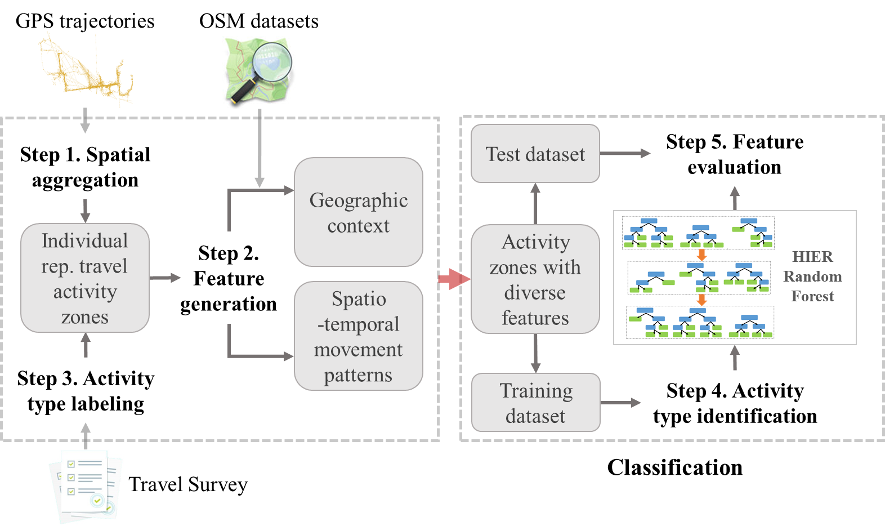

Figure 1. Workflow of individual representative travel activity type identification with features representing spatiotemporal movement patterns and geographic context

**3.1 Activity detection**

Individual travel trajectories are represented as sequences of travel footprints, with each footprint denoted as a pair of geographic coordinates and a timestamp (*x, y, t*). A footprint thus represents the presence of a person at a specific location and a time point. We first detect travel stay points from trajectory footprints by identifying the ones with a speed slower than 1300 m/h (Hwang et al. 2017). Next, we applied the density-based spatial clustering of applications with noise (DBSCAN, Ester et al. 1996) to aggregate spatially adjacent stay points for each individual in order to decrease spatial uncertainty by detecting stay regions that were frequently visited (Liu et al. 2019). DBSCAN requires two input parameters including *eps* and *minPts*, which specify the maximum distance between two adjacent points and the minimum number of points within a cluster respectively (Ester et al. 1996). These two parameters are selected based on the spatial distribution of all data points to be clustered. Activity zones are generated as convex hulls of the detected spatial clusters (i.e., stay regions) so that spatial scopes are specified for the represented travel activities (Huang and Wong 2015). Then activity zones are used to produce features for activity type identification.

**3.2 Spatiotemporal movement patterns**

A comprehensive set of features are extracted from individual travel trajectories to capture their spatiotemporal movement patterns. In particular, 5 features are summarized to represent spatial patterns and 64 features representing temporal patterns respectively by analyzing variations of geographic coordinates of individual travel footprints and their attached timestamps. In the spatial dimension, numbers of incoming and outgoing transitions for each activity zone are counted. Then total numbers of incoming and outgoing transitions for all activity zones of each individual are sorted descendingly, and the largest three numbers are picked to generate an ordinal feature. In the temporal dimension, temporal intervals at different scales (e.g., hour, day and night, weekdays and weekends) are defined, within each of which the number of footprints is counted for an activity zone and used as a distinct numeric feature representing temporal patterns. Moreover, travel speed is calculated within each activity zone to characterize movement patterns across space and time. In the end, a total of 69 features are defined and explained in Table 1.

Table 1. Definition and measurement of features representing spatiotemporal movement patterns

|  |  |  |  |
| --- | --- | --- | --- |
| **Feature type** | **Feature** | **Definition** | **Measurement** |
| Spatial | Average travel distance | The average travel distance between each stay point and its next one within the same activity zone |  |
| Maximum travel distance | The largest travel distance between each stay point and its next one within an activity zone |  |
| Number of incoming spatial transitions | The number of footprint pairs which are consecutive in time and represent travels to current activity zone ($z'$) from other activity zones ($z_{m}$) | $$N_{in}=N_{q→p}, p∈z^{'},q∈z_{m}$$ |
| Number of outgoing spatial transitions | The number of footprint pairs which are consecutive in time and represent travels to other activity zones ($z_{m}$) from the current activity zone ($z'$) | $$N_{out}=N_{p→q}, p∈z^{'},q∈z_{m}$$ |
| Ranking of the total number of transitions | The order of total numbers of footprint pairs which are consecutive in time and represent travels to/from current activity zones from/to other activity zones |  |
| Temporal | Average next time | The average travel time between each footprint and its next footprint within the same activity zone |  |
| Maximum next time | The longest travel time between each footprint and its next footprint within the same activity zone |  |
| Start/end time of a proportion of footprints | One of the 24 hours which marks the start/end of a time slot that covers a proportion ( $p=50\%, 80\%,or 100\%$ ) of footprints within an activity cluster (/) |  |
| Number of footprints within each hour | The number of footprints within each hour on weekdays/weekends | $$N_{i,weekday}=\sum_{t=3600×(i-1)}^{3600×i}{N_{t,weekday}},i=1,…,24$$ $$N_{i,weekend}=\sum_{t=3600×(i-1)}^{3600×i}{N_{t,weekend}},i=1,…,24$$ |
| Proportion of footprints during different time slots | The proportion of footprints during daytime or night on weekdays/weekends | $$P_{weekday,day}=\frac{N_{weekday,day}}{N_{weekday,day}+N_{weekday,night}}$$ $$P_{weekday,night}=\frac{N_{weekday,night}}{N_{weekday,day}+N_{weekday,night}}$$ $$P_{weekend,day}=\frac{N_{weekend,day}}{N_{weekend,day}+N_{weekend,night}}$$ $$P_{weekend,night}=\frac{N_{weekend,night}}{N_{weekend,day}+N_{weekend,night}}$$ |
| Ranking of the number of footprints within a time slot | The order of footprint numbers during weekdays/weekends among different clusters |  |
| Time | Whether at Day or Night hours when the earliest footprint is generated | $$T=^{'}Day^{'} if6≤t_{start,p=100\%}≤19,$$ $$otherwise T='Night'$$ |
| Day of week | Whether include footprints generated on Weekdays or Weekends | $$dow='Weekend' ifall on weekends,$$ $$otherwise dow='All'$$ |
| Spatio-temporal | Average travel speed | The average travel speed within an activity zone |  |
| Maximum travel speed | The largest travel speed within an activity zone |  |

**3.3 Geographic context**

Besides spatiotemporal movement patterns, the underlying land use types and POI distribution of activity zones are integrated to indicate place categories as geographic context for activity type identification. Specifically, we leverage OSM by overlaying its land use and POI layers with point or polygon features on detected activity zones. The polygon feature in the land use layer which has the largest overlap with an activity zone is selected and its type is directly used as a categorical feature. Meanwhile, numbers of POIs of different types within an activity zone are counted as numerical features.

Types of the features in land use and POI layers are mapped by their class names. Each feature is labeled with a class name, while these labels can be generated in a subjective manner (Davidovic et al. 2016). For example, “house” and “family_house” can both indicate home locations. Besides, feature classes in the land use and POI layers are named differently. For example, the “residential” label in land use dataset and the “house” label in POI dataset can both indicate *Dwelling* activity type. Therefore, we manually interpret these feature names by mapping them into 11 typical daily travel activity types (Table 2, Liu et al. 2021).

Table 2. Manual interpretation of land use and POI features of OSM datasets

|  |  |  |
| --- | --- | --- |
| **Daily travel activity type** | **Distinct Feature Classes of OSM Land Use Dataset** | **Distinct Feature Classes of OSM POI Dataset** |
| Dwelling | residential | dormitory, houses, …, house, family_house, shed, condominium, townhouse, apartment, home |
| Eating | NA | bakery, cafe, fast_food, …, restaurant, food_court, caboose, cafeteria |
| Entertainment | recreation_ground, vineyard, park, orchard | alpine_hut, artwork, …, archaeological, attraction, arts_centre, bar, battlefield, bench, biergarten |
| Health | health | dentist, doctors, …, hospital, pharmacy, chemist, optician, nursing_home |
| Service | cemetery | bicycle_rental, atm, …, post_box, car_repair, fort, car_wash, graveyard, guesthouse, hostel, laundry |
| Shopping | retail | beauty_shop, bookshop, …, clothes, beverages, bicycle_shop, butcher, computer_shop, florist |
| Work | farm, meadow, military, industrial, quarry | embassy, courthouse, …, bank, community_centre, fire_station, police, factory, barn, industrial |
| Education | NA | college, kindergarten, …, library, school, academic, university, academic_building |
| Drinking | NA | bar, night_club, nightclub, pub, liquor_store |
| Transportation | NA | dock, ferry_terminal, …, dam, ford, taxi_stand, travel_agency |
| Transportation network | NA | canal, taxi, …, parking_shelter, stop, camera_surveillance |
| NA | commercial | NA |

Note that the “commercial” class in the land use dataset cannot be mapped to any daily travel activity type as it indicates mixed activity types (e.g., *Work*, *Shopping*, *Eating*). Therefore, the commercial type is directly used as a land use type. Also, the land use dataset does not provide a feature class which can be mapped to the *Eating* activity type. In contrast, all of the POI features can be mapped to a daily travel activity type. In this way, land use features and POI features complement each other to provide more comprehensive geographic context.

**3.4 Activity type identification**

Activity type identification in our proposed framework aims to classify travel activities into 7 distinct types which are either directly related to alcohol usage (i.e., *Drinking*) or can contribute to monitoring relapse risks (i.e., *Dwelling*, *Work*, *Shopping*, *Eating*, *Entertainment*, *Health*). Detailed travel activity types are annotated as place labels (e.g., home, work, and errands) via travel surveys by individuals with alcohol use disorders (Section 4.1). Locations reported with these place labels are spatially joint with individual travel activity zones, with the closest annotation selected as the true travel activity type. Only activity zones which are attached with non-trivial place labels (i.e., not *Others* or null) are selected as representative zones for building the identification model (Zheng et al. 2009). A total of 14 valid place labels are reported in our study and they are grouped into the 7 travel activity types (Figure 2).

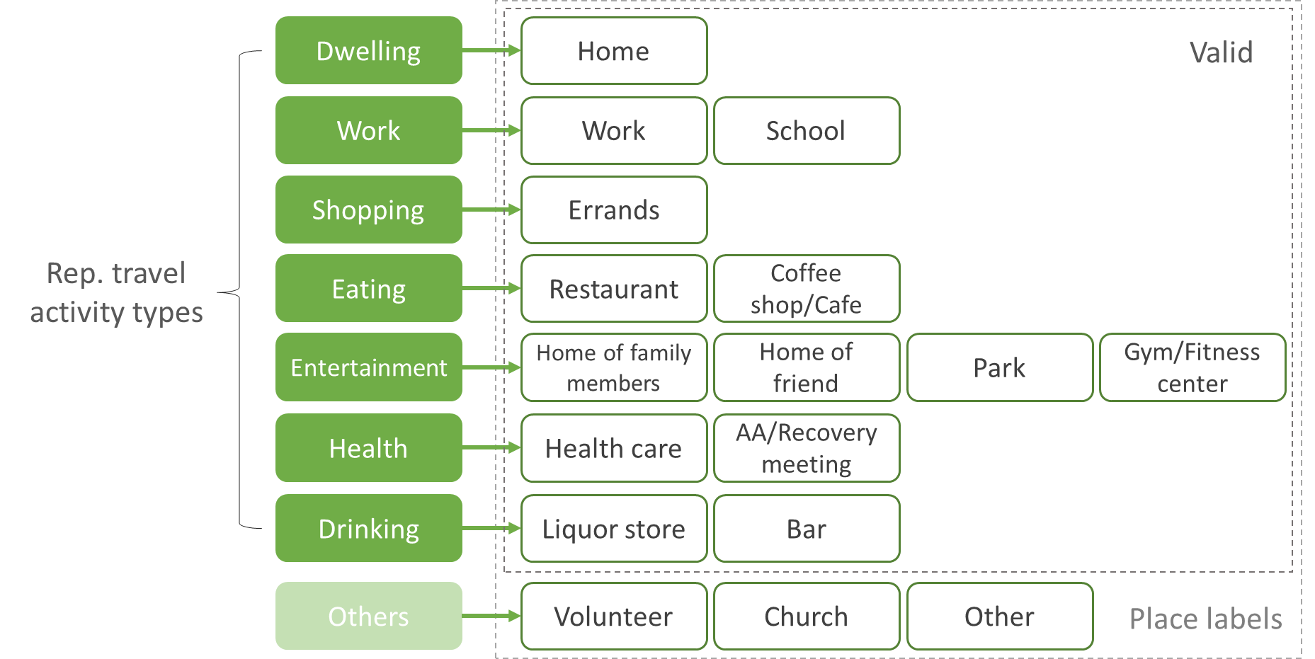

Figure 2. Labeling 7 representative travel activity types based on 14 valid place type annotations

Explicitly, place labels which share the same semantic meaning as signals for relapse risk prediction are integrated as a representative travel activity type. For example, the place labels of work and school are combined as *Work*, since longer time staying at workplaces or campus can both lead to more stress and thus increase relapse risks. We do not differentiate merged types while focusing on identifying the 7 representative travel activity types in this study.

Next, we develop a hierarchical random forest classifier to identify travel activity types of detected activity zones, which can handle both categorical and numeric features generated above (Peng and Li 2019). Preprocessing is applied on these features before input to the model. Specifically, numeric features for each individual are normalized to be at the same scale. Standardization is also applied on all feature values among individuals to balance their mutual differences, so that the classifiers would not favor individuals with many more footprints compared with others.

All individual representative travel activity zones are split into a training set and a test set. The classification model is built hierarchically, with three identification levels, to fit the training set and then evaluated on the test set. At the first level, all activities are classified as 4 primary types, namely *Dwelling*, *Work*, *Shopping*, and *Others*, then one-vs-all classification is applied to identify each of the three non-trivial types (Huang et al. 2012). The remaining activity zones without any type identified are classified as *Others*.

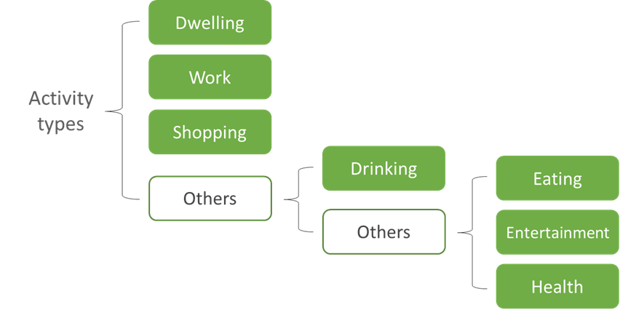

Figure 3. The schema of hierarchical travel activity type identification

In the next identification level, activity zones classified as *Others* at the first level are further classified as *Drinking* and non*-Drinking* types. Specifically, activity type labels of training activity zones are first reclassified into *Drinking* and non*-Drinking*, while activity zones already classified as non-trivial types are removed from the test set and are considered as being predicted as *Others* for the second round of classification. Then a random forest model is trained to fit the reclassified training set, and evaluated on the reclassified test set. In this way, the accumulative errors (i.e., misclassifications of non-trivial types and *Others* into each other) from the last identification level are considered by decreasing the evaluation score in the current level. Similarly, activity zones classified as *Others* at the second level are further classified as *Eating*, *Entertainment*, and *Health* at the third level and are evaluated on the same set of testing activity zones.

**4 Case study**

## **4.1 Datasets**

To validate our proposed framework, we conducted experiments based on real GPS trajectories collected from 56 participants living in Wisconsin or Illinois, which contain 407,066 travel footprints. Initially, a total of 167 participants were recruited through local and targeted national advertising in Facebook (Curtin et al. 2019). These participants are patients in early recovery from alcohol use disorders who just completed residential treatment. GPS sensors were activated in their smart phones to record their daily travel trajectories for a consecutive time period from 1 week to 3 months. During preprocessing of these trajectory data, individuals with multiple work locations are removed as we focus on investigating work activities at single locations in this study. Also, travel footprints outside of WI and IL were discarded as they represent long-distance travels instead of daily travel activities.

These participants were also asked to conduct a weekly patient “check-in” by self-report surveys (Curtin et al. 2019). Approximately 1750 distinct locations with place labels (Table 3) were collected through these surveys. The participants labeled each location with one out of 17 pre-defined place types (Figure 2). These place type labels are used as ground truth data which annotate travel activity types performed at corresponding locations. As two labels (i.e., volunteer, church) are only attached to 3 detected travel activity zones, they cannot be used to build a valid classifier and are thus classified as *Others* during preprocessing (Figure 2).

Table 3. Number of labels for each travel activity type

|  |  |  |  |  |
| --- | --- | --- | --- | --- |
| **Travel activity type** | | **Number of labels** | **Total** | |
| **Level 1** | *Dwelling* | 60 | 670 | 1437 |
| *Work* | 127 |
| *Shopping* | 483 |
| **Level 2** | *Drinking* | 114 | 114 |
| **Level 3** | *Eating* | 272 | 653 |
| *Entertainment* | 263 |
| *Health* | 118 |
| Others | | 315 | 315 | 315 |

**4.2 Results**

We detect 154,582 stay points from all travel footprints, and then adopt 50 meters as *eps* and 4 as *minPts* to apply DBSCAN on the stay points and generate activity zones in an amount ranging from 10 to 30 for each individual. We randomly split all travel activity zones into a training set and a test set with a ratio of 7:3. The proposed hierarchical classification model is fitted on the training set, and evaluated by comparing predicted types of the test set with their actual activity types indicated by place labels (Figure 2). K-fold cross-validation is applied during the training process to choose the parameters which can maximize estimation performance (Ljumović and Klar 2015). The dataset is split differently for five times and a confusion matrix is generated each time, of which the average values are displayed in Table 4-6. Average values of three evaluation metrics (i.e., precision, recall, and f1 score) are also calculated for each representative travel activity type (RF column in Table 7).

Table 4. Confusion matrix of activity type identification at the first level

|  |  |  |  |  |
| --- | --- | --- | --- | --- |
| **Real\predicted** | Dwelling | Work | Shopping | Others |
| Dwelling | 0.946 | 0.011 | 0 | 0.043 |
| Work | 0.016 | 0.762 | 0 | 0.223 |
| Shopping | 0 | 0.006 | 0.765 | 0.228 |
| Others | 0.006 | 0 | 0.155 | 0.838 |

Table 5. Confusion matrix of activity type identification at the second level

|  |  |  |
| --- | --- | --- |
| **Real\predicted** | Drinking | Others |
| Drinking | 0.3 | 0.7 |
| Others | 0.005 | 0.995 |

Table 6. Confusion matrix of activity type identification at the third level

|  |  |  |  |  |
| --- | --- | --- | --- | --- |
| **Real\predicted** | Eating | Entertainment | Health | Others |
| Eating | 0.394 | 0.091 | 0.030 | 0.485 |
| Entertainment | 0 | 0.4 | 0.05 | 0.55 |
| Health | 0.095 | 0.048 | 0.571 | 0.286 |
| Others | 0.025 | 0.041 | 0.008 | 0.926 |

It can be observed that *Dwelling* activities are most distinguishable in our proposed classifier, with few misclassifications or omissions. However, there exists a chance of around 22.5% that either *Work* or *Shopping* activities are misclassified as one of the activity types classified at the second or third levels (i.e., *Drinking*, *Eating*, *Entertainment*, *Health*, or *Others*). Also, these activity types can be misidentified as *Shopping* activities with a possibility of 15.5%, which leads to most of their misclassifications (i.e., being classified as *Others* at the second and third identification levels). This is because there exist a large number of *Shopping* related POIs (e.g., mall) in our database. Although other types of activities (e.g., *Eating*, *Entertainment*) can also take place around these POIs, we lack more precise information to identify them as the non-*Shopping* types.

Table 7. Analysis of the precision, recall, and f1 score for identifying different activity types

|  |  |  |  |  |  |  |  |  |  |  |
| --- | --- | --- | --- | --- | --- | --- | --- | --- | --- | --- |
| **Activity type** | **Precision** | | | **Recall** | | | **F1 score** | | | **Avg support** |
| RF | ST | GeoCtx | RF | ST | GeoCtx | RF | ST | GeoCtx |
| Dwelling | **0.94** | 0.79 | 0.23 | **0.95** | 0.88 | 0.76 | **0.94** | 0.83 | 0.36 | 17 |
| Work | **0.96** | 0.20 | 0.18 | 0.76 | **1.00** | 0.19 | **0.85** | 0.33 | 0.19 | 21 |
| Shopping | **0.78** | NA | 0.49 | **0.77** | NA | 0.30 | **0.77** | NA | 0.37 | 67 |
| Drinking | **0.75** | NA | 0.19 | 0.30 | NA | **0.70** | **0.43** | NA | 0.30 | 10 |
| Eating | **0.72** | NA | 0.31 | 0.39 | NA | **0.45** | **0.51** | NA | 0.37 | 33 |
| Entertainment | **0.47** | NA | 0.23 | **0.40** | NA | 0.15 | **0.43** | NA | 0.18 | 20 |
| Health | **0.80** | NA | 0.15 | **0.57** | NA | 0.10 | **0.67** | NA | 0.12 | 21 |

We also evaluated previous methods which simply rely on spatiotemporal movement patterns for travel activity type identification (ST column in Table 7). Specifically, the number of home events and the ranking of work events within each activity zone are identified and leveraged by a logistic regression model for inferring the two most significant daily travel activity types, *Dwelling* and *Work* (Isaacman et al. 2011). While home events are detected as footprints recorded before 7am or after 7pm, work events are identified as footprints recorded between 1pm and 5pm, which is considered as the primary time slot for typical work. This method receives high scores (e.g., f1 score = 0.83) for identifying *Dwelling* activities and high recall for detecting *Work* activities on the same test set as in our proposed model. However, its precision of identifying either *Dwelling* or *Work* activities are much lower. One reason is that neither home nor work events can be simply detected with temporal features. For example, some *Entertainment* activities (e.g., going to the park) can be performed during evenings and weekends, while *Health* activities can be engaged during *Work* hours.

Meanwhile, we applied geographic context features to classify travel activity types with OSM datasets using a typical semantic annotation method (Yan et al. 2011, Huang et al. 2014, Liu et al. 2021). The results (GeoCtx column in Table7) show that POI related activities (e.g., *Shopping*, *Eating*, *Drinking*, and *Dwelling*) are identified with relatively high evaluation scores compared with other activities (e.g., *Work*, *Entertainment*), which are usually conducted in diverse categories of places. Overall, the low evaluation scores (i.e., f1 score < 0.40) indicate that the ambiguity of place categories for revealing travel activity types prevent us from accurate identification (Santani et al. 2018). In comparison, our proposed model integrates features representing spatiotemporal movement patterns to successfully improve identification accuracy and receives high precision scores for most activity types.

It is observed that our proposed method receives the highest f1 scores for identifying all travel activity types compared with the other two models. Particularly, primary activity types including *Dwelling*, *Work*, and *Shopping* are identified with over 75% of precision, recall, and f1 scores, which means that these activity types are well distinguished with the extracted features representing spatiotemporal movement patterns and geographic context. Additionally, our method considerably improves the precision of identifying *Drinking*, *Eating*, *Entertainment*, and *Health* activities and achieves a precision score of over 70% on inferring them except for *Entertainment*.

**4.3 Feature importance**

To evaluate the importance of each feature for identifying different travel activity types, the permutation feature importance is calculated for each classifier when applied on testing activity zones. The permutation importance of a specific feature is defined as the decrease of the model score after randomly shuffling feature values, which indicates how much the model depends on the feature (Molnar 2020). We evaluate each feature with 100 different permutations and generate top features with the highest importance scores for the three classifiers (Figure 4-6).

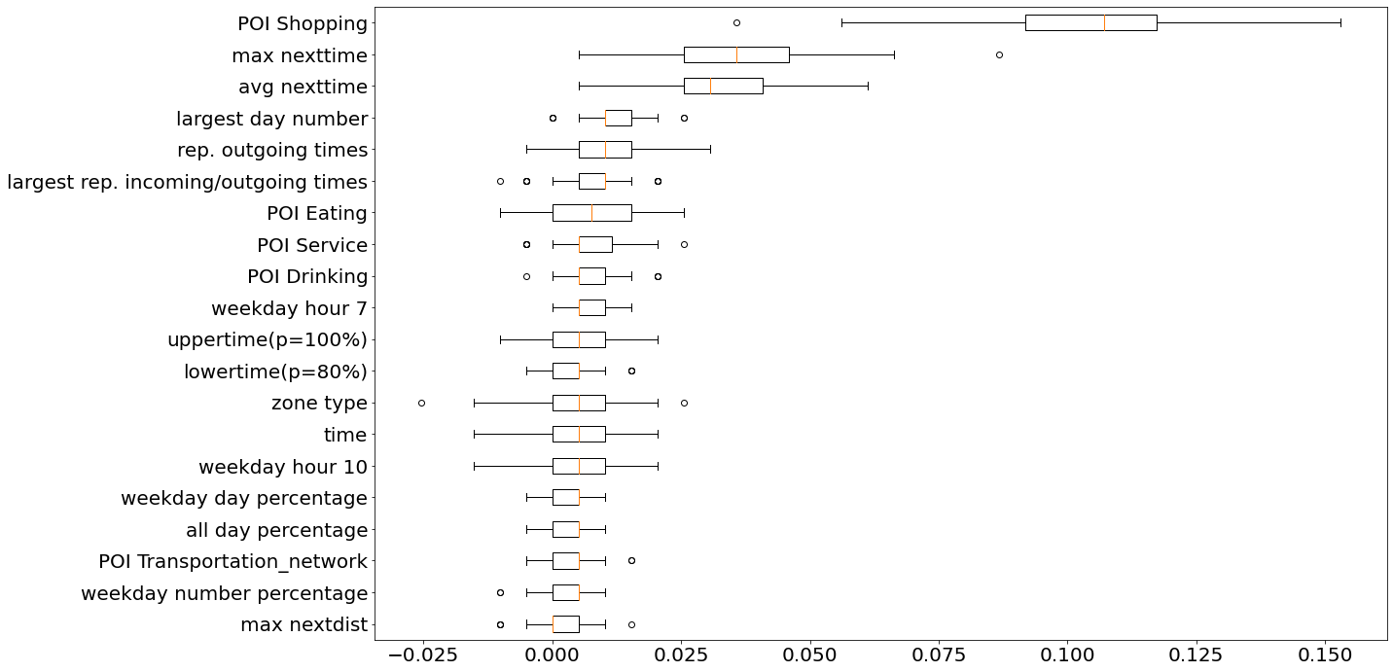

Figure 4. Top 20 features with the highest permutation importance for identifying *Dwelling*, *Work*, and *Shopping* activities in the test set

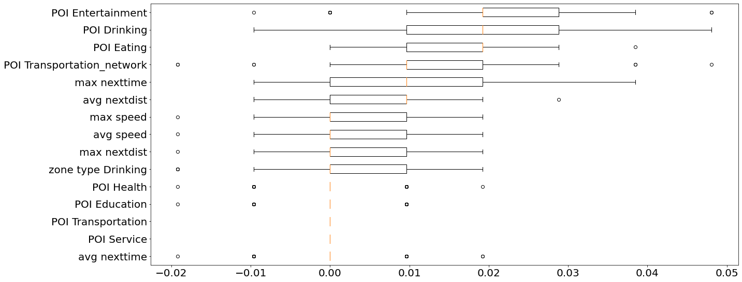

Figure 5. Top 15 features with the highest permutation importance for identifying *Drinking* activities in the test set

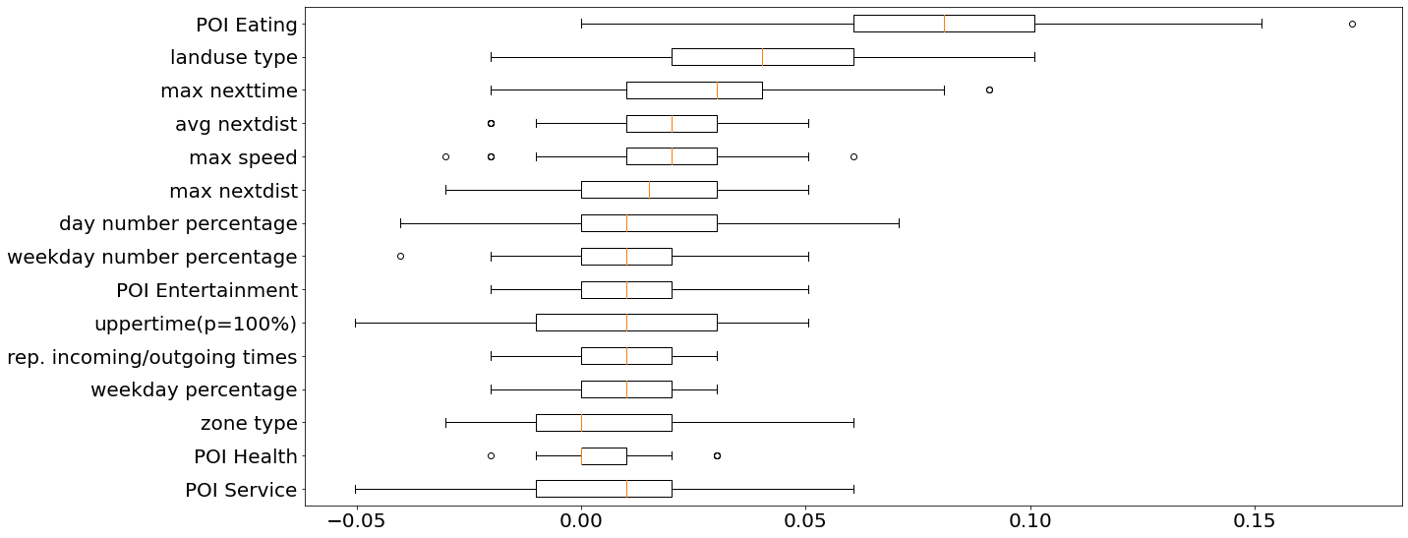

Figure 6. Top 15 features with the highest permutation importance for identifying *Eating*, *Entertainment*, and *Health* activities in the test set

In general, both spatiotemporal movement pattern and geographic context features are of high importance in classifying all travel activity types. However, feature importance differs at each identification level. Particularly, the distribution of *Shopping* POIs and features representing temporal patterns, such as the maximum or average time difference between two consecutive footprints and the frequency of footprints generated during daytime, become the most crucial features for identifying *Dwelling*, *Work*, and *Shopping* activities (Figure 4). Spatial pattern features, especially the frequencies of outgoing and incoming footprints, also make a difference (Figure 4). Distributions of other types of POIs contribute substantially to identifying remaining activity types (i.e., *Drinking*, *Eating*, *Entertainment*, and *Health*). For example, the distribution of *Entertainment*, *Drinking*, and *Eating* POIs (Figure 5) jointly contributes to improving the precision of identifying *Drinking* activities compared with the model which only leverages *Drinking* POIs (Table 7). On the other hand, distributions of *Eating*, *Entertainment*, and *Health* POIs show great importance in differentiating their representative travel activity types (Figure 6).

**4.4 Class imbalance**

At each identification level, the sampling frequency of one activity type could be much less than the other (e.g., 60 *Dwelling* and 483 *Shopping* activities are discovered respectively, Table3), while random forest classifiers are biased towards the majority class, raising an imbalanced classification challenge (Brownlee 2021). At the first identification level, one-vs-all classification is used to overcome the imbalance problem (Huang et al. 2012). This is because each of the three primary activities can be easily differentiated from the rest using our proposed features. Meanwhile, in the remaining two identification levels, different weights are given to the minority and majority classes, so that the misclassification made by the minority class would be penalized more heavily with a higher class weight (Procrastinator 2020). Specifically, inverse weighting from the training dataset is used at the third level to weigh more on the minority class (Brownlee 2021). At the second level, where the two classes of *Drinking* and *Others* can be severely imbalanced, class weights are manually defined to disallow more false positive of the minority class (i.e., *Drinking* activities) for improving the precision of identifying them (Procrastinator 2020, Brownlee 2021).

**5 Conclusion and future work**

With the development of location-based services, a large amount of individual daily travel trajectories can be collected via GPS installed on portable mobile devices, which allows us to investigate individual daily travel activities as novel risk signals for opioid relapse prediction. Previous studies failed to identify all related travel activity types (i.e., *Dwelling*, *Work*, *Shopping*, *Drinking*, *Eating*, *Entertainment*, and *Health*) for our targeted population (e.g., alcohol addicts). Additionally, these methods mostly rely on manual annotations of place labels instead of ground truth data for training activity type classifiers, which suffers from bias of human subjectivity or ambiguity of place categories for activity type indication.

Therefore, this study extracts diverse features representing spatiotemporal movement patterns from individual travel trajectories and integrates locational geographic context by leveraging OSM datasets to comprehensively capture characteristics of each distinct activity type. A hierarchical classification model is also developed based on Random Forest and customized class weights are applied to overcome the challenge of imbalanced classification of all travel activity types. Our proposed model receives high precision scores for classifying most activity types and high recall for identifying primary activities including *Dwelling*, *Work*, and *Shopping*. Finally, we examine the importance of each feature for identifying different activity types and find that while geographic context features are effective in classifying all activity types, spatiotemporal movement patterns are particularly useful for inferring three primary activity types.

The accuracy of travel activity type identification could be further enhanced in our future efforts. Specifically, more advanced models should be developed to explicitly leverage travel sequence features (e.g., typical direct transitions from *Dwelling* to *Work* or from *Work* to *Entertainment*), which represent internal human mobility structures and can contribute to more accurate activity type identification (Martin et al. 2018). Additionally, potential bias of the model should be alleviated by improving the identification accuracy when including trajectory data with more diverse travel scenarios (e.g., individual trajectories with flexible *Work* schedules at multiple *Work* locations, Stiles and Smart 2020). Further, more robust models should be developed to automatically and dynamically leverage our proposed features from raw data, so that the process of feature extraction and hierarchical classification could be simplified to increase training efficiency and to reduce uncertainties brought by customized hyper-parameters.

**References**

R. Agrawal and J. Shanahan. Location disambiguation in local searches using gradient boosted decision trees. pages 129–136, 01 2010.

L. Alexander, S. Jiang, M. Murga, and M. C. González. Origin-destination trips by purpose and time of day inferred from mobile phone data. Transportation Research Part C: Emerging Technologies, 58:240–250, 2015. Big Data in Transportation and Traffic Engineering.

L. Alvares, V. Bogorny, and B. Kuijpers. Towards semantic trajectory knowledge discovery. 10 2007.

S. Bae, D. Ferreira, B. Suffoletto, J. Puyana, R. Kurtz, T. Chung, and A. Dey. Detecting drinking episodes in young adults using smartphone-based sensors. Proceedings of the ACM on Interactive, Mobile, Wearable and Ubiquitous Technologies, 1:1– 36, 2017.

V. D. Blondel, A. Decuyper, and G. Krings. A survey of results on mobile phone datasets analysis. EPJ Data Science, 4:1–14, 2015.

J. Brownlee. Bagging and random forest for imbalanced classification. Imbalanced Classification, 1 2021.

D. Choujaa. Activity recognition from mobile phone data: State of the art, prospects and open problems. 2014.

J. Curtin, D. Shah, X. Zhu, D. Gustafson, R. Brown, W. Sethares, and Q. Huang. Contextualized daily prediction of lapse risk in opioid use disorder by digital phenotyping. 2019.

N. Davidovic, P. Mooney, L. Stoimenov, and M. Minghini. Tagging in volunteered geographicinformation: An analysis of tagging practices forcities and urban regions in openstreetmap. ISPRS International Journal of Geo-Information, 5(12), 2016.

W. El-Hajj, G. Brahim, C. El-Hayek, and H. Hajj. Feature Extraction and Large Activity-Set Recognition Using Mobile Phone Sensors, pages 65–70. 092017.

M. Ester, H.-P. Kriegel, J. Sander, and X. Xu. A density-based algorithm for discovering clusters in large spatial databases with noise. pages 226–231.AAAI Press, 1996.

H. Gao, J. Tang, and H. Liu. Mobile location prediction in spatio-temporal context. 04 2012.

L. Gong, R. Kanamori, and T. Yamamoto. Data selection in machine learning for identifying trip purposes and travel modes from longitudinal gps data collection lasting for seasons. Travel Behaviour and Society, 11:131–140, 2018.

C.-M. Huang, J. J.-C. Ying, and V. S. Tseng. Mining users’ behaviors and environments for semantic place prediction. 2012.

Q. Huang, G. Cao, and C. Wang. From where do tweets originate?: a gis approach for user location inference. pages 1–8, 11 2014.

Q. Huang and D. W. Wong. Activity patterns, socioeconomic status and urban spatial structure: what can social media data tell us? International Journal of Geographical Information Science, 30(9):1873–1898, 2016.

S. Hwang, C. Evans, and T. Hanke.Detecting StopEpisodes from GPS Trajectories with Gaps, pages 427–439. 10 2016.

S. Isaacman, R. Becker, R. Cáceres, S. Kobourov, M. Martonosi, J. Rowland, and A. Varshavsky. Identifying important places in people’s lives from cellular network data. pages 133–151, 06 2011.

S. Jiang, G. Fiore, Y. Yang, J. Ferreira, E. Frazzoli, and M. C. Gonzalez. A review of urban computing for mobile phone traces: Current methods, challenges and opportunities. 08 2013.

F. Liu, D. Janssens, G. Wets, and M. Cools. Annotating mobile phone location data with activity purposes using machine learning algorithms. Expert Systems with Applications, 40:3299–3311, 062013.

X. Liu, Q. Huang, and S. Gao. Exploring the uncertainty of activity zone detection using digital footprints with multi-scaled dbscan. International Journal of Geographical Information Science, 33(6):1196–1223, 2019.

X. Liu, Q. Huang, S. Gao, and J. Xia. Activity knowledge discovery: Detecting collective and individual activities with digital footprints and open source geographic data. Computers, Environment and Urban Systems, 85:101551, 01 2021.

Y. Liu, X. Liu, S. Gao, L. Gong, C. Kang, Y. Zhi,G. Chi, and L. Shi. Social sensing: A new approach to understanding our socioeconomic environments. Annals of the Association of American Geographers, 105(3):512–530, 2015.

M. Ljumovic and M. Klar. Estimating expected errorrates of random forest classifiers: A comparison of cross-validation and bootstrap. pages 212–215, 062015.

M. Lv, L. Chen, and G. Chen. Discovering personally semantic places from gps trajectories. pages 1552–1556, 10 2012.

H. Martin, D. Bucher, E. Suel, P. Zhao, F. Pérez-Cruz, and M. Raubal. Graph convolutional neural networks for human activity purpose imputation. InNIPS 2018, 2018.

C. Meng, Y. Cui, Q. He, L. Su, and J. Gao. Travel purpose inference with gps trajectories, pois, and geo-tagged social media data. pages 1319–1324, 122017.

C. Molnar. Interpretable machine learning. Lulu.com, 2020.

R. Montoliu and D. Gatica-Perez. Discovering human places of interest from multimodal mobile phone data. InMUM, 2010.6

F. Pargent, B. Bischl, and J. Thomas. A benchmark experiment on how to encode categorical features in predictive modeling. PhD thesis, M.Sc. Thesis, Ludwig-Maximilians–Universitat Munchen, pp12, 2019.

Procrastinator. How to improve class imbalance using class weights in machine learning. Data Science Blogathon, 10 2020.

I. R. Pulshashi, H. Bae, H. Choi, S. Mun, and R. A. Sutrisnowati. Simplification and detection of outlying trajectories from batch and streaming data recorded in harsh environments. ISPRS International Journal of Geo-Information, 8(6), 2019.

A. Rivero-Rodriguez, H. Leppäkoski, and R. Piché.Semantic labeling of places based on phone usage features using supervised learning. In2014 Ubiquitous Positioning Indoor Navigation and Location Based Service (UPINLBS), pages 97–102, 2014.

A. Rivero Rodriguez and O. Nykänen. Context Awareness for Semantic Mobile Computing. 032017.

D. Santani, T. Do, F. Labhart, S. Landolt, E. Kuntsche, and D. Gatica-Perez. Drinksense: Characterizing youth drinking behavior using smartphones. IEEE Transactions on Mobile Computing, 17:2279–2292, 2018.

S. Shiffman. Dynamic influences on smoking relapse process. Journal of Personality, 73(6):1715–1748, 2005.

M. Shoaib, S. Bosch, O. D. Incel, H. Scholten, and P. J. Havinga. A survey of online activity recognition using mobile phones. Sensors, 15(1):2059–2085, 2015.

J. Stiles and M. J. Smart. Working at home and else-where: daily work location, telework, and travel among united states knowledge workers. Transportation, pages 1–31, 2020

R. Su, E. McBride, and K. Goulias. Pattern recognition of daily activity patterns using human mobility motifs and sequence analysis. Transportation Research Part C Emerging Technologies, 120, 112020.

K. Witkiewitz and G. Marlatt. Modeling the complexity of post-treatment drinking: it’s a rocky road to relapse. Clinical psychology review, 27:724-38, 08 2007.

G. Xiao, Z. Juan, and C. Zhang. Detecting trip purposes from smartphone-based travel surveys with artificial neural networks and particle swarm optimization. Transportation Research Part C: Emerging Technologies, 71:447–463, 2016.

Z. Yan, D. Chakraborty, S. Spaccapietra, K. Aberer, and C. Parent. Semitri: A framework for semantic annotation of heterogeneous trajectories, 2011.

V. Zheng, Y. Zheng, and Q. Yang. Joint learning user’s activities and profiles from gps data. pages 17–20, 01 2009.

S. Çolak, L. P. Alexander, B. G. Alvim, S. R. Mehndiratta, and M. C. González. Analyzing cellphone location data for urban travel: Current methods, limitations, and opportunities. Transportation Research Record, 2526(1):126–135, 2015.