**RA Audio Transfer Step By Step**

The study phone is always kept in RM 187. Never leave the study phone unattended, lock it up if you need to leave your desk.

Programs to have open:

1. iMazing
2. R Studio - The script you want to have open is located here: **P:\StudyData\RISK\Analysis\RISK\mak_iMazing**

Documents to have open:

1. The Audio transfer SOP
2. Audio Transcript Check spreadsheet, located here: **P:\StudyData\RISK\Administration\Participants\Compliance\Audio Transcript Check)**

Web pages to have open:

1. Merge (audio converter) <https://online-audio-converter.com/>

**Step 1: iMazing**

1. Open iMazing and select the study iPhone and then select “backup”
2. Now, go to **Messages** in iMazing.
3. The messages should be sorted by SubId.
4. Select a SubId and transfer each Sub ID’s message(s) to the appropriate SubId folder.
5. In order to copy the message to the participant’s Raw Data folder, click on the message in the right-hand pane of the box, and then right click on the message.

*\*\*If the participant has several messages you can export them all at once by clicking on the first message, pressing and hold shift and then clicking the last message from that Sub ID, and then right clicking the group of messages**The important thing is that the messages must be individually highlighted. If you try to export all of the attachments from the Sub ID you’ll lose the information regarding the date and time the message was sent.*

1. Select **Export Attachments.**
2. A dialog box will pop up titled **Browse For Folder**.
3. Scroll down to RISK>RawData>SubID>Audio and press **OK**.

**Step 2: R Studio**

1. Open R Studio,
2. Click **Open File**
3. Select this path **P:\StudyData\RISK\Analysis\RISK\ mak_iMazing**
4. Run the script by pressing Ctrl + A and clicking on **Run**
5. When the script is done running all of the files will be renamed with this format:

SubID_year of recording_date of recording_time of recording (military time)   
Ex: 002_2016_1128_0730

1. You will get a list of the files that were renamed in R Studio

**Step 3: Listen to the messages from the raw data folder**

1. Make sure your speakers are turned on/headphones are plugged in
2. Click on the audio message you are reviewing in the participant’s Audio folder in the Raw Data folder
3. If the message won’t play you will need to convert it using the Merge program.
4. If the message still won’t play contact study staff or leave the message on the phone for study staff to review.

**To convert files that won’t play use this website** <https://online-audio-converter.com/>

1. Click on the  button in the top left-hand side of the screen

2. Click on  and click on the participant’s audio file in the Raw Data folder

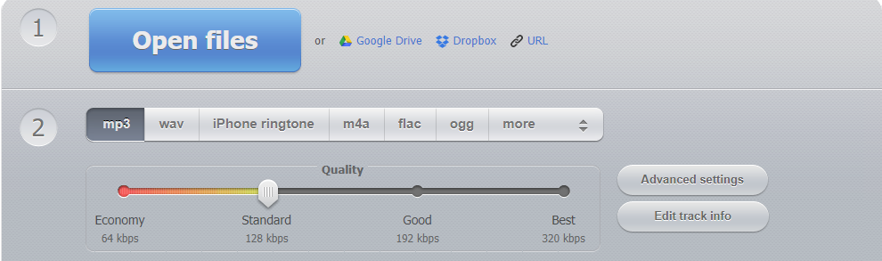

3. Click on  and download the file

4. Save downloaded file to the participant’s audio folder

**Step 4: Record the messages on the Audio Transcript Check spreadsheet**

1. P:\StudyData\RISK\Administration\Participants\Compliance\Audio Transcript Check

**Step 5: Delete the Backup from iMazing**

1. To delete files from iMazing click on and select Delete All. Once the backup is deleted you can close iMazing.

**Step 7: Delete messages from the iPhone**

1. Once you have confirmed that all of the audio files have been transferred to the raw data folder, renamed, listened to, and recorded on the audio transcript check sheet, you can delete the messages from the iPhone. Messages that are deleted cannot be recovered, so if you are unsure about any step of the process please consult with the study coordinator or staff to ensure files have been properly transferred before deletion.