**RISK Standard Operating Procedure (SOP)**

**Survey Signal**

Last Edited: 6/28/2019 12:13 PM

Contents

File Locations 3

General notes about Survey Signal 4

Survey set up 5

Survey Signal registration 11

Survey download (off study participants) 13

File Locations

EMA form

* Located in the participants folder, found in the second drawer of the RISK file cabinet

# General notes about Survey Signal

1. Each participant has their own set of 4 surveys (**Morning**, **Audio**, **Randomized**, and **Evening**) created with the general format of RISK – Type of Survey Sub ID, e.g., **RISK - Morning 000**
2. The Morning survey should be set at the participants’ EARLIEST wake time.
3. The Evening survey should be set 1 HOUR BEFORE the participants’ EARLIEST bed time.
4. ALWAYS USE MILITARY TIME
5. Have this document open to copy information from
6. Each **Mobile Survey starts after 1** day – so the participant can start getting their surveys the day after their Intake
7. Each survey **Start Date** should be set at the day of the participants scheduled Intake
8. Each survey **End Date** should be set at approximately 95 days after their scheduled Intake (the number of days is arbitrary as long as it is over 90 days).
9. The **Morning, Randomized** and **Evening** surveys have a should have the Signal Timeout of 6 hours.
10. The SMS Signal Subject for the **Morning, Randomized** and **Evening** surveys is: “Time to take your survey:”
11. If you change anything after creating the survey you must hit the red “Update” button in the section that you changed – Survey Signal does not automatically save changes

# Survey set up

1. Staff will notify you when Survey Signal needs to be set up through Asana
   1. When a participant passes the screening visit they need to have 4 different daily surveys set up before their intake visit
2. Go to <http://surveysignal.com/login.aspx>
   1. Log in using the following:
      1. Username: [schneck2@wisc.edu](mailto:schneck2@wisc.edu)
      2. Password: CurtinLab
3. Click on My Surveys on the left-hand side
4. On the righthand side click the button
5. A popup should appear asking if you want to create a ‘create one shot survey project’ or to ‘create repeated survey project’
   1. Select
6. **Morning Survey**
   1. In general parameters:
      1. The **Survey Project Name** and **Survey Project Description** are:
         1. **RISK - Morning** **(SubID)**
      2. The **SMS Signal Subject** is: Time to take your survey:
      3. **Signal Timeout after** is set at **6h**
      4. **Send Reminder after** should be set to **Off**
      5. **Additional Code Required?** and **Parallel Signals…** should be set to **NO** (the default setting)
      6. **Survey Distribution via** should be set to **SMS**
   2. In schedule parameters:
      1. **Survey Window Start Date** should be set at the participant’s intake date
      2. **Survey Window End Date** should be set approximately 95 days later
         1. To calculate 95 days follow this link: <https://www.convertunits.com/dates/daysfromdate/>
         2. Adjust the number of days and the date to get 95 days from intake
      3. The Morning survey is set at the participants earliest wake time
         1. **Daily Window Start Time** should be set at 1 minute before their earliest reported wake time
         2. **Daily Window End Time** should be set at 1 minute after their earliest reported wake time
         3. e.g., if their earliest reported wake time is 7:00 am you would set their times like this:

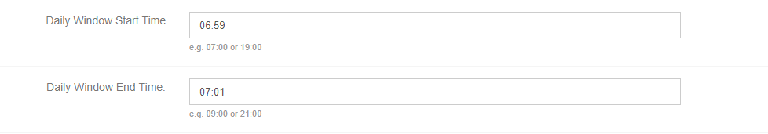

* + 1. **Mobile Survey starts after** is always set to1
       1. this means that the survey will start the day after the scheduled intake
    2. **Mobile Survey Duration** is always set to 90 days
    3. **Number of Signals/Day** should be set to 1
    4. **Survey Schedule** is set to **RANDOM**
    5. **Type of Randomization** is set to **RANDOM WITHIN SEGMENTS**
    6. **Add Fixed Signals** is set to 0
    7. **Minimum Distance betw. Signals** is 1
    8. **Mobile Morning Survey Link** is:

<https://uwmadison.co1.qualtrics.com/SE/?SID=SV_bBGKAzNQeyXuN6Z&SubID=test>

* + - 1. Change “test” to the appropriate SubID
  1. **Participant Registration Parameters (Optional)** do not need to be adjusted
  2. Click on to finish creating the survey
     1. if you have successfully created the survey, without errors, you will be directed back to the **My Surveys** page

1. **Evening Survey**
   1. In general parameters:
      1. The **Survey Project Name** and **Survey Project Description** are:
         1. **RISK - Evening** **(SubID)**
      2. The **SMS Signal Subject** is - Time to take your survey:
      3. **Signal Timeout after** is set at **6h**
      4. **Send Reminder after** should be set to **Off**
      5. **Additional Code Required?** and **Parallel Signals…** should be set to **NO** (the default setting)
      6. **Survey Distribution via** should be set to **SMS**
   2. In schedule parameters:
      1. **Survey Window Start Date** should be set at the participant’s intake date
      2. **Survey Window End Date** should be set approximately 95 days later
         1. To calculate 95 days follow this link: <https://www.convertunits.com/dates/daysfromdate/>
         2. Adjust the number of days and the date to get 95 days from intake
      3. The Evening survey is set one hour before the participants earliest reported bed time
         1. **Daily Window Start Time** should be set at 61 minutes before their earliest reported bedtime
         2. **Daily Window End Time** should be set at 59 minutes before their earliest reported bedtime

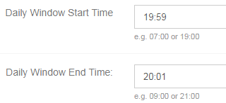

* + - 1. e.g., if their earliest reported bedtime is 9:00 pm you would set their times like this:
    1. **Mobile Survey starts after** is always set to1
       1. this means that the survey will start the day after the scheduled intake
    2. **Mobile Survey Duration** is always set to 90 days
    3. **Number of Signals/Day** should be set to 1
    4. **Survey Schedule** is set to **RANDOM**
    5. **Type of Randomization** is set to **RANDOM WITHIN SEGMENTS**
    6. **Add Fixed Signals** is set to 0
    7. **Minimum Distance betw. Signals** is 1
    8. **Mobile Evening Survey Link** is: <https://uwmadison.co1.qualtrics.com/SE/?SID=SV_aViOZNT66b7wff7&SubID=test>
       1. Change “test” to the appropriate SubID
  1. **Participant Registration Parameters (Optional)** do not need to be adjusted
  2. Click on to finish creating the survey
     1. if you have successfully created the survey, without errors, you will be directed back to the **My Surveys** page

1. **Randomized Survey**
   1. In general parameters:
      1. The **Survey Project Name** and **Survey Project Description** are:
         1. **RISK - Randomized (SubID)**
      2. The **SMS Signal Subject** is - Time to take your survey:
      3. **Signal Timeout after** is set at **6h**
      4. **Send Reminder after** should be set to **Off**
      5. **Additional Code Required?** and **Parallel Signals…** should be set to **NO** (the default setting)
      6. **Survey Distribution via** should be set to **SMS**
   2. In schedule parameters:
      1. **Survey Window Start Date** should be set at the participant’s intake date
      2. **Survey Window End Date** should be set approximately 95 days later
         1. To calculate 95 days follow this link: <https://www.convertunits.com/dates/daysfromdate/>
         2. Adjust the number of days and the date to get 95 days from intake
      3. The Evening survey is set one hour before the participants earliest reported bed time
         1. **Daily Window Start Time** should be set at 2 hours after their latest wake time
         2. **Daily Window End Time** should be set at 3 hours before their earliest bedtime
         3. e.g., if their earliest reported bedtime is 8:00 pm you would set their times like this:

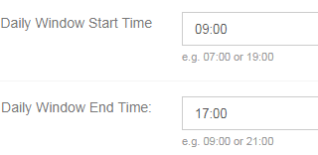

* + - 1. Please note: This window needs to be at least 8 hours. If the window is less than this survey signal will not let you submit the survey. To fix this move the start time back 1 hour followed by moving the end time. Do this until you reach 8 hours. Do not go further than this if you do not have to.
    1. **Mobile Survey starts after** is always set to1
       1. this means that the survey will start the day after the scheduled intake
    2. **Mobile Survey Duration** is always set to 90 days
    3. **Number of Signals/Day** should be set to 2
    4. **Survey Schedule** is set to **RANDOM**
    5. **Type of Randomization** is set to **RANDOM WITHIN SEGMENTS**
    6. **Add Fixed Signals** is set to 0
    7. **Minimum Distance betw. Signals** is 120
    8. **Mobile Randomized Survey Link** is: <https://uwmadison.co1.qualtrics.com/SE/?SID=SV_aViOZNT66b7wff7&SubID=test>
       1. Change “test” to the appropriate SubID
  1. **Participant Registration Parameters (Optional)** do not need to be adjusted
  2. Click on to finish creating the survey
     1. if you have successfully created the survey, without errors, you will be directed back to the **My Surveys** page
     2. Alert study staff if you get any errors – if there is significant variation in their sleep/wake schedules then we will have to adjust when the random surveys are sent.

1. **Audio Survey**
   1. In general parameters:
      1. The **Survey Project Name** and **Survey Project Description** are:
         1. **RISK - Audio (SubID)**
      2. The **SMS Signal Subject** is - Please send your daily audio msg to 608-572-2496 now
      3. **Signal Timeout after** is set to expire at midnight
         1. E.g., if participant has a wake time of 7:00 AM, the link should timeout after 17 hours
         2. E.g., if participant has a wake time of 7:30 AM, the link should still timeout after 17 hours
      4. **Send Reminder after** should be set to **Off**
      5. **Additional Code Required?** and **Parallel Signals…** should be set to **NO** (the default setting)
      6. **Survey Distribution via** should be set to **SMS**
   2. In schedule parameters:
      1. **Survey Window Start Date** should be set at the participant’s intake date
      2. **Survey Window End Date** should be set approximately 95 days later
         1. To calculate 95 days follow this link: <https://www.convertunits.com/dates/daysfromdate/>
         2. Adjust the number of days and the date to get 95 days from intake
      3. The Evening survey is set one hour before the participants earliest reported bed time
         1. **Daily Window Start Time** should be set at 4 minutes after their earliest reported wake time
         2. **Daily Window End Time** should be set at 6 minutes after their earliest reported wake time
         3. e.g., if their earliest reported wake time is 7:00 AM you would set their times like this:

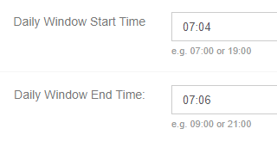

* + 1. **Mobile Survey starts after** is always set to1
       1. this means that the survey will start the day after the scheduled intake
    2. **Mobile Survey Duration** is always set to 90 days
    3. **Number of Signals/Day** should be set to 1
    4. **Survey Schedule** is set to **RANDOM**
    5. **Type of Randomization** is set to **RANDOM WITHIN SEGMENTS**
    6. **Add Fixed Signals** is set to 0
    7. **Minimum Distance betw. Signals** is 1
    8. **Mobile Audio Survey Link** is: <https://uwmadison.co1.qualtrics.com/jfe/form/SV_00X6MBp2i6CPozP>
       1. You do not need to add SubID to this survey
  1. **Participant Registration Parameters (Optional)** do not need to be adjusted
  2. Click on to finish creating the survey
     1. if you have successfully created the survey, without errors, you will be directed back to the **My Surveys** page

# Survey Signal registration

1. **General reminders:** 
   1. Participants’ surveys should be set up before their intake appointment
   2. They will have four surveys to register for, each designated by their Sub ID.
      1. The 4 surveys will be titled:
         1. RISK – Morning (Sub ID)
         2. RISK – Audio (Sub ID)
         3. RISK – Randomized (Sub ID)
         4. RISK – Evening (Sub ID)
2. **To register the participant**:
3. Click on the appropriate survey
4. Click on the **Participant Signup Link.**
5. You will be directed to a page that asks for a first name, last name, email and phone number
   1. Use the designation RISK and the participant’s assigned Sub ID as their first name, last name, and email address
      1. (e.g., RISK 001)
   2. enter their actual cell phone number
6. Have participants open all four links to register
7. Verify that they have registered by clicking on each of their surveys and clicking the Participants icon:
8. You will see a box that looks like this that has **YES** under **SMS** **Verified**  and under **Active.**



1. Participants may be sent registration links before the tech part of the visit, just make sure that the RA running the interview alerts the participant not to open the links until instructed to.
2. **Test Surveys for Intake**
   1. Steps for setting up test Morning EMA:
      1. Open Survey Signal on the lab laptop.
      2. Go to the participant’s **Morning Survey** and click on the participants icon
      3. Click on **Send Message**
         1. Subject is "SurveySignal>"
         2. Body is " Time to take your survey: <https://goo.gl/Xst8uc>”
      4. Repeat for Evening survey and audio EMAs
   2. Steps for setting up test Evening EMA:
3. Go to the participant’s **Evening Survey** and click on the participants icon
4. Click on **Send Message**
   1. Subject is "SurveySignal>"
   2. Body is " Time to take your survey: <https://goo.gl/Mb1XSQ>”
   3. Steps for setting up test Audio EMA:
5. Next set up the participant’s **Audio survey** and click on the participants icon
6. Click on **Send Message**
   1. Subject is "SurveySignal>"
   2. Body is "Please send your daily audio msg to 608-572-2496 now. <https://uwmadison.co1.qualtrics.com/jfe/form/SV_00X6MBp2i6CPozP>"
7. **Troubleshooting issues:**
   1. If a participant reports that they aren’t getting surveys:
      1. Check to make sure they are registered for the survey
      2. Check to make sure that the start date is correct
      3. Check to make sure that the Number of Signals/Day is set to 1 (or if it’s the Randomized surveys that it is set to 2)
      4. If the problem persists, try to re-register their phone number for the survey – if the phone number was put in accurately it will not let you re-register
      5. If all else fails, contact Susan for further assistance

Survey download (off study participants)

1. Staff will notify you when Survey Signal needs to be downloaded through Asana
2. Go to <http://surveysignal.com/login.aspx>
   1. Log in using the following:
      1. Username: [schneck2@wisc.edu](mailto:schneck2@wisc.edu)
      2. Password: CurtinLab
3. When a participant becomes off study all four surveys need to be downloaded and put in the participants RawData folder
   1. The following files need to be downloaded
      1. Morning
      2. Audio
      3. Randomized
      4. Evening
4. Click on **My Surveys**
5. Find the survey that you want to download and click on the survey
6. Click on **Download Data**

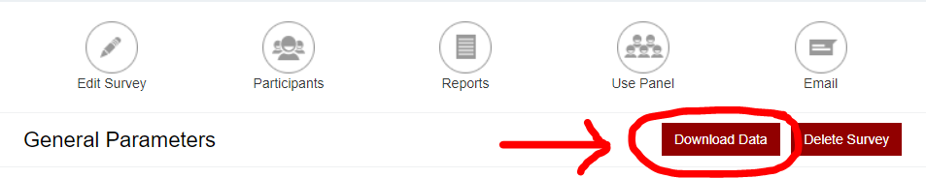

1. When this screen comes up, click **Download Data** 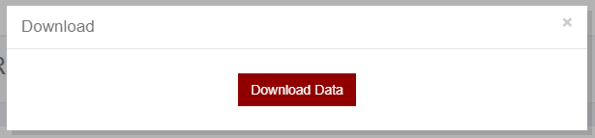
2. Once it is finished it’ll return to the Survey Screen

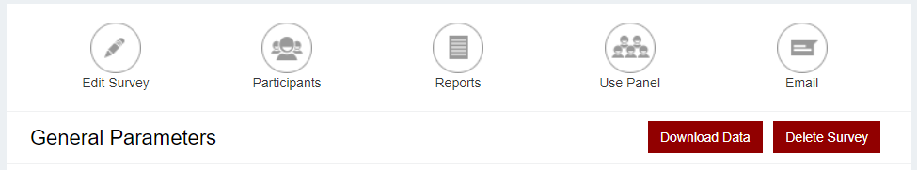



1. Click Download Data again
2. A screen like this will come up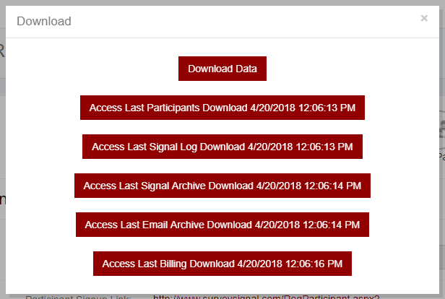
3. Make sure the downloads are timestamped with the date and time that you downloaded the data

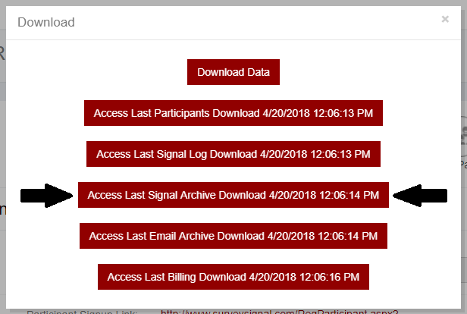

1. Click on **Access Last Signal Archive Download**
2. You’ll see a file that is labeled with the Survey ID followed by DailySignalArchive

For this example: the file is 100417134019DailySignal

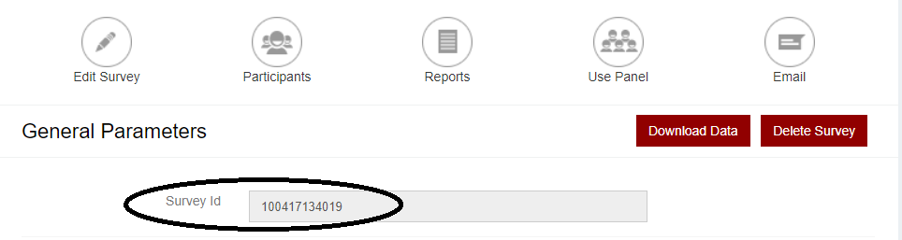

* 1. Rename the files using the following format while still in the downloads folder:
     1. SubID_SSAM for the Morning survey
     2. SubID_SSRan for the Randomized survey
     3. SubID_SSPM for the evening surveys
     4. SubID_SSAudio for the Audio surveys

1. Open the file. You’ll see this message

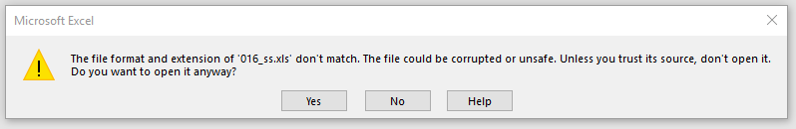

1. Click **Yes**
2. Click **Enable Editing**
3. Click **File > Save As** from the file type drop box select **Excel Workbook**

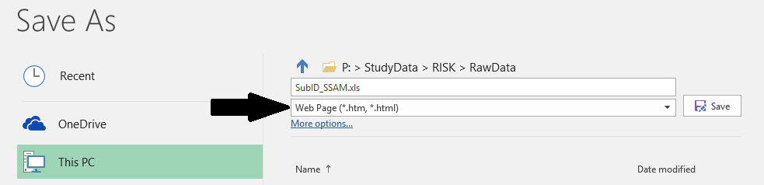

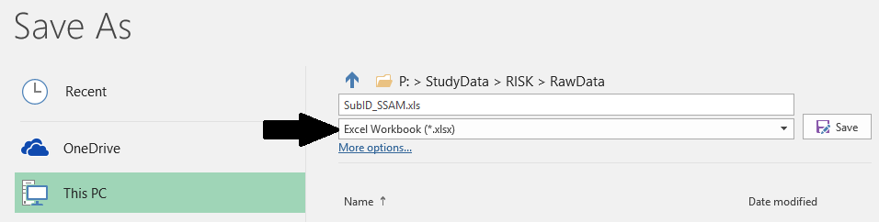

1. Save the file to the participant’s raw data folder.
2. Complete these steps for all 4 surveys
3. In Asana in the RA tasks there is a task labeled “Survey Signal Download.” This task is for Susan to review the downloads before deleting the Surveys in Survey Signal. Once you have completed the downloads create a subtask in the “Survey Signal Download” task labeled with the participants Sub ID. Assign the task to Susan for review.