|  |
| --- |
| **Bozen / Bolzano,** |
| **03/07/2018** |
|  |
|  |
|  |
|  |

**Letter of invitation**

Dear ,

Prof. Barbara Russo of the Faculty of Computer Science is pleased to invite you on October 4-5 2018 to give the talk and participate to the MSc thesis defence day.

“<title>”

at the Faculty of Computer Science, p.za Domenicani, 3, I-39100 Bolzano, Italy.

We are looking forward to your visit.

Best regards

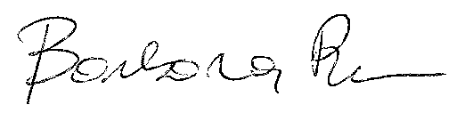

Prof. Barbara Russo

Faculty of Computer Science

Free University of Bozen-Bolzano,

I-39100, Bolzano, Italy

Email: brusso@unibz.it