Defects:

1.For few questions all the answers are wrong but still it shows green

2. Images are not aligned for few scenarios

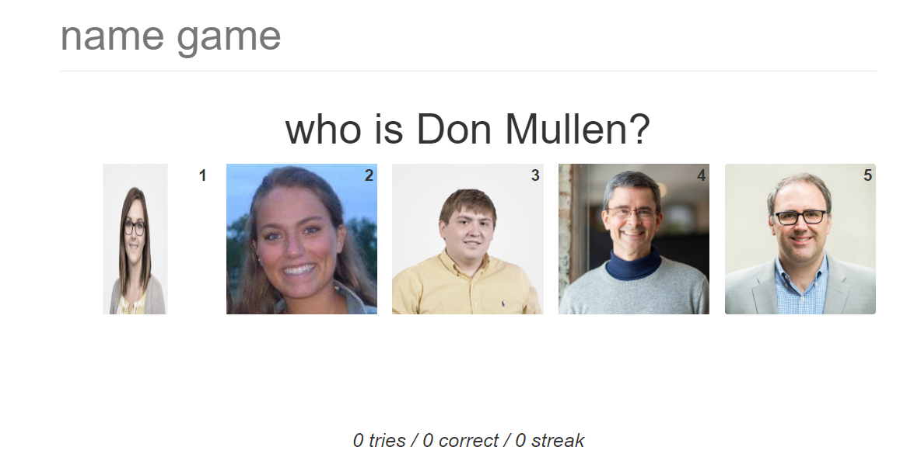

3.Even after giving incorrect answers the streak count increases instead of decreasing

4.The alphabets are not in sync like capitals and small letters