PHOENIX TABLES COMPARATOR
BETWEEEN 2 SERVERS

- Make sure queryserver is up and running in both servers needed to be compared.

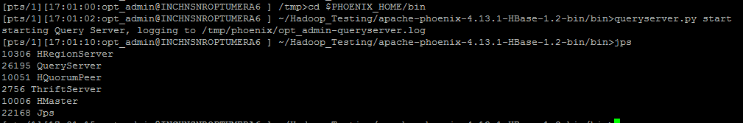
- Hostname-1 acts as master server and discrepancies are listed from the server -2
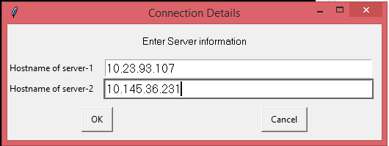

- In order to do a vice versa comparison ,just swap the entries.

