 | Cognizant Academy  Collateral Loans – Risk Assessment  FSE – Business Aligned Project  Case Study Specification  Version 1.0
 | Prepared By / Last Updated By | Reviewed By | Approved By
Name | Srilakshmi Jayaraman
Role | Solution Designer
Signature
Date

Table of Contents

1.0 Important Instructions 3
2.0 Introduction 4
2.1 Purpose of this document 4
2.2 Project Overview 4
2.3 Scope 4
2.4 Hardware and Software Requirement 5
2.5 System Architecture Diagram 6
3.0 Functional Requirements and High Level Design 6
3.1 Use Case Diagram 6
3.2 Individual Components of the System 7
3.2.1 Collaterals Management Microservice 7
3.2.2 Loan Management Microservice 8
3.2.3 Risk Assessment Microservice 9
3.2.4 Authorization Microservice 10
3.2.5 Swagger 10
3.2.6 Collateral Loans Portal 10
4.0 Cloud Deployment requirements 11
5.0 Design Considerations 11
6.0 Reference learning 11
7.0 Change Log 12

Important Instructions
- Associate must adhere to the Design Considerations specific to each Technolgy Track
- Associate must not submit project with compile-time or build-time errors
- Being a Full-Stack Developer Project, you must focus on ALL layers of the application development
- Unit Testing is Mandatory, and we expect a code coverage of 100%. Use Mocking Frameworks wherever applicable.
- All the Microservices, Client Application, DB Scripts, have to be packaged together in a single ZIP file. Associate must submit the solution file in ZIP format only
- If backend has to be set up manually, appropriate DB scripts have to be provided along with the solution ZIP file
- A READ ME has to be provided with steps to execute the submitted solution, the Launch URLs of the Microservices in cloud must be specified.
(Importantly, the READ ME should contain the steps to execute DB scripts, the LAUNCH URL of the application)
- Follow coding best practices while implementing the solution. Use appropriate design patterns wherever applicable
- You are supposed to use an In-memory database or sessions as specified, for the Microservices that will be deployed in cloud. No Physical database is suggested.

Introduction

Purpose of this document
The purpose of the software requirement document is to systematically capture requirements for the project and the system “Collateral Loans – Risk Assessment System” that has to be developed. Both functional and non-functional requirements are captured in this document. It also serves as the input for the project scoping.
The scope of this document is limited to addressing the requirements from a user, quality, and non-functional perspective.
High Level Design considerations are also specificed wherever applicable, however the detailed design considerations have to be strictly adhered to during implementation.

Project Overview
The term "collateral" refers to any asset or property that a consumer promises to a Bank as backup in exchange for a loan. Typically, collateral loan agreements let the Bank to take over the asset if the borrowers fail to repay the debt according to the loan contract.
This Collateral can be any item of value that is accepted as an alternate form of repayment in case of default. If loan payments are not made, assets can be seized and sold by banks. This ensures that a lender receives full or partial compensation for any outstanding balance on a defaulted debt.
The Bank wants to develop a Microservies based middleware layer, for the core components like:
- Loan Management
- Collateral Management
- Risk Assessment
There will be an MVC based back office portal called “Collateral Loans” portal, that will allow the back office staff to continuously monitor the risks (for both consumer and as well as bank) for every loan issued by the bank.

Scope
Below are the modules that needs to be developed part of the Project:
Req. No. | Req. Name | Req. Description
REQ_01 | Loan Management | Loan Management Module is a Middleware Microservice that performs following operations:  - Get the Loan Details  - Save Collaterals for Sanctioned Loan
REQ_02 | Collateral Management | Collateral Management Module is a Middleware Microservice that performs the following operations:  - Verify and Save the Collaterals  - Get Collaterals
REQ_03 | Risk Assessment | Risk Assessment Module is a Middleware Microservice that performs the following operations:  - Raise Risk based the Collaterals Value based on Market
REQ_04 | Collaterals Loan Portal | A Web Portal that allows a Back Office Staff to Login and allows to do following operations:  - Login  - Get Loan Details based on customer / loan ID  - Save Collaterals for a sanctioned Loan  - View Risk Assessment for every Collateral Loans (for Bank)

Hardware and Software Requirement
- Hardware Requirement:
  - Developer Desktop PC with 8GB RAM
- Software Requirement (Java)
  - Spring Tool Suite (STS) Or any Latest Eclipse
    - Have PMD Plugin, EclEmma Code Coverage Plugin and AWS Code Commit Enabled
    - Configure Maven in Eclipse
  - Maven
  - Docker (Optional)
  - Postman Client in Chrome
- Software Requirement (Dotnet)
  - Postman Client in Chrome

System Architecture Diagram
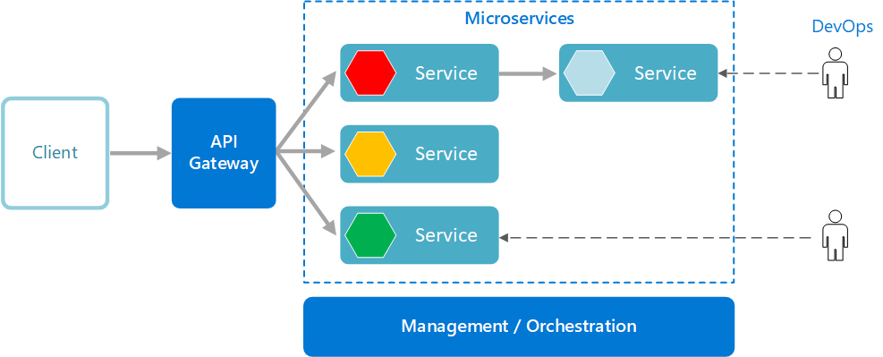

Functional Requirements and High Level Design

Use Case Diagram
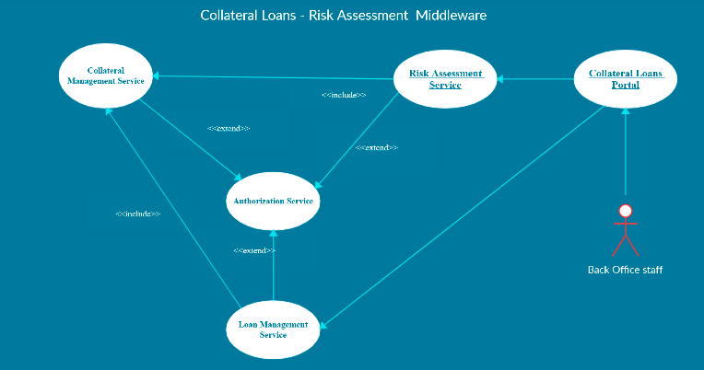

Individual Components of the System

Collaterals Management Microservice
- Collateral Loans – Risk Assessment | - Collaterals Management Microservice
Functional Requirements
This Microservice will be invoked by Loan Management Service and Risk Assessment Service.

When invoked by Loan Management Microservice,
- Authorization will be performed
- For a sanctioned loan, save the collateral details for the loan ID.
When invoked by Risk Assessment Microservice,
- Authorization will be performed
- While assessing a risk, the Risk Assssment Microservice wil invoke the Collateral Management Microservice to retrieve the latest collateral details

Entities
- Collateral_Loan
<Details of Collateral like Loan ID, Collateral ID, Collateral Value, Pledged Date etc.>
Few Entities based on type of collaterals can be created, given below are examples.
- Collateral_RealEstate
<Loan ID and Details of Collateral like Collateral Type, Owner Details, Address, Current Value, Rate Per Sq.Ft., Depreciation Rate etc.>
- Collateral_CashDeposits
< Loan ID and Details of Collateral like Collateral Type, Owner Details, Bank Name, Current Value, Interest Rate, Deposit Amount, Lock Period etc.>

REST End Points
Collaterals Management Microservice
  - GET: /getCollaterals (Input: Loan_ID, Customer_ID | Output: Collateral ID, Type, Collateral Details based on each Type)
  - POST: /saveCollaterals (Input: Loan_ID, Collateral_ID, Collateral Type, Details of the Collateral based on Type) | Output: Status)
Note: can also have different POST calls for different type of collaterals, or can be in single POST call.
Trigger – Can be invoked from Loan Management Service or from Risk Assessment Service
Steps and Actions
- Once a request is received to Collaterals Service, Authorization will be performed
- If /getCollaterals end point is invoked the corresponding collateral details of the loan, has to be returned.
- If /saveCollateral end point is invoked, then the Microservice will save the collateral based on appropriate type.
Non-Functional Requirement:
- Only Authorized Back Office Staff can access these REST End Points
- If the getCollateral request is received multiple times for the same Loan ID, there must not be multiple hits leading to performance issues.

Loan Management Microservice
- Collateral Loans Risk Assessment | - Loan Management Microservice
Functional Requirements
Loan Management Microservice will be invoked from Collateral Loans Portal. This Microservice will be invoke Collateral Management Service for saving the Collaterals related to the loan.

To view the loan details:
- Retrieve the Loan Details based on Loan ID

To save the collaterals for the sanctioned loan:
- This will in turn reach the Collateral Management Microservice and saves the collateral details

Entities
- Loan
<Loan Products, Maximum Loan eligible, Interest, Tenure, Type of Collateral Accepted etc.>
- Customer_Loan
<Loan Product ID, Loan_ID, Customer_ID, Loan_Principal, Tenure, Interest, EMI, Collateral ID etc.>
- Customer
<Details of the Customer>

REST End Points
Loan Management Microservice
  - GET: /getLoanDetails (Input: Loan_ID, Customer_ID | Output: Loan ID, Sanctioned Loan Amount, Tenure, Interest, Collateral ID pledged etc.)
  - POST: /saveCollaterals (Input: Loan_ID, Collateral_ID, Collateral Type, Details of the Collateral based on Type) | Output: Status)

Trigger – Can be invoked from Collaterals Loan Portal, however for saving collaterals, this will in turn invoke the Collateral management microservice.
Steps and Actions
- Loans Management Microservice will have 2 End Points exposed to Collaterals Loan Portal used by Back Office.
- If /getLoanDetails end point is invoked, the Microservice will return the appropriate loan details
- If / saveCollaterals end point is invoked, then the Microservice will invoke the Collaterals Management Microservice for saving the collateral details of the sanctioned loan.
Non-Functional Requirement:
- Saving the Collaterals for every input request must happen in parallel

Risk Assessment Microservice
- Collateral Loans Risk Assessment | - Risk Assessment Microservice
Functional Requirements
Risk Assessment Microservice interacts with Collaterals Management Microservice. Collaterals Loan Portal will invoke the services of Risk Assessment Microservice to portray the risks of the collaterls held by the bank

- View Risks of Collaterals held by the bank

Entities
- Collateral_Risk
<Risk Details of each Collateral pledged, % Risk, Date Assessed, Market Value, Sanctioned Loan etc..>
- Collateral_Market_Value
<market Value of each collateral ex: Rate / Square feet of land in dfferent areas, Intereset rate of a Fixed Deposit in a Bank.> - Assume that this will be refreshed in the system using a flat file, whenever there is a change. However there must ben an option to refresh the values using a file.

REST End Points
Risk Assessment Microservice
  - GET: /getCollateralRisk (Input: Loan_ID | Output (Risk Percent, Date of Risk Assessed)

Trigger – Can be invoked from Collaterals Loan Application. Howeve this Microservice need to access Collaterals Management Microservice for getting the details of collaterals pledged for a given Loan ID.
Steps and Actions
- Risk Assessment Microservice will have only one end point exposed to Collateral Loans Portal
  - Based on Collateral Market Value for the pledged collateral, whenever the market value goes down beyond the loan sanctioned, then a risk alert must be raised.

Authorization Microservice
- Collateral Loans Risk Assessment | - Authorization Microservice
Security Requirements
- Service to Service communication has to happen using JWT
- Pass End User Context across Microservices
- Have the token expired after specific amount of time say 15 minutes.
- Have this service configured in the cloud along with other services

Swagger
- Collateral Loans Risk Assessment | - Swagger
Documentation Requirements
- All the Microservices must be configured with Swagger for documentation
For Java based Implementation:
- Register the swagger resources in the Swagger Microservice and enable them as REST end points
- Configure this service along with other services in the cloud

Collateral Loans Portal
- Collateral Loans Risk Assessment | - Collateral Loans Portal
Client Portal Requirements
- Collateral Loans Portal must allow a Back Office Staff to Login. Once successfully logged in, the staff can do the following operations:
  - View Loan Details
  - Save Collaterals of a Sanctioned Loan
  - View Risks associated with the collateral
- Each of the above operations will reach out to the middleware Microservices that are hosted in cloud.

Cloud Deployment requirements
- All the Microservices must be deployed in Cloud
- All the Microservices must be independently deployable. They have to use In-memory database or user sessions wherever applicable
- The Microservices has to be dockerized and these containers must be hosted in Cloud using CI/CD pipelines
- The containers have to be orchestrated using AWS Kubernetes Services.
- These services must be consumed from an MVC app running in a local environment.

Design Considerations
Java and Dotnet specific design considerations are attached here. These design specifications, technology features have to be strictly adhered to.

Reference learning
Please go through all of these k-point videos for Microservices deployment into AWS.
https://cognizant.kpoint.com/app/video/gcc-6e36500f-c1af-42c1-a6c7-ed8aac53ab22
https://cognizant.kpoint.com/app/video/gcc-92f246c9-024a-40b7-8bfc-96b3ce7c1a39
https://cognizant.kpoint.com/app/video/gcc-cfedd9c1-e29e-4e3e-b3e2-1960277f72a3
https://cognizant.kpoint.com/app/video/gcc-900a7172-43b7-42f3-a6cc-e301bd9cc9b3

Other References:

Java 8 Parallel Programming | https://dzone.com/articles/parallel-and-asynchronous-programming-in-java-8
Feign client | https://dzone.com/articles/Microservices-communication-feign-as-rest-client
Swagger (Optional) | https://dzone.com/articles/centralized-documentation-in-Microservice-spring-b
ECL Emma Code Coverage | https://www.eclipse.org/community/eclipse_newsletter/2015/august/article1.php
Lombok Logging | https://javabydeveloper.com/lombok-slf4j-examples/
Spring Security | https://dzone.com/articles/spring-boot-security-json-web-tokenjwt-hello-world
H2 In-memory Database | https://dzone.com/articles/spring-data-jpa-with-an-embedded-database-and-spring-boot  https://www.baeldung.com/spring-boot-h2-database

Change Log
 | - Changes Made
V1.0.0 | Initial baseline created on <24-Jul-2020> by <Srilakshmi Jayaraman>
 | Section No. | Changed By | Effective Date | Changes Effected

