***Harpy Aerospace Summer Internship***

*AIOT project*

*Recommendation system*

Seshavarshan M

Madras Institute of Technology

2022506109

B. Tech Artificial Intelligence and Data Science

07/04/2024

**LOADING THE DATASET**

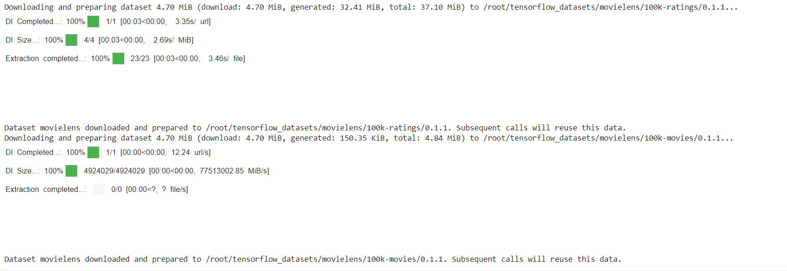

**Viewing dataset:**

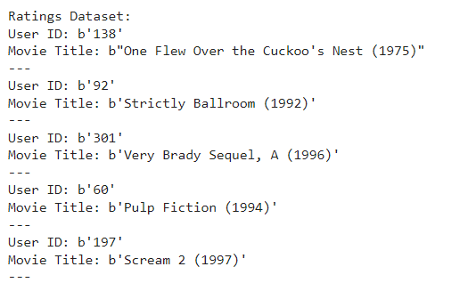

MODEL TRAINING :

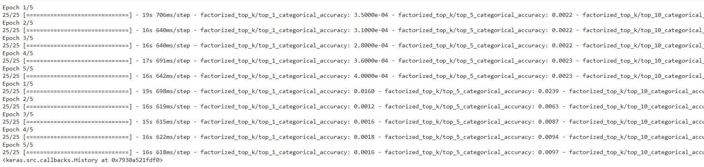

EVALUATING MODELS:



EPOCH FACTORIZED TOP K(5 CARDS) :

[MODEL 1]:

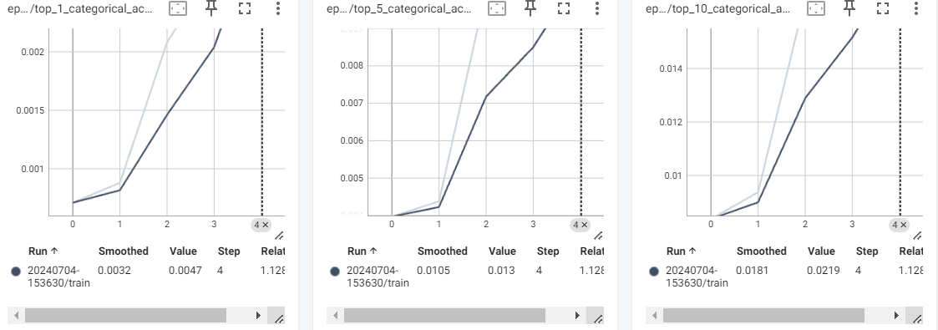

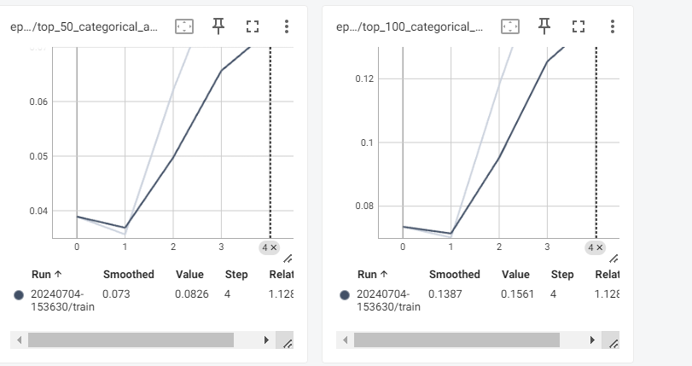

[MODEL 2]:

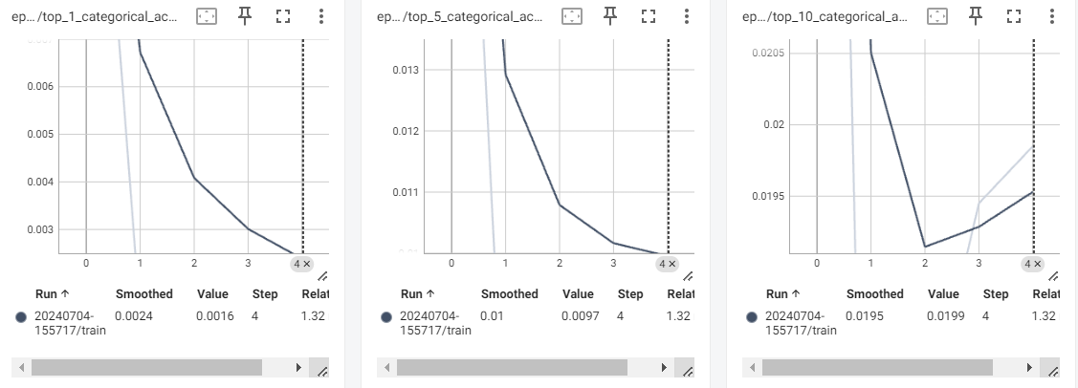

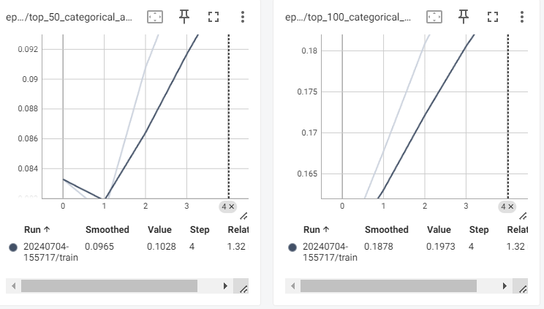

EPOCH LOSS:

[MODEL 1]

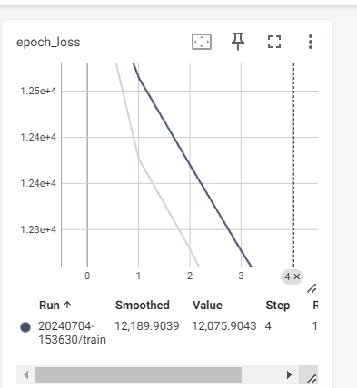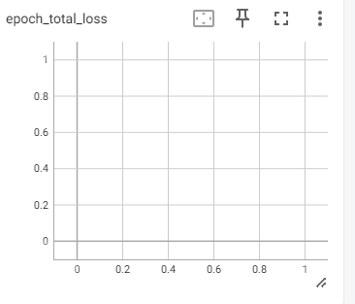

[MODEL 2]

