Software Configuration Management system

GitHub Makes Version Control Easier where developers can display the work done by them, and look and contribute into open source software.

* Git – Local
* GitHub - Over the network

## How to create account on Github:

<https://www.wikihow.com/Create-an-Account-on-GitHub>

#### Create your first Github Repository (Repo in short)

1. Click on New button after opening github and logging in your account

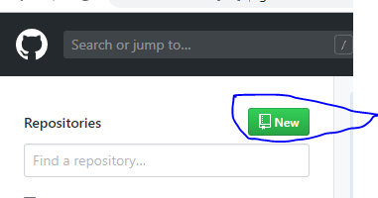

1. Put in necessary details in the create repo form.

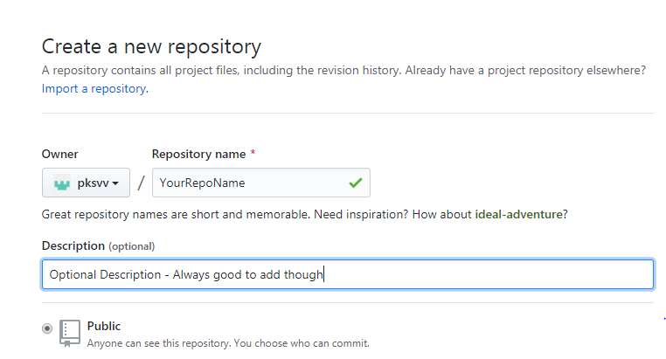

1. Details
   1. Repository Name: Choose a unique name
   2. Put additional description, this will come in handy when there will be a lot of repositories.
   3. Keep all other things default and click on “Create Repository”

## Local Installation

#### Install GIT Windows:

<https://git-scm.com/download/win>

#### Install GIT Mac:

<https://www.atlassian.com/git/tutorials/install-git#mac-os-x>

#### Clone repo

git clone https://github.com/pksvv/MachineLearningSL.git