|  |  |
| --- | --- |
|  | **MS Business Analytics & Project Management** |

**OPIM 5641- Business Decision Modeling**

**Fall 2016**

**Icebergs for Kuwait – Project Formulation**

**Team-3  
Amit Madhup  
Abhinav Suggula  
Seshi Harianathan  
Ziou Zhang**

**Project Formulation**

Entire middle east and especially Kuwait are facing extreme water scarcity and are looking for options to provide pure water to residents in the most economical way. A traditional approach to address this problem has been desalination of sea water from the Persian Gulf, but the governments have started looking for more economical options. Recent studies have suggested a more economical alternative of towing icebergs from Antarctic as source of drinking water which might be a more cost efficient solution.

The Antarctic ice sheet is one of the two polar ice caps of the earth. It covers about 98% of the Antarctic continent and is the largest single mass of ice on the planet. It covers an area of almost 14 million square kilometers and contains 30 million cubic kilometers of ice. That is, approximately 61% of all fresh water on earth – an amount equivalent to 70% of the volume of world’s oceans.

**A**) **Decision Variables:**

* + - Size of the boat (Small, Medium, Large) chosen for transportation
    - Speed of the boat (1, 3, 5 kmph) while towing iceberg from Antarctic to Kuwait
    - Starting size of the iceberg being towed.

**Output Measure:**

The output measure is the cost per unit of fresh water (including the rental and fuel cost occurred in the process of towing) converted from the iceberg being towed.

**Parameters:**

* + - Total towing distance from Antarctic to Kuwait (9,600 km)
    - Maximum and minimum capacities of the ship being chosen for towing process
    - Daily rental cost for the ship
    - Dynamic melting rates of the iceberg depending on the speed and distance from pole
    - Fuel cost incurred in the process, depends on the speed and current volume of the berg
    - Per unit cost of desalination of water (0.1 GBP/cu. Meter)
    - Shrinkage factor of the ice.
      1. **Influence Diagram:**

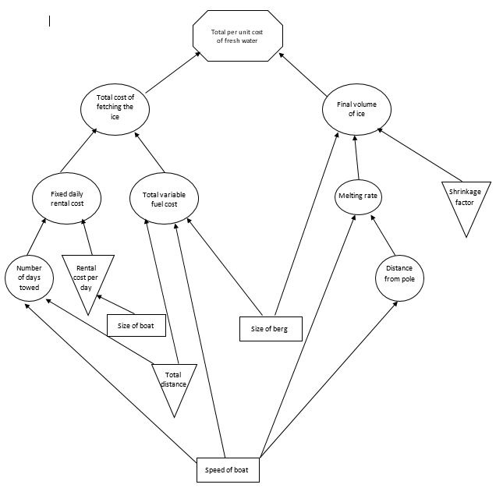

* + - 1. **Logical Structure:**

1. **Intermediate values:**

The intermediate values that will be considered while arriving at the final output are the following:

* + - Total number of days required for towing the iceberg
    - Starting radius of the berg
    - Number of days to travel first 1000km, next 1000 to 2000 km and next 2000 to 3000km and final distance from 3000km to 9600 km
    - Melting rates with respect to the distance from pole
    - Total radius melted
    - Radius of remaining iceberg after towing is complete
    - Final volume of the iceberg after towing is complete
    - Final volume of water converted from the towed iceberg
    - Rental cost of the boat for the entire journey
    - Total fuel cost incurred for the entire process
    - Total final cost for the entire towing process

1. **Calculation of Intermediate values and final output:**
   * Number of days required for towing = Total Distance/(24*speed of boat in kmph)
   * Starting radius of ice berg = ((Volume of iceberg)/(4/3*pi))^(1/3)
   * Number of days required for traveling 1000km = 1000/(24*speed of boat in kmph)
   * Melting rate 1 = melting rate corresponding to speed of the boat and distance 1000 km
   * Melting rate 2 = melting rate corresponding to speed of the boat and distance 2000 km
   * Melting rate 3 = melting rate corresponding to speed of the boat and distance 3000 km
   * Melting rate 4 = melting rate corresponding to speed of the boat and distance >= 4000 km
   * Radius 1 = Radius melted for first 1000km of journey = No. of days required for travelling 1000km * melting rate 1
   * Radius 2 = Radius melted between 1000km and 2000km of journey = No. of days required for travelling 1000km * melting rate 2
   * Radius 3 = Radius melted between 2000km and 3000km of journey = No. of days required for travelling 1000km * melting rate 3
   * Radius 4 = Radius melted for final part of journey after first 3000 km = (Total no of days for travel – 3*No. of days required for travelling 1000km) * melting rate 4
   * Total radius melted = Radius 1 + Radius 2 + Radius 3 + Radius 4
   * Radius of berg remaining after towing = Starting radius of ice berg – Total radius melted
   * Final volume of ice left after towing = 4/3*pi*(radius of berg remaining after towing) ^3
   * Final volume of water converted from ice = Shrinkage factor of ice * Final volume of ice left after towing
   * Boat rental cost per day = Rental cost corresponding to the speed of the boat and initial size of berg
   * Total rental cost for the entire towing process = boat rental cost per day * Number of days required for towing
   * Fuel cost per km = corresponding fuel cost for given boat speed and initial volume of berg
   * Total fuel cost = Fuel cost per km * Total distance
   * Total cost of entire towing process = Total rental cost for entire towing process + Total fuel cost
   * Cost per unit of fresh water through towing process = Final volume of water converted from ice / Total cost of entire towing process
     + 1. **Assumptions:**
   * The icebergs will be considered to be spherical in shape for simplicity of cost estimates
   * The icebergs are available for free of cost
   * The speed of the ship is constant throughout the process of towing from Antarctic to Kuwait
   * There are only 3 types of ships available in terms of capacity (small, medium and large) and speed (1, 3, 5 kmph)
   * Only one ship will be used for the entire process of towing an iceberg as there is no chance of changing the size of ship midway through the journey
   * There is no inflation in the time period of fetching the iceberg
   * Fuel cost in dependent on the initial size of the iceberg for simplicity sake, the current volume is not being considered here
   * The iceberg stops melting once the final destination i.e. Kuwait is reached