|  |  |
| --- | --- |
|  | **MS Business Analytics & Project Management** |

**OPIM 5641- Business Decision Modeling**

**Fall 2016**

**Icebergs for Kuwait**

**Team-3  
Amit Madhup  
Abhinav Suggula  
Seshi Harianathan  
Ziou Zhang**

**SCENARIO ANALYSIS**

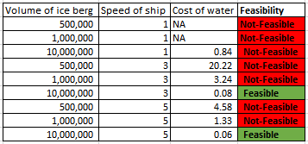By analyzing the output variable i.e. cost of water per unit cu. meter, considering that we are starting with the maximum amount of ice a ship can hold, we can see that only two cases when the volume of ice is 10,000,000 cu. Meter and speed is 3/5 Kmph are feasible.

**TORNADO CHART ANALYSES**

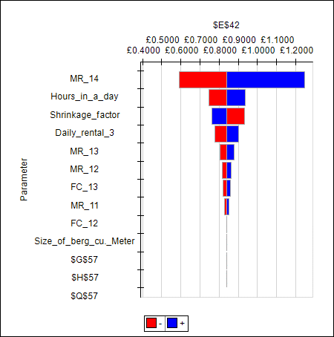

When the speed of boat is 1kmph, we can see that the most important factor affecting the cost is melting rate (>4000 km) which makes sense because this is influenced by the maximum amount of distance throughout the journey.

It is followed by length of the day and shrinkage factor which are fixed variables, which are in turn followed by melting rates for 3000 km and 2000 km.

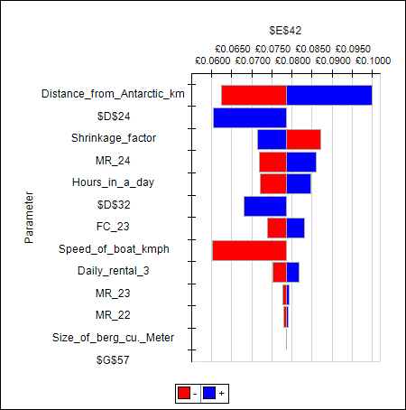

For the case when speed of boat is 3kmph, we can see that the most influential factor is distance which is a fixed parameter, followed by speed of boat and shrinkage factor which are again fized variables. These were followed by melting rate (>4000 km), hours in a day, fuel cost (10,000,000 cu. meter).

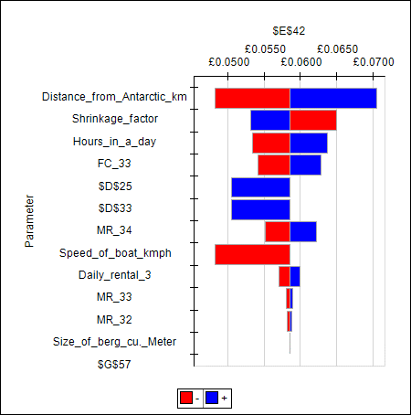

When the speed of boat is 5 kmph, the top three factors are constant namely distance, shrinkage factor and hours in a day. They are followed by fuel cost (10,000,000 cu. Meter), speed of boat, melting rate (>4000km) etc.

Overall for the cases where speed of boat is 3kmph or 5kmph, the factors affecting the output are very similar while for case of 1kmph the factors differ substantially.

**Sensitivity Analyses**

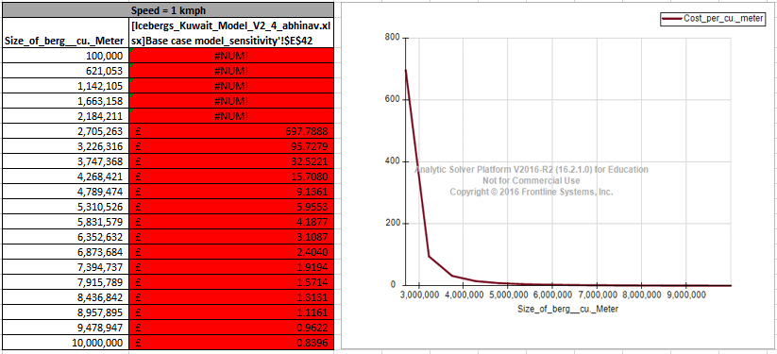

From the sensitivity chart for case of speed 1kmph above, we can see that varying the size of ice berg from 100,000 cu. Meter to 10,000,000 cu. Meter has an adverse effect on the cost, but still the traditional method fares well compared to the new method.

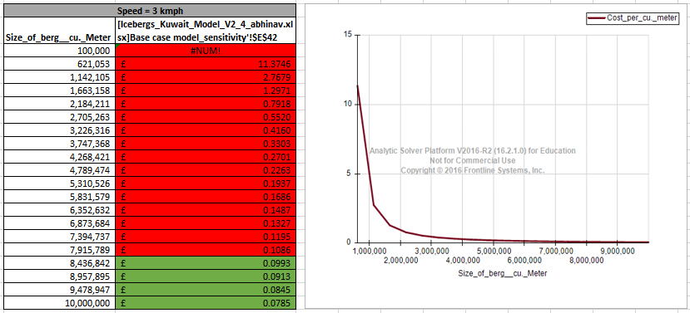

From the sensitivity chart for case of speed 3kmph above, we can see that varying the size of ice berg has an effect on the cost, the trend captured shows that there is an inversely decreasing relationship. The volume of iceberg has to be greater than ~8.5 million cu. Meter so that the cost of new method becomes less than traditional method.

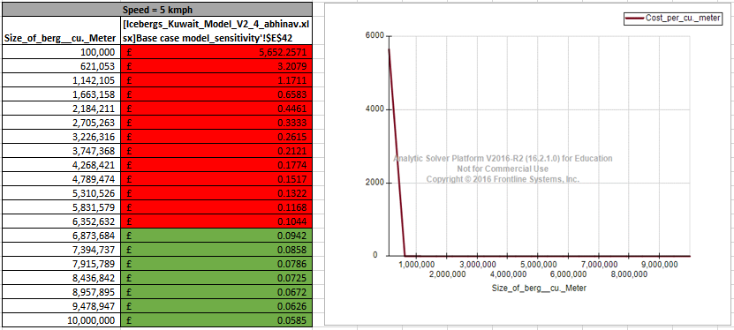

From the sensitivity chart for case of speed 5kmph above, we can see that varying the size of ice berg has an effect on the cost, the trend captured shows that there is an inversely decreasing relationship which is very similar to case of 3kmph. The volume of iceberg in this case has to be greater than ~6.5 million cu. Meter so that the cost of new method becomes less than traditional method.

**Breakeven Analysis – Volume of ice berg**

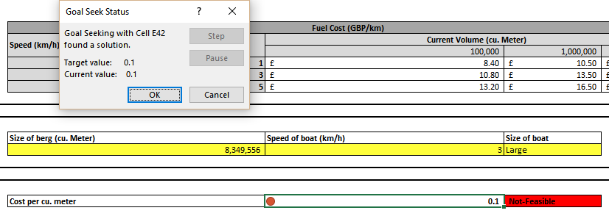

When the speed of boat is **3 kmph**, the breakeven point to attain a cost less than that of traditional method is **8.4 million cu. Meter**.

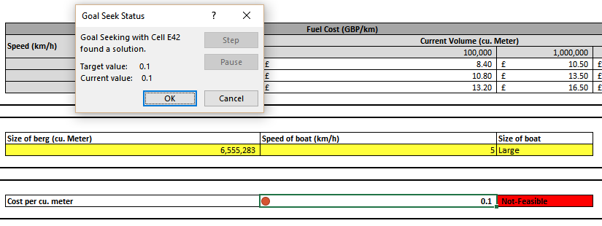

When the speed of boat is **5 kmph**, the breakeven point to attain a cost less than that of traditional method is **6.6 million cu. Meter**.

**Breakeven Analysis – Rental Cost**

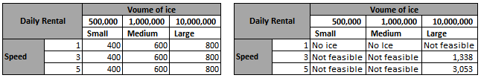

We can see from the above breakeven analysis that only 2 cases are feasible for towing considering the maximum amount of ice each ship can carry. Considering other parameters constant, we can see that the maximum fuel cost could go from 800 GBP to 1338 GBP for the case when speed of ship is 3kmph and 800 GBP to 3053 GBP for the case when speed of ship is 5kmph which is an increase of 67% and 282% respectively.