|  |
| --- |
| **Name**: Team 2 – The Concorde |
| **Project Management – OPIM 5270** |
| **Team Paper – Work Breakdown Structure (WBS) / Gantt Chart** |
|  |
| **Topic / Question:**  When developing a Gantt Chart for a project, building a Work Breakdown Structure (WBS) is essential.    As a team, build a WBS and Gantt Chart for your Team Project. Use the following page to describe the process you used to develop your WBS/Gantt, and describe what the team learned from building them. In the bottom of this page, past an image of your completed WBS. It can be a photo, or an enhanced metafile image of a PowerPoint slide, Excel Worksheet, Word Diagram, Free Mind Map, or whatever tool you used. Attached a MS Project file separately in HuskyCT for your Gantt Chart |
|  |
|  |
| **Limit your paper to one page, beginning on the next page. Format: Arial – 11 pt. 1 ½ line spacing**. |
|  |

**3rd level tasks are not shown below due to limited space. Please open the file to see the complete WBS: **

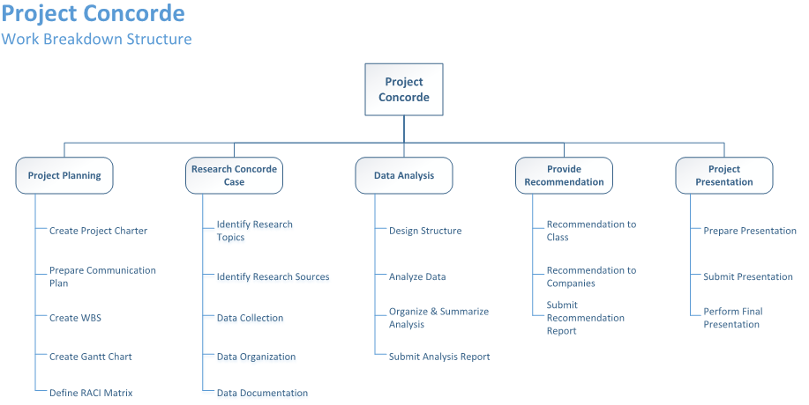

**WBS/Gantt Chart Development Process:**

**1. We started with the scope of work:** We have already defined the highest level of work that has to be completed through the project charter exercise and the WBS exercise we did in class, which we used as our base to help scope the work.

**2. Task Identification Work Breakdown:** When we were creating the top-down hierarchical work items, we took the approach of decomposing the work into measurable tasks. We make sure we decompose them to the level that allows easy and accurate estimates of duration and identification of ownership. To us, level 1 items represent phases and major work groups, level 2 items include deliverables, and level 3 items are activities and tasks. Keeping that in mind helped us organize the tasks

**3. Clean up the tasks list for WBS:** We walked through the entire list of tasks identified and removed duplicated or unnecessary tasks. Then we transferred the WBS chart we drew on the whiteboard into Visio.

**4. Data transfer:** Once we have all the tasks identified in WBS, we transferred all the tasks into MS Project to build a Gantt Chart.

**5. Project timeline:** We didn’t immediately assign dates for each individual task. Instead, we looked at the level 1 and level 2 tasks/deliverables, and identified the deadline for each deliverable.

**6. Assignment & Ownership:** We walked through the list of all the work items and assigned a task leader for each task. We had already identified the ownership of each task through the RACI matrix exercise so we were able to assign each task to team members in the Gantt Chart very quickly.

**7. Task Duration:** We then looked at the time needed to complete each task and identify start date and end date for each task. We asked the team, specifically the task owner the minimum and maximize time they would need to complete the task to make sure we have some flexibility.

**8. Logical Relationships and Dependencies:** We then looked at the logical relationship and dependencies among the tasks to make sure that tasks that are dependent upon each other are not assigned to one person and that work can be actually worked on at the assigned start time.

**Learnings and takeaways for the team:**

Decompose the work to the level that we can actually assign owners and accurately estimate the time duration. The bigger the work is, the harder it is for us to estimate the duration, and the higher the risk is to complete the work on time.

Use the project charter, RACI matrix when creating WBS is very helpful for the team to stay on track. Having a clean WBS ready before creating Gantt Chart made the process much easier.