CS5590 APS

Programming for Web/Cloud based Application

In Class Assignment

**Library Application:**

**Home.html:**

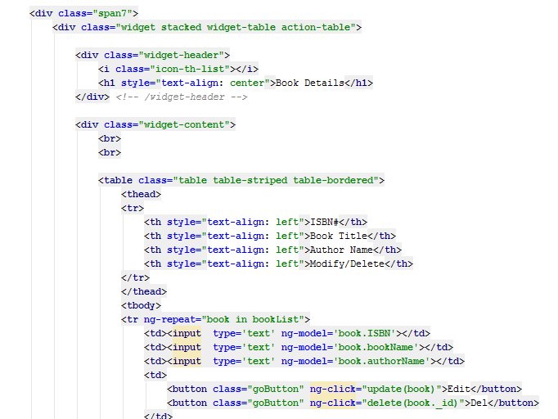

**Add book.html**

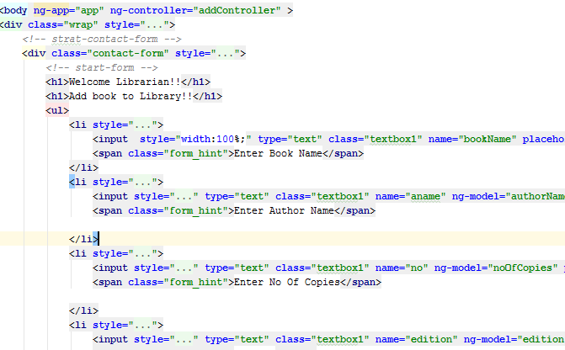

**JavaScript file**

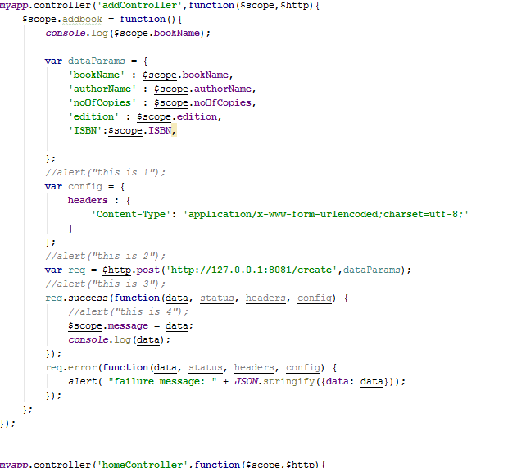

**DataBase file:**

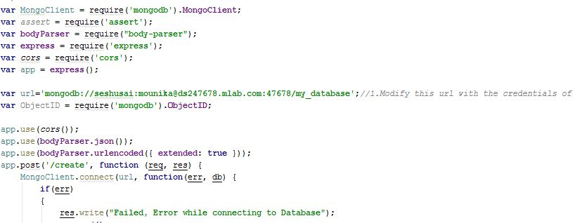

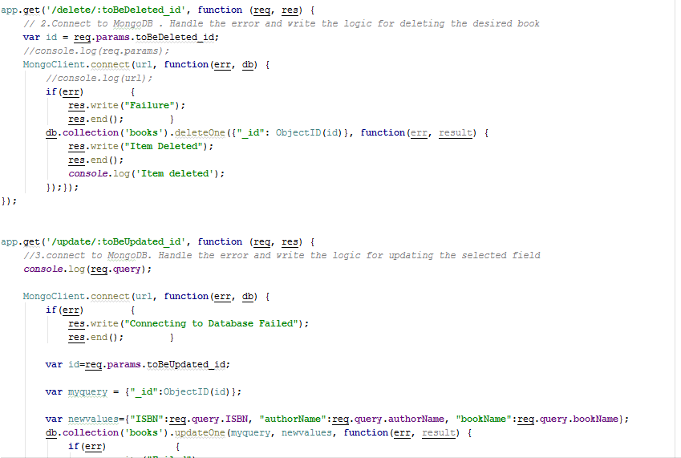

**Output:**

