2018 Spring: COMP - SCI 5590/490 -Special

Lab Assignment 2

Lab Assignment

PART I:

In this part we created an app which works as a step counter. For this we are using a sensor named pedometer. We used the code given to us and filled out the three To-do lines.

The output is as shown below.. 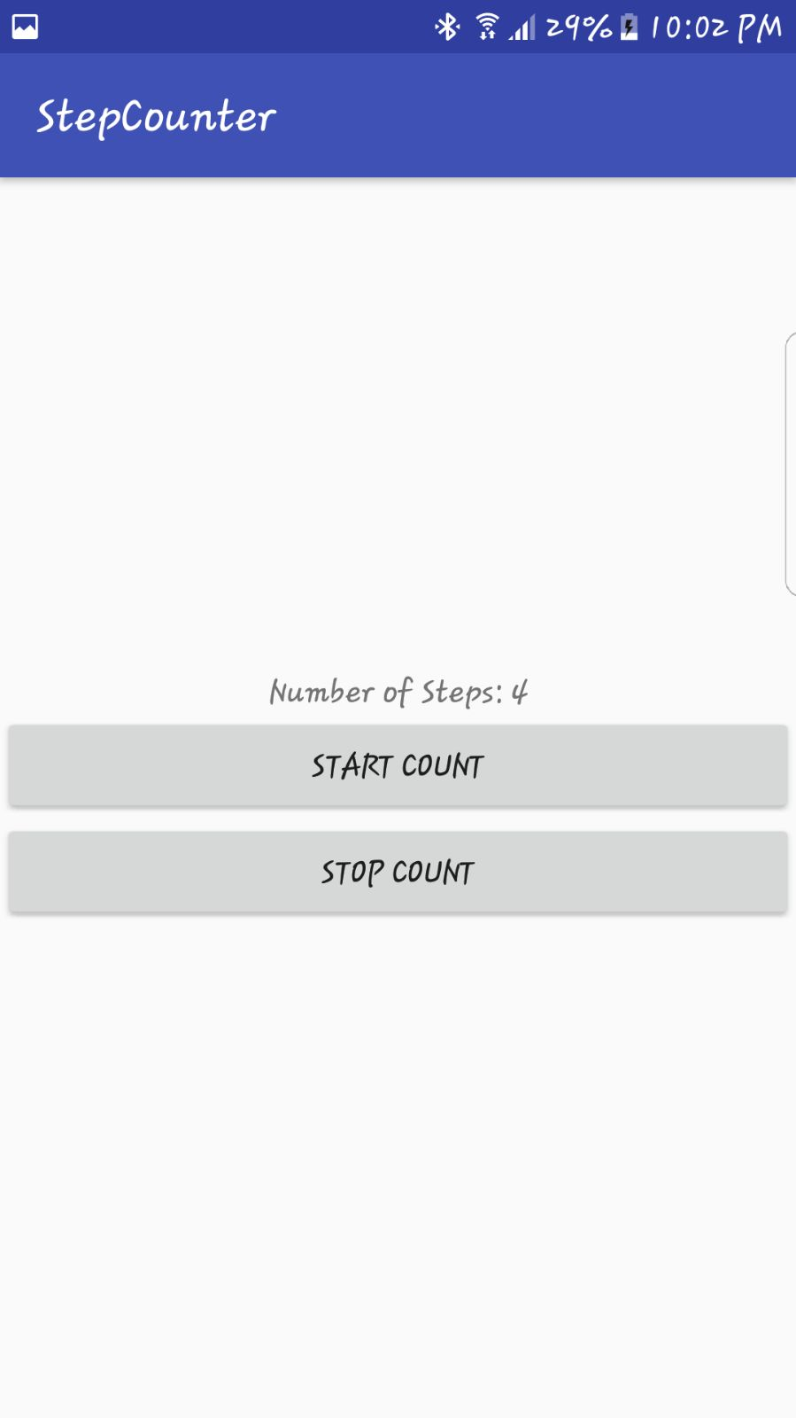

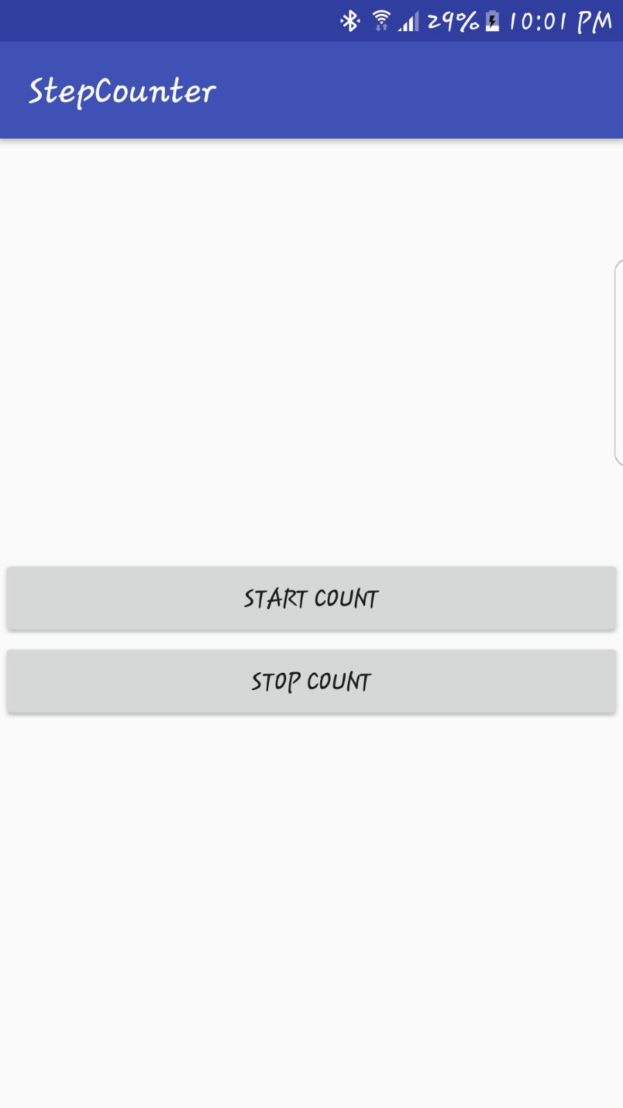

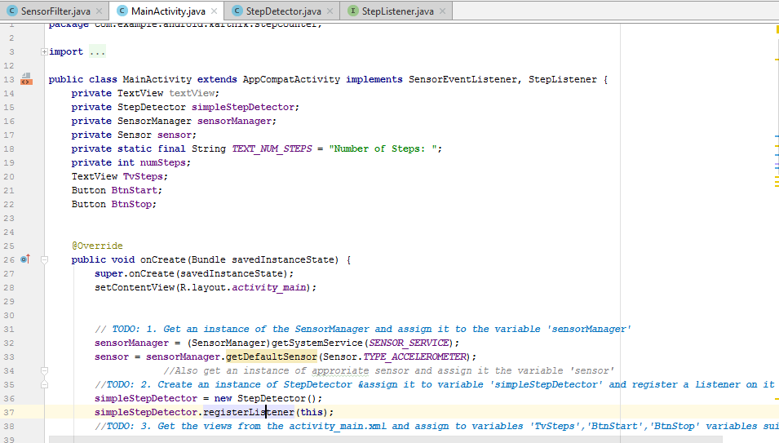

Part2:

In part 2 I wrote a code to detect faces and display their face attributes

The outputs are as follows



