CS5590 APS

Programming for Web/Cloud based Application

ASSIGNMENT 2

**Part 1:**

**News Application:**

**News_login.html:**

Here in this page I wrote the code for login and register forms. I used html, css , jquery for creating these forms. Below are the code snippets.

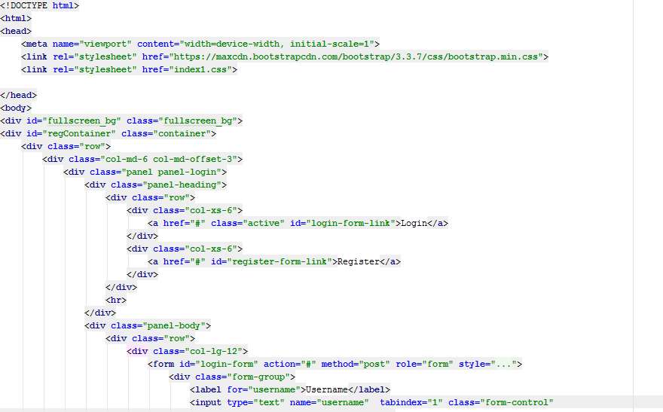

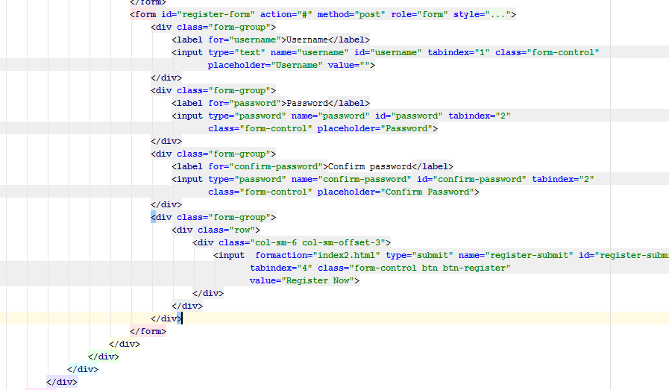

**News_login.css:**

Below are the code snippets of css file.

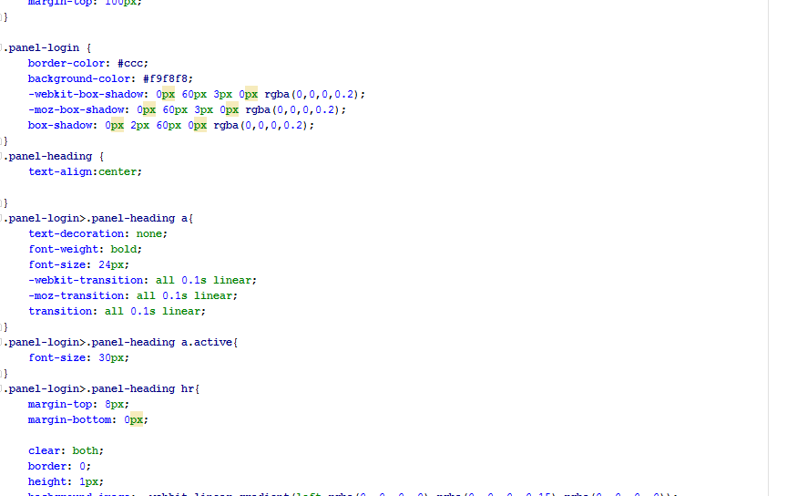

**News_login.js:**

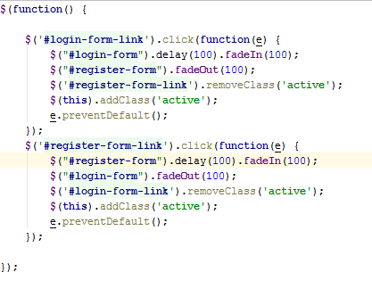

**Output:**

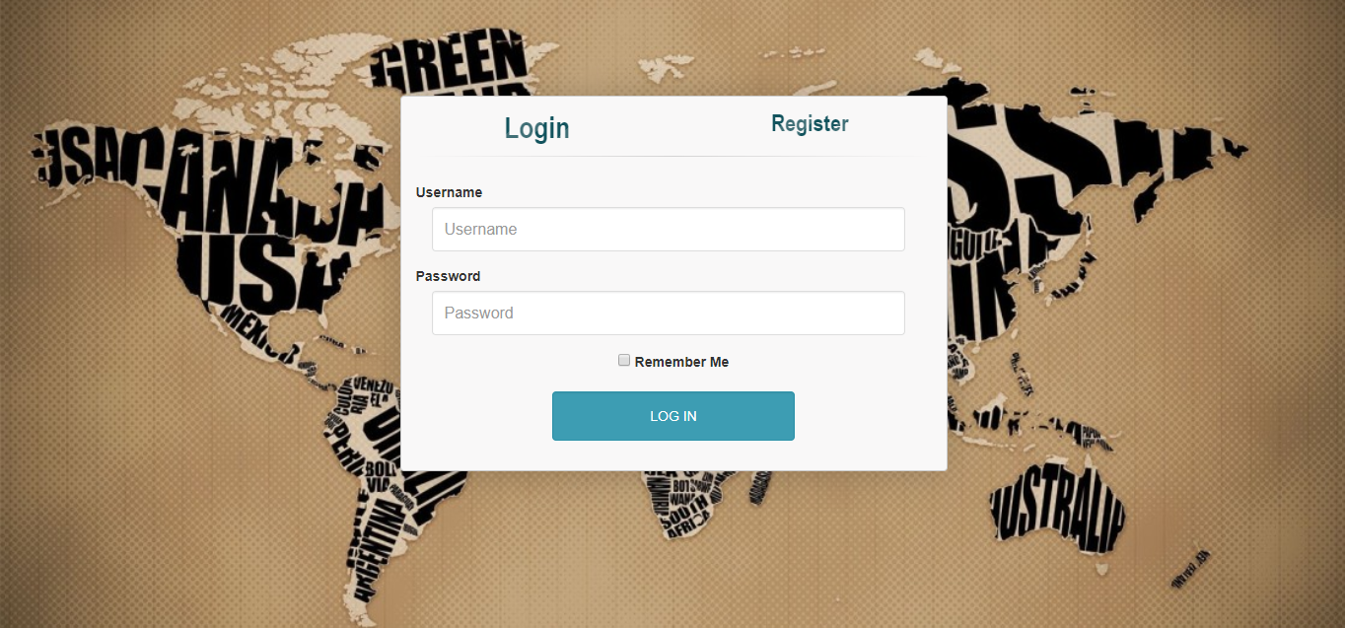

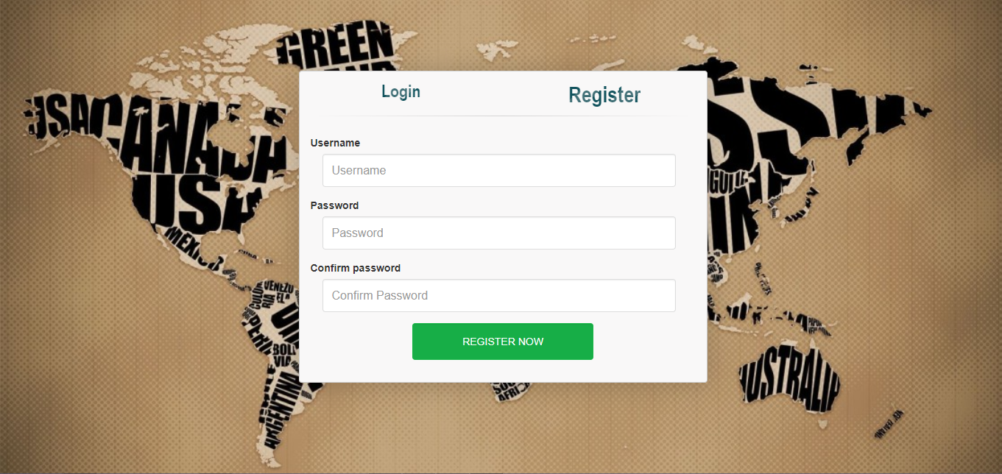

**News_main.html:**

Here in main.html I used jumbotron, form group, select, and some bootstrap methods to create a good looking page.

The code snippets are as follows:

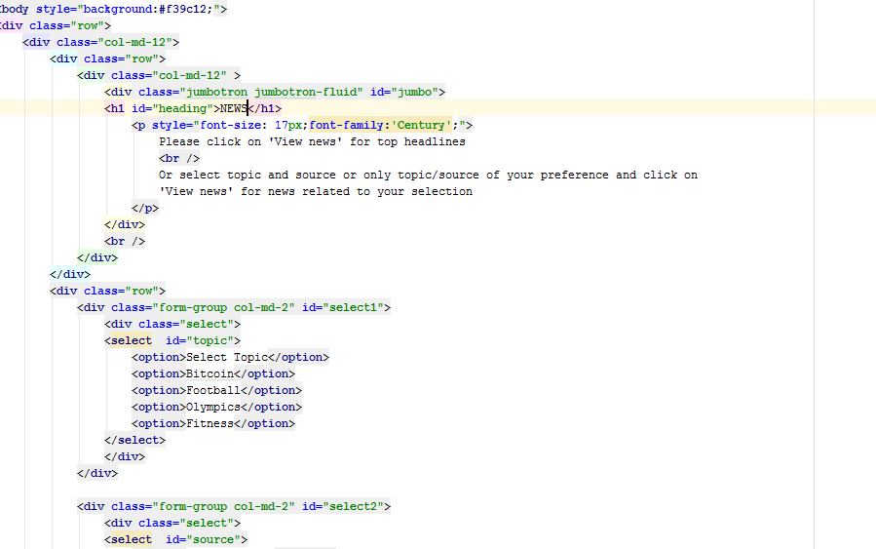

**News_main.css:**

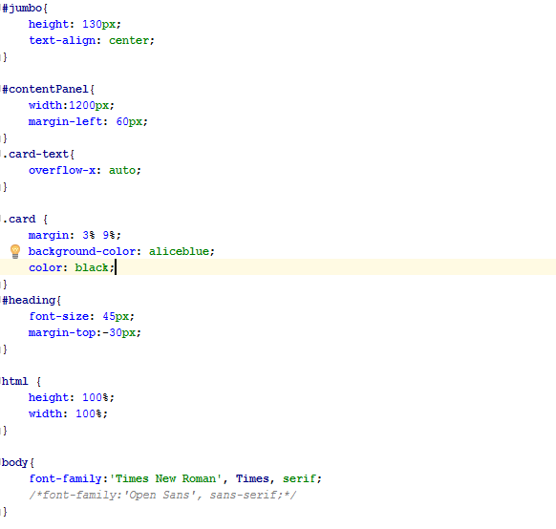

**News_main.js:**

In this file I wrote the logic for news api (i.e) starting from how to call the api and get information from the api, how to display the information we got.

To get the information from the api I used xhttp request using the key I got from the news api website.

And to display this information I used bootstrap cards.

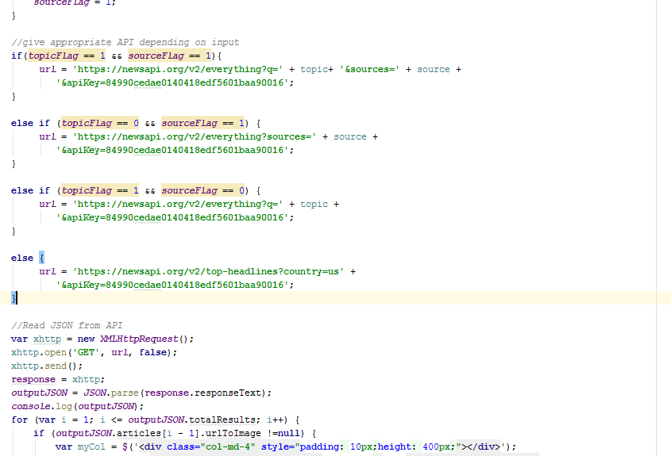

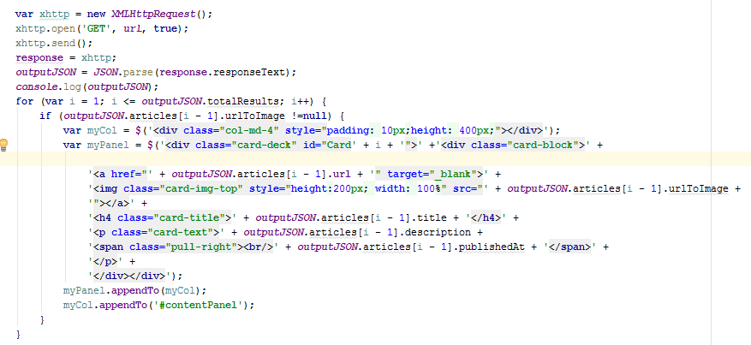

**Output:**

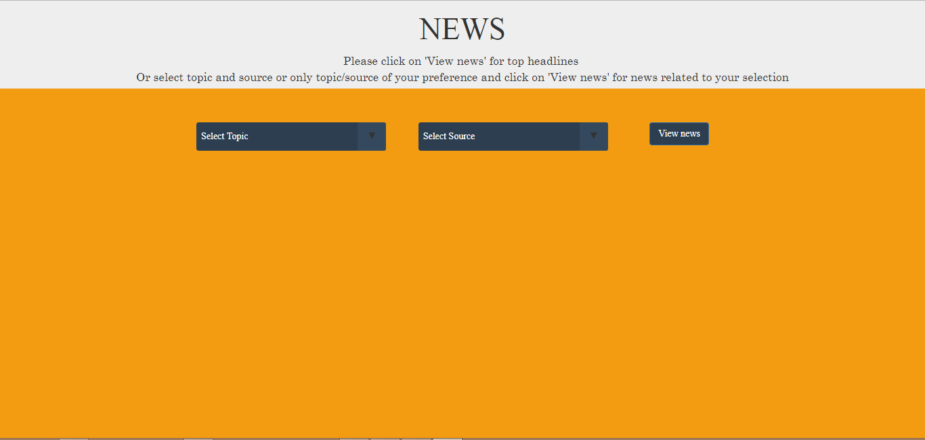



**Problems faced:**

The problem I faced was about displaying the data that I received from the xhttp request. The problem was solved by using the bootstrap cards.

**Part 2:**

**Tic-Tac-Toe Game Development:**

**Tic_Tac_Toe.html:**

In this part, I started with Tic_Tac_Toe.html page. In the head I linked all the style sheets and scripts that are required for this assignment.

Now I created three div with each containing a table. One table for player1, one for player2 and one for the board.

All these div’s are contained in a main div which has ng-app and ng-controller which in the background are connected to Tic_Tac_Toe.js file.

This is all about Tic_Tac_Toe.html. Below are the snippets of index.html.

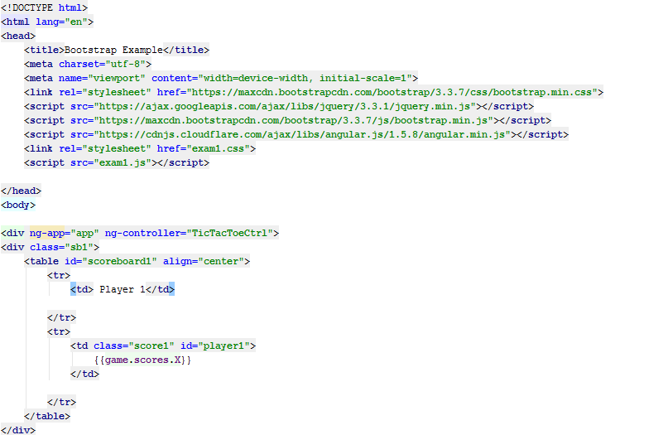

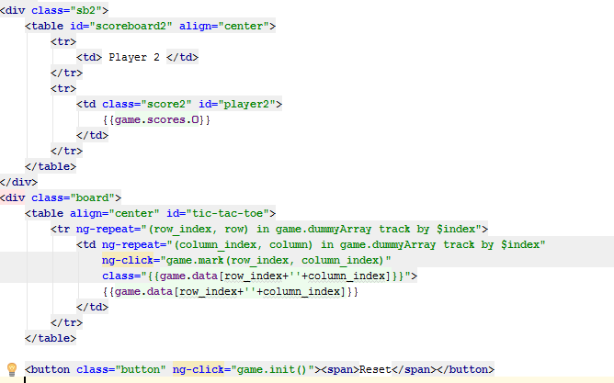

**Tic_Tac_Toe.css:**

In this file I wrote all the styling required line margins, board size, colors etc..

The code snippets for Tic_Tac_Toe.css are below

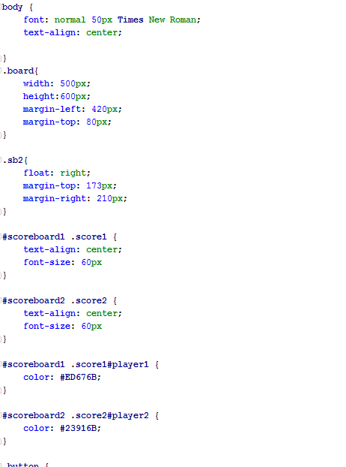

**Tic_Tac_Toe.js:**

In this JavaScript file I wrote all the code required for the game to be executed properly.

I used different angular js modules, controllers, services, methods.

The snippets of my java script file are below

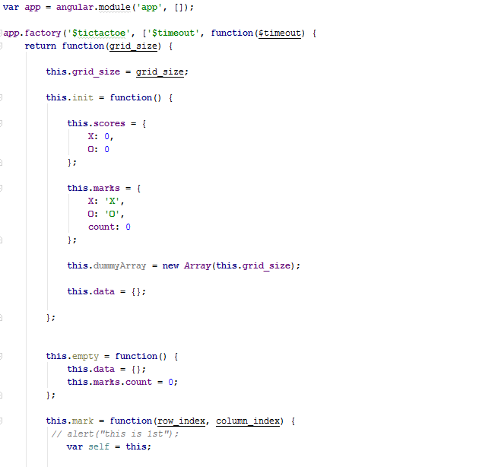

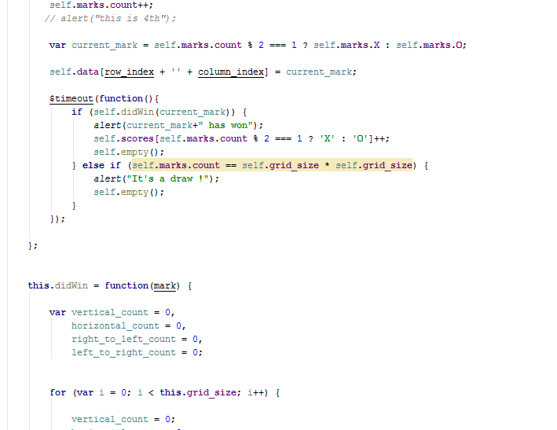

**Output for Tic_Tac_Toe game:**

