CS5590 APS

Programming for Web/Cloud based Application

ASSIGNMENT 3

**Part 1:**

**Youtube Search API:**

**Youtube.html**

Created a HTML page named Youtube.html. Below are the code snippets

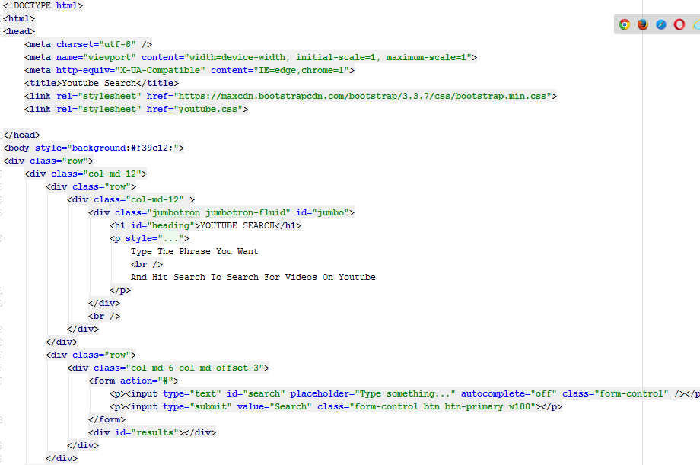

**Youtube.css**

This is a styling file where it contains all the code used for styling my page. Code snippets are as below

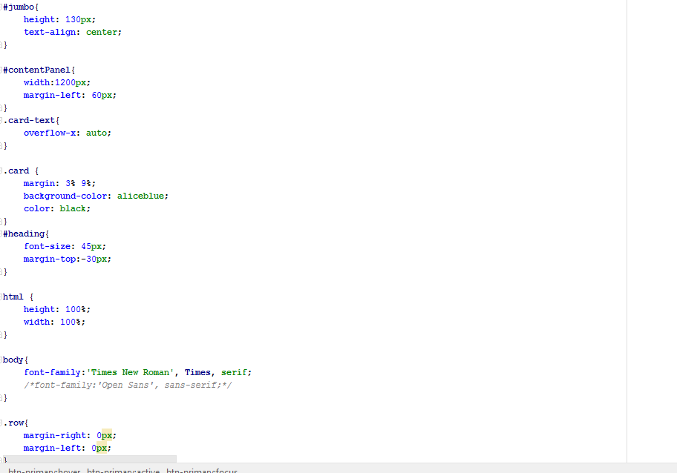

**Youtube.js**

This is a java script file which has all the logic behind the working of the search.

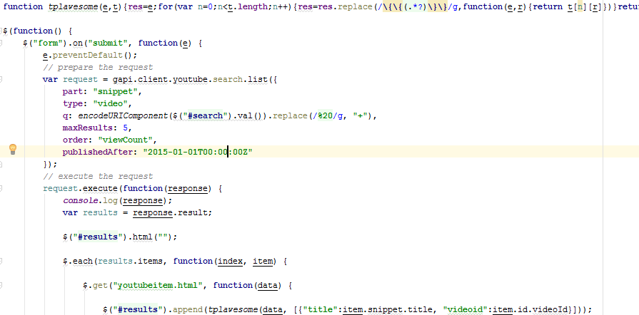

**Output:**

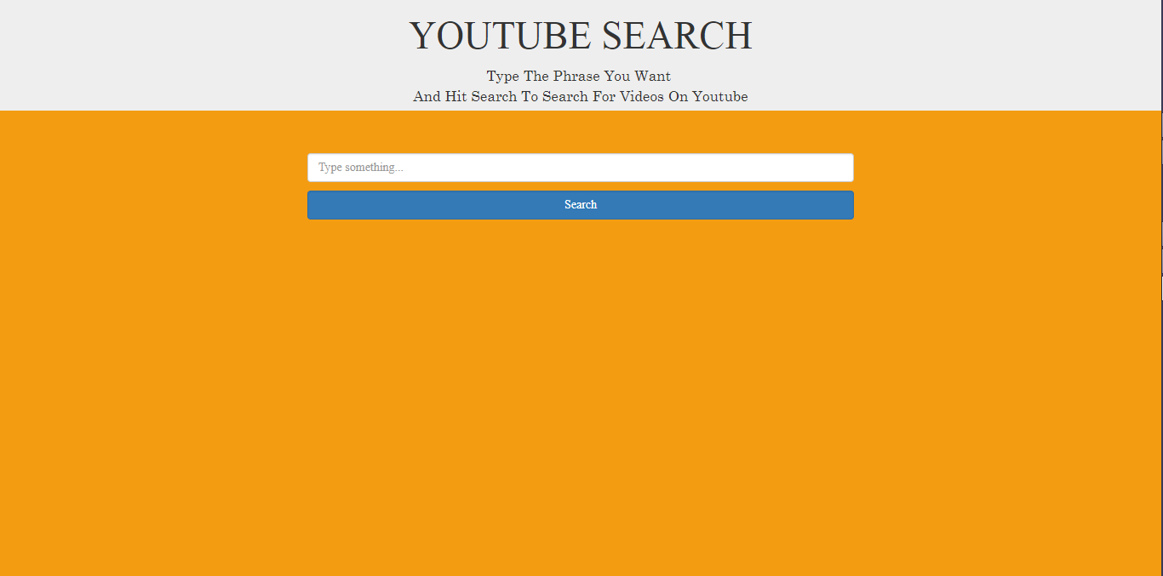

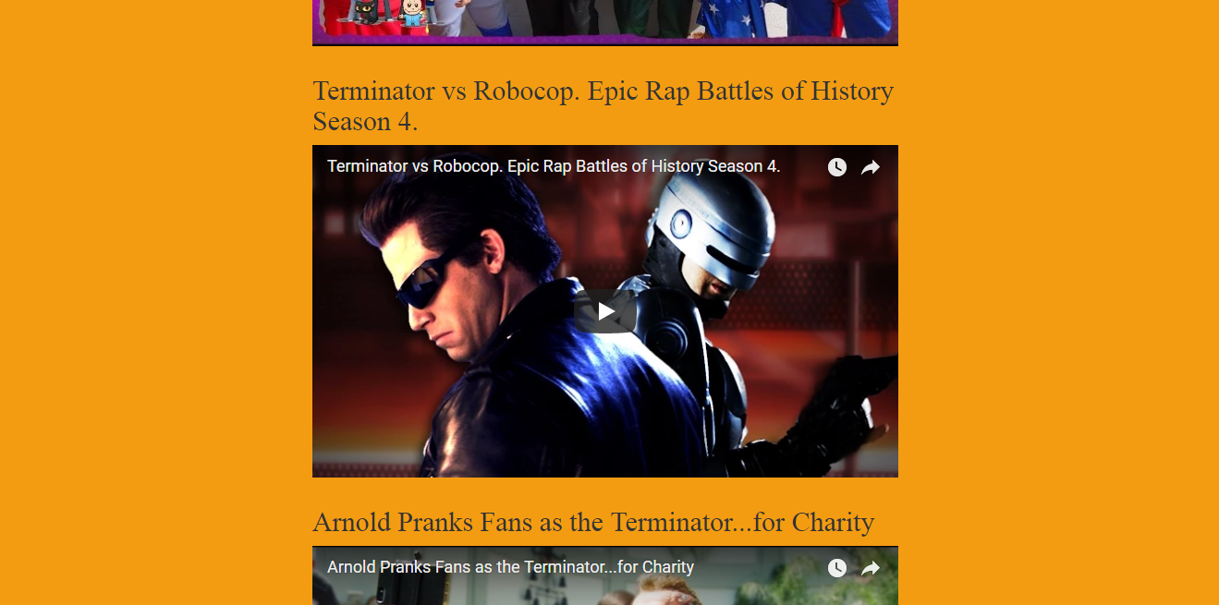

**Part 2:**

**Index1.html**

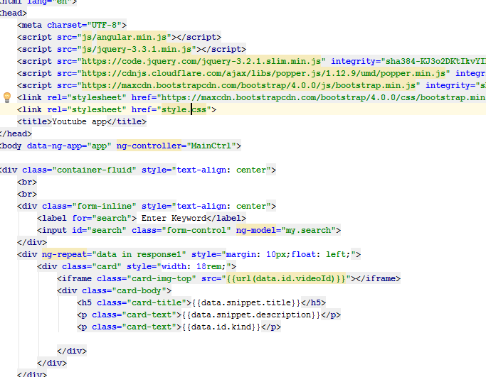

**Index2.html**

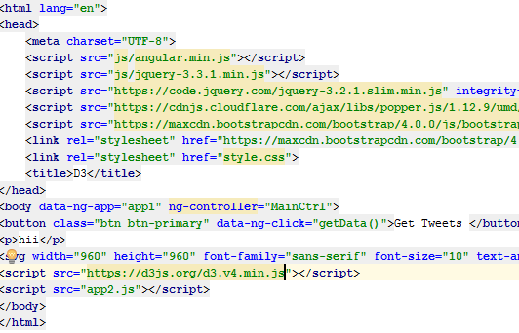

**App.js**

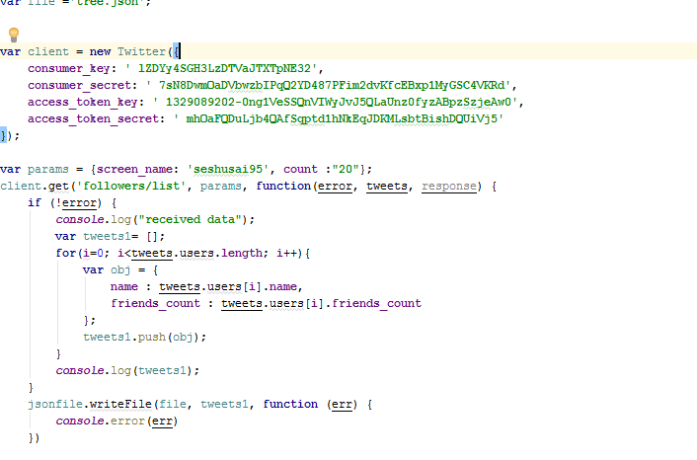

**Charts.js**

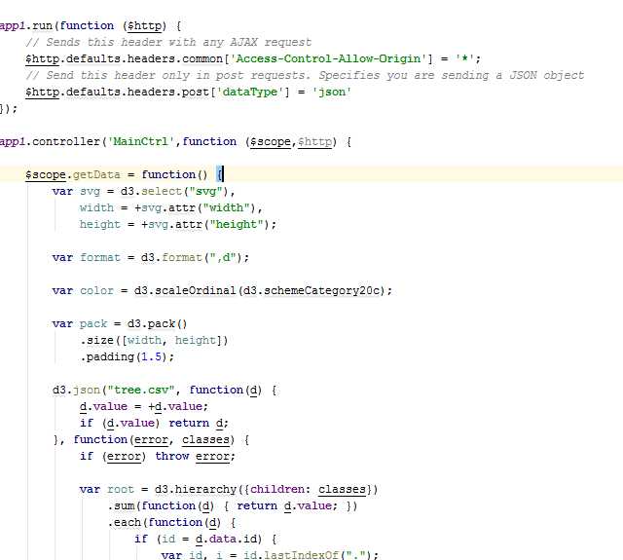

Json data

