COMP - SCI 5590/490 - Special Topics

Mobile Programming

Lab Assignment 1

Signup page:

In signup page there are two fields email and password. Once we fill them and click register the data will be stored in the data base in this case firebase.

In this page there are three buttons Register, Forgot your password and Go to back to login buttons.

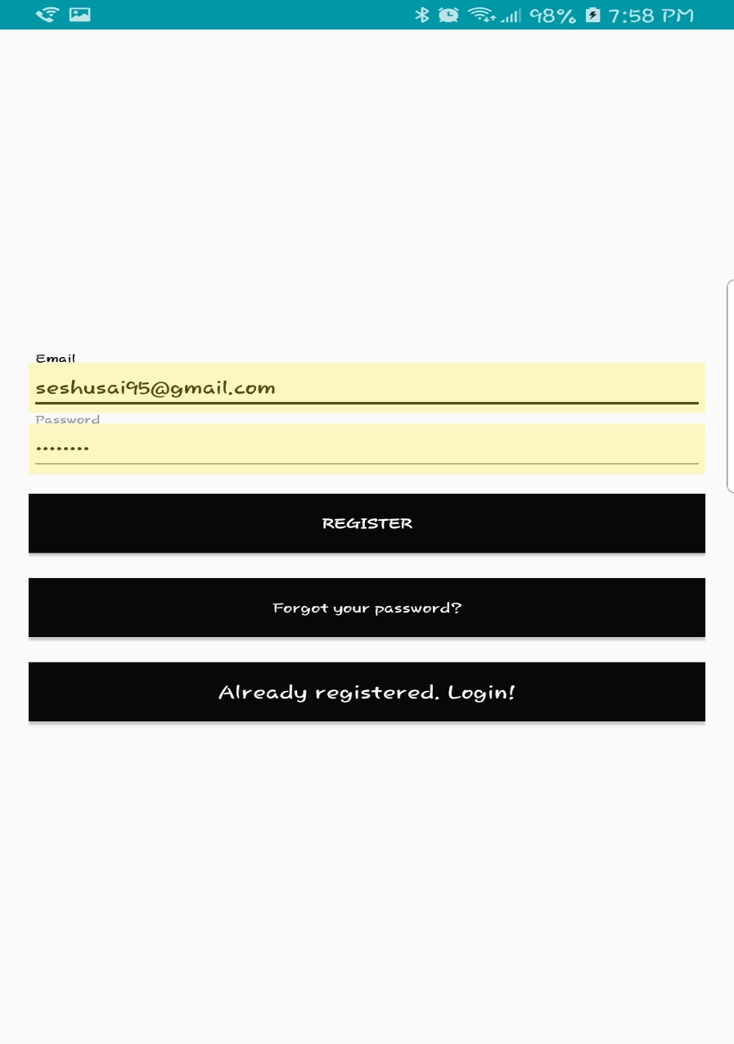

Code snippets:

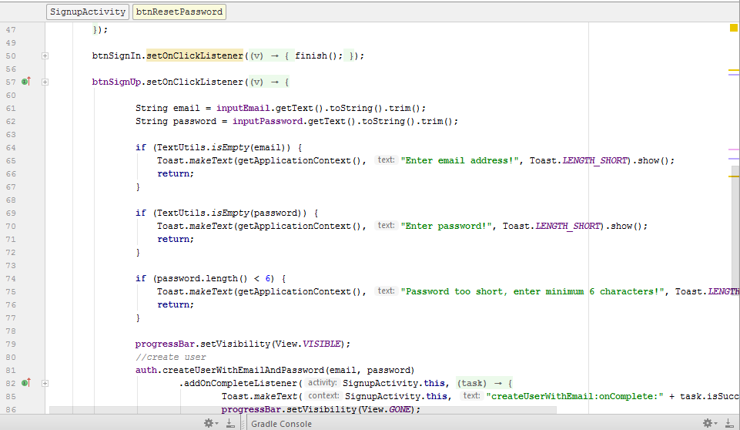

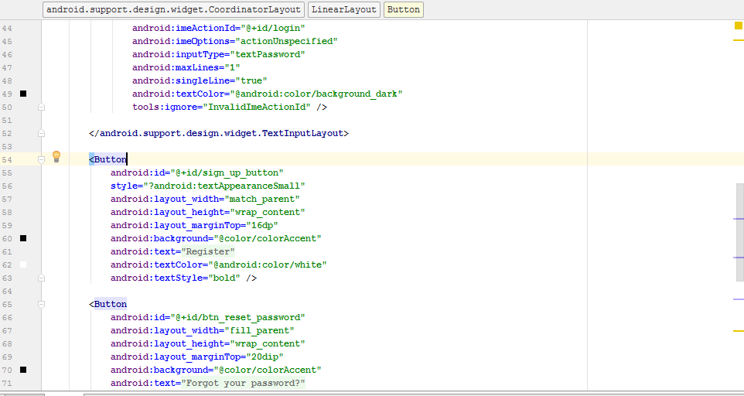

Forgot password page:

In this page there are two options one is reset password. When we click by typing our email in and hit the button its sends an email to reset password.

When we click on back button it goes back to the login page.

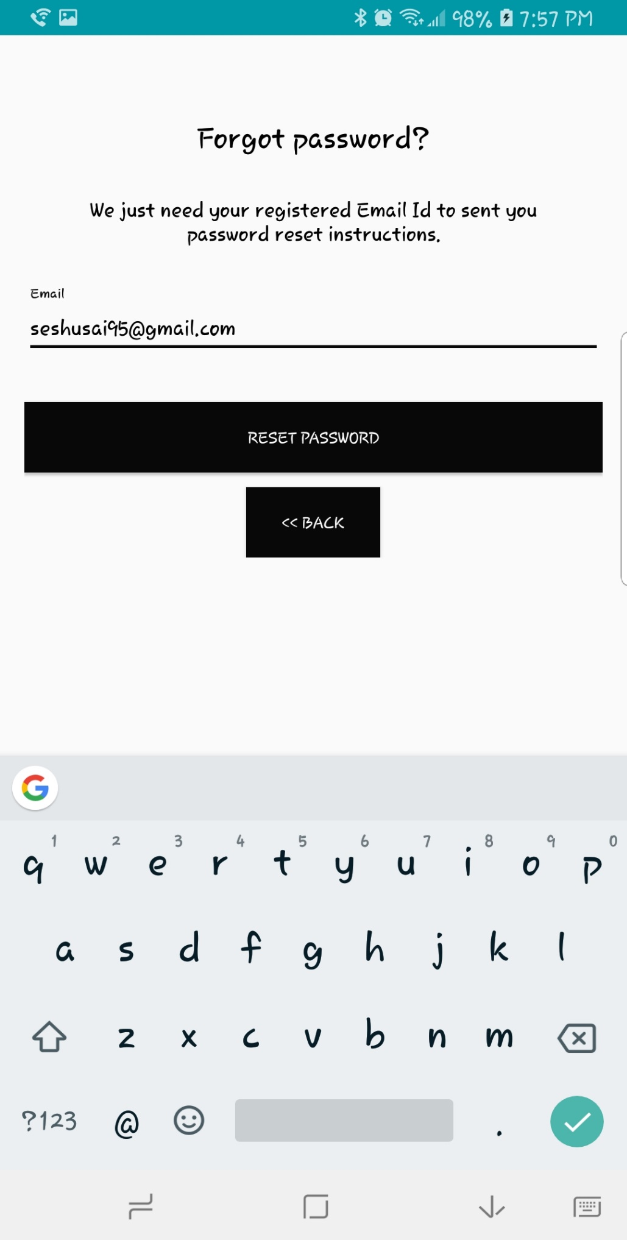

Code snippets:

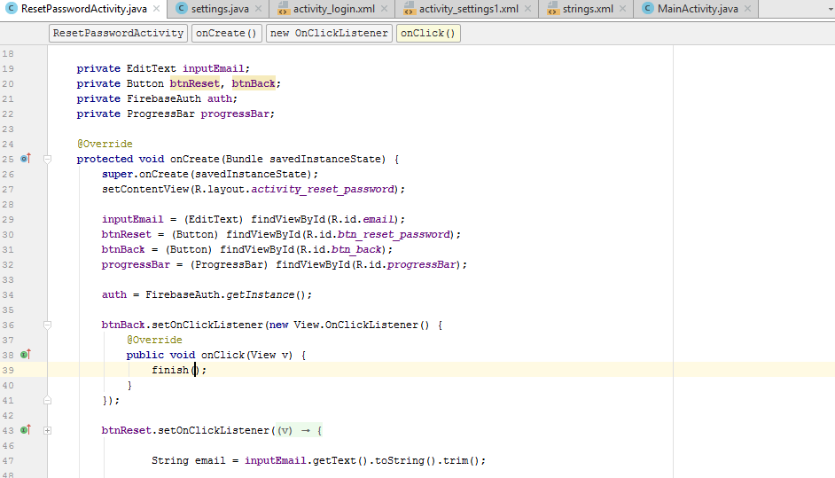

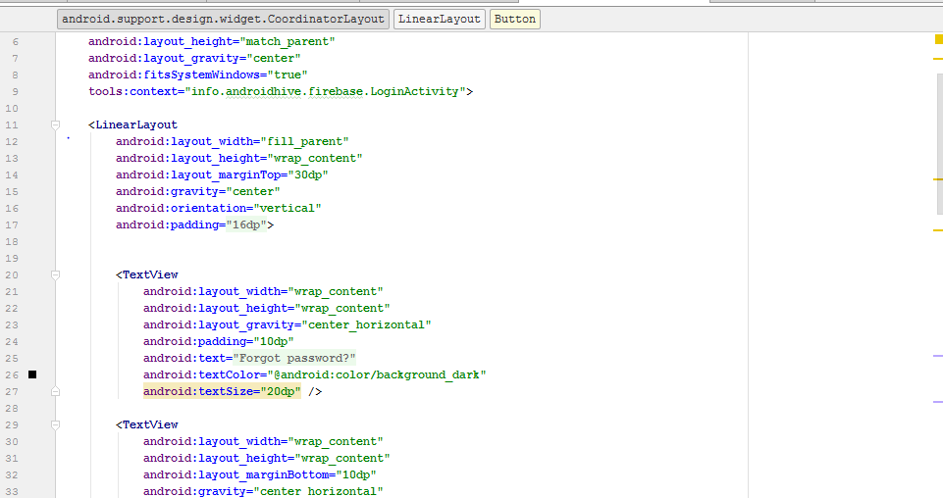

Login page:

In the login page we enter the email and password and when we click login it enters in to home page.

When entered wrong details its gives us an error.

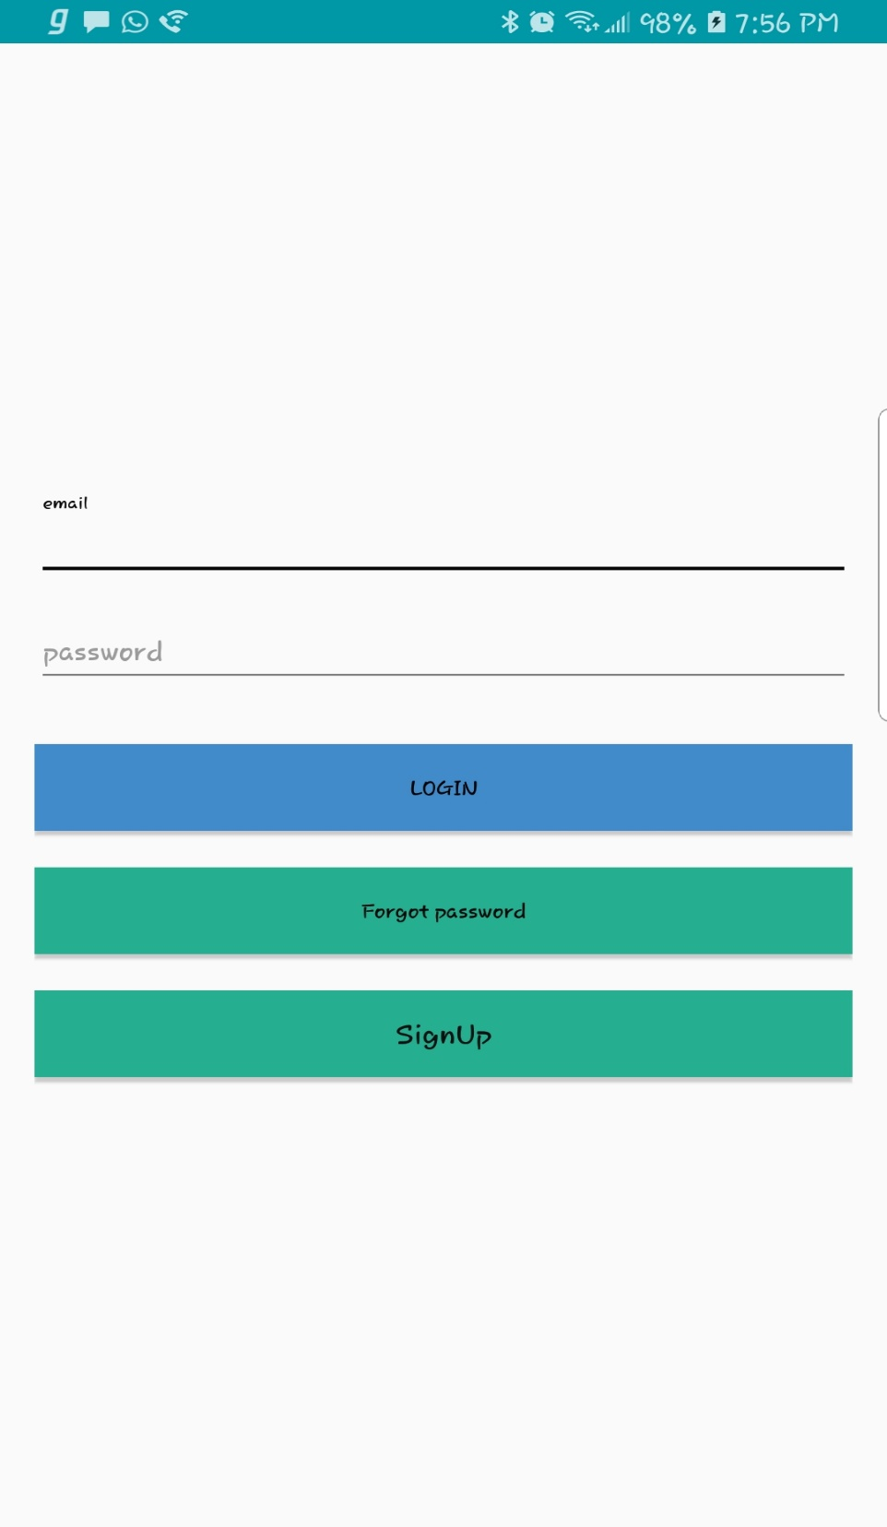

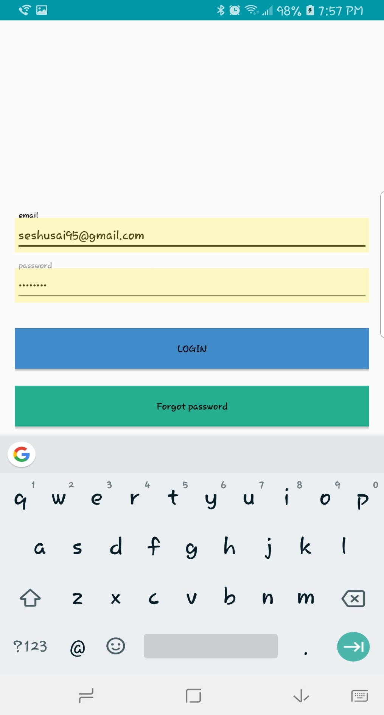

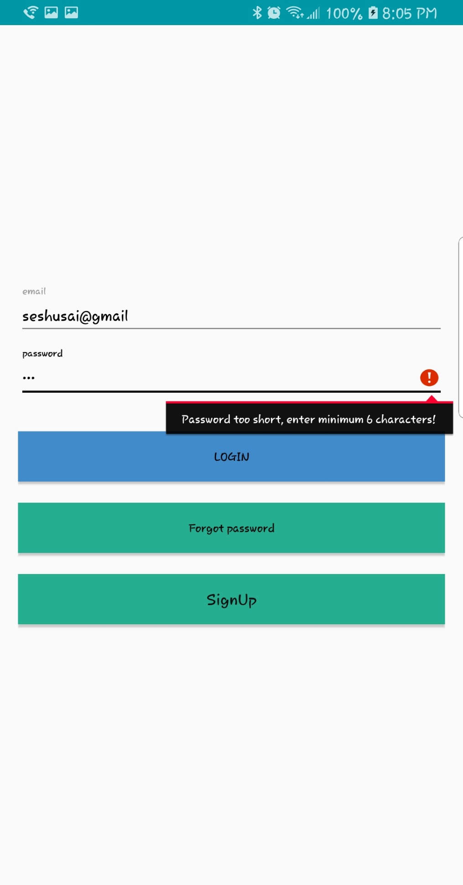

Code snippets:

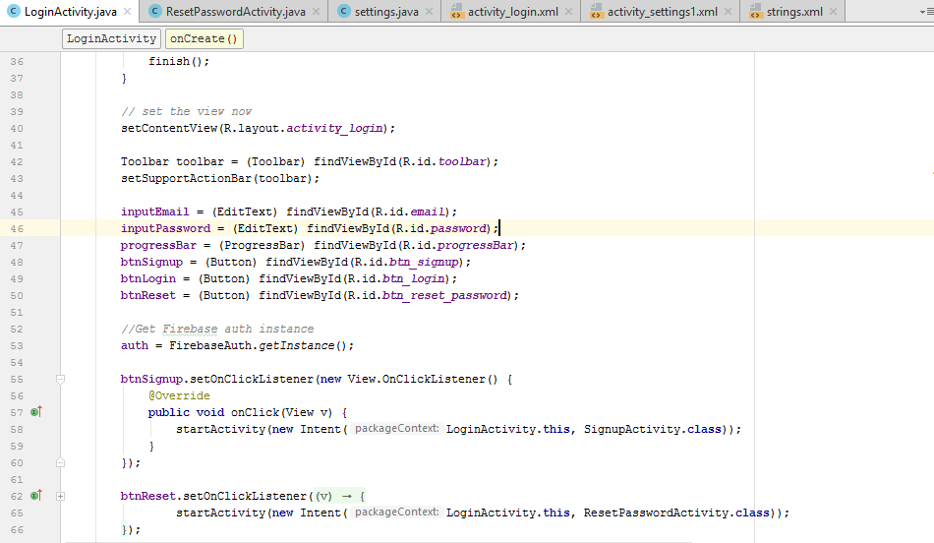

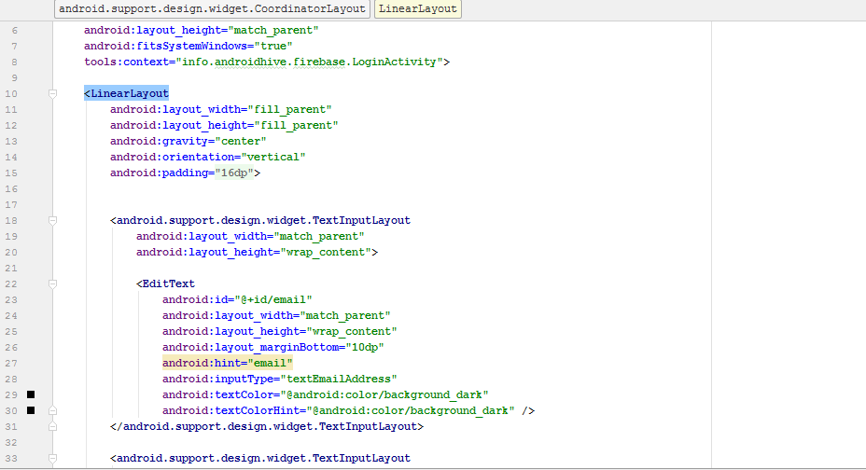

Home page

In this page we have three buttons settings, help and go back

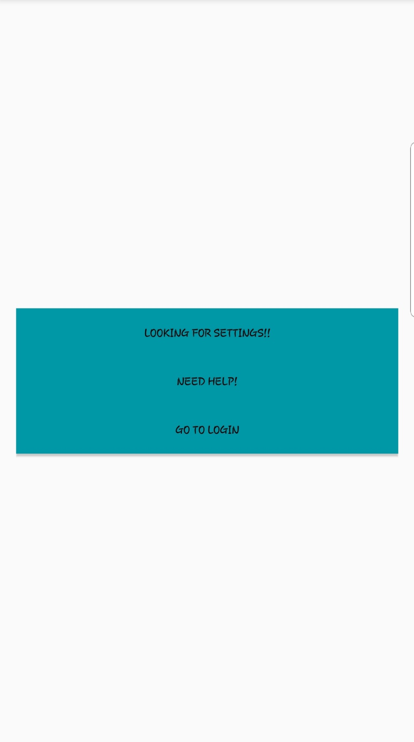

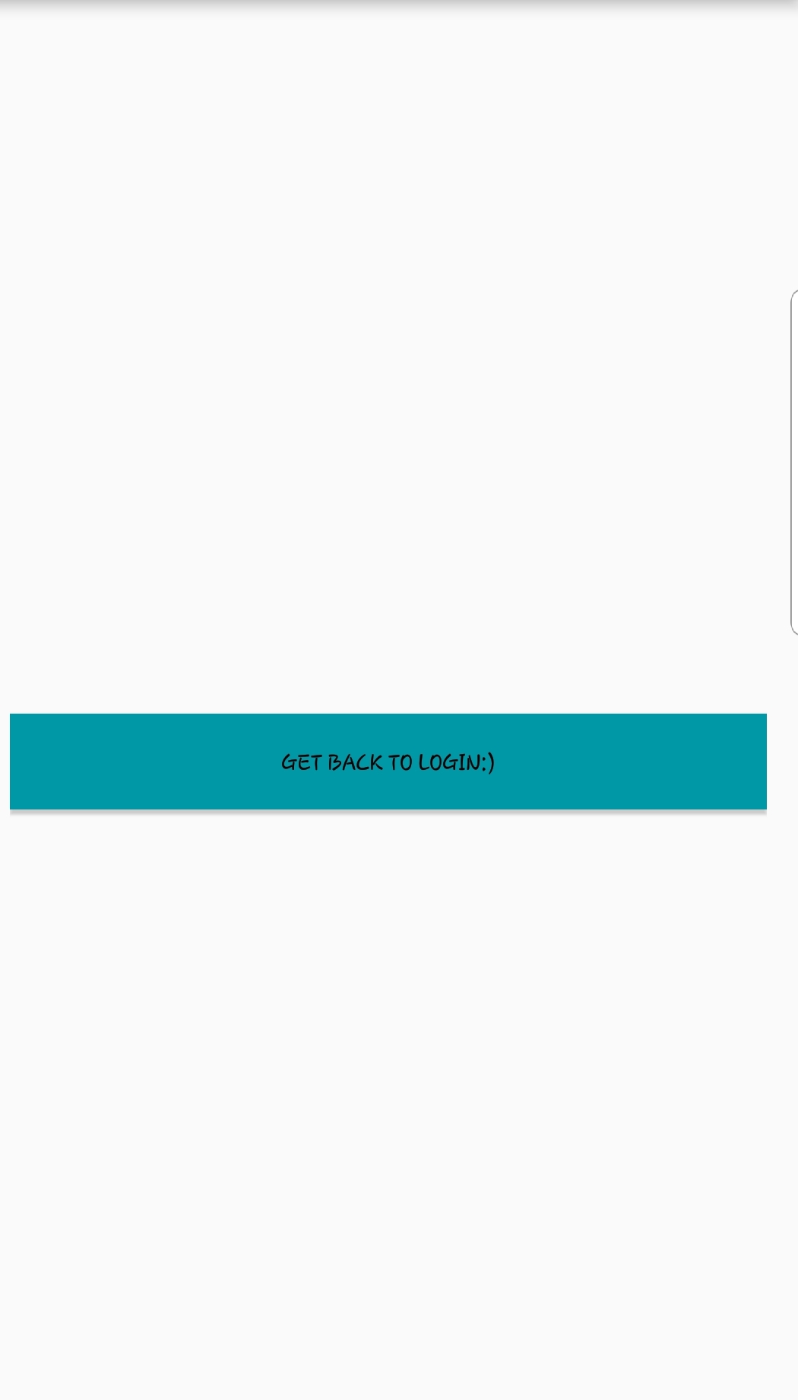

Code snippets:

