|  |
| --- |
| [Type the company name] |
| Assigntment 02 |
| Term Project: Part II |

|  |
| --- |
| Christopher M. Sims  11/27/2012 |

Table of Contents

Apply for Scholarship 2

XML Schemas 3

Applicant 3

Student 4

TuitionAmountRequest 5

TuitionAmountResponse 6

Interactions with Registrar 7

Award Scholarship 8

# Apply for Scholarship

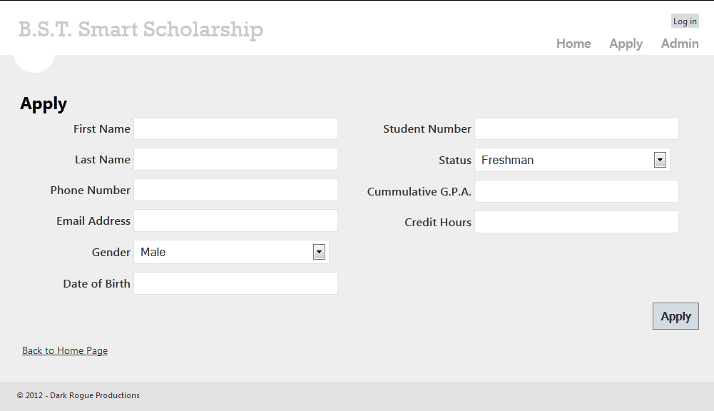

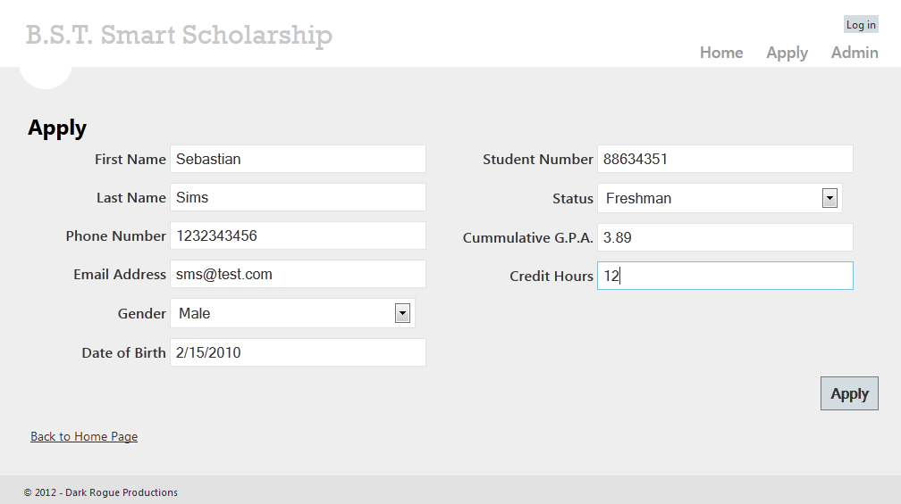

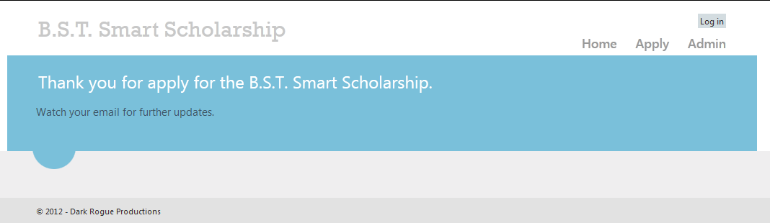

# XML Schemas

## Applicant

<?xml version="1.0" encoding="utf-8"?>

<xs:schema id="Applicant"

targetNamespace="http://bstsmartscholarship.sesmar.net/applicant"

elementFormDefault="qualified"

xmlns="http://bstsmartscholarship.sesmar.net/applicant"

xmlns:mstns="http://bstsmartscholarship.sesmar.net/applicant"

xmlns:xs="http://www.w3.org/2001/XMLSchema"

>

<xs:element name="Applicant" type="ApplicantType" />

<xs:complexType name="ApplicantType">

<xs:sequence>

<xs:element name="StudentNumber" type="StudentNumberType"/>

<xs:element name="FirstName" type="xs:string"/>

<xs:element name="LastName" type="xs:string"/>

<xs:element name="PhoneNumber" type="xs:string"/>

<xs:element name="EmailAddress" type="EmailAddressType"/>

<xs:element name="Gender" type="GenderType"/>

<xs:element name="DateOfBirth" type="xs:dateTime"/>

<xs:element name="Status" type="StatusType"/>

<xs:element name="CumulativeGPA" type="GPAType"/>

<xs:element name="CreditHours" type="CreditHoursType"/>

<xs:element name="IsEligible" type="xs:boolean" nillable="true"/>

<xs:element name="IsVerified" type="xs:boolean" nillable="true"/>

</xs:sequence>

</xs:complexType>

<xs:simpleType name="StudentNumberType">

<xs:restriction base="xs:string">

<xs:pattern value="\d{8}" />

</xs:restriction>

</xs:simpleType>

<xs:simpleType name="EmailAddressType">

<xs:restriction base="xs:string">

<xs:pattern value=".*@.*\.[A-Za-z]{2,4}" />

</xs:restriction>

</xs:simpleType>

<xs:simpleType name="GenderType">

<xs:restriction base="xs:int">

<xs:minInclusive value="1" />

<xs:maxInclusive value="2" />

</xs:restriction>

</xs:simpleType>

<xs:simpleType name="StatusType">

<xs:restriction base="xs:int">

<xs:minInclusive value="1" />

<xs:maxInclusive value="4" />

</xs:restriction>

</xs:simpleType>

<xs:simpleType name="GPAType">

<xs:restriction base="xs:double">

<xs:minInclusive value="0" />

<xs:maxInclusive value="4" />

</xs:restriction>

</xs:simpleType>

<xs:simpleType name="CreditHoursType">

<xs:restriction base="xs:int">

<xs:minInclusive value="0" />

<xs:maxInclusive value="21" />

</xs:restriction>

</xs:simpleType>

</xs:schema>

## Student

<?xml version="1.0" encoding="utf-8"?>

<xs:schema id="Student"

targetNamespace="http://bstsmartscholarship.sesmar.net/student"

elementFormDefault="qualified"

xmlns="http://bstsmartscholarship.sesmar.net/student"

xmlns:mstns="http://bstsmartscholarship.sesmar.net/student"

xmlns:xs="http://www.w3.org/2001/XMLSchema"

>

<xs:element name="Student" type="StudentType" />

<xs:complexType name="StudentType">

<xs:sequence>

<xs:element name="StudentNumber" type="StudentNumberType"/>

<xs:element name="FirstName" type="xs:string"/>

<xs:element name="LastName" type="xs:string"/>

<xs:element name="Status" type="StatusType"/>

<xs:element name="CumulativeGPA" type="GPAType"/>

<xs:element name="CreditHours" type="CreditHoursType"/>

<xs:element name="DateOfBirth" type="xs:dateTime"/>

<xs:element name="Gender" type="GenderType"/>

<xs:element name="CurrentGPA" type="GPAType"/>

</xs:sequence>

</xs:complexType>

<xs:simpleType name="StudentNumberType">

<xs:restriction base="xs:string">

<xs:pattern value="\d{8}" />

</xs:restriction>

</xs:simpleType>

<xs:simpleType name="EmailAddressType">

<xs:restriction base="xs:string">

<xs:pattern value=".*@.*\.[A-Za-z]{2,4}" />

</xs:restriction>

</xs:simpleType>

<xs:simpleType name="GenderType">

<xs:restriction base="xs:int">

<xs:minInclusive value="1" />

<xs:maxInclusive value="2" />

</xs:restriction>

</xs:simpleType>

<xs:simpleType name="StatusType">

<xs:restriction base="xs:int">

<xs:minInclusive value="1" />

<xs:maxInclusive value="4" />

</xs:restriction>

</xs:simpleType>

<xs:simpleType name="GPAType">

<xs:restriction base="xs:double">

<xs:minInclusive value="0" />

<xs:maxInclusive value="4" />

</xs:restriction>

</xs:simpleType>

<xs:simpleType name="CreditHoursType">

<xs:restriction base="xs:int">

<xs:minInclusive value="0" />

<xs:maxInclusive value="21" />

</xs:restriction>

</xs:simpleType>

</xs:schema>

## TuitionAmountRequest

<?xml version="1.0" encoding="utf-8"?>

<xs:schema id="TuitionAmountRequest"

targetNamespace="http://bstsmartscholarship.sesmar.net/tuitionamountrequest"

elementFormDefault="qualified"

xmlns="http://bstsmartscholarship.sesmar.net/tuitionamountrequest"

xmlns:mstns="http://bstsmartscholarship.sesmar.net/tuitionamountrequest"

xmlns:xs="http://www.w3.org/2001/XMLSchema"

>

<xs:element name="TuitionAmountRequest" type="TuitionAmountRequestType" />

<xs:complexType name="TuitionAmountRequestType">

<xs:sequence>

<xs:element name="StudentNumber" type="StudentNumberType"/>

</xs:sequence>

</xs:complexType>

<xs:simpleType name="StudentNumberType">

<xs:restriction base="xs:string">

<xs:pattern value="\d{8}" />

</xs:restriction>

</xs:simpleType>

</xs:schema>

## TuitionAmountResponse

<?xml version="1.0" encoding="utf-8"?>

<xs:schema id="TuitionAmountResponse"

targetNamespace="http://bstsmartscholarship.sesmar.net/tuitionamountresponse"

elementFormDefault="qualified"

xmlns="http://bstsmartscholarship.sesmar.net/tuitionamountresponse"

xmlns:mstns="http://bstsmartscholarship.sesmar.net/tuitionamountresponse"

xmlns:xs="http://www.w3.org/2001/XMLSchema"

>

<xs:element name="TuitionAmountResponse" type="TuitionAmountResponseType" />

<xs:complexType name="TuitionAmountResponseType">

<xs:sequence>

<xs:element name="StudentNumber" type="StudentNumberType"/>

<xs:element name="TuitionAmount" type="xs:double"/>

</xs:sequence>

</xs:complexType>

<xs:simpleType name="StudentNumberType">

<xs:restriction base="xs:string">

<xs:pattern value="\d{8}" />

</xs:restriction>

</xs:simpleType>

</xs:schema>

# Interactions with Registrar

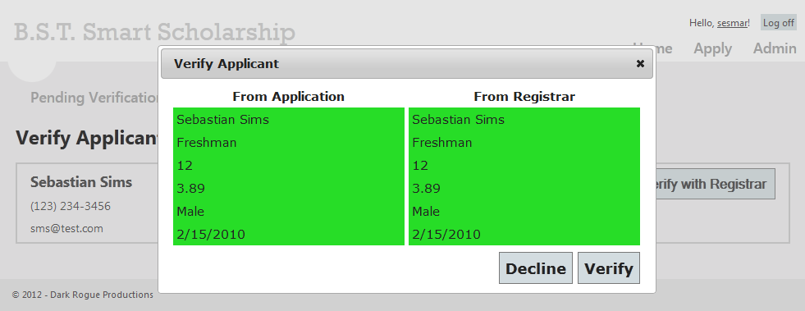

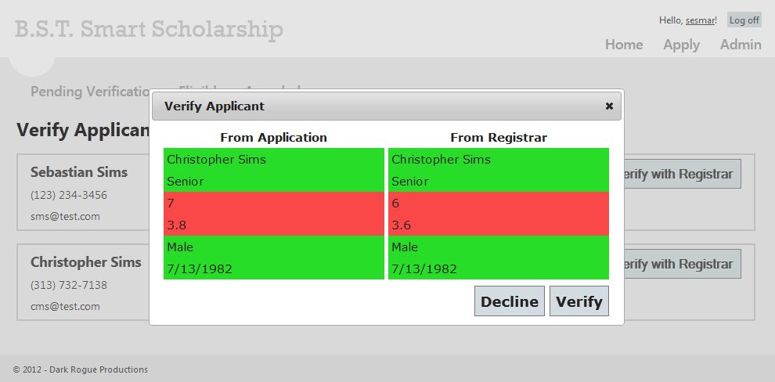

# Award Scholarship

