Table of Contents

Dataflow Diagrams 3

Context Level Diagram 3

Level 0 Diagram 3

Level 1 Diagram 4

Level 2 Diagram 4

Level 3 Diagram 5

Level 4 Diagram 5

Decision Trees 5

Check Eligibility 5

Select Awardee 6

Applicant User Interface Design 6

Welcome Screen: 6

Details: 6

Wire Frame: 7

Application Form: 7

Details: 7

Wire Frame: 8

Validation Rules: 8

Reviewer User Interface Design 9

Welcome Screen 9

Details: 9

Wire Frame: 9

Login Screen 10

Details: 10

Wire Frame: 10

Pending Verification Screen 10

Details: 10

Wire Frames: 11

Eligible Screen 12

Details: 12

Wire Frames: 13

Awarded Screen 13

Details: 13

Wire Frames: 14

# Dataflow Diagrams

## Context Level Diagram

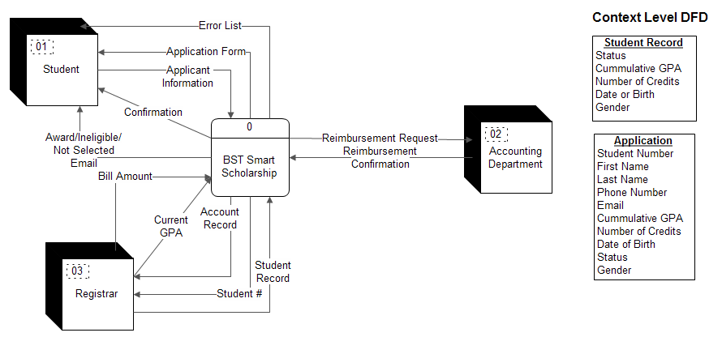

## Level 0 Diagram

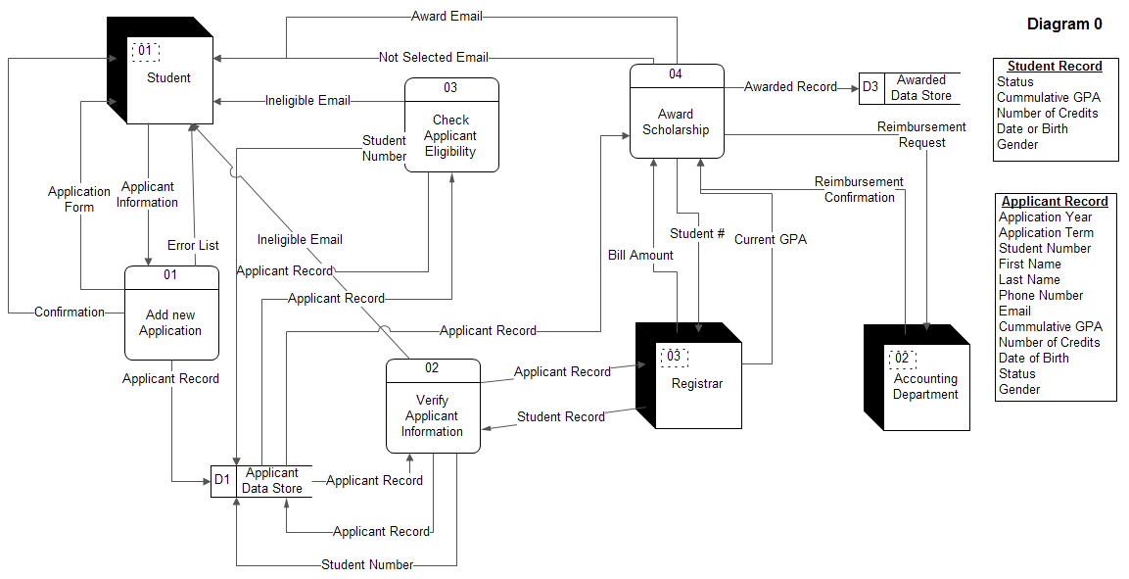

## Level 1 Diagram

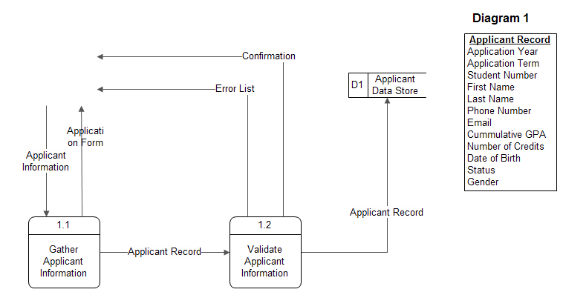

## Level 2 Diagram

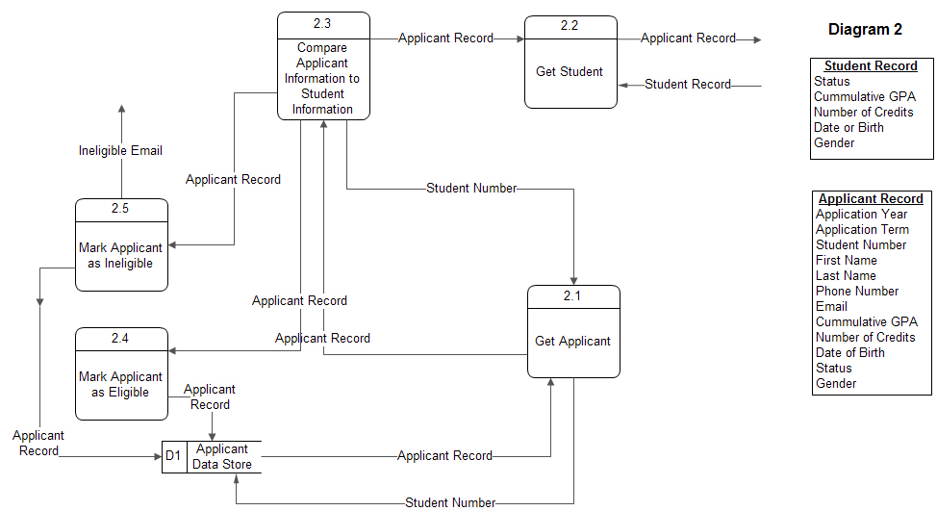

## Level 3 Diagram

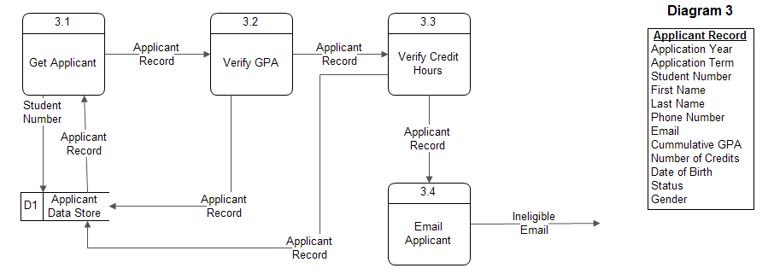

## Level 4 Diagram

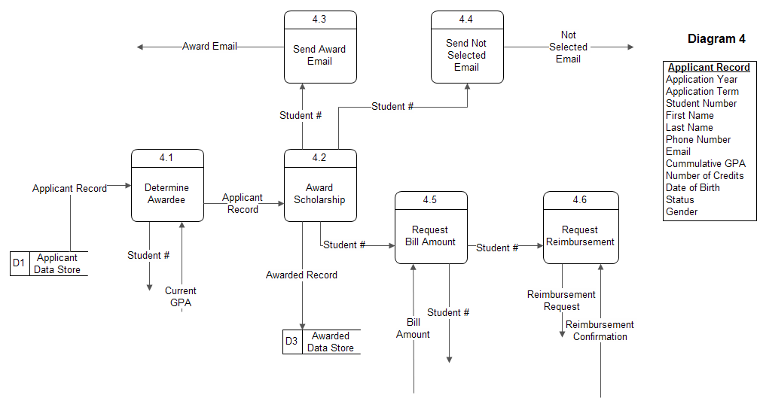

# Decision Trees

## Check Eligibility

|  |  |  |  |  |
| --- | --- | --- | --- | --- |
| **Conditions** | 1 | 2 | 3 | 4 |
| G.P.A. >= 3.2 | T | F | - | - |
| At least 12 Credit Hours | T | - | F | - |
| < 24 Years Old | T | - | - | F |
| **Actions** |  |  |  |  |
| Mark as Eligible | X |  |  |  |
| Mark as Ineligible |  | X | X | X |
| Send Email |  | X | X | X |

## Select Awardee

|  |  |  |  |  |  |  |  |
| --- | --- | --- | --- | --- | --- | --- | --- |
| **Conditions** | 1 | 2 | 3 | 4 | 5 | 6 | 7 |
| One with highest G.P.A. | T | F | F | F | F | F | F |
| More than one with highest G.P.A. | F | T | T | T | T | T | T |
| One with highest G.P.A in semester | - | T | F | F | F | F | F |
| More than one with highest G.P.A. in semester | - | F | T | T | T | T | T |
| One Junior | - | - | T | F | F | F | F |
| More or less than one Junior | - | - | F | T | T | T | T |
| One female | - | - | - | T | F | F | F |
| More or less than one female | - | - | - | F | T | T | T |
| Most Votes | - | - | - | - | - | T | F |
| **Actions** |  |  |  |  |  |  |  |
| Interview Youngest |  |  |  |  | X |  |  |
| Award Scholarship | X | X | X | X |  | X |  |

# Applicant User Interface Design

## Welcome Screen:

### Details:

The first screen applicants will see is welcome screen explaining what the BST Smart Scholarship is and how to apply. Since applying for the scholarship is the main focus a “navigation item” in the form of a graphic button is very prominent on the page. This will take applicants to the application form.

### Wire Frame:

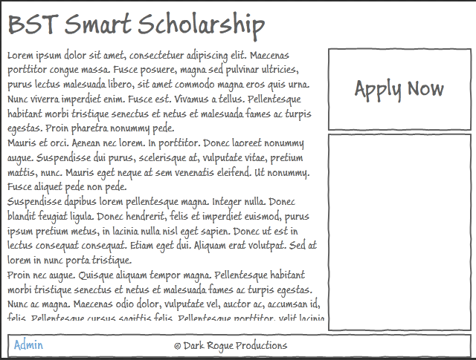

## Application Form:

### Details:

The application form is made up of ten fields broken into two sections. The fields were broken into two sections based on the nature of the information they collect, personal and collegiate. This decision was made just to break the form up a little instead of putting the field in a long top down manner. It also makes it easier to see everything on one pages and I believe it presents the form in a less overwhelming way.

### Wire Frame:

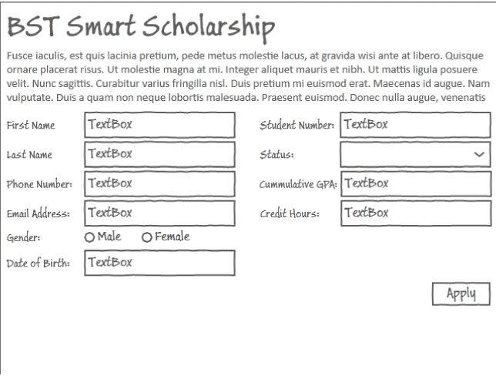

### Validation Rules:

|  |  |
| --- | --- |
| **Field Name** | **Validation** |
| Student Number | Required  Length 10  Alphanumeric |
| First Name | Required  Length 128 |
| Last Name | Required  Length 128 |
| Phone Number | Required  Length 10 (Unformatted)  Regex to allow formatting and strip formatting. |
| Email | Required  Length 128  Regex to check for valid format XXX@XXX.XXX |
| Gender | Required  Radio Buttons to ensure proper choice |
| Date of Birth | Required  Regex to check proper format |
| Status | Required  Drop Down List to ensure proper selection |
| Cumulative G.P.A. | Required  Range check must be 0 < X < 4.0  Allow only numbers. |
| Credit Hours | Required  Range Check 0 < X < 21  Allow only Integers |

# Reviewer User Interface Design

## Welcome Screen

### Details:

The initial screen reviewers will see upon enter the site is the same as the applicant welcome screen. In order to gain access to the administrative side of the system, reviewers will be required to log-in. There will be a link in the bottom left hand corner of the footer that will allow reviewers to log-in and begin using the administrative side of the system.

### Wire Frame:



## Login Screen

### Details:

This is a simple login screen for them to enter a username and password. The header also functions as a link back to the home page in case they do not want to log in at this time.

### Wire Frame:

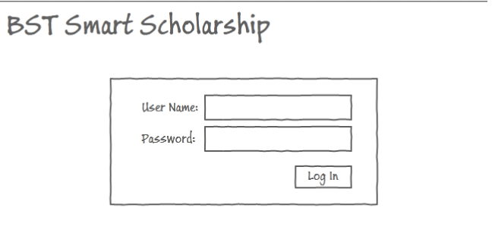

## Pending Verification Screen

### Details:

This screen is used by the reviewers to verify the applicant’s information with the registrar. It initial list show basic information about the applicant. When the reviewer clicks on the “Verify with Registrar” button for a particular applicant it will retrieve the applicants student record from the registrar and give the reviewer a side by side comparison. I have not made this process entire automatic because I thought that some discrepancies may occur; however, they might not have been intentional. Once the side by side comparison is done the review can mark an applicant as eligible or ineligible by hitting the accept or decline buttons.

### Wire Frames:

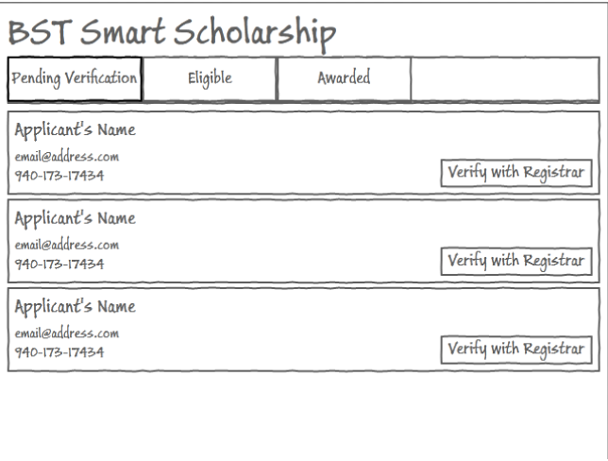

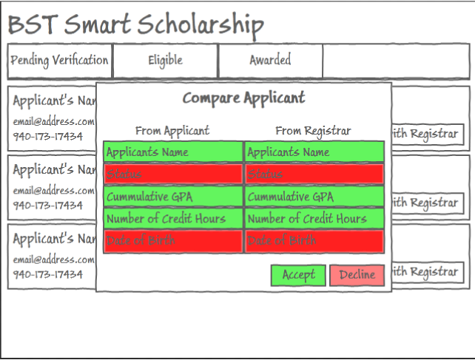

## Eligible Screen

### Details:

The eligible screen has two purposes: first it displays all of the applicants to have passed verification with the registrar, secondly it allows the reviewers to filter out applicants that do not meet the minimum status/gpa/credit hour requirements. If an applicant does not meet the requirements a reviewer can click on the decline button and the applicant is marked as ineligible.

### Wire Frames:

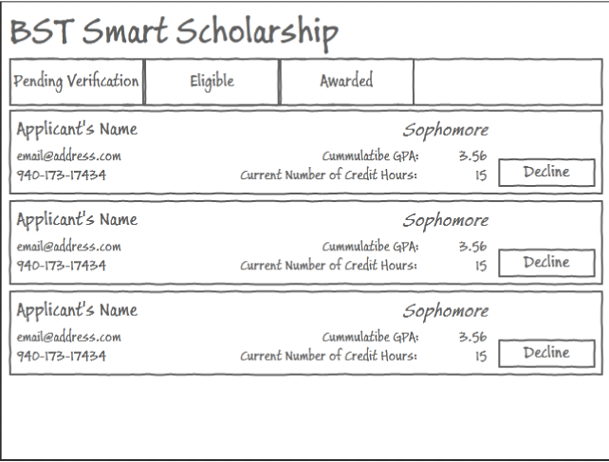

## Awarded Screen

### Details:

The details screen will show, at any given time, the person who will receive the award if the scholarship was to be award at this time. If more than one person would be selected, this is where the reviewers cast their vote once the interviewing has been completed.

### Wire Frames:

