Examining the New Neoclassical Synthesis through Agent Based Computational Modeling
Abstract
The New Neoclassical Synthesis (NNS) is an intriguing blend between real business cycles and Keynesian theories. Using a simple Agent Based Computational (ABC) model, this paper attempts to put NNS to the test. The model starts with two types of agents, households and firms, and will attempt to examine various theories and finding of the NNS model though the unemployment rate. The simulation is run several times without any economic shocks, once with a shock to future income prospects, once with a negative shock to productivity, and finally, once with a positive shock to productivity. The results are analyzed and compared to that of Goodfiend’s findings and theories from 2004.

1. Introduction
The aim of this paper, first and foremost, is to try and provide a reasonably simple Agent Based Computational (ABC) model in which the theories and finding of the New Neoclassical Synthesis (NNS) model can be evaluated. Secondly, this paper provides a basic understanding of ABC models and how they can be used to help better understand the current economy. The paper is divided into 6 sections. The model is developed and the basic rules that the agents will conform to are explained. Simulation results are presented and analyzed with comparisons to the NNS model in section 3. Section 4 concludes the paper.

2. The Model
There are two different types of ABC models, realistic models that try to mimic real world economies with highly detailed rules and agents and stylized models that abstract from real economies with a small subset of agents and simplistic rules. The model developed in this paper, based on Lengnick (2011), falls into the second category with only two types of agents with limited interactions.
The model consists of two types of agents, firms and households, just as the NNS model. Each firm sets their own price, controls their wage, and has a different initial markup. At the beginning of each month, the first thing a firm does is pay their employees, and once all employees have been paid for the period firms decided whether they need to make a changes to their current workforce. That is, a firm will evaluate if they need to hire an additional employee or let one go. This decision is made based on the firm's current inventory. If their inventory from the prior month as been depleted for more than a months, a firm will bring on an additional employee (post a job offering) at the current wage. On the other hand, if a firm is running a surplus of v for more than b months a firm will let one employee go. If a position goes unfilled for more than a month, the firm will raise their offered wage; however, if a firm fills an offered position for f months running they will lower their offered wage. Once employees have been paid and the workforce has been evaluated a firm can produce goods for the month. Goods production is based on:
inventory = (employees * productivity) * (days in month)
Employee payment, posting a job offering, and production of goods are all monthly operations, they happen on the first day of each month. If a firm does not have enough liquidity to pay all employees, the unpaid employees resign and attempt to find work elsewhere.
Households maintain two different types of connections. They maintain a connection with their employer as well as a network of trade connections. Each household can have a trade connection with up to y firms at any given time. At the beginning of each month, if a household has fewer than y trade connections they will randomly select a firm to establish a trade connection with. In addition to trade connections, a household has a reservation wage and a current wage. A household's reservation wage is the lowest they would like to be paid for their services. At the beginning of each day, a household compares their current wage to their reservation wage, if their current wage is lower than their reservation wage, they will randomly select an existing hiring firm and check if it is offering a higher wage. If the new firm is offering a higher wage, the household will resign their current position and except the new one. In the event that a household is currently unemployed they will except the first position found. After all trade connections have been filled and employment established, a household will randomly choose a firm from among its trade connections to purchase a good from. If the selected firm currently has available inventory and the price is lower than the household's current liquidity, the household will purchase the good. Although, if the firm does not have enough inventory to meet a household's needs, the household will sever the trade connection with that firm. The household will repeat this process between one and g times.
Both firms and households maintain their own liquidity. Liquidity is constrained to positive numbers and determines whether firms can pay employees or households can purchase goods. A firm receives additional liquidity whenever a household purchases a good from it, while a household receives liquidity when a firm pays them for services rendered.

3. Simulations and Results
For all simulations prices are fixed and the period (month) length is set to fifteen ticks (days). The remaining variables, as described in Appendix A, are configured, as described in Appendix B, per simulation. The model itself is governed by a fairly simple rule set; however, through simplicity complex behavior can emerge as can be seen by examining the unemployment rate from each simulation.

3.1 Simulation 1
The results of the first simulation show a very bleak outlook on the economy with an unemployment rate around 92%. This is an important part of the process for developing an ABC model. The first simulation with initial parameters for the model gives important results in order to properly calibrate the model. Another important outcome from the simulation is that it appears to have settled at an equilibrium point. This is important as it validate the standard belief from most Dynamic Stochastic General Equilibrium (DSGE) models that are built on the premise of an economy returning to equilibrium. On its own, left to follow the predetermined rules, the unemployment rate has settled around its own equilibrium. In order to try and bring down the unemployment rate, one must understand the reason why firms are not hiring. In this model, if households are not purchasing enough goods to sufficiently reduce a firm's inventory each period it will fire employees. Since the unemployment rate is so high, it would suggest that demand for goods is extremely low. Households are not purchasing goods fast enough or firms are producing an excess amount, since firms are ending each month with a surplus they are letting employees go. Since households no longer have a job, they run out of liquidity to purchase goods and the cycle repeats until a balance is found.

3.2 Simulation 2
For the second simulation the only variable that changes is g, it is increased from 1 to 8 in order to simulate an increase in demand. Once again, the simulation is run for a little over 9000 days in order to get a simulation time of fifty years. The results of the second run looks a lot more promising than the first. The mean unemployment rate is around 32%, a significant reduction from the 92% achieved in the initial run. This result also confirms that an increase in demand results in lower unemployment. A second difference between the first and second run is the amount of variance in actual unemployment throughout the simulation. While the first simulation had a much higher mean unemployment rate, the standard deviation is only 1.99 while the standard deviation from simulation 2 is 7.21. This suggests a much higher rate of volatility between cycles, created by firms “jumping” to conclusion too quickly. When inventories start to pile up they are letting employees go too quickly or, on the flip side, when inventories are diminished they are quickly looking to hire another employee when maybe they should not.

3.2 Simulation 3
For the third simulation, in order to try and smooth the volatility in the unemployment rate both a and b are changed from 1 to 3. This will simulate a slight delay in the hiring/firing process; instead of a firm immediately hiring or firing an employee as soon as conditions look good or bad respectively, it will give a few month's time to see if the conditions remain the same. After running for 50 years, the increase in both a and b seems to have helped reduce some of the volatility in unemployment. Interestingly, the standard deviation did not get any better, it actually increased; however, the volatility between these peaks is greatly reduced. Another large deviation from past simulations is the downward slope of the trend (orange) line. While the standard deviation did increase by almost double for this run, the increase in both a and b does appear to have also had a more stabilizing effect on the model over time. Earlier in the simulation the unemployment rate seems to have moved upward fairly quickly, and it also starts to stabilize and trend downward reaching as low as 9% which none of the other simulations have even come close to. After viewing the result of this simulation, the model appears to be stabilized enough in order to simulate various shocks and get a good idea of the results from the model.

3.4 Simulation 4 – Negative Shock to Productivity
The first case examined is a negative shock to productivity. In order to simulate this, after 25 years have elapsed in the simulation, q will be reduced from 2 to 0.5. According to Goodfriend (2004), due to a negative productivity shock, firms should hire more employees in order to meet the current demand causing a decrease in unemployment; however, Goodfriend goes on to state that this decrease would not remain permanent as the economy adjusts to the initial shock. The results of the simulation seem to contradict this finding. Around the 25 year mark, productivity, economy wide, decreases from 2 to 0.5, at this same time unemployment starts trending upward, which seems to be the opposite of what would be expected in this situation. In order to ensure there was not a “glitch” in the system, a second simulation is run this time spanning 150 years instead of the normal 50 years. The results of the second simulation once again show a similar increase in unemployment at the 25 year mark when the shock is introduced; however, following the simulation past the standard 50 year mark it shows that unemployment stabilizes again and comes back down with no significant change due to the negative shock to productivity.

3.5 Simulation 5 – Positive Shock to Productivity
The second case examined is a positive shock to productivity. In order to simulate a positive shock, after 25 years, q will be increased from 2 to 4. Based on the Goodfriend's (2004) statements regarding negative shocks to productivity, a reasonable assumption would be that unemployment will rise due to a fewer number of employees being needed in order to meet the current demand. On the other hand the results of the prior simulation actually found the opposite to be true in the short to medium run; although, ultimately the shock had no significant impact on unemployment. Given that result, it would also be reasonable to believe that unemployment will show a decrease in the short to medium run and a return to mean in the long run. In the first run, results similar to what would be expected based on Goodfriend's findings occur; however, the second run of the simulation once again shows that the positive shock has no significant impact on unemployment in the long run.

3.6 Simulation 6 – A Positive Demand Shock
The third and final case examined with this model is a positive demand shock. In order to facilitate this type of shock, 25 years into the simulation g is increased from 8 to 16. With a positive demand shock the model can, to an extent, simulate optimism about future income prospects. According to Goodfriend (2004), optimism about future income would lead to an increase in current demand, and an increase in demand leads to lower unemployment as firms hire more employees in order to meet the increase in demand. In both simulations at the 25 year mark, there was a significant and prolonged reduction in the unemployment rate, which is consistent with Goodfriend's findings. Even though the increased demand caused an immediate reduction in unemployment, the effects do not appear to have been permanent as towards the end of the 150 year span unemployment starts trending upward towards the initial starting point.

Section 4
While the model created for this paper employs a rather simple rule set, it is capable of producing fairly complex results and simulating fairly realistic economic outcomes. Through several simulations with three different economic shocks, the model was able to test certain theories presented by Goodfriend (2004). The first three simulations provided valuable insight into helping properly calibrate the model. Getting the model to a point in which effects of the various shocks would be noticeable was essential in order to properly observe and validate them against the NNS. After running the simulation for each shock twice, most results aligned with Goodfriend's finding. This appears to validate Goodfriends finding while also validating the simple model. Agent Based Computational modeling is a valuable tool when applied properly and under the appropriate circumstances. This model is only one example of many using simple rules to validate macro-economic ideas on a micro level, other, more sophisticated models are capable of simulating a more realistic economy and providing even more valuable information.

Appendix A
a – Number of months a firm needs to deplete its inventory before bringing on an additional employee
b – Number of months a firm needs to run a surplus before letting an employee go.
w – Percentage profit remaining in order to consider a firm maintain surplus.
f – Number of months a firm need to fill an offered position before increasing offered wage.
y – Number of trade connections allowed.
g – Max number of good to purchase in a day.
q - Productivity

Appendix B

B.1: Simulation 1
a | 1
b | 1
w | 10% (0.1)
f | 3
y | 7
g | 1
q | 2
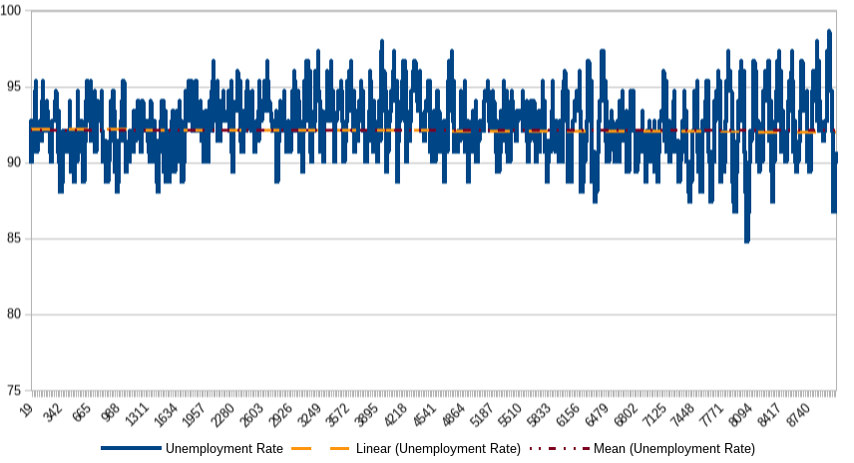

B.2: Simulation 2
a | 1
b | 1
w | 10% (0.1)
f | 3
y | 7
g | 8
q | 2
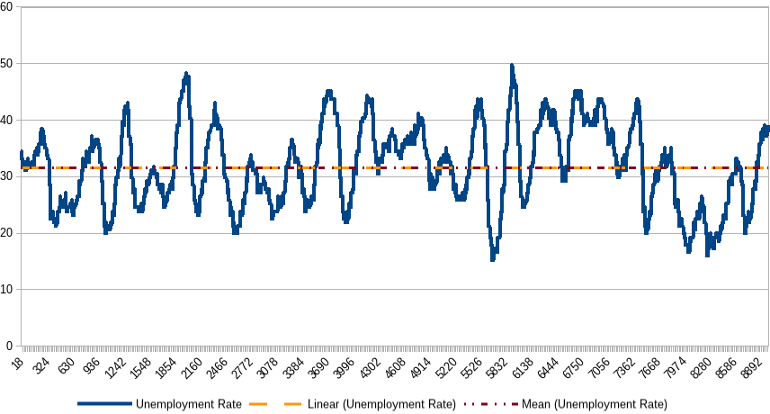

B.3: Simulation 3

a | 3
b | 3
w | 10% (0.1)
f | 3
y | 7
g | 8
q | 2
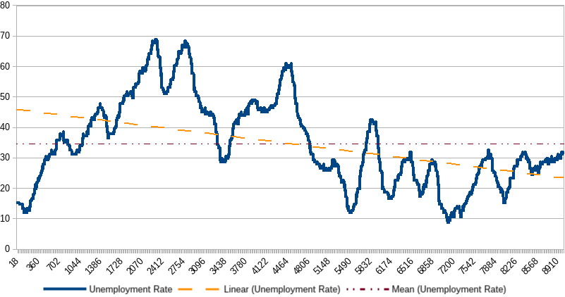

B.4: Simulation 4

a | 3
b | 3
w | 10% (0.1)
f | 3
y | 7
g | 8
q | 2 moved to 0.5, 25 years into the simulation.
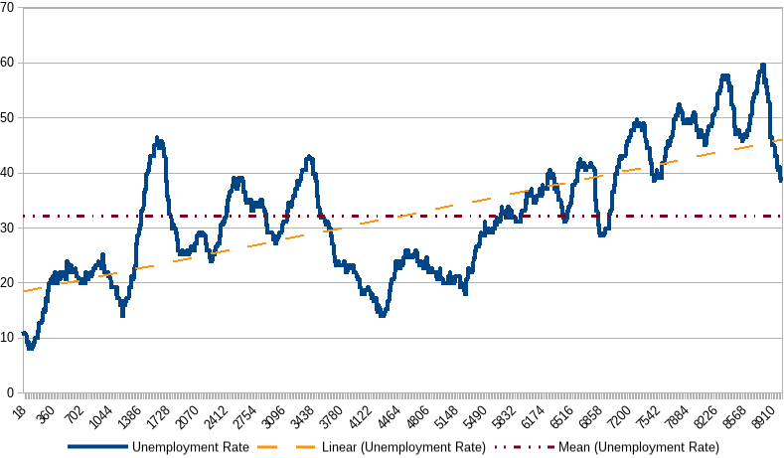
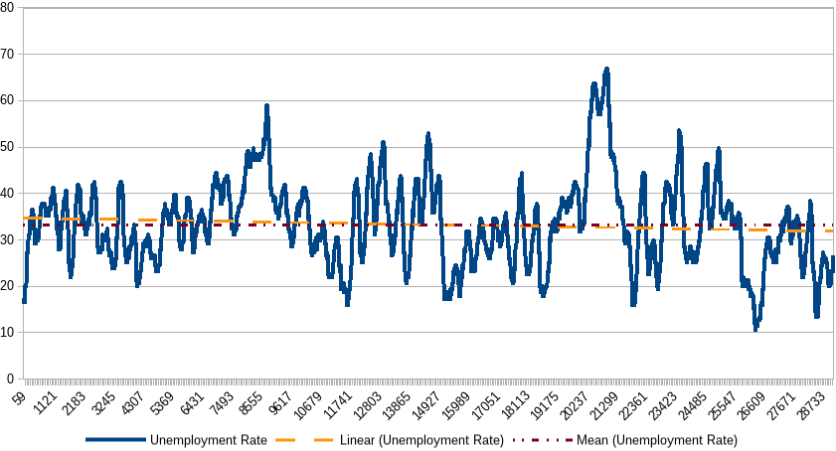

B.5: Simulation 5

a | 3
b | 3
w | 10% (0.1)
f | 3
y | 7
g | 8
q | 2 moved to 4, 25 years into the simulation.
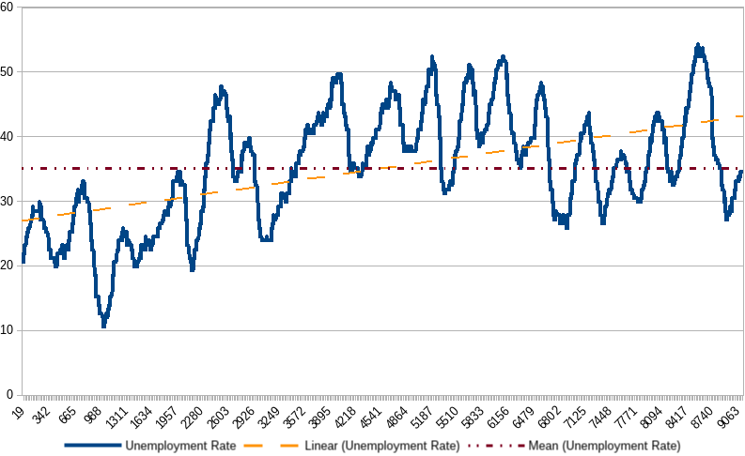
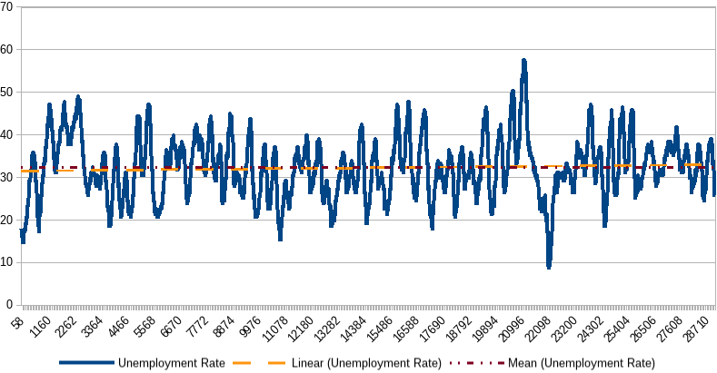

B.6: Simulation 6
a | 3
b | 3
w | 10% (0.1)
f | 3
y | 7
g | 8 moved to 16, 25 years into the simulation.
q | 2
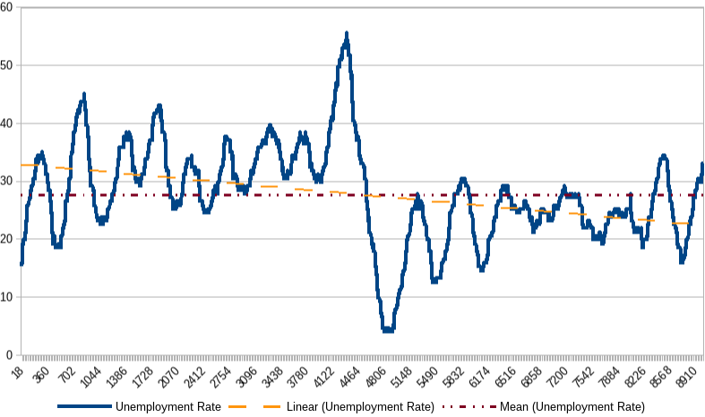
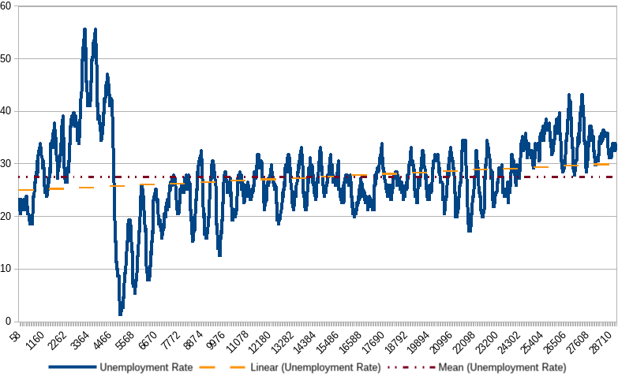

Bibliography
Ashraf, Q., Gershman, B., and Howitt, P., 2010, Banks, Market Organization and Macroeconomic Performance: An Agent-Based Computational Analysis
Bersini, H., 2012, UML for ABM, Journal of Artificial Societies and Social Simulation No.15 (1) 9
Goodfriend, M., 2004, Monetary Policy in the New Neoclassical Synthesis: A Primer, Federal Reserve Bank of Richmond Economic Quarterly v 90/3
Lengnick, M., 2011, Agent-based macroeconomics - a baseline model, Economics working paper / Christian-Albrechts-Universität Kiel, Department of Economics, No. 2011,04
Wolfram, S., 2002, A New Kind of Science, Wolfram Media, 1305 p.

Lengnick 2011
The model is programmed in Java using Repast Symphony, sources available at: https://github.com/sesmar/NNS
Wolfram 2002
See Appendix B.1 for parameters and results.
See Appendix B.2 for parameters and results.
See Appendix B.3 for parameters and results.
See Goodfriend 2004 section 4 Fluctuations and Stabilization Policy / A Temporary Productivity Shock for more information.
5500 ticks, given the 1000 tick burn off period.
Two simulations were run for this as well given interesting and unconclusive results after found after only 50 years, the second simulation ran for 150 years.
See Goodfriend 2004 Section 4 Optimism and Pessimism about Future Income Prospects for more information.
Given that two simulations have been run for the prior to shocks, two simulations for 50 and 150 years were run for this shock as well.

