**Question**: How are T.gratilla affected by climate change, specifically increased temperatures and decreased pH?

**Hypothesis**:

- Increased T = decreased body size

- Decreased pH = decreased calcification, alterations in composition

- Both = smaller and less calcified, alterations in composition

**Treatments**: T/OA, T, OA

**Controls**: Ambient

**Responses**: Growth (Diameter, mm), Calcification and/or dissolution.

**Experimental Units**: Technically header tanks… n=2

**Sample Units**: Individual urchins… n=24

**Materials and Methods Sections:**

1. **Experimental System**

**-** Describe the actual system -> seawater from bay to header buckets to tanks

- Flow rates and turnover

- Keishas 2 papers ( (Bahr & Jokiel, 2016; Jokiel, Bahr, & Rodgers, 2014))

• **FIGUREs**:

**2. Study Animal Collection and Acclimation**

- describes how got urchins

- acclimation period? Amp up period?

**• FIGUREs**: urchin diagram?

- Growth plot here??

**3. Experimental Treatments** **and** **Data Collection**

- Describe what and how treatments were done

- What was measured

- How data was collected

• **FIGURES**

- Table of treatment means

5. **SEM**

**-** Sample collection and mounting prep as well as actual use of machine

6. **Statistical Analysis**

- Describe what tests done and how and significance.

- Include residuals shown for normality and variances

- Image Analysis?

**- Possible Figures**

**-References**

**1. Experimental System**

This experiment was conducted in a flow-through system at the University of Hawai’i at Manoa’s Hawai’i Institute of Marine Biology (HIMB) on Moku o Lo’e in Kāne’ohe Bay Hawai’i and followed a similar low-cost, high-flow system outlined in Jokiel et. al. 2014. Four treatments were applied based on future projected climate change conditions; control (ambient temperature and CO2), high temperature (+2°C), high CO2 (to lower pH -0.3 units), and combined high temperature and CO2 (+2°C, -0.3 pH units) (Przeslawski, Ahyong, Byrne, Wörheide, & Hutchings, 2008). There were six replicates of each treatment.

Unfiltered seawater was pumped directly from the bay from a depth 3 m depth into eight 5-gallon header buckets where seawater conditions were manipulated. Each header flowed into 3 randomly assigned 8L tanks where individual urchins were housed, for a total of 24 microcosms of 6 replicates per treatment. Water flowed into tanks at a rate of 1.2 L min-1, resulting in a complete volume exchange every 6 minutes. Although tanks and hoses were cleaned and exchanged regularly, biofouling did occur in the water lines, leading to the slowest flow rate of 0.9 L min-1 with a complete turnover occurring every 8 minutes. This lower rate of exchange still provided ample available oxygen of over 95% desired throughout the study. The experiment ran for 138 days, not including a two week acclimation period, by which urchins had reached mature adult size of at least 60mm (72.12 ± 0.99mm) (Byrne et al., 2014; Dworjanyn & Byrne, 2018).

**2. Study animal collection and acclimation**

Urchins were collected from the Department of Land and Natural Resources (DLNR) from the Division of Aquatic Resources (DAR) sea urchin hatchery and acclimated to Kaneohe Bay conditions for two weeks. Test diameters were not significantly different upon initial collection (7.53 ± 0.15 mm, ) or after acclimation (16.11 ± 0.35 mm). Urchins were fed *Gracilaria Salicornia* collected from the shores of HIMB in excessto ensure consistent food availability. Throughout the experiment, there was only one mortality on day 116 of an urchin in a heated condition.

**3. Experimental Treatments and Data Collection**

Temperature was controlled using ﻿titanium heaters (Finnex©, TH-800, 800 W). Seawater pH was manipulated by direct CO2 bubbling through a hydro pump to maximize diffusion (Jokiel et al., 2014). All ambient and heated conditions were bubbled with air to ensure consistency in dissolved oxygen concentrations.

Because of the open-system, all treatments tracked natural daily and seasonal fluctuations. No treatment was applied for the first two weeks while urchins acclimated to Kaneohe Bay conditions. After which, treatments were ramped up for two more weeks. Temperature (°C), salinity ﻿(‰), and dissolved oxygen (% saturation) were measured at mid-day (11:00 – 14:00 h) to ensure consistent desired environmental conditions. Water samples were collected once a week for use in titrations and photometric pH determinations.

﻿

**pH Spectrophotometer:** (Bahr & Jokiel, 2016)**:**

Seawater pH was determined spectrophotometrically (pHTotal) each week using m-cresol purple dye (Sigma-Aldrich© #857890). All procedures were followed according to SOP 7 (Dickson, Sabine, & Christian, 2007). In addition to the above procedure, pH was checked frequently using an Accumet© AP72pH/mV/temperature meter (pHNBS) to ensure stability in between sampling.

**Titrations:**

**﻿**Total alkalinity was measured weekly using an automatic titrator (Titrino© Plus 877, Metrohm) with pH glass electrode (9101 Herisau, Metrohm©). The automatic titrator was checked and confirmed for precision with certified reference materials (CRM) (Batch 127 from A. Dickson Laboratory, Scripps Institution of Oceanography). Additional seawater parameters were calculated using the program CO2SYS (Pierrot, D., 2012) with stoichiometric dissociation constants (K1, K2) as redefined (original by Mehrbach et. al., 1973) by Dickson & Millero, 1987.

* Need to add use of CO2Sys * moulin 2014: acid-base regulations

**4. SEM and Image J**

At the end of the 138-day experimental period, spines were plucked from each individual urchin (n=23) for use in scanning electron microscopy (SEM) at the Biological Electron Microscope Facility (BEMF) at the University of Hawaiʻi at Mānoa. Approximately 10–20 spines were haphazardly selected from the skirt of the urchin test (*possible diagram from (Collard et al., 2016)*). Spines were soaked in 10mL of 10% bleach solution for 20 minutes to remove organic material, rinsed in distilled water to remove bleach residue, and dried at 60°F for 24 hours. All spines selected were measured for length using Neiko digital calipers (Resolution: 0.01mm, Accuracy: 0.02mm) and three were randomly selected to be prepped for SEM imaging. Each selected spine was cut 2 mm from the tip and base using a fresh razor blade and air blasted to remove dust particles. In the event that a spine broke during the mounting process, another spine was randomly selected. The mid-section was saved for potential future compositional analysis. The base and tip selections were mounted cut-side upward on aluminum stubs using carbon conductive adhesive paint and coated with gold/palladium for 45 seconds in a Hummer 6.2 sputter coater. Specimens were viewed with a Hitachi S-4800 Field Emission Scanning Electron Microscope at an accelerating voltage of 5.0 kV. Because the SEM allows for maneuverability on the X, Y, and Z planes, stubs could be rotated to ensure a direct overhead image could be captured.

Images were analyzed using ImageJ (NIH, Bethesda, MD, USA). A manual selection of each spine cross-section was made to include only the inner portion of the spine. A custom macros was run to convert each image to binary and adjust for outlying bright spots. The image was then scanned to divide it in half with equal area on each side. Although great care was taken to remove dust before SEM imaging, some spines still had small specks of dust that could interfere with results. If dust was visible, images were rotated so the dust occupied only one side. If there was too much dust across the entire cross-section, that image was not used in analysis (n=1). Three ratios of black to white (left, right, and full) were calculated to represent calcified to non-calcified material. There was no difference between left and right non-dusty sides, so analysis was conducted on only one side per image.

**6. Statistical Analyses**

Data analysis was conducted using JMP and R programs. This study followed a blocked factorial design in which the headers were randomly assigned to tanks. Residuals were checked for normality and variances determined for equality. Linear mixed models with nested…

**POSSIBLE FIGURES?**

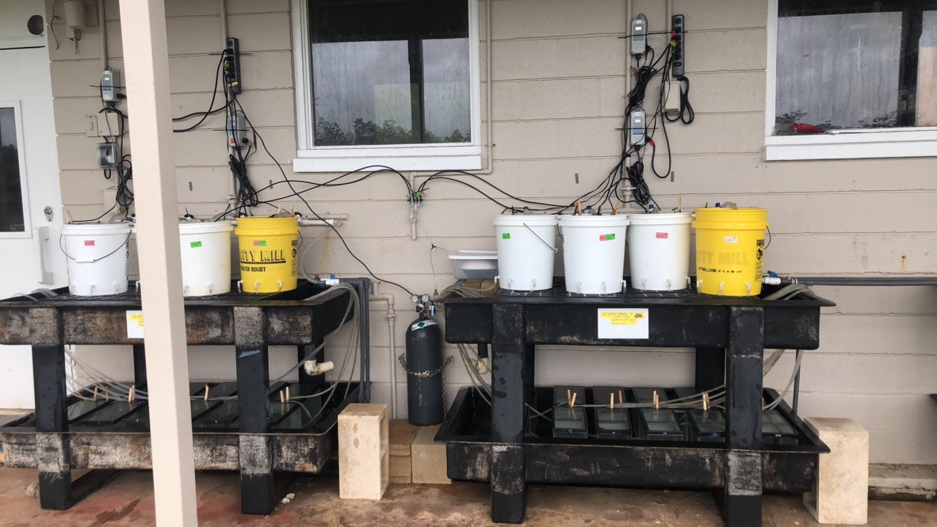

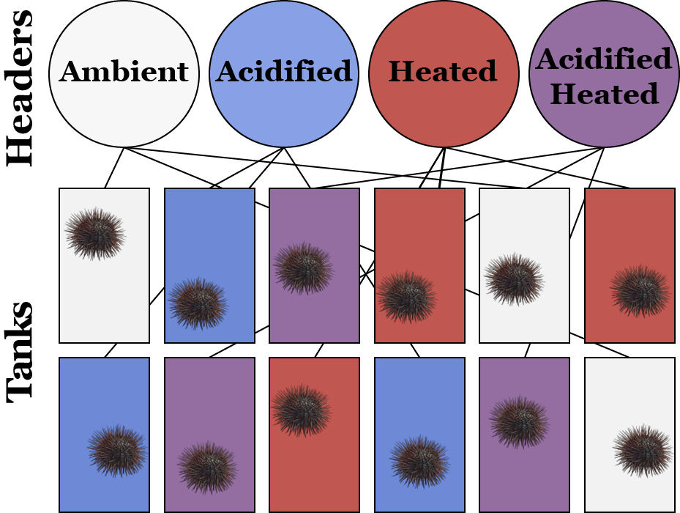

Fig. 1. Experimental set-up (top) on Moku oʻ loʻe and schematic diagram representing the design and treatments in one side of the system.

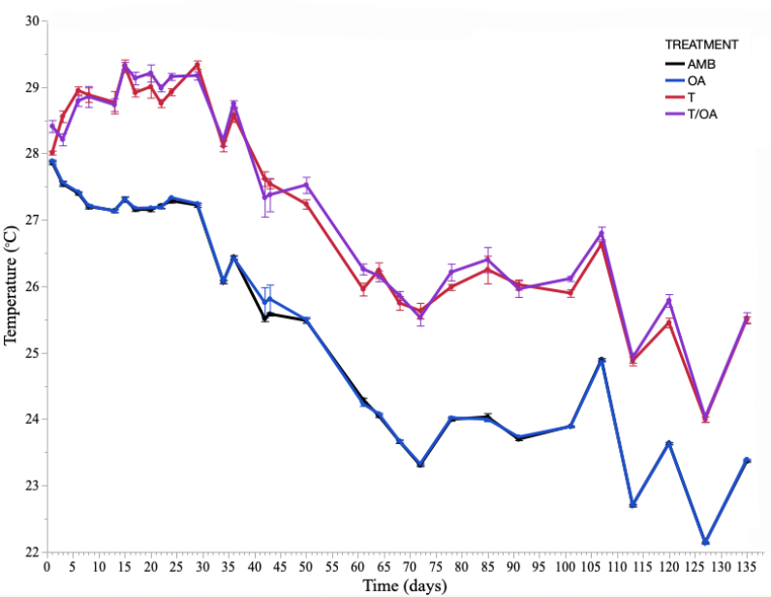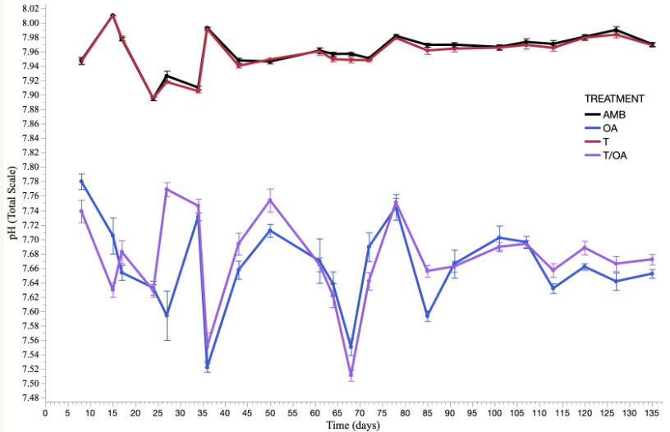

Fig 2. Temperature conditions (top) and pH conditions (bottom) over the 138-day experiment period. Desired treatment conditions of +2°C and -0.3 pH units were achieved by day 15 after a two week ramp up period.

Table 1. Experimental treatments and environmental conditions throughout the course of the 138-day experiment (mean ± s.e.)

|  |  |  |  |  |  |
| --- | --- | --- | --- | --- | --- |
| **Treatment** | **Salinity (ppt)** | **Temp (°C)** | **At (µmol kg-1)** | **pCO2 (ppm)** | **pH** |
| **Amb T, Amb ﻿*p*CO2** | 33.70 ± 0.03 | 25.38 ± 0.11 | 2180.6 ± 1.75 | 493.00 ± 11.41 | 7.96 ± 0.004 |
| **Amb T, High *p*CO2** | 33.70 ± 0.04 | 25.40 ± 0.11 | 2182.17 ± 1.76 | 1068.64 ± 11.41 | 7.66 ± 0.004 |
| **High T, Amb *p*CO2** | 33.70 ± 0.05 | 27.30 ± 0.11 | 2180.25 ± 1.77 | 537.34 ± 11.52 | 7.96 ± 0.004 |
| **High T, High *p*CO2** | 33.70 ± 0.06 | 27.30 ± 0.11 | 2182.53 ± 1.76 | 1120.93 ± 11.41 | 7.68 ± 0.004 |

|  |
| --- |
| macro "Sesno-ify" {  run("Clear Outside");  run("Crop");  roiManager("add");  run("Make Binary");  roiManager("Select", roiManager("count")-1);  run("Remove Outliers...", "radius=2 threshold=50 which=Bright");  run("Remove Outliers...", "radius=2 threshold=50 which=Bright");  roiManager("Rename", getTitle);  //divides current roi into left and right half  getSelectionBounds(x, y, width, height)  getRawStatistics(totalArea);  minOff = 1e9;  for (w=1; w < width; w++){  roiManager("Select", roiManager("count")-1);  setKeyDown("alt");  makeRectangle(x, y, w, height);  getRawStatistics(rightArea);  off = abs(2*rightArea - totalArea);  if (off < minOff){  minOff = off;  xHalf = x + w;  wHalf = w;  halfArea = rightArea;  }  }  //Display result:  roiManager("Select", roiManager("count")-1);  setKeyDown("alt");  makeRectangle(x, y, wHalf, height);  run("Copy");//work around  run("Add to Manager");  roiManager("Select", roiManager("count")-1);  roiManager("Rename", getTitle + "_Right");  //run("Measure");  wait(500);  roiManager("Select", roiManager("count")-2);  setKeyDown("alt");  makeRectangle(x+wHalf, y, width - wHalf, height);  run("Copy");//work around  run("Add to Manager");  roiManager("Select", roiManager("count")-1);  roiManager("Rename", getTitle + "_Left");  //get histogram  roiManager("Select", roiManager("count")-3);  getStatistics(area, mean, min, max, stddev, histogram);  setResult("Skeletal", 0, histogram[255]);  setResult("Void", 0, histogram[0]);  setResult("Ratio", 0, histogram[255]/histogram[0]);  updateResults();    roiManager("Select", roiManager("count")-2);  getStatistics(area, mean, min, max, stddev, histogram);  setResult("Skeletal", 1, histogram[255]);  setResult("Void", 1, histogram[0]);  setResult("Ratio", 1, histogram[255]/histogram[0]);  updateResults();    roiManager("Select", roiManager("count")-1);  getStatistics(area, mean, min, max, stddev, histogram);  setResult("Skeletal", 2, histogram[255]);  setResult("Void", 2, histogram[0]);  setResult("Ratio", 2, histogram[255]/histogram[0]);  updateResults();  setResult("Label", 0, getTitle)  setResult("Label", 1, getTitle + "_Right")  setResult("Label", 2, getTitle + "_Left")  } |

**References**

Bahr, K. D., & Jokiel, P. L. (2016). Seasonal and annual calcification rates of the Hawaiian reef coral, Montipora capitata, under present and future climate change scenarios Keisha.

Byrne, M., Smith, A. M., West, S., Collard, M., Dubois, P., Graba-Landry, A., & Dworjanyn, S. A. (2014). Warming influences Mg2+ content, while warming and acidification influence calcification and test strength of a sea urchin. *Environmental Science and Technology*, *48*(21), 12620–12627. https://doi.org/10.1021/es5017526

Collard, M., Rastrick, S. P. S., Calosi, P., Demolder, Y., Dille, J., Findlay, H. S., … Dubois, P. (2016). The impact of ocean acidification and warming on the skeletal mechanical properties of the sea urchin Paracentrotus lividus from laboratory and field observations. *ICES Journal of Marine Science*, *73*(3), 727–738. https://doi.org/doi:10.1093/icesjms/fsv018

Dickson, A. G., & Millero, F. J. (1987). A Comparison of the Equilibrium Constants for the Dissociation of Carbonic Acid in Seawater Media, *34*, 1733–1743.

Dickson, A. G., Sabine, C. L., & Christian, J. R. (2007). *Guide to best practices for ocean CO2 measurements*. *PICES Special Publication 3* (Vol. 3). https://doi.org/10.1159/000331784

Dworjanyn, S. A., & Byrne, M. (2018). Impacts of ocean acidification on sea urchin growth across the juvenile to mature adult life-stage transition is mitigated by warming. *Proceedings of the Royal Society B: Biological Sciences*, *285*(1876). https://doi.org/10.1098/rspb.2017.2684

Jokiel, P. L., Bahr, K. D., & Rodgers, K. S. (2014). Low-cost, high-flow mesocosm system for simulating ocean acidification with CO2 gas. *Limnology and Oceanography: Methods*, *12*(MAY), 313–322. https://doi.org/10.4319/lom.2014.12.313

Mehrbach, C., Culberson, C. H., Hawley, J. E., & Pytkowicz, R. M. (1973). Measurement of the Apparent Dissociation Constants of Carbonic Acid in Seawater At Atmospheric Pressure. *Limnology and Oceanography*, *18*(6), 897–907. https://doi.org/10.4319/lo.1973.18.6.0897

Pierrot, D. E. Lewis, and D. W. R. W. (2006). MS Excel Program Developed for CO2 System Calculations. https://doi.org/10.3334/CDIAC/otg.CO2SYS_XLS_CDIAC105a

Przeslawski, R., Ahyong, S., Byrne, M., Wörheide, G., & Hutchings, P. (2008). Beyond corals and fish: The effects of climate change on noncoral benthic invertebrates of tropical reefs. *Global Change Biology*, *14*(12), 2773–2795. https://doi.org/10.1111/j.1365-2486.2008.01693.x