**RESULTS:** Growth and Skeletal Sensitivity of the Common Collector Urchin, *Tripneustes gratilla*, to Projected Climate Change: Interactive effects of Warming and Acidification

Emily Sesno

**Statistical Analyses**

Data analysis was conducted using the programs JMP® Pro 13.1.0 and R Version 1.2.1335. Residuals were checked for normality and variances determined for equality. Where assumptions were not met, transformations were done to assure normality. Growth (described by change in test diameter) was analyzed using a linear mixed model, with temperature and CO2 as fixed factors and individual tanks as a random effect. This was followed by a *post-hoc* t-test comparison to determine differences between treatments. Spine lengths and calcification ratios were analyzed using one-way ANOVA followed by Tukey’s post-hoc comparison. A probability level of p< 0.05 was considered significant. In the event of unequal variances, such as in spine length, the Kruskal-Wallace test of significance was used.

**RESULTS**

**Effect on Body Size**:

Important Info:

* Mean initial test diameters did not differ significantly between individuals (Day -24: 7.54 mm ± 0.15 mm s.e., n=24, F3,20=0.8508, p<0.4825).
* After the two-week acclimation period and subsequent ramp-up of conditions, urchin test diameters were not significantly different by treatments (Day 1: 16.12 ± 0.35 mm, n=24, F3,20=1.0907, p<0.3759).
* By the end of the experimental period, test diameters did differ significantly between treatments (70.52 ± 1.41 mm, F3,19 =4.0602, p<0.0218).

**A.** ambient CO2, ambient temperature (72.90 ± 1.86 mm s.e.),

**B.** high CO2, ambient temperature (63.63 ± 2.04 mm s.e)

**C.** ambient CO2, high temperature (74.02 mm ± 3.80 mm s.e.),

**D.** high CO2, high temperature (72.12 ± 1.82 mm s.e.).

Growth Analysis:

1. *Linear Mixed Model* with:

**DiamMean~ Day*Temp*CO2+Tank effect**

1. Residuals not normal, variances equal
2. Transform: ^1.6 to make normal
3. After transform, variances not equal...maybe try different analysis...
4. *Linear mixed model* using growth (change/initial diam) instead of diam: **Growth~Day*Temp*CO2+Tank**
5. Residuals not normal, variances not equal
6. Transform: canʻt get it to work.. need diff analysis
7. *Linear Model* REMOVE DAY by calculating Growth* (*TotalGrowth=final-initial)

**TotalGrowth~Temp*CO2**

(Canʻt do tank effect b/c only last time point, so must be able to say checked for tank effect and there was none..?)

1. Residuals normal (small sample size but okay); variances equal
2. Results: Temp* (0.02776), CO2*(0.03989) Temp:CO2 not sig.
3. *LM* REMOVE DAY by calc. normalized Growth* (*EndGrowth = (final-initial)/initial) **EndGrowth~Temp*CO2**
4. Resid Normal √ and variances equal √
5. Results: Shows no significance....

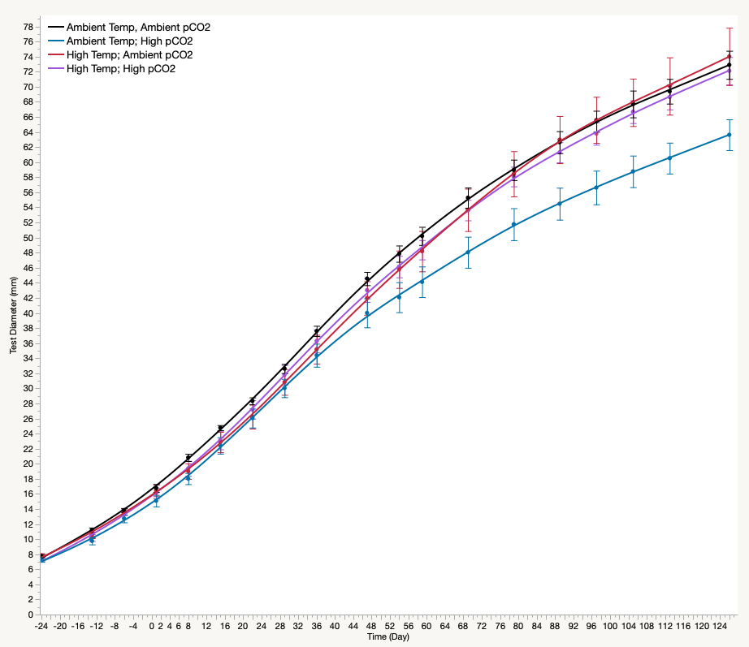

**Figure 3.1** Growth, shown in test diameter (mm) over the 126 day experiment. Negative days indicate pre-treatment sizes; i.e. includes 2-week acclimation and subsequent conditioning.

**Effect on Calcification:**

Image analysis of cross sections of spine reveal a difference between the tip and base of single spines across treatments.

1. *Linear Model* of calcification ratio at the Tip of spines

**Ratio~Temp*CO2 (RatioTip)**

(Canʻt do tank effect b/c only last time point, so must be able to say checked for tank effect and there was none..?)

1. Residuals normal, variances equal
2. Results: No significance
3. *Linear Model* of calcification ratio at the Base of spines

**Ratio~Temp*CO2 (RatioBase)**

(Canʻt do tank effect b/c only last time point, so must be able to say checked for tank effect and there was none..?)

1. Residuals not normal, variances equal
2. Transform: log(ratio) makes resid normal and variances still =
3. Results: Temp*(0.03951), CO2*** (1.478e-05)

**Effect on Spine Length:**

Mean length of urchin spines between treatments was significantly different (F3,211 = 60.7905, p<0.0001)

1. *Linear Mixed Model* with:

**SpineLength~ Temp*CO2+Tank effect**

1. Residuals normal, variance equal
2. Results: CO2***(9.183e-10), Temp:CO2* (0.04944)

**So this confirms what iʻve been seeing as iʻve been using more appropriate models – CO2 (regardless of T) has more of an effect on calcification than it does on growth!

**Effect on Spine Dropped:**

More spines were observed to be loose on the bottom of the tank in treatments of increased *p*CO2, regardless of temperature throughout the experimental period. This was quantified to reveal a significant difference (F3,19 = 9.8549, p,0.0004). *Post hoc* analysis revealed that urchins in acidified conditions, regardless of temperature, shed spines more readily (data below…)

