**Statistical Analyses**

Effect of treatments on growth (final-initial/initial diameter), calcification ratio (proportion of material to void area of spine cross-sections in SEM images), relative spine lengths (ratio of spine length to test diameter), and number of dropped spines were analysed using one and two-way ANOVA analyses with temperature and pH as fixed factors. Since urchins were not a repeated measure in the calculated growth, data were analysed using a linear model without the random effect of indiviual. Calcification ratio and relative spine lengths however, did include individual urchins as a random effect using a linear mixed effect model with the *lmer* in the *lme4* package (Bates, et al. 2015). Specific differences in calcification ratios were determined using Satterthwaits method, Type II sum of squares ANOVA tables, generated using *lmerTest* (Kuznetsova, Brockhoff, & Christensen, 2017). Where significance occured, pairwise post-hoc tests of main effects was conducted using Tukeyʻs test. Alpha was set to 0.05 for all analyses. Residuals were checked for normality and confirmed with the Shapiro-Wilk test and homogeniety of variance using Bartletts test. Where data were not normal in count of dropped spines, Kruskall-wallis one-way ANOVA was used to analyse differences between treatments. Data analysis was conducted using the programs JMP® Pro 13.1.0 and R Version 1.2.1335 (R Core Team, 2018).

**RESULTS**

**Effect on Body Size**:

Mean initial test diameters did not differ significantly between individuals (Day -24: 7.54 mm ± 0.15 mm s.e., n=24, F3,20=0.8508, p<0.4825). After the two-week acclimation period and subsequent ramp-up of conditions, urchin test diameters were not significantly different by treatments (16.12 ± 0.35 mm, n=24, F3,20=1.0907, p=0.3759). High temperatures, although not significant (p=0.055), seemed to positively influenced growth rate while pH didnʻt seem to influence growth (p=0.62284) (Fig. 3.1). There was no interaction between temperature and pH (p=0.482).

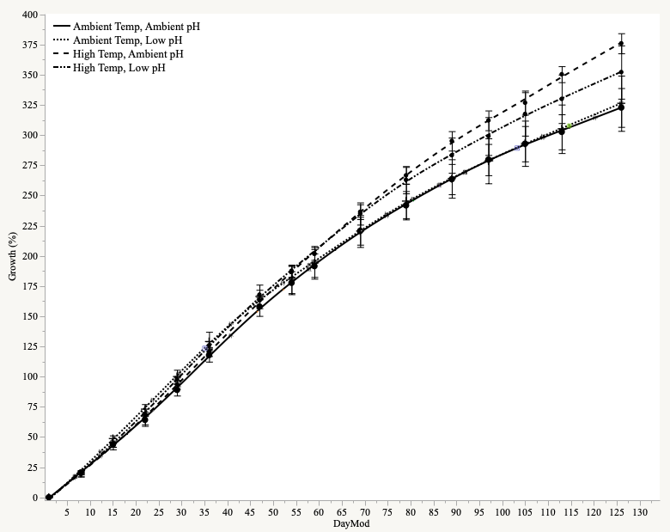

•

•

**Figure 3.1** Percentgrowth (change in diameter/initial diameter) over the 126 day experiment across treatments. While not statistical significance (p=0.055), temperature seemed to have more influence on growth (•) than pH.

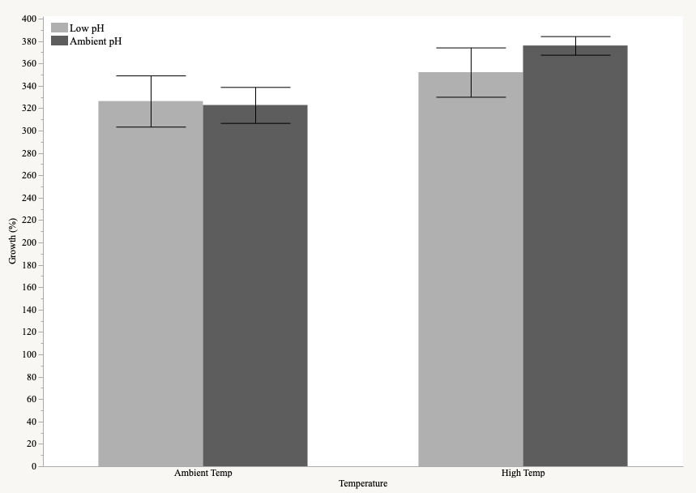

•

•

**Figure 3.2.** Effect of temperature and pH on the cumulative growth on day 126 of the experiment. While not statistically significant (p=0.055), temperature seemed to influence growth more (•) than pH, with no interaction of the two.

**Effect on Calcification:**

There was no significant effect of temperature (p=0.387), pH (p=0.437), or the interaction of both (p=0.091) on the calcification ratio of cross-sections at the tips of *T. gratilla* spines. On the other hand, at the base of the spines, pH contributed to a significant reduction of the calcification ratio (p=0.002) regardless of temperature (p=0.164). There was no interaction between temperature and pH (p=0.536).

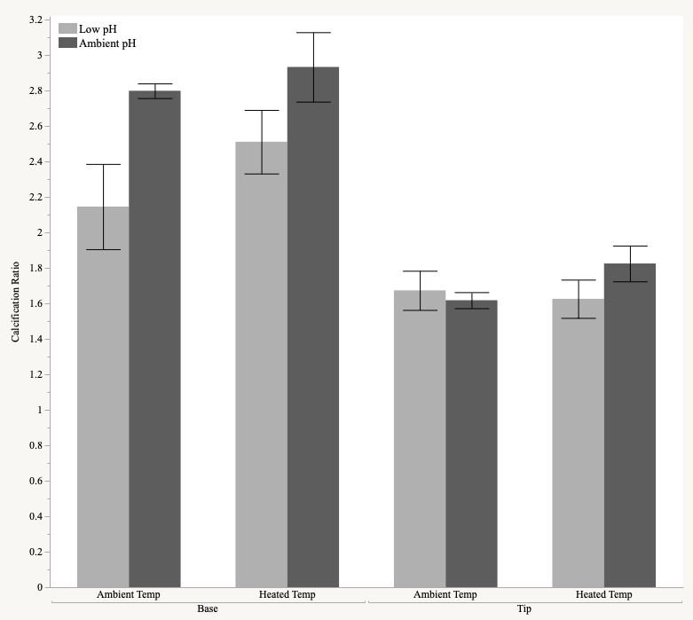

**

**

**Figre 3.3.** Effect of temperature and pH on the calcification ratio (ratio of calcified to void area from SEM images using ImageJ). Low pH, regardless of temperature, reduced the calcification ratio at the base of spines only (p = 0.002302).

**Effect on Relative Spine Length:**

Although not significant, pH seemed to influence relative spine length (spine length normalized to test diameter) (p=0.0540) more than temperature (p=0.1799). There was no interaction of both temperature and pH (p=0.9737).

﻿

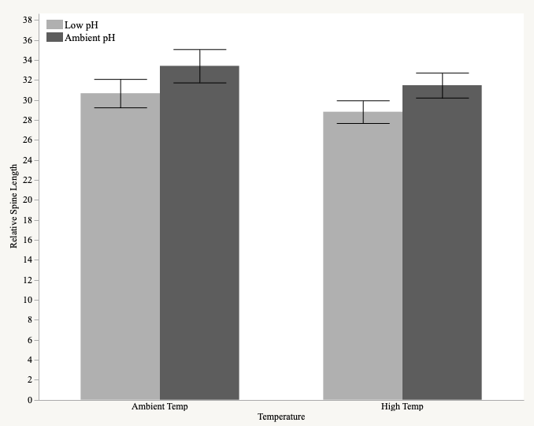

•

•

**Figure 3.4.** Effect of temperature and pH on the relative spine lengths (ratio of spine length to test diameter). While not significant (•, p=0.05398), low pH seemed to contribute to shorter spine lengths.

**Effect on Spine Dropped:**

More spines were observed to be loose on the bottom of the tank in treatments of increased *p*CO2 regardless of temperature throughout the experimental period. This was quantified to reveal that low pH significantly increased the number of spine shed (p<.0001).

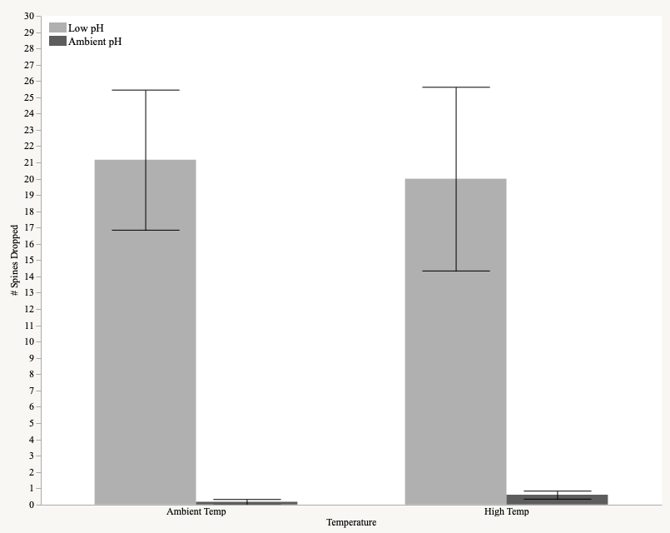

***

***

**Figure 3.5.** Effect of temperature and pH on the number of spines dropped.

**Table 3.1**. Linear model and linear mixed model analysis of the biological responses of growth, calcification ratio, relative spine length, and dropped spines at the end of the experimental period (126 days) for *Tripneustes gratilla*. Significant effects at the level of α <0.05 are in bold.

|  |  |  |  |  |
| --- | --- | --- | --- | --- |
| **Biological Response** | **Factor** | **Estimate** | ***t*** | **p** |
| Growth  *Linear Model* | Intercept | 3.2283 | 17.361 | **<.0001** |
| Temperature | 0.5317 | 1.928 | 0.069 |
| *p*CO2 | 0.0350 | 0.133 | 0.896 |
| Temp\**p*CO2 | -0.2733 | -0.717 | 0.482 |
| Calcification Ratio (Tip)  *Linear Mixed Model* | Intercept | 1.6166 | 18.627 | **<.0001** |
| Temperature | 0.2389 | 1.821 | 0.0733 |
| *p*CO2 | 0.0746 | 0.599 | 0.5512 |
| Temp\**p*CO2 | -0.3056 | -1.689 | 0.0961 |
| Calcification Ratio (Base)  *Linear Mixed Model* | Intercept | 2.7964 | 15.987 | **<.0001** |
| Temperature | 0.1342 | 0.517 | 0.6109 |
| *p*CO2 | -0.6524 | -2.637 | **0.0163** |
| Temp\**p*CO2 | 0.2224 | 0.619 | 0.5434 |
| Relative Spine Length | Intercept | 30.6437 | 22.359 | **<.0001** |
| Temperature | -1.8426 | -0.0948 | 0.355 |
| *p*CO2 | 2.7559 | 1.417 | 0.173 |
| Temp\**p*CO2 | -0.0929 | -0.033 | 0.974 |
|  |  | **Statistic** |  | **p** |
| Dropped Spines | Temperature | 0.3755 |  | 0.7073 |
| *p*CO2 | 4.1310 |  | **<.0001** |

**Table 3.2.** Summary of ANOVA individual and combined effects of increased temperature and acidification stress on the the biological responses of growth, calcification ratio, relative spine length, and dropped spines at the end of the experimental period (126 days) for *Tripneustes gratilla* based on the statistical models given in Table 3.1.

|  |  |  |  |
| --- | --- | --- | --- |
| **Summary of linear and mixed model Results** | | | |
| **Biological Response** | **Temp** | ***p*CO2** | **Temp x *p*CO2** |
| **Growth** | 0.0554 | 0.6228 | 0.4820 |
| **Calcification Ratio (Tip)** | 0.3867 | 0.4372 | 0.0912 |
| **Calcification Ratio (Base)** | 0.1637 | **0.0023** | 0.5361 |
| **Relative Spine Length** | 0.1799 | 0.0540 | 0.9737 |
| **Dropped Spines** | 0.7073 | **<0.0001** | na |

**STAT RESULTS:**

**GROWTH:**

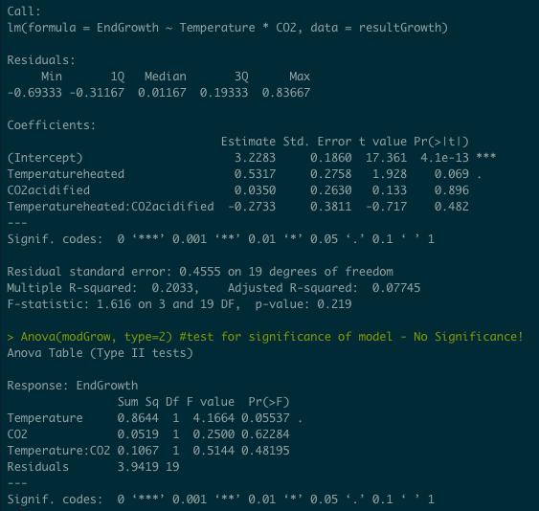

**CALCIFICATION**:

(TIP)

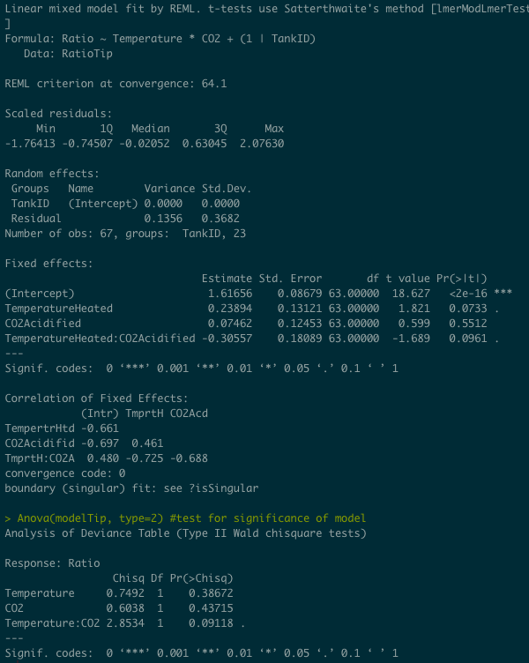

(BASE)

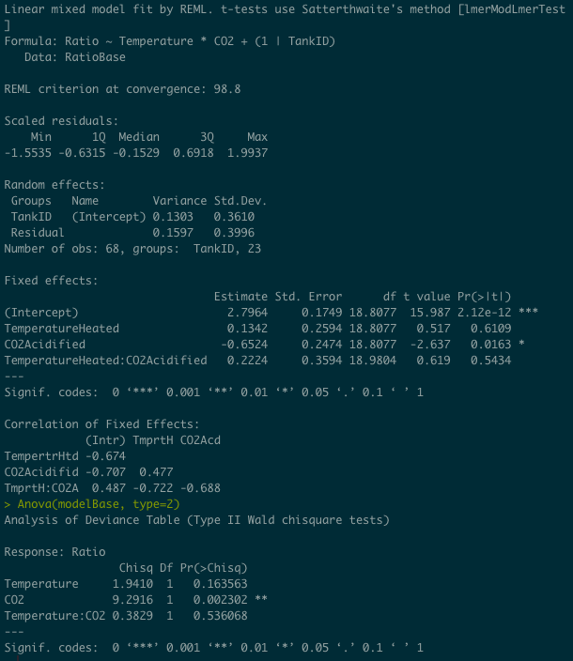

**RELATIVE SPINE LENGTH:**

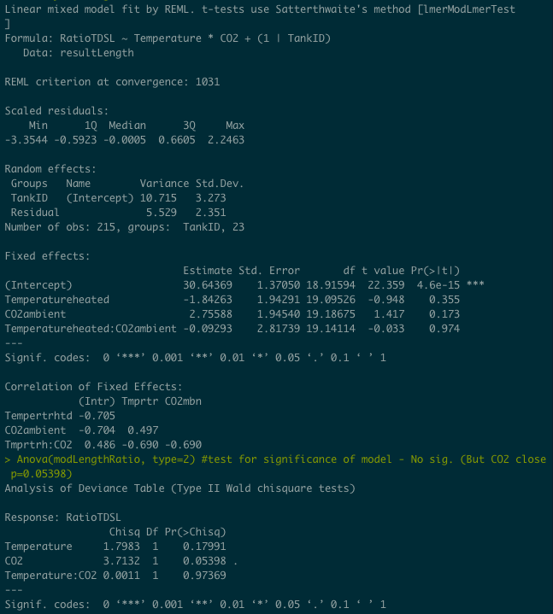

**Table 2.3.**  Final R script conducting statistical modeling.

|  |
| --- |
| ####SET UP####  rm(list=ls(all=TRUE)) #  setwd("/Users/emilysesno/Desktop/R_Analysis/R_Analysis/data") #  library("lsmeans") #post-hoc tests  library("effects") #plot effects of modeling  library("lmtest") #linear mixed modeling  library("lme4") #linear mixed modeling  library("lmerTest") #calculate p-values in models  library("emmeans") #post-hoc tests  library("cowplot") #arrange plots  library("MuMin")  library("car") #levenes tests  library("tidyverse")  library("stats")  library("plyr") #splitting, applying, and combining data  library("dplyr")  library("onewaytests") #allows for Welch test with unequal variances (spine lengths)  library("stats")  ### STEPS FOR COMPLETING MIXED MODEL ANALYSIS ###  #1. Build and run model  #2. Check for normality of residuals  #3. Check for homogeniety of variance of residuals  #4. Look at model summary  #5. Run anova to check for significance  #6. Run post-hoc  ### LOAD and CHECK DATA ###  result<-read.csv("UrchinResults.csv", header=T, na.strings="NA")  result$Header<-as.factor(result$Header)  summary(result)  names(result)  ##VARIABLES: with some explanation:  #[1] "Season" "Date" "DayRaw" "DayCond" "DayMod"  #[6] "TREATMENT" "Header" "Temperature" "CO2" "TankID"  #11] "Temp" "Sal" "Dopcnt" "DOmgL" "WatFlo"  #[16] "Diam1" "Diam2" "DiamMean" "HalfGrowth" "EndGrowth"  #[21] "RawGrowth" "Height" "Food" "pHprobe" "pHspec"  #[26] "pHtitr" "pCO2out" "AlkTotal"  ## "DayRaw" - starts day 1 at when I first got the urchins (Sept. 26)\  ## TOTAL DAYS: 152  ## "DayCond" - starts day 1 at when conditioning first began (Oct. 10).  #((Sept. 26 is day -12))  ## TOTAL DAYS: 138  ## "DayMod" - starts day 1 at when treatment conditions were reached (Oct 22). **To use in models  # ((Sept. 26 is day -24, Oct 10 is day -11))  ## TOTAL DAYS: 126  #Growth RATE Variables - using DayMod as reference days:  ## "HalfGrowth" - (size at day 126 - size day 36)/size day 36  # meant to explore the growth at about halfway through to see if rate changed later...  ## "EndGrowth" - (size at day 126 - size day 1)/size day 1 *****If looking at rate, use this.  ## "RawGrowth" - (size at day 126 - size day -24)/size day -24  ## "TotalGrowth" - Final size-initial size  ## "CondGrowth - growth using the start of conditioning as intial size (aka -1 of DayCond, 15 of DayRaw, day -11 DayMod)  # so ((final size - Initial (Day -13))/initial size day -13  ## DATASET reminders created throughout script  # 1. result = original upload  # 2. resultDay = subset to only have from day 1 at treatment conditions  # 3. resultDiam = takes the above set and removes all naʻs from DiamMean  # 4. growthdata = takes the above set and uses only columns: DayMod, TREATMENT, Temperature, CO2, DiamMean,  # EndGrowth, TankID, Temp, pHspec, TotalGrowth  # 5. resultGrowth = takes above data and removes all NA from TotalGrowth i.e. only see last day of exp.  ##################### GROWTH/BODYSIZE ########################  ### ORGANIZE DATA for GROWTH ###  #reminder: original csv upload is called "result"  #subset so only using data from day 1 onward in DayMod colum (i.e. after acclimation and conditioning reached)  resultDay<-result[which (result$DayMod>0),]  #remove na's in DiamMean column to look at growth  resultDiam<-resultDay[!is.na(resultDay$DiamMean),]  names(resultDiam)  #subset to remove extraneous variables not needed for growth ***  growthdata <- resultDiam[c("DayMod", "TREATMENT", "Header", "Temperature", "CO2",  "DiamMean", "EndGrowth", "TankID", "Temp", "pHspec","TotalGrowth", "CondGrowth")]  #change reference level of treatment  growthdata$CO2 <- relevel(growthdata$CO2, ref = "ambient")  print(levels(growthdata$CO2))  names(growthdata)  ################ Model 1: LM Growth ###############  ### EndGrowth=Final-Initial/Initial  #subset so only using endpoint  resultGrowth<-growthdata[!is.na(growthdata$TotalGrowth),  c("DayMod", "TREATMENT",  "Temperature", "CO2", "DiamMean",  "EndGrowth", "TankID","TotalGrowth", "CondGrowth")]  names(resultGrowth)  #change reference level of treatment  resultGrowth$CO2 <- relevel(resultGrowth$CO2, ref = "ambient")  print(levels(resultGrowth$CO2))  ### Linear Model to look at EndGrowth (normalized to initial) from last day  modGrow <- lm(EndGrowth~ Temperature * CO2, data=resultGrowth)  summary(modGrow) #generate results  Anova(modGrow, type=2) #test for significance of model - No Significance!  # Test Assumptions  # 1. Normality of residuals  qqPlot(residuals(modGrow)) #Normal enough  hist(residuals(modGrow)) #Kind of same as above  shapiro.test(residuals(modGrow)) #PASSES  # 2. Equal variances  bartlett.test(residuals(modGrow)~resultGrowth$TREATMENT) #passes  plot(fitted(modGrow),resid(modGrow,type="pearson"),col="blue")  plot(allEffects(modGrow))  #################### CALCIFICATION RATIO ############################  ### ORGANIZE DATA for RATIO ###  ### LOAD and CHECK DATA ###  resultRatio<-read.csv("ResultRatio.csv", header=T, na.strings="NA")  resultRatio$Header<-as.factor(resultRatio$Header)  summary(resultRatio)  names(resultRatio)  #subset to remove extraneous variables not needed and subset by chosen=yes***  resultRatio1 <- resultRatio[which(resultRatio$Chosen == "yes"),  c("PartOfSpine", "Treatment", "Temperature", "CO2", "TankID", "Ratio", "Chosen")]  ##Subset by tip and base  RatioTip <- resultRatio1[which(resultRatio1$PartOfSpine == "Tip"),]  RatioBase <- resultRatio1[which(resultRatio1$PartOfSpine == "Base"),]  #change reference level of treatments  RatioTip$CO2 <- relevel(RatioTip$CO2, ref = "Ambient")  RatioBase$CO2 <- relevel(RatioBase$CO2, ref = "Ambient")  levels(RatioTip$CO2)  levels(RatioBase$CO2)  ############### Model 2: LMM Calcification at TIP #####################  modelTip <- lmer(Ratio~ Temperature * CO2 + (1|TankID), data=RatioTip)  summary(modelTip) #generate results  Anova(modelTip, type=2) #test for significance of model  # 1. Normality of residuals  qqPlot(residuals(modelTip)) #Normal!  hist(residuals(modelTip))  shapiro.test(residuals(modelTip)) #PASSES  # 2. Equal variances  bartlett.test(residuals(modelTip)~RatioTip$Treatment) #passes homogeneity of variance test  plot(fitted(modelTip),resid(modelTip,type="pearson"),col="blue")  ############### Model 3: LMM Calcification at BASE ##################  ##### MODEL Ratio BASE  modelBase <- lmer(Ratio~ Temperature * CO2 + (1|TankID), data=RatioBase)  summary(modelBase) #generate results  Anova(modelBase, type=2) #test for significance of model  # 1. Normality of residuals  qqPlot(residuals(modelBase)) #Normal looking...  hist(residuals(modelBase))  shapiro.test(residuals(modelBase)) # Pass!  # 2. Equal variances  bartlett.test(residuals(modelBase)~RatioBase$Treatment) #passes homogeneity of variance test  plot(fitted(modelBase),resid(modelBase,type="pearson"),col="blue")  ####################### SPINE LENGTHS ##################################  ### ORGANIZE DATA for SPINELENGTH ###  ### LOAD and CHECK DATA ###  resultLength<-read.csv("ResultLengths.csv", header=T, na.strings="NA")  resultLength$Header<-as.factor(resultLength$Header)  summary(resultLength)  names(resultLength)  ##Remove NAs to try and get rid of error message in variance test...it worked!  resultLength<-resultLength[!is.na(resultLength$Spinelength),]  ###### Model 4. LMM of relative spine lengths (in relation to diameter) #####  modLengthRatio <- lmer(RatioTDSL~Temperature*CO2 + (1|TankID), data=resultLength)  rand(modLengthRatio)  summary(modLengthRatio)  Anova(modLengthRatio, type=2) #test for significance of model - No sig. (But CO2 close p=0.05398)  # 1. Normality of residuals  qqPlot(residuals(modLengthRatio)) #Normal!  hist(residuals(modLengthRatio))  shapiro.test(residuals(modLengthRatio)) #passes!  # 2. Equal variances  bartlett.test(residuals(modLengthRatio)~resultLength$TREATMENT) #passes  plot(fitted(modLengthRatio),resid(modLengthRatio,type="pearson"),col="blue")  plot(allEffects(modLengthRatio))  ######################### DROPPED SPINES ####################  ### ORGANIZE DATA for SPINECOUNT ###  ### LOAD and CHECK DATA ###  SpineCount<-read.csv("SpineCount.csv", header=T, na.strings="NA")  SpineCount$Header<-as.factor(SpineCount$Header)  summary(SpineCount)  names(SpineCount)  ##Remove NAs to try and get rid of error message in variance test...it worked!  SpineCount<-SpineCount[!is.na(SpineCount$SpineCount),]  modCount <- lm(SpineCount~Temperature*CO2, data=SpineCount)  summary(modCount)  Anova(modCount, type=2) #test for significance of model - Sig = CO2***, Temp:CO2*  # 1. Normality of residuals  qqPlot(residuals(modCount)) ##not normal  hist(residuals(modCount))  shapiro.test(residuals(modCount)) #faaaiiilll  # 2. Equal variances  bartlett.test(residuals(modCount)~SpineCount$TREATMENT) #FAAIILL  plot(fitted(modCount),resid(modCount,type="pearson"),col="blue") # visually doesnt appear to be a pattern.  ## ATTEMPT AT Transformation - cant get normal, must use nonparametric ###  SpineCount$tdata<-(SpineCount$SpineCount)^1/4  modelCount1 <- lm(tdata~ Temperature * CO2, data=SpineCount)  qqPlot(residuals(modelCount1))  hist(residuals(modelCount1))  shapiro.test(residuals(modelCount1))  # equal variances  bartlett.test(residuals(modelCount1)~SpineCount$TREATMENT) #passes homogeneity of variance test  plot(fitted(modelCount1),resid(modelCount1,type="pearson"),col="blue")  # Get results  summary(modelCount1)  Anova(modelCount1, type=2) #test for significance of model  plot(allEffects(modelCount1))  ## Non parametric ###  kruskal.test(SpineCount$SpineCount~SpineCount$TREATMENT)# SIG*** (p=0.0005563)  kruskal.test(SpineCount$SpineCount~SpineCount$CO2)# SIG *** (p=3.612e-05)  kruskal.test(SpineCount$SpineCount~SpineCount$Temperature)# NOT SIG (p=0.7073)  mw.test(SpineCount~CO2, data=SpineCount)  mw.test(SpineCount~Temperature, data=SpineCount) |