**Statistical Analyses**

Effect of temperature and CO2 treatments on growth (%), calcification ratio, and relative spine length were analysed using a linear mixe effects models ~~with~~ *~~lmer~~* in the *lme4* package (Bates, et al. 2015) in R Statistical Programming (citation). Temperature and pH were included as fixed effects with individual urchin included as a random intercept in cases of repeated measures. Significance of effects was determined using a type II analysis of deviance (ANOVA) table with Wald chi-square tests in the *car* package (Fox et al. 2019). Alpha was set to 0.05 for all analyses. Residuals were checked for normality and confirmed with the Shapiro-Wilk test and homogeniety of variance was confirmed using Levene’s test. Post hoc contrast analyses were conducted using estimated marginal means (EMMs) in package *emmeans* (Lenth et al., 2018). Analysis of dropped spines was conducted using a non-parametric Kruskal-Wallis test followed by a post hoc Dunn’s Test with a Bonferonni adjustment (Alexis Dinno, 2017) as the normality assumption was violated. Data visualization and analysis was conducted using the programs JMP® Pro 13.1.0 (citation?) and R Version 1.2.1335 (R Core Team, 2018). Open access citation (depending on what your committee wants)? Could be something like: Data and scripts to produce analysis and figures are available at github.com/Sesnos_project.

**RESULTS**

**Effect on Body Size**:

Mean test diameters did not differ significantly between individuals on the day of collection (7.54 ± 0.29 mm, n=24, F3,20=0.851, p<0.4825, one-way ANVOA). After the two-week acclimation period and subsequent ramp-up of conditions, urchin test diameters were not significantly different by treatments (16.12 ± 0.67 mm, n=24, F3,20=1.0907, p=0.3759, one-way ANOVA). Increased temperatures significantly influenced growth (p = 0.042) while pH did not (p=0.611) (Fig. 3.1). There was no interaction between temperature and pH (p=0.482).

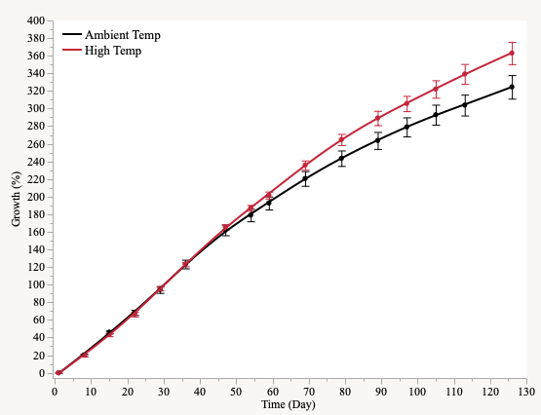

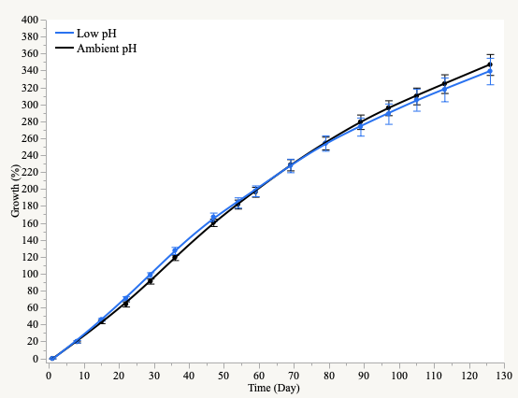

**Figure 3.1** Growth (%) over the 126 day experiment in ambient and high temperature (top) and ambient and low pH treatments.

**Effect on Calcification:**

There was no significant effect of temperature (p=0.387), pH (p=0.437), or the interaction of both (p=0.091) on the calcification ratio of cross-sections at the tips of *T. gratilla* spines. At the base of the spines, pH contributed to a significant reduction of the calcification ratio (p=0.002) while temperature did not (p=0.164). There was no interaction between temperature and pH (p=0.536) (fig. 3.3).

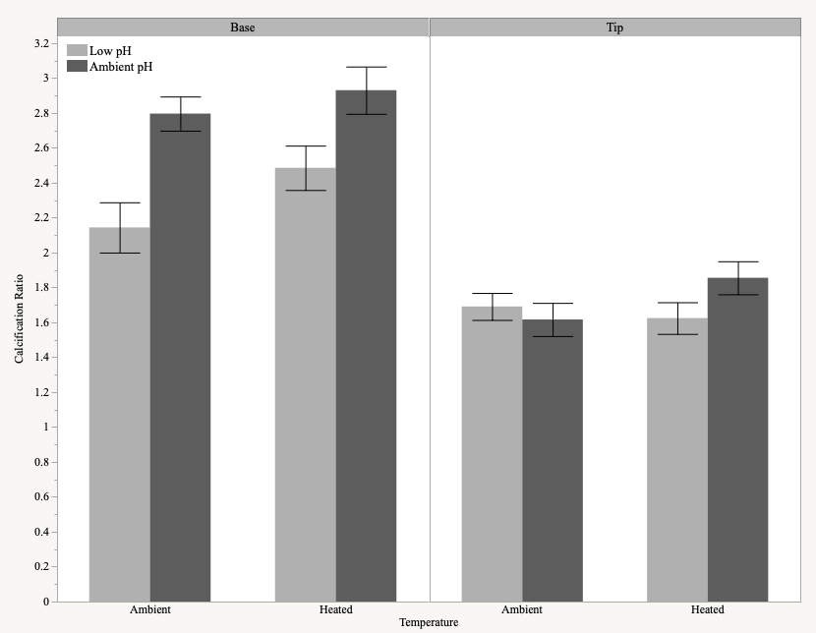

a.

b.

ab.

ab.

**Figre 3.3.** Effect of temperature and pH on the calcification ratio at the base (left) and tip (right) of spine cross-sections.

**Effect on Relative Spine Length:**

Although not significant, pH influenced relative spine length (spine length normalized to test diameter) (p=0.0540) more than temperature (p=0.180). There was no interaction of both temperature and pH (p=0.974) (fig. 3.4).

﻿

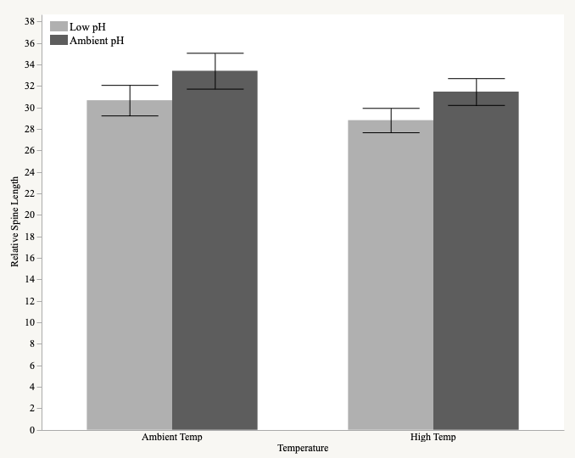

**Figure 3.4.** Effect of temperature and pH on the relative spine lengths.

**Effect on Spine Dropped:**

More spines were observed to be loose on the bottom of the tank in treatments of lower pH regardless of temperature throughout the experimental period. This was quantified to reveal that low pH significantly increased the number of spine shed (p<.0001). Urchins in low pH and ambient temperatures shed more spines than those in control conditions ((p = 0.004) and high temperatures (p = 0.045). Those in low pH and high temperatures also shed more spines than those in control (p=0.011) (fig 3.5).

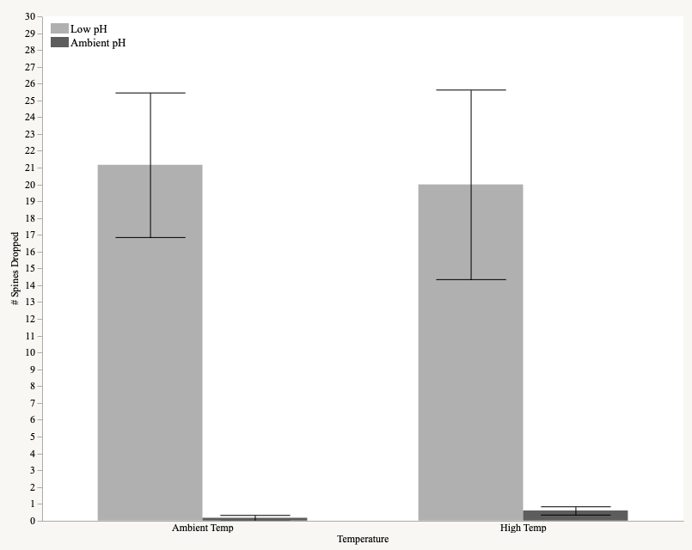

a.

b.

bc.

ac.

**Figure 3.5.** Effect of temperature and pH on the number of spines dropped.

**Table 3.1.** Summary of ANOVA individual and combined effects of increased temperature and acidification stress on the the biological responses of growth, calcification ratio, relative spine length, and dropped spines at the end of the experimental period (126 days) for *Tripneustes gratilla* based on the statistical models given in Table 3.1.

|  |  |  |  |  |  |  |
| --- | --- | --- | --- | --- | --- | --- |
| ***Biological Response*** | *Effect* | | *df* | *Chisq* | | *p* |
|  | Temp | | 1 | 4.137 | | **0.042** |
| **Growth** | *p*CO2 | | 1 | 0.258 | | 0.611 |
|  | Temp x *p*CO2 | | 1 | 0.534 | | 0.465 |
|  |  | |  |  | |  |
|  | Temp | | 1 | 0.749 | | 0.387 |
| **Calcification Ratio (Tip)** | *p*CO2 | | 1 | 0.604 | | 0.437 |
|  | Temp x *p*CO2 | | 1 | 2.853 | | 0.091 |
|  |  | |  |  | |  |
|  | Temp | | 1 | 1.941 | | 0.164 |
| **Calcification Ratio (Base)** | *p*CO2 | | 1 | 9.292 | | **0.002** |
|  | Temp x *p*CO2 | | 1 | 0.383 | | 0.536 |
|  |  | |  |  | |  |
|  | Temp | | 1 | 1.798 | | 0.180 |
| **Relative Spine Length** | *p*CO2 | | 1 | 3.713 | | 0.054 |
|  | Temp x *p*CO2 | | 1 | 0.001 | | 0.974 |
|  |  | |  |  | |  |
| *Nonparametric* | | | | | | |
| **Dropped Spines** | Treatment | | 3 | 17.505 | | **<0.001** |
|  |  |  | | |  |  |