**Statistical Analyses**

Effect of temperature and pH treatments on growth (% change), calcification ratio, and relative spine length (ratio of spine length (mm) to radius) were analysed using linear mixed effects models in the *lme4* package (Bates, et al. 2015) in R Statistical Programming (R Core Team, 2018). Temperature and pH were included as fixed factors with individual urchin included as a random effect. Significance of effects was determined using a type II analysis of deviance (ANOVA) table with Wald chi-square tests in the *car* package (Fox et al. 2019). Alpha was set to 0.05 for all analyses. Residuals were checked for normality and confirmed with the Shapiro-Wilk test and homogeniety of variance was confirmed using Levene’s test. Post hoc contrast analyses were conducted using estimated marginal means (EMMs) in package *emmeans* (Lenth et al., 2018). Analysis of dropped spines was conducted using a non-parametric Kruskal-Wallis test followed by a *post hoc* Dunn’s Test with a Bonferonni adjustment (Alexis Dinno, 2017) as the normality assumption was violated. Data visualization and analysis was conducted using the programs JMP® Pro 13.1.0 (SAS Institute Inc., 2019) and R Version 1.2.1335 (R Core Team, 2018).

**RESULTS­­**

**Treatment Conditions**

Manipulations of header tanks were not different between the same temperature and pH treatments, so were pooled with analysis of environmental conditions. Temperatures were not significantly different between ambient treatments (Kruskal-Wallis Test; Chi square= 1.96; p = 0.9995, df = 12) and high temperature treatments (Kruskal-Wallis Test; Chi square= 8.69; p = 0.7293, df = 12), but were different across treatments (Kruskal-Wallis Test; Chi square= 148.13; p <0.0001, df = 24) (Fig. 3.1a). Similarly, pH levels were not significantly different between ambient treatments (Kruskal-Wallis Test; Chi square= 19.60; p = 0.0750, df = 12) and low pH treatments (Kruskal-Wallis Test; Chi square= 13.54; p = 0.3310, df = 12), but were different across treatments (Kruskal-Wallis Test; Chi square= 323.46; p <0.0001, df = 24) (Fig. 3.1b).

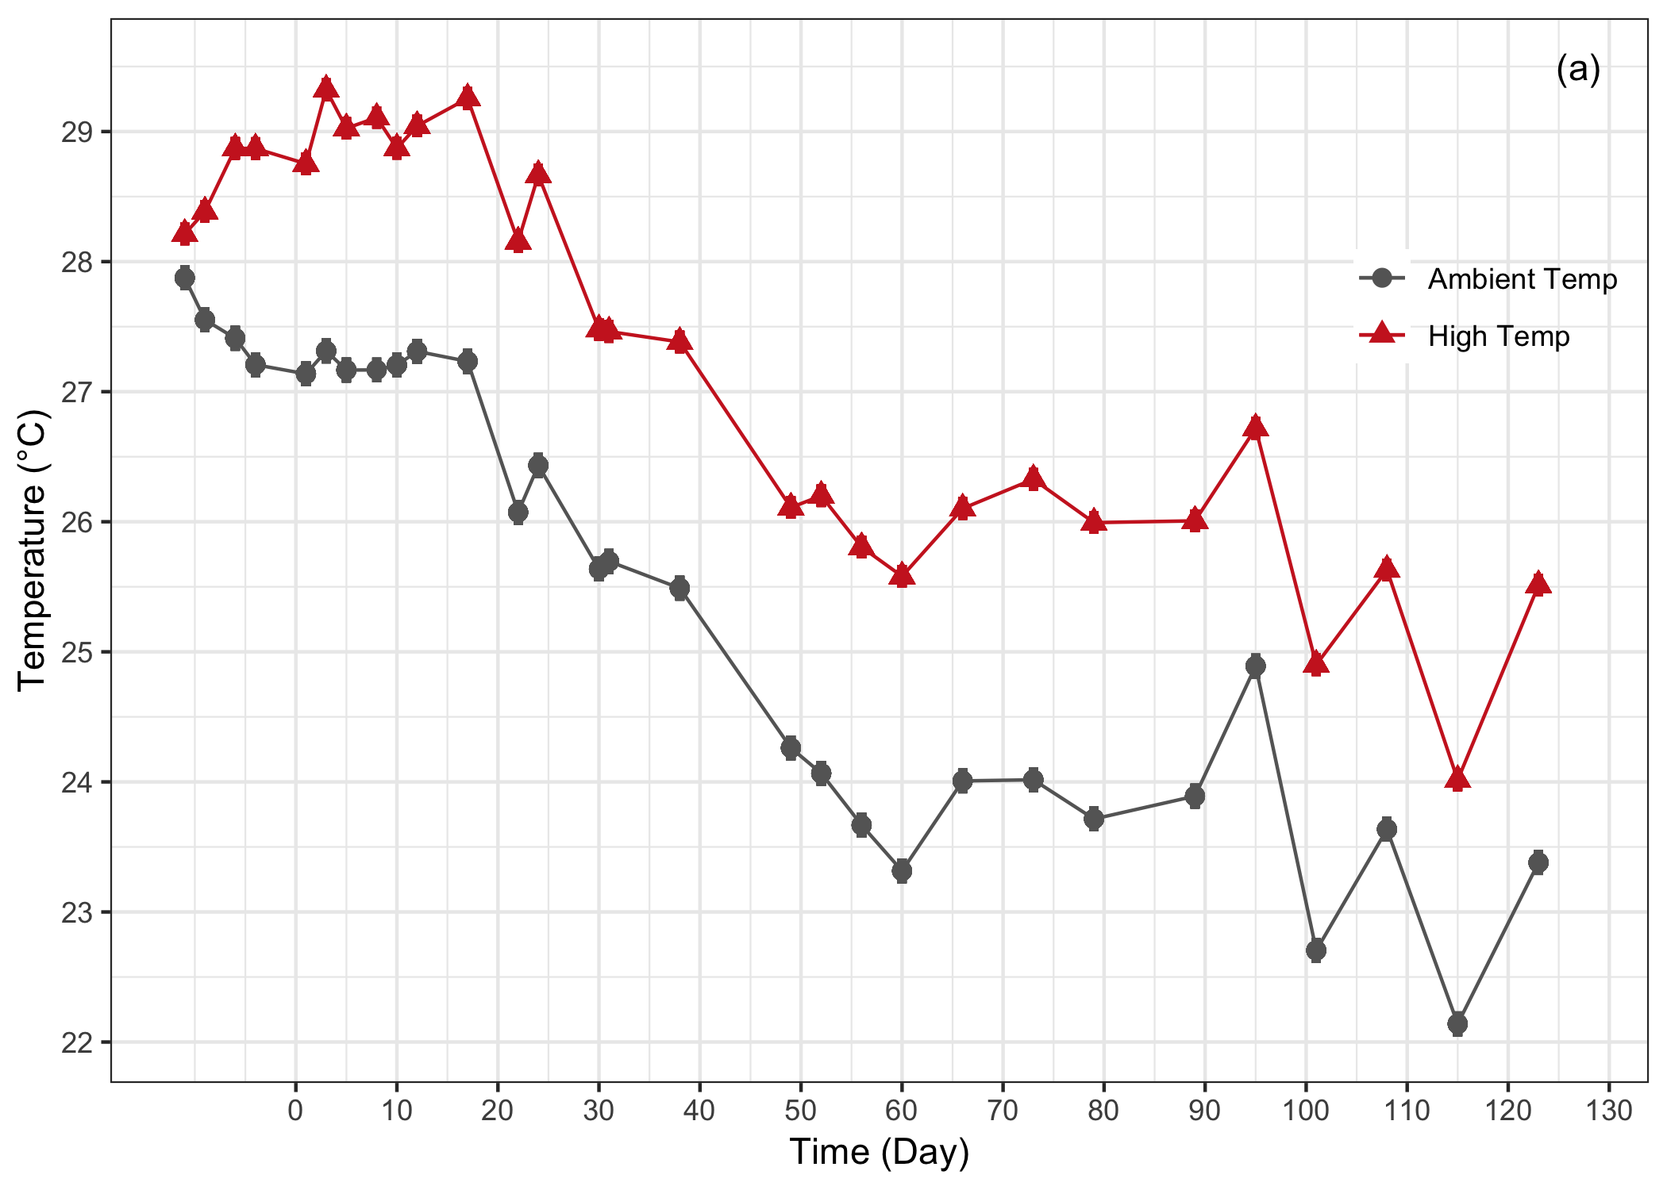

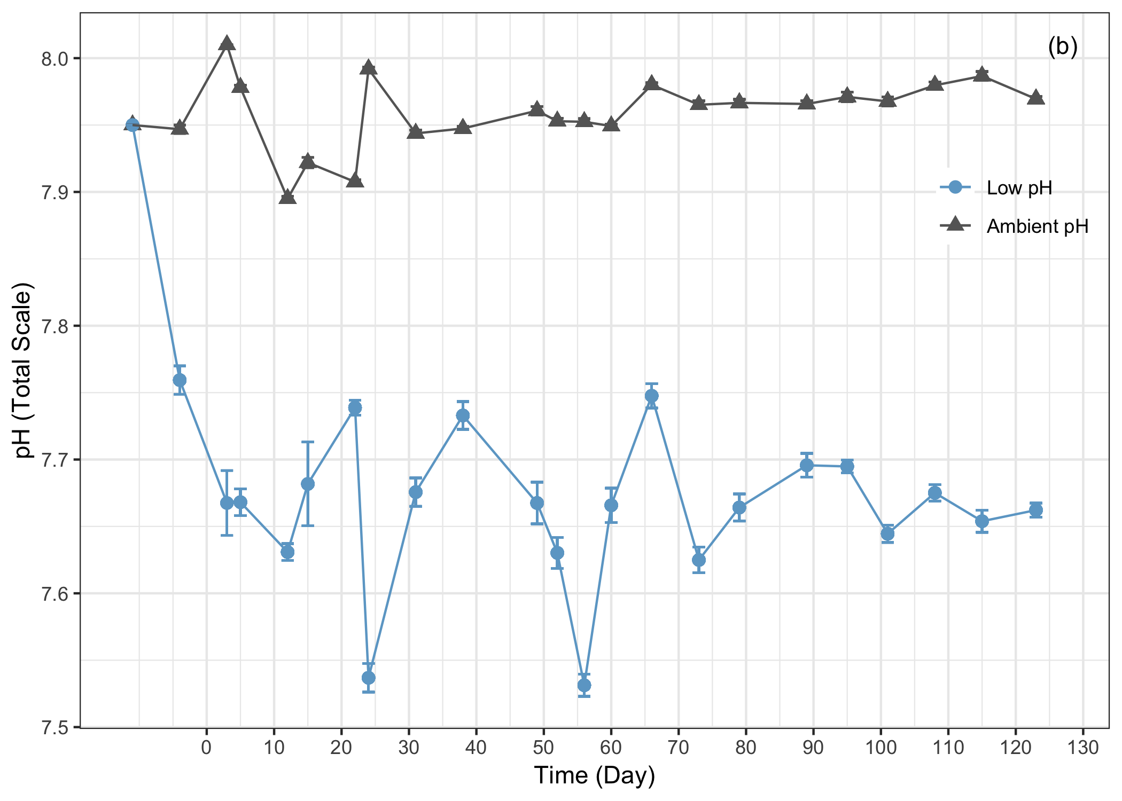

**Figure 3.1.** Temperature (a) and pH (b) conditions over the 126-day experiment period. Data are mean ± standard error (s.e.). Where error bars are not visible, error is too small to be seen. Days prior to 0 indicate the acclimation and conditioning period.

**Effect on Body Size**:

Increased temperatures significantly influenced growth (p = 0.042) while pH did not (p=0.611) (Fig. 3.1). There was no interaction between temperature and pH (p=0.482) (Fig. 3.2).

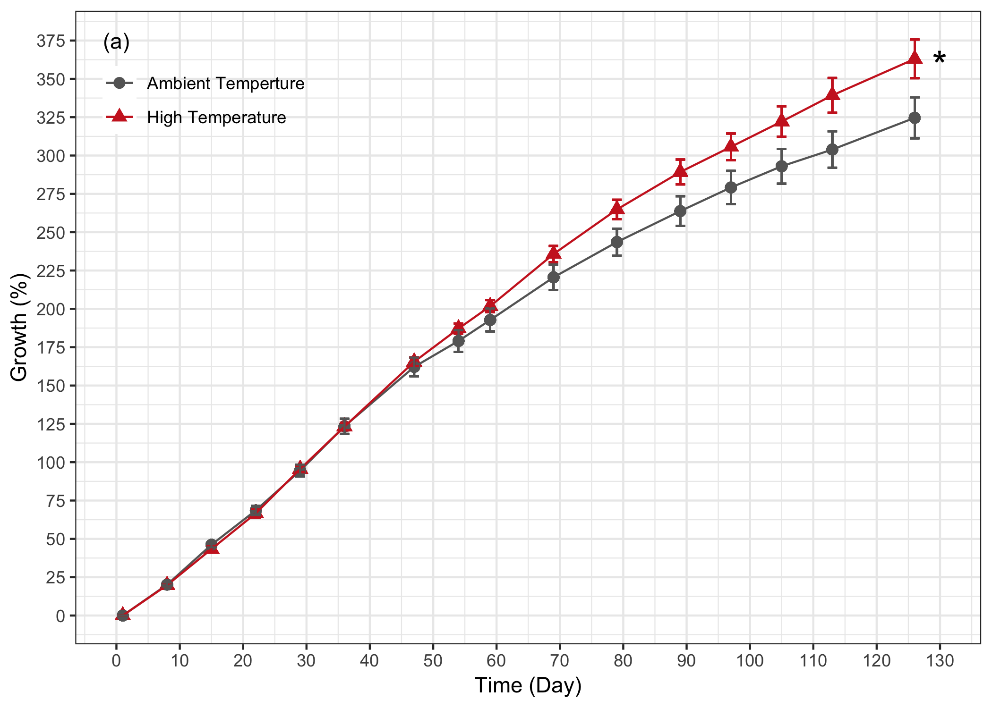

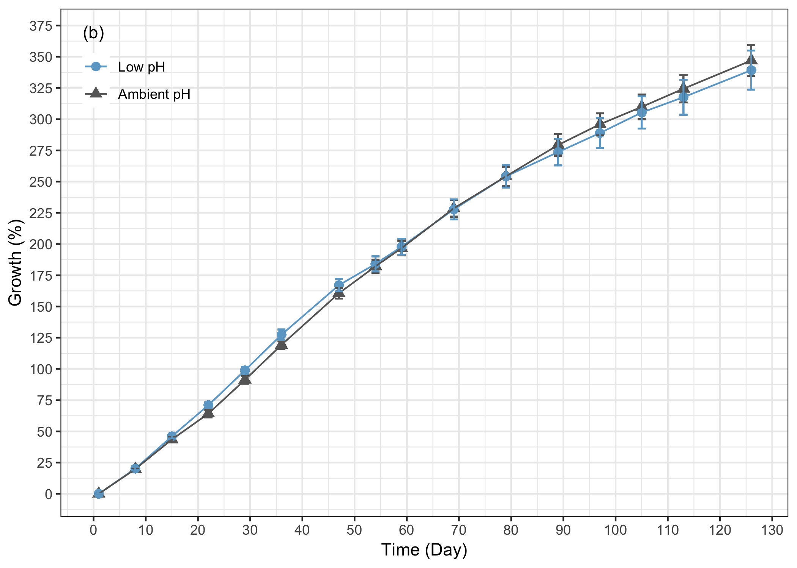

**Figure 3.2** Effect of (a) temperature and (b) pH on growth (%) of *Tripneustes gratilla* test diameters over the 126-day experiment. Temperature and pH data presented here are pooled for ease of interpretation as there were no significant interactive effects. Data are mean ± standard error (s.e.), n= 11-12, * indicates significance.

**Effect on Calcification:**

There was no significant effect of temperature (p=0.387), pH (p=0.437), or the interaction of both (p=0.091) on the calcification ratio of cross-sections at the tips of *T. gratilla* spines. At the base of the spines, pH contributed to a significant reduction of the calcification ratio (p=0.002) while temperature did not (p=0.164). There was no interaction between temperature and pH on the calcification ratio at the base of the spines (p=0.536) (Fig. 3.3).

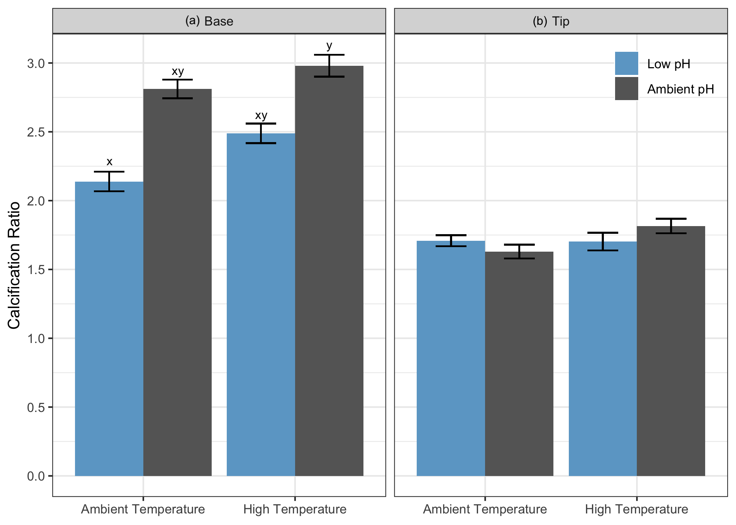

**Figre 3.3.** Effect of temperature and pH on the calcification ratio at the base (a) and tip (b) of spine cross-sections. ﻿Letters indicate significant difference in *post hoc* pairwise tests. Data are means ± standard error (s.e.), n = 14-18.

**Effect on Relative Spine Length:**

Although marginally significant, pH influenced relative spine length (spine length normalized to test diameter) (p=0.0540) more than temperature (p=0.180). There was no interaction of both temperature and pH (p=0.974) (Fig. 3.4).

﻿

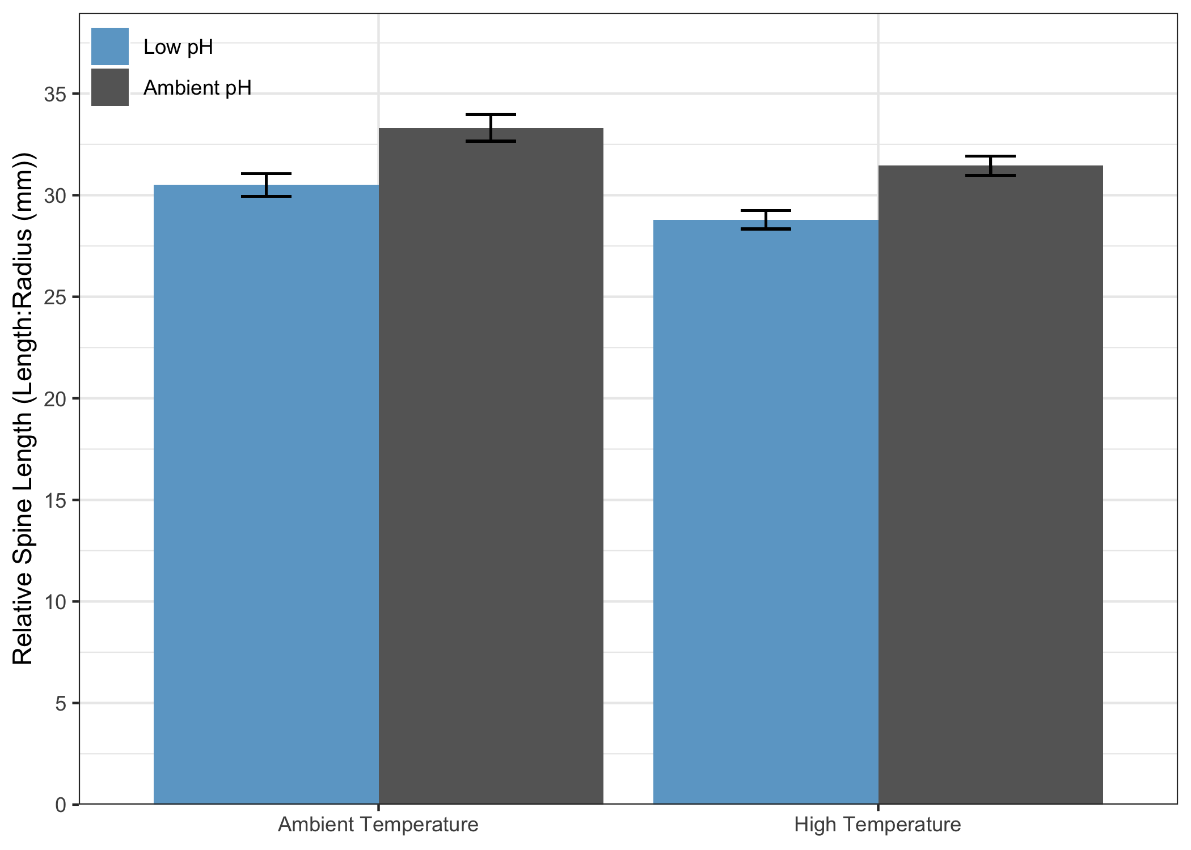

**Figure 3.4.** Effect of temperature and pH on the relative spine lengths. Data are means ± standard error (s.e.), n = 51.

**Effect on Spine Dropped:**

More spines were observed to be loose on the bottom of the tank in treatments of lower pH regardless of temperature throughout the experimental period. This was quantified to reveal that low pH significantly increased the number of spine shed (p<.0001). Urchins in low pH and ambient temperatures shed more spines than those in control conditions ((p = 0.004) and high temperatures (p = 0.045). Those in low pH and high temperatures also shed more spines than those in control (p=0.011) (Fig 3.5).

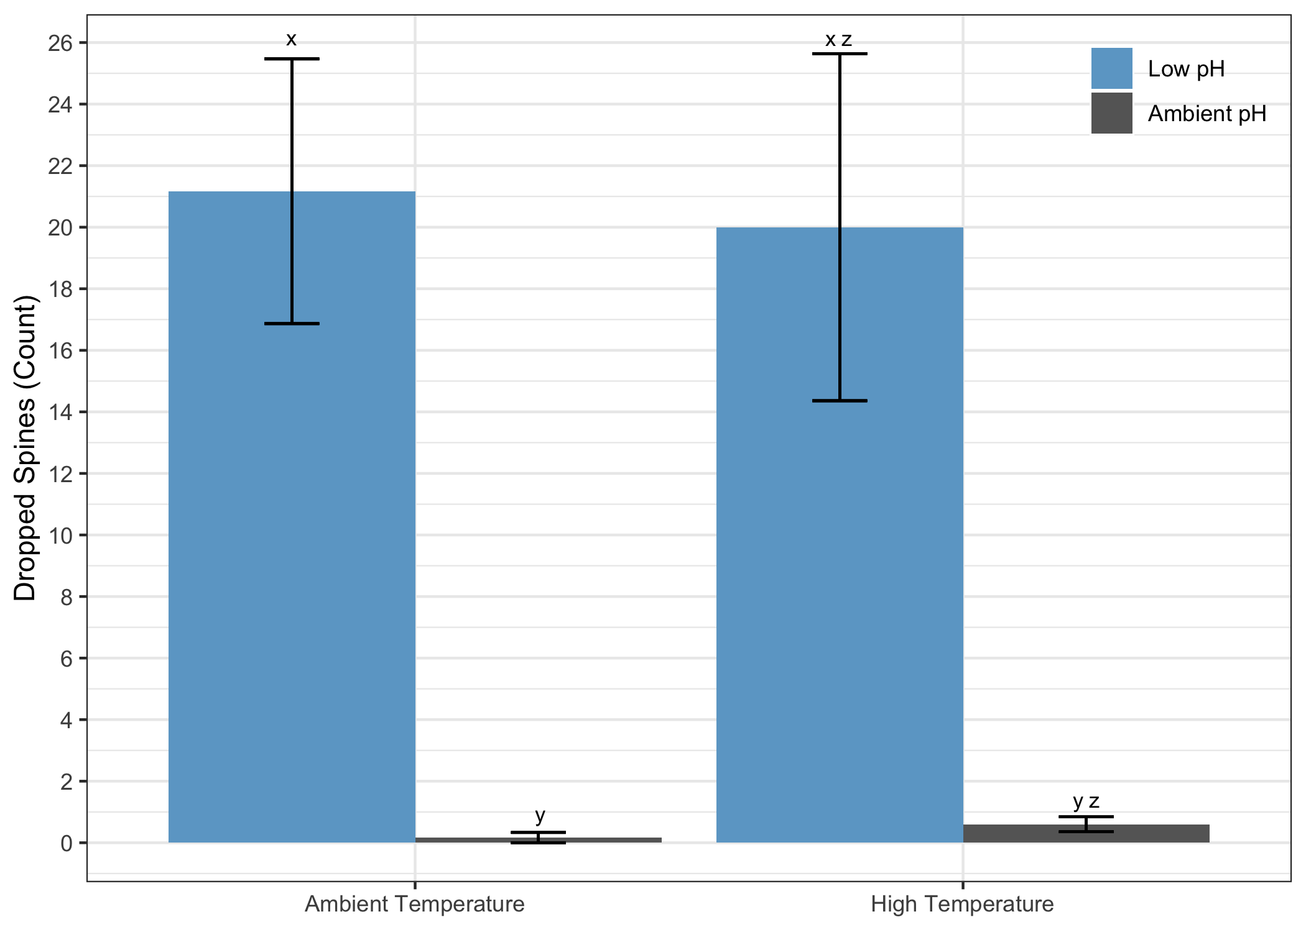

**Figure 3.5.** Effect of temperature and pH on the number of spines dropped. Letters indicate significant difference in *post hoc* pairwise tests. Data are means + standard error (s.e.), n = 6–7

**Table 3.2.** Summary of ANOVA of individual and combined effects of increased temperature and acidification stress on the biological responses of growth, calcification ratio, relative spine length, and dropped spines at the end of the experimental period (126 days) for *Tripneustes gratilla* based on the statistical models. Bold numbers represent significant effects.

|  |  |  |  |  |  |  |
| --- | --- | --- | --- | --- | --- | --- |
| ***Biological Response*** | *Effect* | | *df* | *Chisq* | | *p* |
|  | Temp | | 1 | 4.137 | | **0.042** |
| **Growth** | *p*CO2 | | 1 | 0.258 | | 0.611 |
|  | Temp x *p*CO2 | | 1 | 0.534 | | 0.465 |
|  |  | |  |  | |  |
|  | Temp | | 1 | 0.749 | | 0.387 |
| **Calcification Ratio (Tip)** | *p*CO2 | | 1 | 0.604 | | 0.437 |
|  | Temp x *p*CO2 | | 1 | 2.853 | | 0.091 |
|  |  | |  |  | |  |
|  | Temp | | 1 | 1.941 | | 0.164 |
| **Calcification Ratio (Base)** | *p*CO2 | | 1 | 9.292 | | **0.002** |
|  | Temp x *p*CO2 | | 1 | 0.383 | | 0.536 |
|  |  | |  |  | |  |
|  | Temp | | 1 | 1.798 | | 0.180 |
| **Relative Spine Length** | *p*CO2 | | 1 | 3.713 | | 0.054 |
|  | Temp x *p*CO2 | | 1 | 0.001 | | 0.974 |
|  |  | |  |  | |  |
| *Nonparametric* | | | | | | |
| **Dropped Spines** | Treatment | | 3 | 17.505 | | **<0.001** |
|  |  |  | | |  |  |