6B Unit 1 The Lion and the mouse -- Cartoon Time
日期：______ 班级_____ 姓名：______ 组别：______ 自我评价：______教师评价：______
【学习目标】
1. Read Cartoon time and get to know the main idea of the fable.
2. Grasp the new words and phrases.
3. Read Cartoon time correctly and fluently and retell and act it.
4. Try to retell the main idea of The Crow and the Pitcher which is similar to Cartoon time.
【学习重点】
1. Grasp the new words and phrases.
2. Read Story time correctly and fluently and retell and act it.
【学习难点】
Read Story time correctly and fluently and retell and act it.
【Basic part基础部分】
Free talk
Can you retell the fairy tales with such a sentence pattern “One day, there was a ...”.
_____________________________________________________________________
_____________________________________________________________________

【Key part要点部分】
Task 1: Read and match
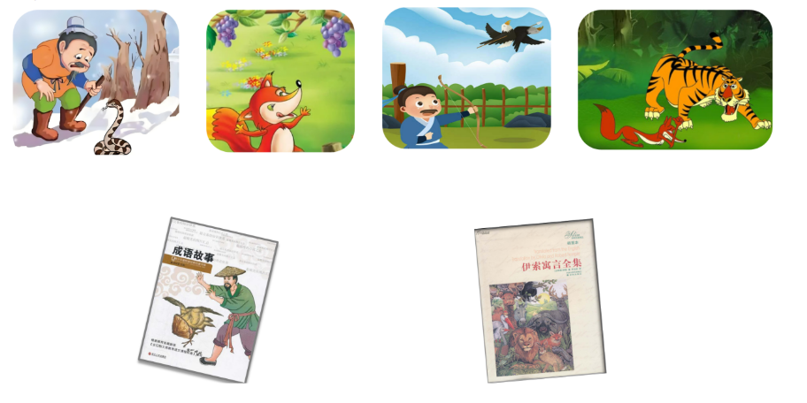
Task 2: Watch and answer
- What are Sam and Bobby doing?
- What’s wrong with them?
- Where is the ball?
- How do they get the ball?

Task 3: Read and fill (Pic. 3-4)

First, they in the playground. But it’s .
Sam can’t .
Next, Sam .

Then, Sam .

Finally, they .

Task 4: Group work
Work in groups to talk about how the crow gets to drink water.
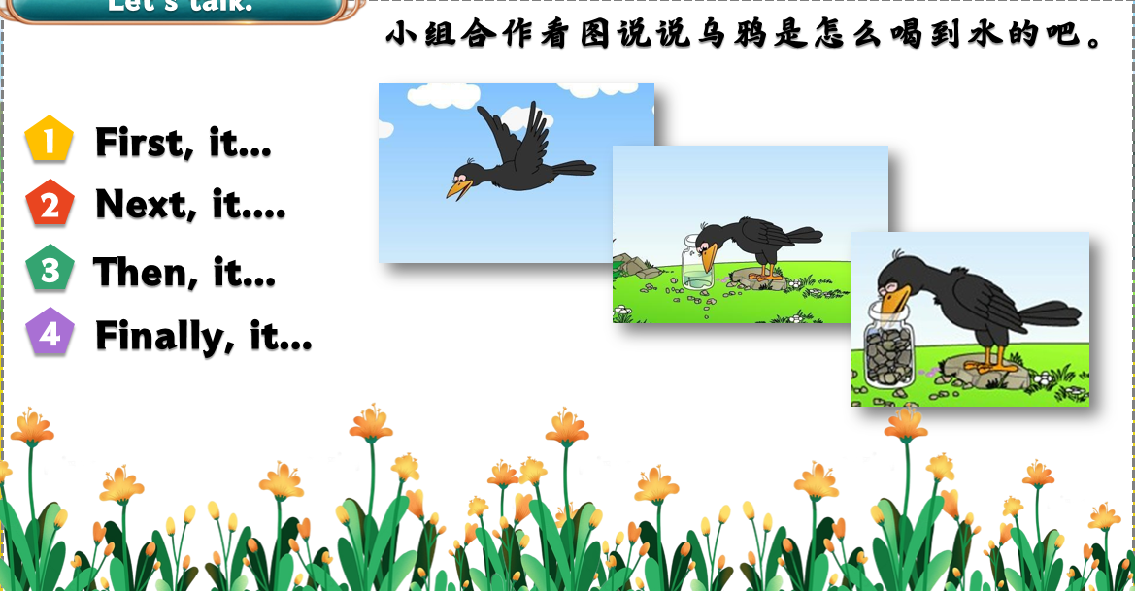

【Exercises目标检测】
一、根据句意选择合适的词填空。
1. Look at the sign on the wall, it means we should keep . (quiet/quietly)
2. The mouse (bite/bit) the net, and the lion got out.
3. My grandparents were . They laughed . (happy/happily)
4.“How can you help me?” the lion asked . (sad/sadly)

二、看图补全短文。
