For inserting data we did next steps:

In our computer we have this folder where we hold all required data(data_file, control_file and images as well)

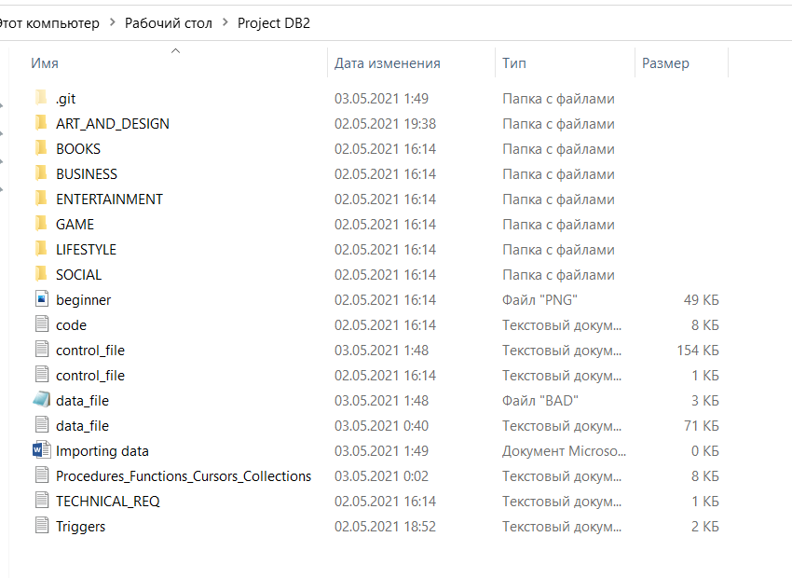

In data_file.txt we hold all data separated by comma:

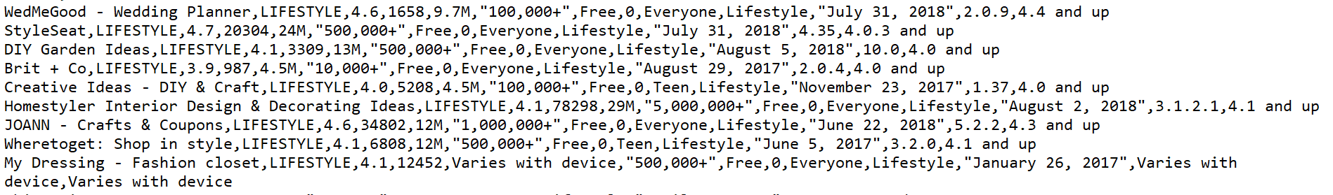

And we push all data which stores in data_file.txt into database by the usage of this control_file.txt.

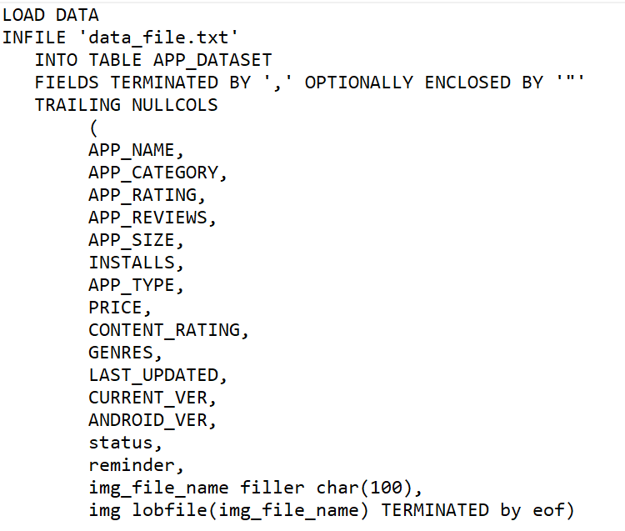

1. In command line we get into this folder and typed piece of code shown below:



Here system is my username of database and plmoknqw is the password. After typing this command all data appear in our database.

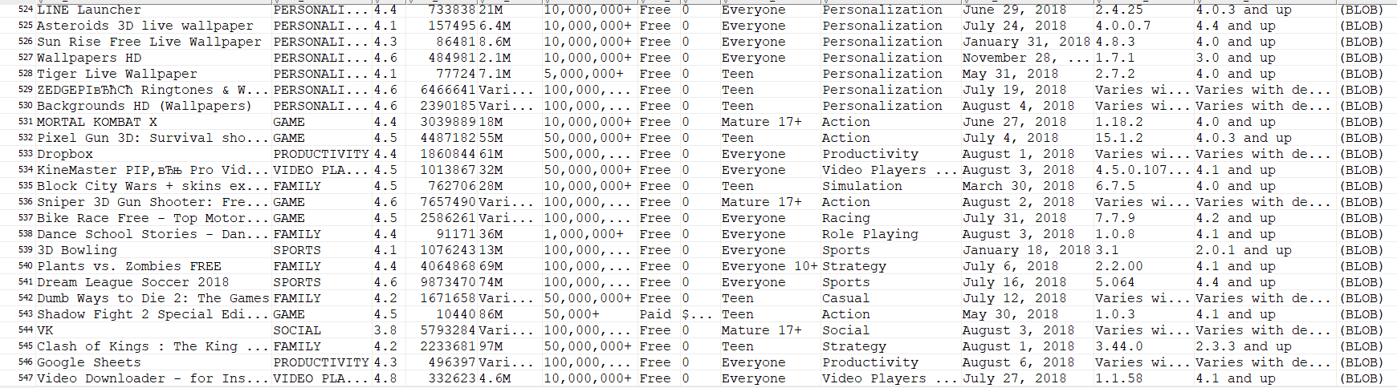

Into our database we’ve inserted 547 rows of data, images we hold in BLOB datatype, and we can see it by double clicking as shown below:

