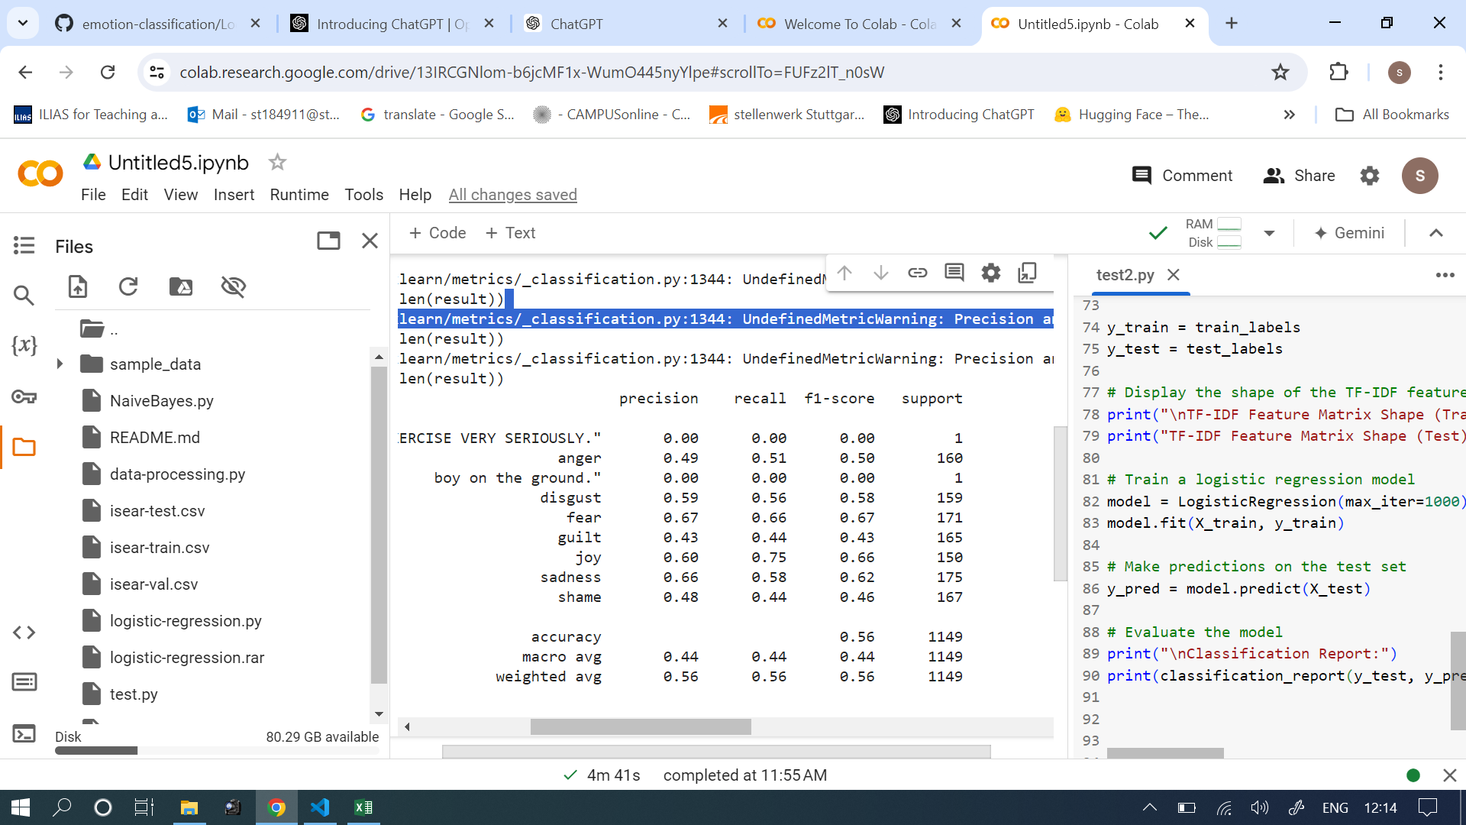

Evaluation for 'joy': {'precision': 0.7417218543046358, 'recall': 0.6021505376344086, 'f1_score': 0.6646884272997032, 'true_positives': 112, 'false_positives': 39, 'false_negatives': 74, 'true_negatives': 923, 'support': 186} didn’t change

Evaluation for 'sadness': {'precision': 0.6342857142857142, 'recall': 0.5362318840579711, 'f1_score': 0.581151832460733, 'true_positives': 111, 'false_positives': 64, 'false_negatives': 96, 'true_negatives': 877, 'support': 207} improved

Evaluation for 'guilt': {'precision': 0.45454545454545453, 'recall': 0.38461538461538464, 'f1_score': 0.41666666666666663, 'true_positives': 75, 'false_positives': 90, 'false_negatives': 120, 'true_negatives': 863, 'support': 195} Improved

Evaluation for 'disgust': {'precision': 0.4528301886792453, 'recall': 0.5901639344262295, 'f1_score': 0.5124555160142349, 'true_positives': 72, 'false_positives': 87, 'false_negatives': 50, 'true_negatives': 939, 'support': 122} improved

Evaluation for 'fear': {'precision': 0.6900584795321637, 'recall': 0.6820809248554913, 'f1_score': 0.6860465116279069, 'true_positives': 118, 'false_positives': 53, 'false_negatives': 55, 'true_negatives': 922, 'support': 173} down with 1%

Evaluation for 'shame': {'precision': 0.38323353293413176, 'recall': 0.44755244755244755, 'f1_score': 0.41290322580645156, 'true_positives': 64, 'false_positives': 103, 'false_negatives': 79, 'true_negatives': 902, 'support': 143} improved

Evaluation for 'anger': {'precision': 0.375, 'recall': 0.4918032786885246, 'f1_score': 0.42553191489361697, 'true_positives': 60, 'false_positives': 100, 'false_negatives': 62, 'true_negatives': 926, 'support': 122} improved

General F1-Score: 0.5377579714022865

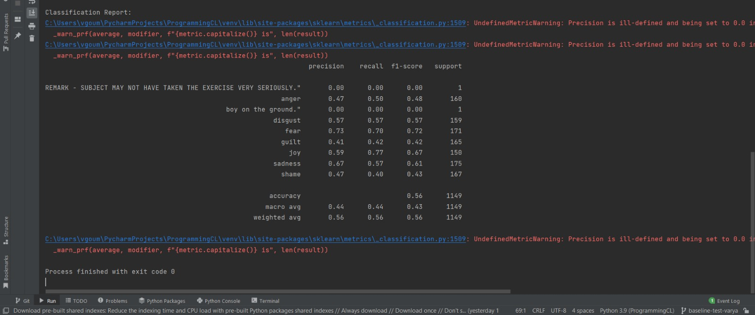

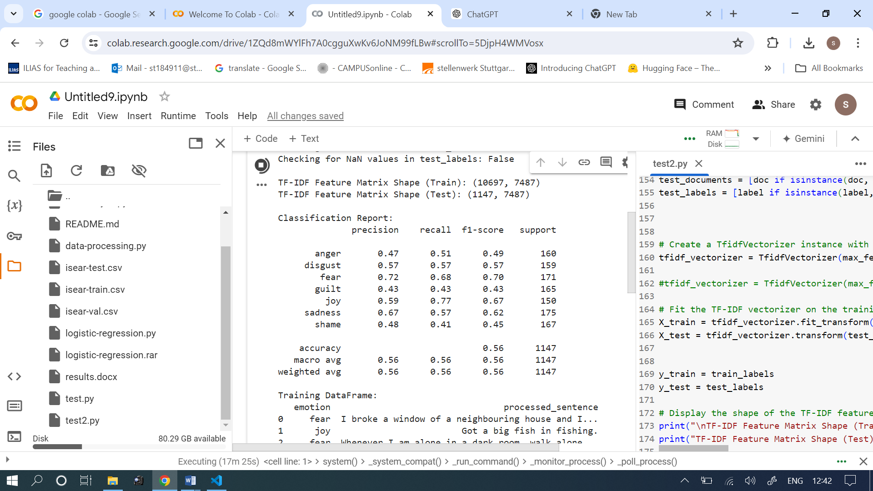

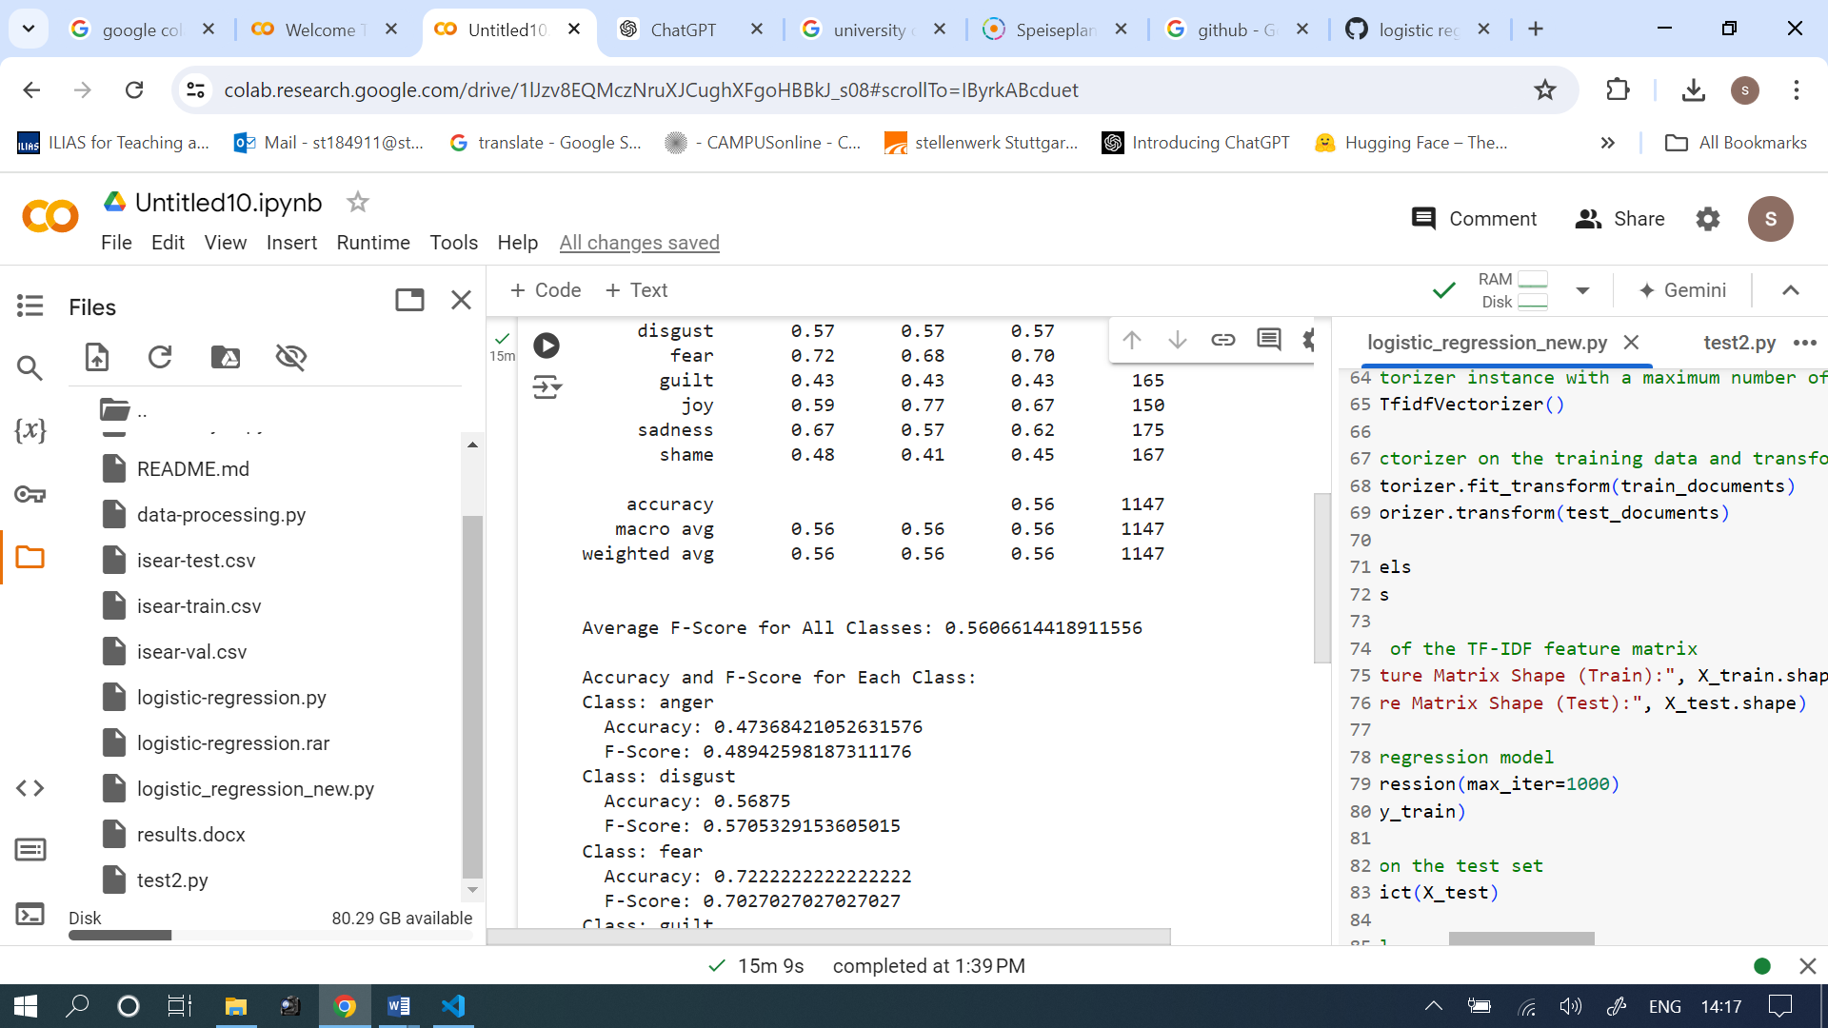

Reducing the features to 1000 actually brings down the general f-score by 1 percent.

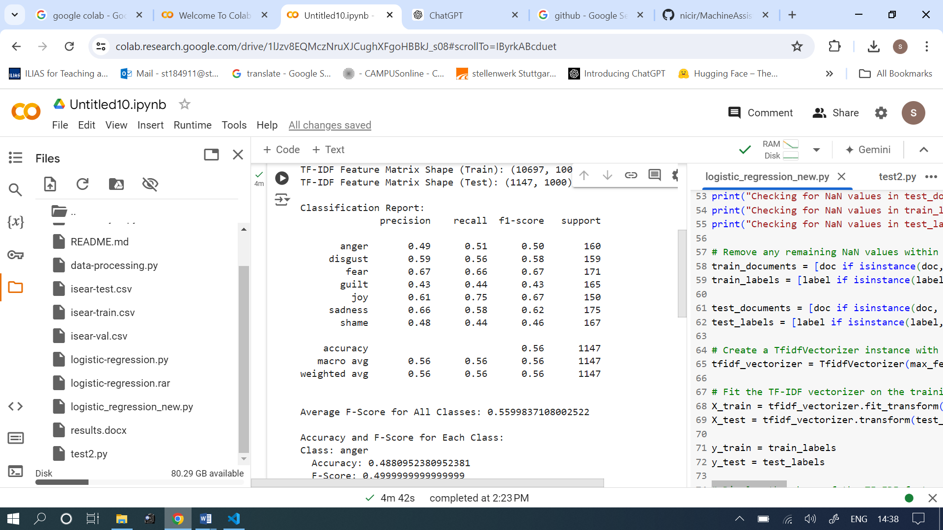

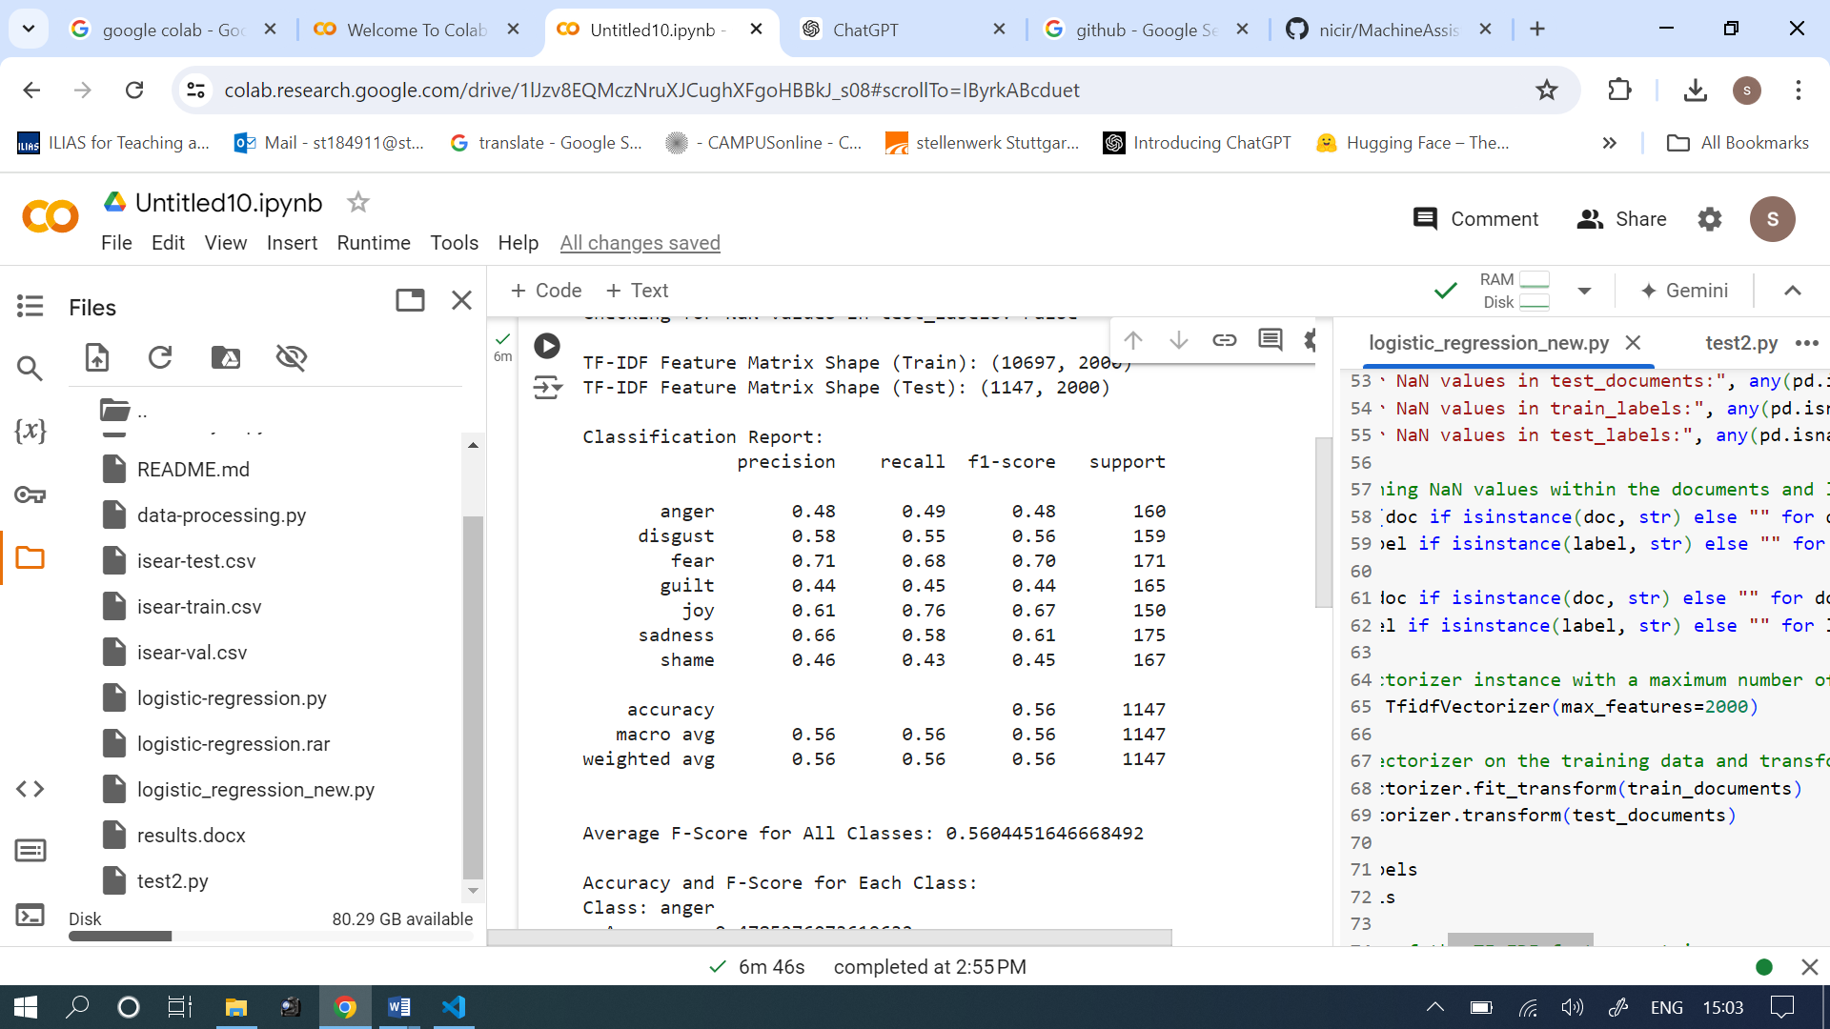

TF-IDF Feature Matrix Shape (Train): (10718, 7494)

TF-IDF Feature Matrix Shape (Test): (1148, 7494)

(emotion-env) PS C:\Users\User\Documents\germany\4th-term\logistic-regression> & C:/Users/User/anaconda3/envs/emotion-env/python.exe c:/Users/User/Documents/germany/4th-term/logistic-regression/data-processing-logistic-regression.py

TF-IDF Feature Matrix Shape (Train): (10718, 1000)

TF-IDF Feature Matrix Shape (Test): (1148, 1000)

Classification Report:

precision recall f1-score support

anger 0.47 0.48 0.47 160

disgust 0.60 0.59 0.60 159

fear 0.68 0.66 0.67 171

guilt 0.41 0.44 0.42 165

joy 0.62 0.74 0.67 151

sadness 0.64 0.54 0.59 175

shame 0.46 0.43 0.44 167

accuracy 0.55 1148

macro avg 0.55 0.55 0.55 1148

weighted avg 0.55 0.55 0.55 1148

Average F-Score for All Classes: 0.5523473551355472

Accuracy and F-Score for Each Class:

Class: anger

Accuracy: 0.4666666666666667

F-Score: 0.47384615384615386

Class: disgust

Accuracy: 0.6025641025641025

F-Score: 0.5968253968253968

Class: fear

Accuracy: 0.6766467065868264

F-Score: 0.6686390532544378

Class: guilt

Accuracy: 0.4114285714285714

Class: joy

Accuracy: 0.6201117318435754

F-Score: 0.6727272727272727

Class: sadness

Accuracy: 0.6375838926174496

F-Score: 0.5864197530864198

Class: shame

Accuracy: 0.4585987261146497

F-Score: 0.4444444444444444

(emotion-env) PS C:\Users\User\Documents\germany\4th-term\logistic-regression> & C:/Users/User/anaconda3/envs/emotion-env/python.exe "c:/Users/User/Documents/germany/4th-term/logistic-regression/import pandas as pd.py"

emotion sentences

0 joy When I understood that I was admitted to the U...

1 fear I broke a window of a neighbouring house and I...

2 joy Got a big fish in fishing.,,,,,

4 shame I bought a possible answer to a homework probl...

... ... ...

10713 sadness ""After a disagreement between my parents, whe...

10714 guilt ""One day I shouted at my brother who didn't d...

10715 fear ""Before one of my final exams of the third ye...

10716 disgust ""A drunk man bumped into me and wanted to gri...

10717 shame ""Had a very good friend. We grew apart I foun...

[10718 rows x 2 columns]

(emotion-env) PS C:\Users\User\Documents\germany\4th-term\logistic-regression> & C:/Users/User/anaconda3/envs/emotion-env/python.exe "c:/Users/User/Documents/germany/4th-term/logistic-regression/import pandas as pd.py"

emotion

joy 1558

guilt 1540

sadness 1531

disgust 1524

shame 1522

anger 1516

fear 1516

2

note: for guilt go to record nâ¦231"";; 1

nb: in bulgarian schools """"a three"""" is the second worst mark."";; 1

b) description of a disfigured orphaned child in hiroshima calling for her mother."";; 1

but i felt that i was not able to express myself very well - i felt ashamed and blushed."";; 1

but i felt that i was not able to express myself very well - i felt ashamed and blushed. 1

nb: in bulgarian schools """"a three"""" is the second worst mark. 1

b) description of a disfigured orphaned child in hiroshima calling for her mother. 1

note: for guilt go to record nâ¦231 1

;; 1

Name: count, dtype: int64

Filtered Class Frequencies (Training Set):

emotion

joy 1558

guilt 1540

sadness 1531

disgust 1524

shame 1522

anger 1516

fear 1516

Name: count, dtype: int64

Number of unique classes: (17,)