Table of Contents
About the Manual 3
Audience 3
Contact 3
Introduction 3
Functions 4
Windows Mail 4
Thunderbird Mail 6
Conclusion 11

Table of Figure
Figure 1 4
Figure 2 4
Figure 3 5
Figure 4 5
Figure 5 6
Figure 6 7
Figure 7 8
Figure 8 8
Figure 9 9
Figure 10 9

USER MANUAL

About the Manual
These documents are written as user manual guide for Hagbes PLC and sister companies’ employees to guide how to set up and uses their new mail platform. and this document contains how the users add their account reset their password and etc. It defines the new mail system how it differs from the existing or previous outlook that that the company uses.

Audience
The audience for these user manuals is every one in HAGBES PLC and Sister companies in each department.

Contact
Should you encounter any questions or require additional assistance, please don't hesitate to contact our support team using these mail address.
support@bestavtech.com

Introduction
The user manual is the technical documentation that helps people to use, fix and maintain the product. So, this user manual as we mentioned earlier in these documents, it is about the general guide of new product or the setup of own new mail platform. And the upgrade offers some advantage include flexibility and enhanced security. this manual will guide you with the instruction necessary to setup mail own mail account using windows mail and Mozilla thunderbird mail.
Mozilla thunderbird mail is the free mail application that is easy to setup and customize, and it is loaded with great features.

Functions

Windows Mail
This is the user client setup on windows mail
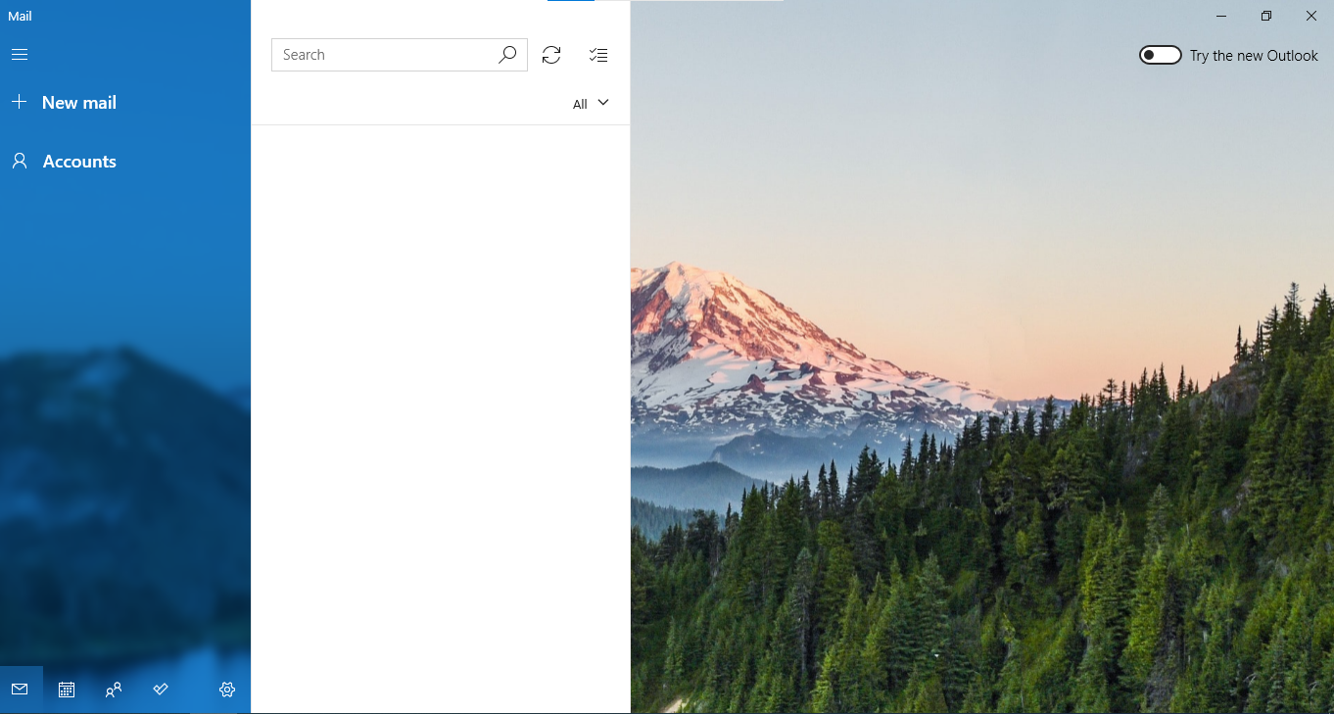
Figure 1
This is the first page of windows mail and in this screen, you have to create or add new account. to add account, click on Account option on left side or click on the gear that appears on side of left bottom as the arrow indicates and for gear or setting option select manage account.

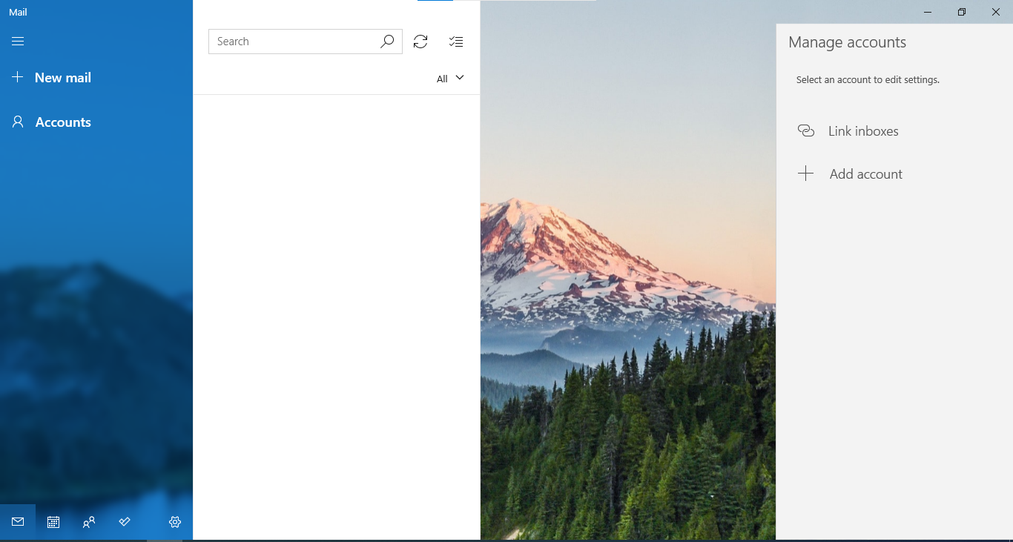
Figure 2

In this screen this comes after the first instruction and click on Add Account option on right side of the screen
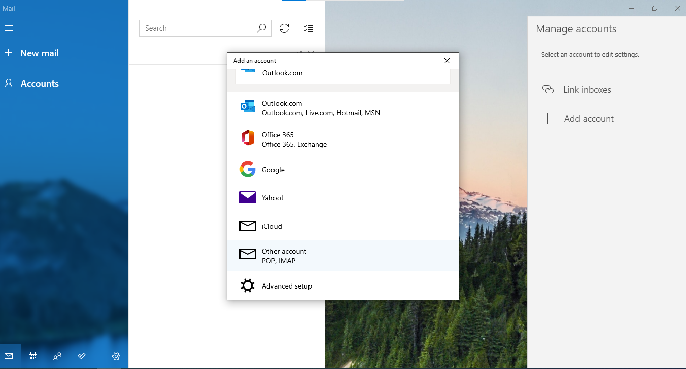
Figure 3
In this screen select the option called Other Account option that indicated by arrow and continuous to next part.
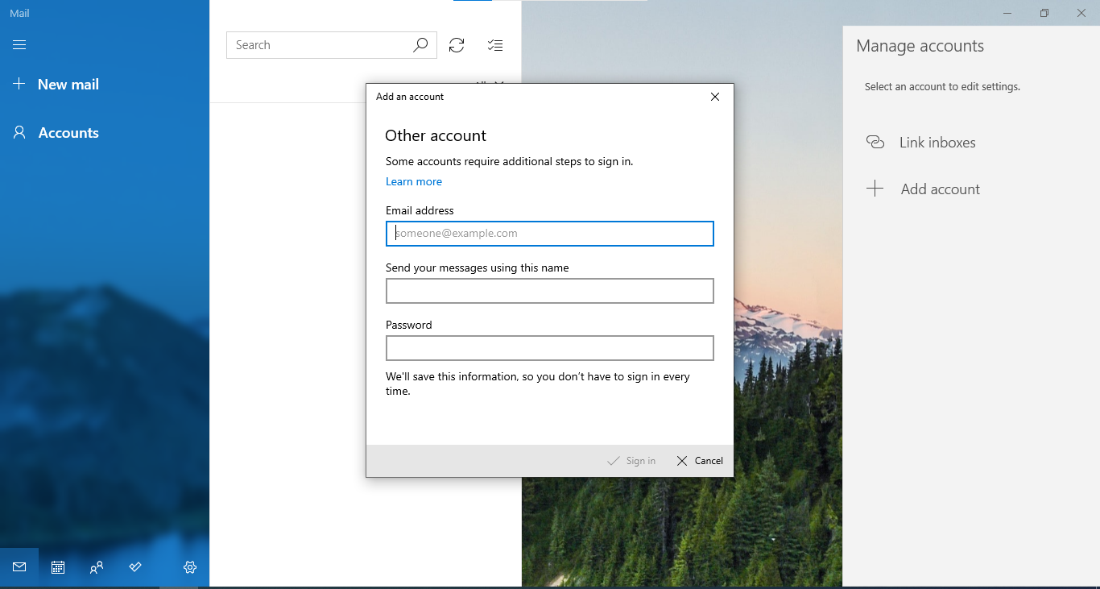
Figure 4

And after this screen will appear and you should fill the valid mail address and your name, the others send the message using this name and your password and finally click sign in option in bottom indicated by arrow.
These is all about mail setup on windows mail.

Thunderbird Mail
The next mail setup is for Mozilla thunderbird mail platform that we will use in Hagbes plc and sister companies.
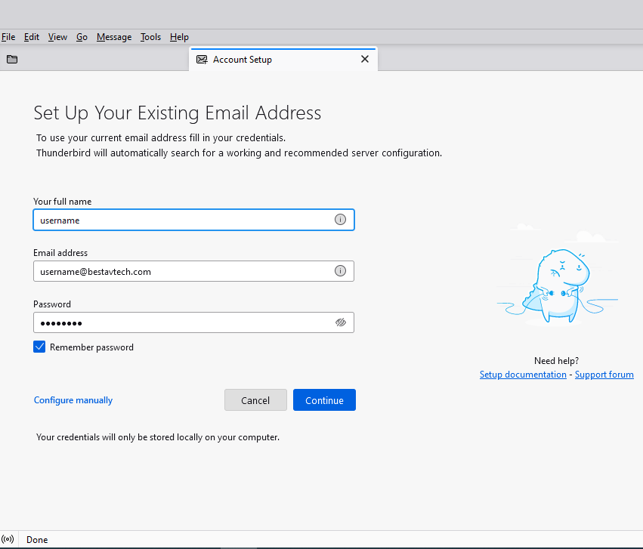
Figure 5
The above picture appears when you are using thunderbird for first time and This shows how to add new account using existing mail account. To do this you have to fill your valid data as shown above. The word “Username” is just for information and the user should replace it with valid name and valid mail also valid password and after that click continue. Go to next

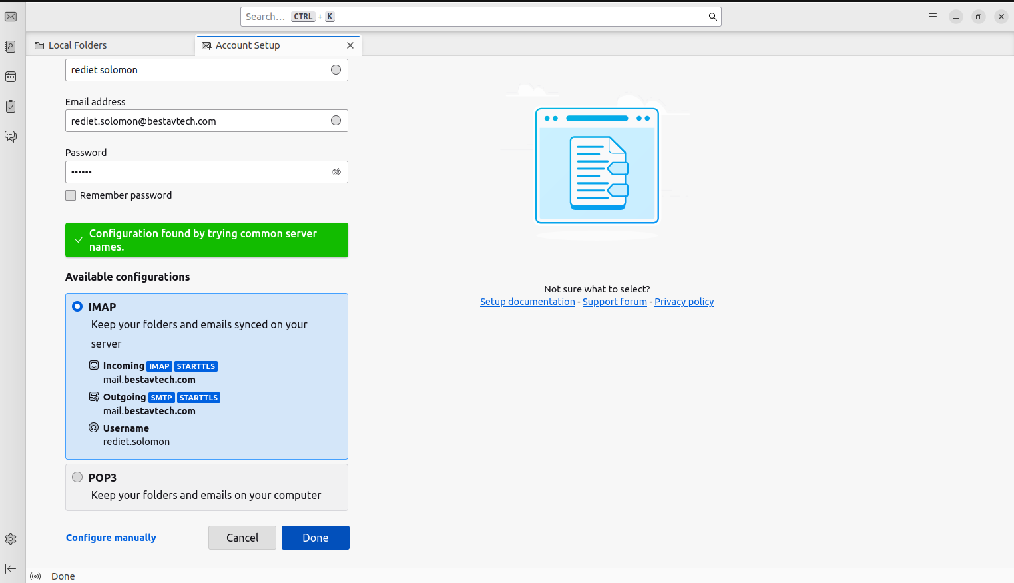
Figure 6
This part appears if the above data that you fill is valid, the thunderbird shows you the message with green color as the above and you are valid user to continue. And then you have to click Done to Continue.

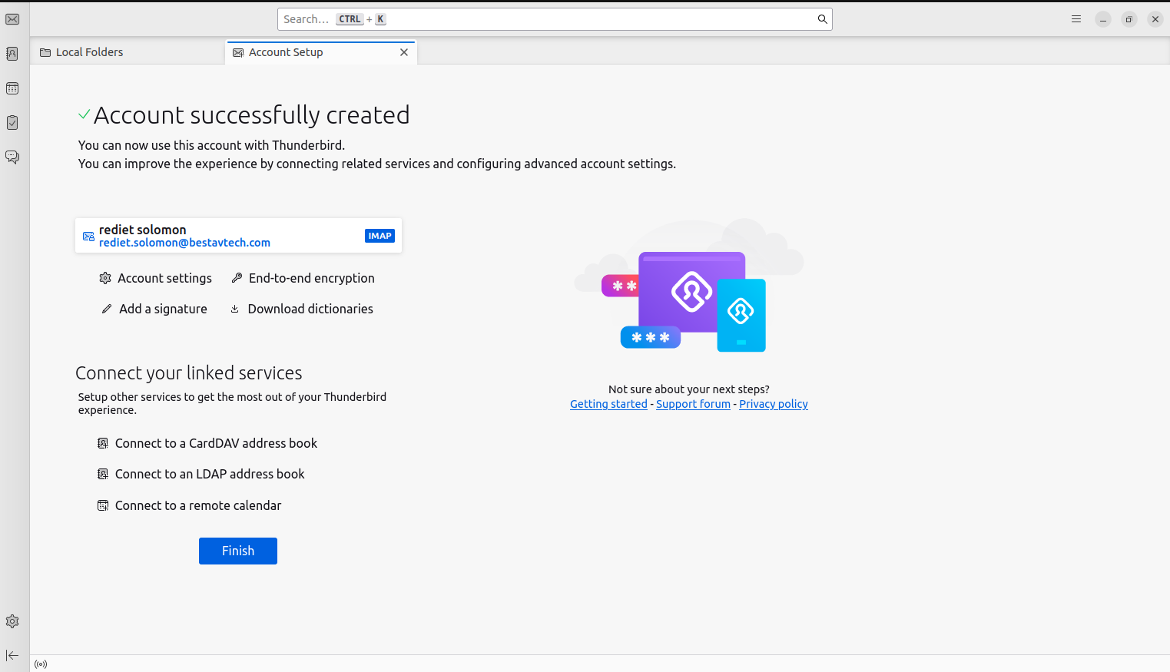
Figure 7
This screen is the final screen that appears after the user fills the valid information of their own account and it says the Account Successfully Created. You are finally ready to use it. And at last, to finish this the user have to click Finish button.
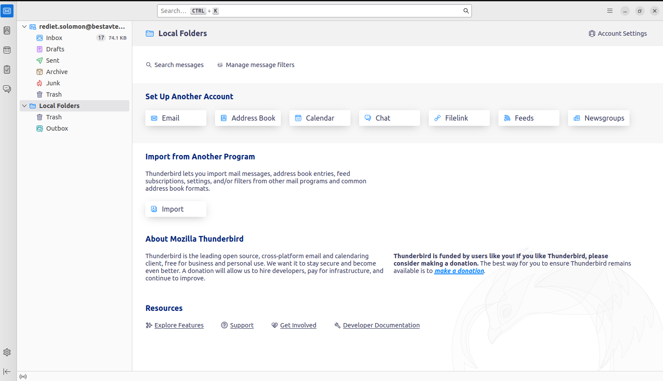
Figure 8
After every thing is done this is the user account page.

For additional setup if the users want to add another mail account in thunderbird they can follow the
following steps to know how to add.
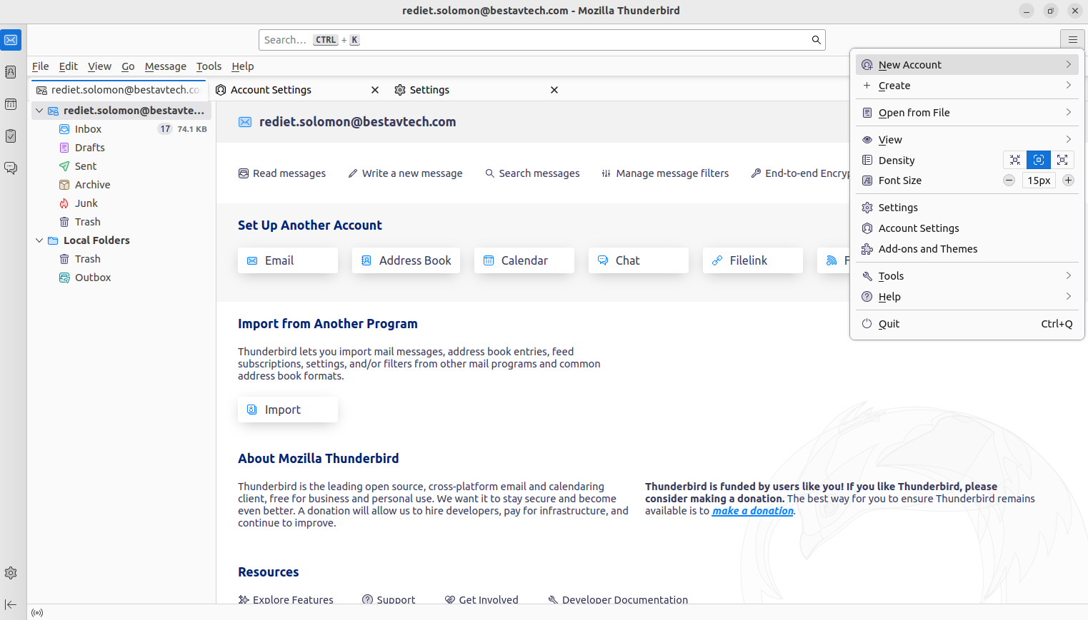
Figure 9
Go to the right above side of the screen and click on three lines and select new account and click on it.
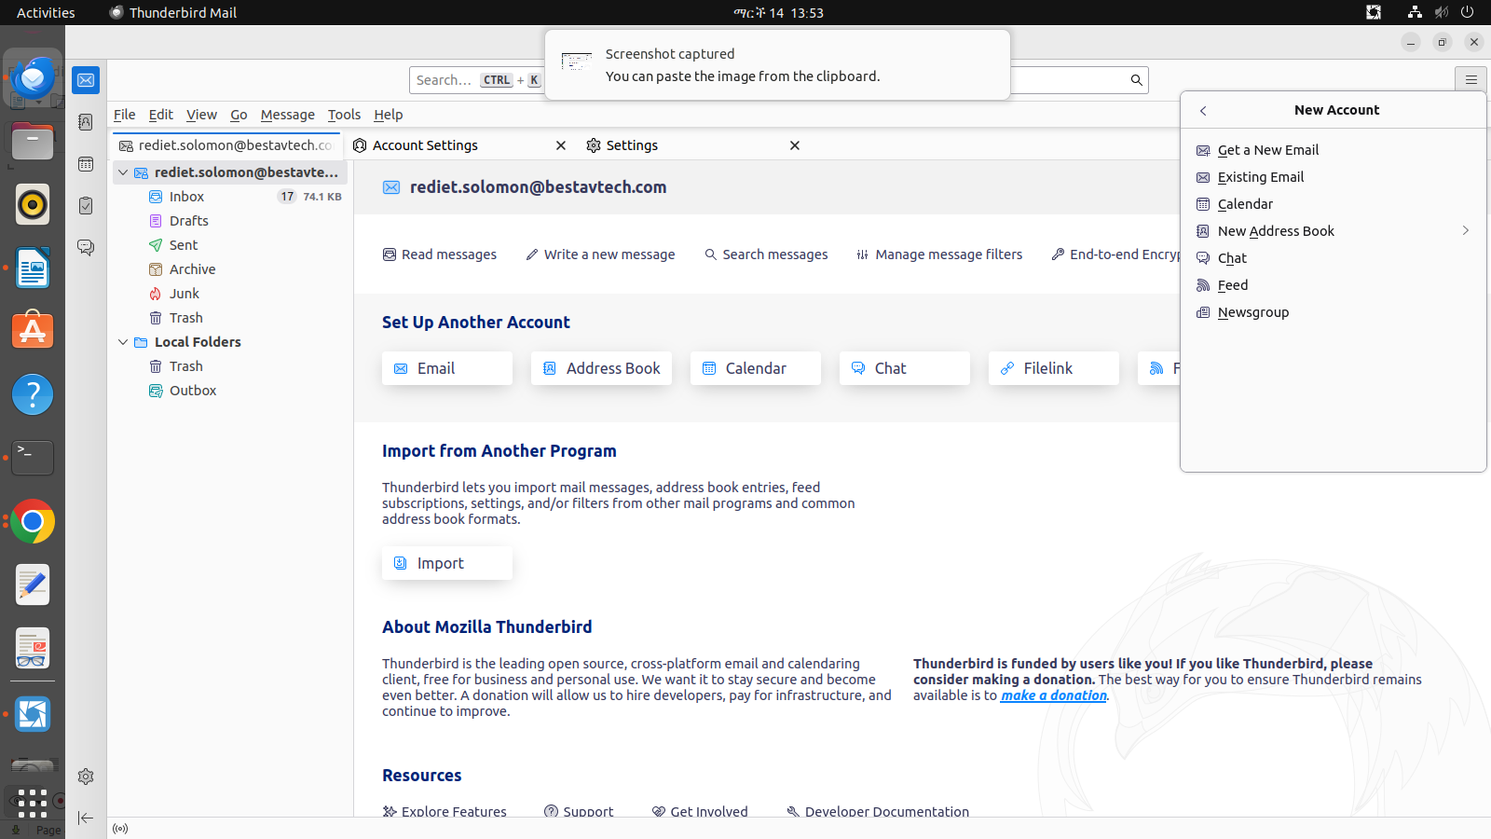
Figure 10

After the above the screen option appears select “Existing Email” option and click it and then it redirects to the first page to fill your information and go to the first picture to continue if you need a guidance.

Conclusion
We hope this user manual will helps you to navigate your mail setup effectively by following the instruction and exploring available resources. for more information or help please use the above support team mail.

