CC LED Driver

System Design Document

Author: Seth Sievers

Created: 9/10/25

Overview

Table of Contents

Overview 1
Table of Contents 2
Hardware Design 3
Requirements 3

Hardware Design

Requirements
- Flicker Free Dimming To Low Brightness -> DC output Buck
- Minimal emitted EMI -> Buck
- Potentiometer for Brightness Adjust with Gamma Correction

Brightness Potentiometer (Gamma Correction)
The luminance (light energy) of an LED is roughly linear with the current through the LED. However, humans perceive luminance in a very nonlinear way, making the perceived brightness very nonlinear with output luminance. This is not ideal for manual adjustment as it is very difficult to get the brightness “just right”.

Perceived brightness roughly follows the following relation.
$B=L^{\frac{1}{γ}}$ $L=B^{γ}$ where $γ≈2.2∈\left[1.5, 3\right]$

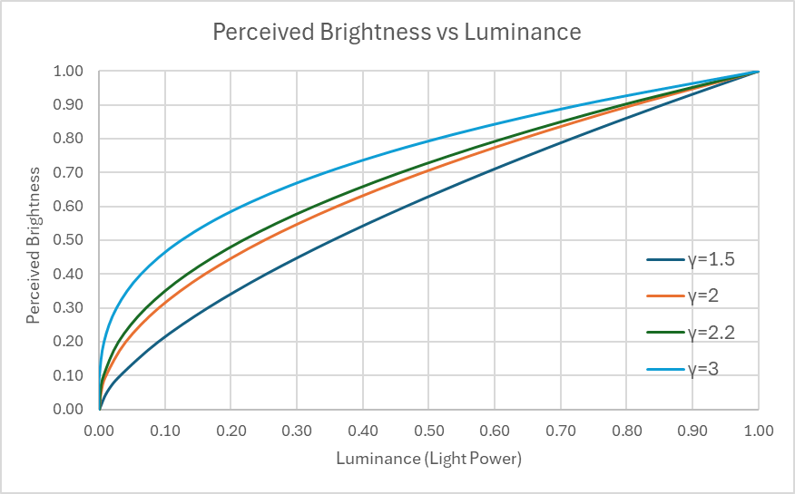

This is trivial to correct for in a microcontroller but since the LED driver will not have one a circuit that roughly follows the inverse of the above curve is needed. Flipping the X and Y axis to visualize the desired function:

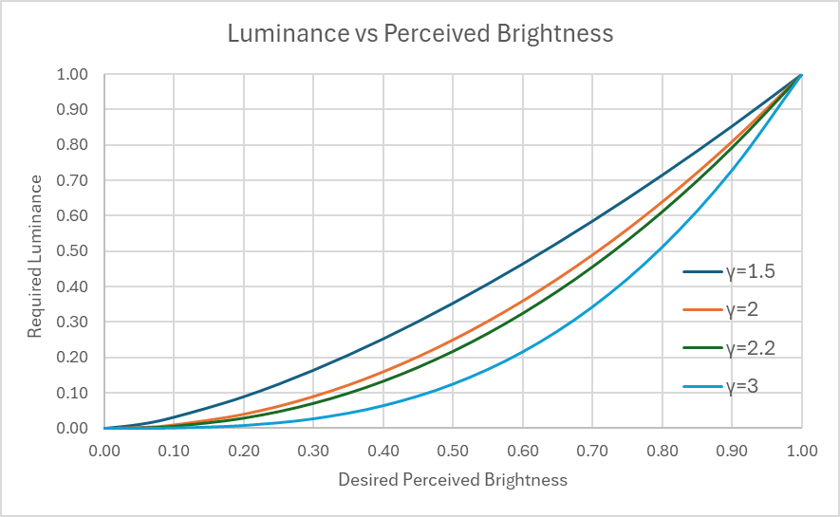

A rough mapping from a linear potentiometer to a curve fitting between the above family of curves would be ideal.

View Rough Circuit Sketch for a preliminary system overview.

Try to achieve the above brightness to luminance mapping in hardware.

It is probably possible to achieve a fairly close matching using diodes or BJTs since the current through them increases exponentially with the voltage across the diode. However, the simpler and easier to adjust method is probably to just use some diodes to make a piecewise approximation of the desired mapping.

For example,

Buck Converter
The LED strip this dimmer is intended to power has a 12V @ 3A rating. This driver is intended to run from ~24V DC and act as a constant current source. The LMR33640 is a synchronous buck converter with a max input voltage of 36V and was chosen to the supply. It does not have a constant current mode so this will need to be implemented externally.

Using the current ripple equation from the datasheet to solve for the inductance required to achieve 30% ripple current with the maximum specified 4A output:
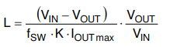
Yields an inductance of ~12.5µH. Solving for the minimum inductance required to avoid subharmonic oscillation:
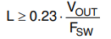
Yields $L ≥5.3μH$ as the lower bound.

Since lowering Vin reduces the inductance required for a % of ripple current and it is more likely that the driver will be used at input voltages lower than 24V rather than higher, the nearest lower standard inductor value of 10µH was chosen as a best guess.

The supply parameters were input into the SMPS spreadsheet to estimate inductor currents. The switching frequency is 400kHz. The efficiency was chosen to be a conservative 90% worst case.

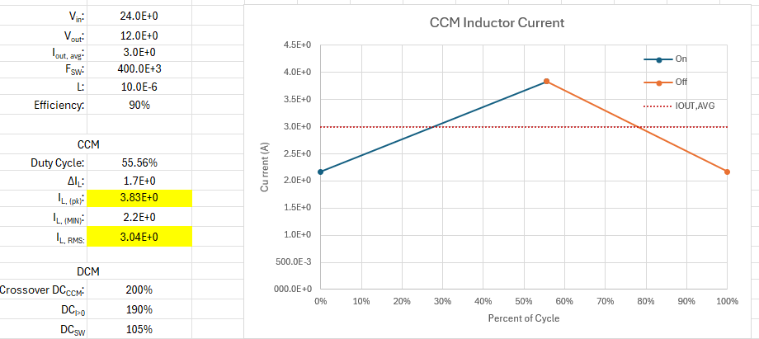
The spreadsheet predicts a peak inductor current of ~4A and an RMS inductor current of ~3A when providing 3A at 12V. From the converter datasheet, the high side switch current limit is typically 5.5A and the low side switch current limit is typically 4.5A so this is within the capability of the supply.

For an inductor, Vishay’s IHLP4040 series was chosen because it is relatively inexpensive, very capable, and has a preexisting footprint in KiCad (Inductor footprints are the worst).

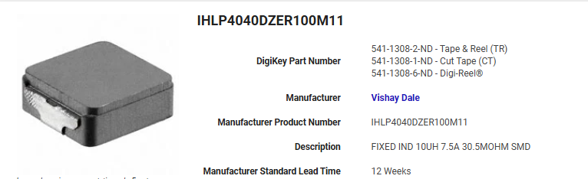

Specifications:
- I_{RMS} = 7.5A
- I_{SAT} = 7.1A
- DC_{R} = 28mΩ

Since the I_{RMS} and I_{SAT} specifications for this inductor are both greater than the current limits for the switcher’s internal FETs, saturation for this inductor should be (almost) impossible, hopefully making this a very reliable supply. Furthermore, 28mΩ is a very low DC resistance and will only contribute to ~0.2% efficiency loss when the supply is providing 36W. Although AC losses will likely be higher than a ferrite core.

The current supply is as follows:
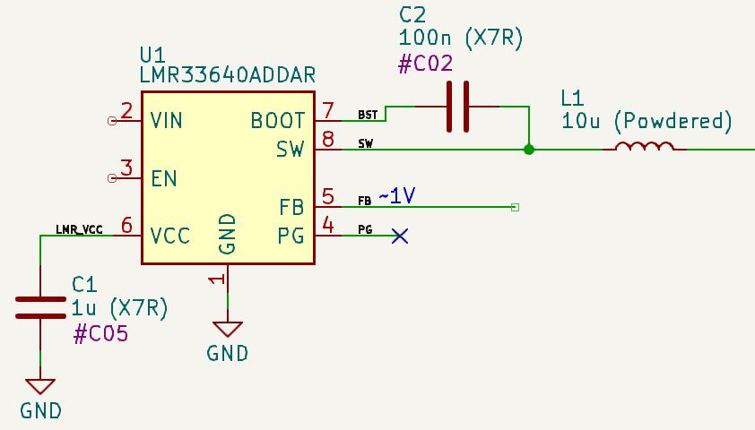

CC Servo
Since the buck converter does not have a constant current mode, constant current operation will need to be implemented externally by driving the FB pin of the buck. This constant current control loop will have implications for the current set potentiometer, gamma correction circuit, and the buck feedback components. To make this solvable all these functional components must be chosen together. Start with an idea and try some values to see if it’s feasible.

One solution to regulate the buck output current is to simply use an opamp to drive the feedback pin of the buck until the current setpoint is achieved. However, since this buck has its compensation network fixed internally, this will likely prove difficult to stabilize since placing the current control loop inside the buck converters feedback will cause an additional phase shift. It is also desirable to have both a constant current control loop and a voltage control loop so that minimum and maximum output voltages can be set.

Solution:
Instead of driving the buck feedback pin directly, use the buck feedback resistor network to provide high frequency immediate feedback to the buck. The output voltage of the buck (which will directly influence the load current) will be set by a MUCH slower current feedback loop. This constant current “servo” will slowly steer or adjust the output voltage until the current drawn by the load is equal to the setpoint. Since an LED is not an active load with fast current transients this will achieve the desired constant current and correct for any temperature drift. Since the bandwidth of the current control loop will be extremely limited, it will have a minimal impact on the buck stability.

Rough Circuit Sketch:

