**Alzheimer's Disease Progression by measuring Hippocampal Volume through AI**

**Student Name: Seth Ramachandiran, Udacity AI course.**

This repository contains a completed "Applying AI to 3D Medical Imaging Data" course, part of the AI for Healthcare Nanodegree program. It submitted along with the AI scripts for the review of the Udacity instructors.

**1.Introduction**

Alzheimer's Disease (AD) is a degenerative brain disease that affects the brain and after years of brain changes, individuals experience symptoms such as memory loss, loss of language function, and other manifestations. AD is the most common cause of dementia.

Currently, an MRI exam is one of the most advanced methods to quantify AD. Studies have shown that measurements of hippocampal volume from MRI exams is useful to diagnose and track progression of several brain diseases, including AD. AD patients have shown a reduced hippocampus volume. However, the process to measure the hippocampus using MRI scans is very time consuming. Each 3D MRI scan volume contains several dozen 2D images slices. With each 2D image slice, the hippocampus must be correctly identified and traced.

AI software can provide a practical solution to quantify hippocampal volume from MRI scans. Deep learning algorithms (UNET) for computer vision segmentation tasks.For this project, a deep learning segmentation model was created to identify hippocampus structures in brain MRI scans on volume pixel (voxel) level. The identified hippocampus voxels are translated to physical volume measurements in mm^3.

The intention of this software is to be integrated into a Picture Archiving and Communication System (PACS) whereby this software will automatically calculate hippocampal volumes of new MRI studies as the studies are committed to a clinical imaging archive server.

The project was done in three steps:

* Step 1 Curating a Dataset of Brain MRIs: Analyze Medical Segmentation Decathlon dataset metadata, analyze & visualize image volumes & corresponding labels, and identify & remove data that is not of a brain MRI.
* Step 2 Training a segmentation CNN model: Used 70,20 and 10% to split the data for train, validate and test image files, image volume pre-processing, split dataset using Scikit-Learn, build & train a UNet Fully Convoluted Neural Network (FCN) with PyTorch, and evaluate model performance metrics - overall Dice Similarity Coefficient & Jaccard Index.
* Step 3 Integrating into a Clinical Network: To simulate the clinical environment following systems were installed.
  + OHIF for image viewer.
  + Orthanc as a PACS server
  + AI engine is the program
  + Scripts to simulate the MRI Scanner

In this completed model run, the model achieved performance as below:-

* **Mean Dice : 0.8994065060551371,**
* **Mean Jaccard: 0.8176876389140472.**

A full discussion of completed project results and model performance can be read in [Validation_Plan_Proposal](https://github.com/ElliotY-ML/Hippocampus_Segmentation_MRI/blob/master/Validation_Plan_Proposal.pdf)

As part of the project the test volumes were used to determine the size of the volume and present it through the image viewer software. Total volume if 3631 cubic mm of the Hi There are three main steps in the project**.** 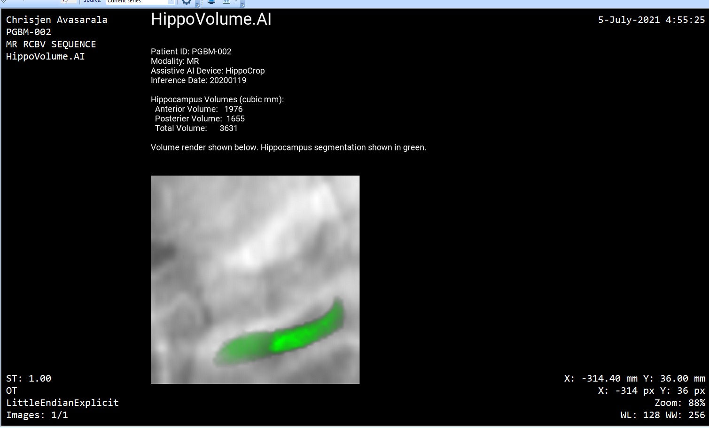  
**Figure 1.** Example report output for Test Volumes Study 1

_____________________________________________________________________________

**2.Dataset**

The project dataset was provided by Udacity. It was adapted from the Medical Segmentation Decathlon "Hippocampus" dataset. The original "Hippocampus" dataset consisted of cropped T2 MRI scans of the full brain. The volumes were cropped to only the region around the right hippocampus. This reduces the dataset size and allows for shorter model training times. The project dataset was stored as a collection of NIFTI files, with one file per image volume and one file per corresponding segmentation mask volume

**3.Environment**

**Hardware /SW:**

* P-620 Thinkstation with 1 Graphics card
* OS Windows 10 + Ubundu windows sub system
* DICOM reader: Micro Dicom reader v3.8.1 (build 422)– Unlicensed for commercial use.
* Slicer 2.11.20210226
* Anaconda 3
* Jupiterlab with debugger extension
* Xpython3.8 for compatibility the debugger extension.
* [OHIF zero-footprint web viewer for viewing images](https://docs.ohif.org/development/getting-started.html). The OHIF will also install the Orthanc Server. It is the PACK server.
* Orthanc configured OHIF to read data based on the document: <https://docs.ohif.org/configuring/data-source.html>

**Project Steps**

**Part 1: Curating a Dataset for Machine Learning Training and Validation**

The human brain has two hippocampi, one in the left hemisphere and one in the right hemisphere of the brain. Udacity provided this project's dataset that consists of cropped regions around the right hippocampus.

Inputs:

* /data/TrainingSet/images contains 262 NIFTI files for MRI Scan Volumes
* /data/TrainingSet/labels contains 262 NIFTI files for corresponding Segmentation label masks.

Outputs:

* /TrainingSet/images contains 260 NIFTI files that are Brain MRI Scan Volumes
* /TrainingSet/labels contains 260 NIFTI files that are Brain Hippocampus Segmentation label masks

Coding:

1. This section of the project was completed in the Jupyter Notebook / /Final Project EDA.ipynb. Open this notebook to start.
2. The first step is to create lists for images and labels filepaths.
3. Using the NiBabel python library, the NIFTI files are extracted.
4. For a handful of files, visualize select 2D slices from each 3D MRI volume.
5. Explore the metadata from NIFTI file headers. This contains information about MRI volume dimensions, MRI scanner settings, and voxel dimensions.
6. Use metadata, image data, and segmentation mask data to find MRI volumes that do not appear similar to most of the dataset.
7. Use voxel information and segmentation mask to calculate Hippocampus volume per MRI scan. Investigate MRI scans that are not in a typical range of Hippocampus sizes.
8. ***Since the Jupiter notebook does not support Bash comment when it runs on the Windows some of the steps are done outside manually -like file compare etc***

**Part 2: Train U-Net Fully Convoluted Network for Brain Segmentation**

* + - Algorithm: Recursive UNET
    - Hyper Parameter and other Parameter
* Root dir = r"./TrainingSet/"
* No of epochs = 10
* Learning rate = 0.0002
* Batch size = 32
* Patch size = 64
* Test results_dir = "./results/"
* Loss Function cross entropy
* Optimizer Adam.

Tensor board will write logs into the director called runs. View the progress by opening a browser and navigate to port 6006 of the machine where you are running it.

* Mean Dice : 0.8994065060551371,
* Mean Jaccard: 0.8176876389140472.

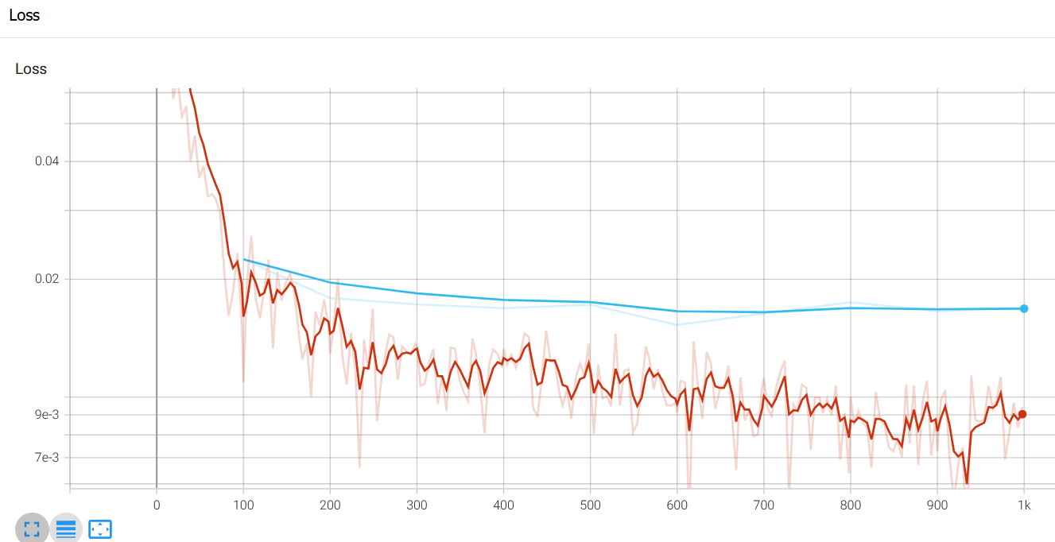

Figure 2: The training and validation loss curves

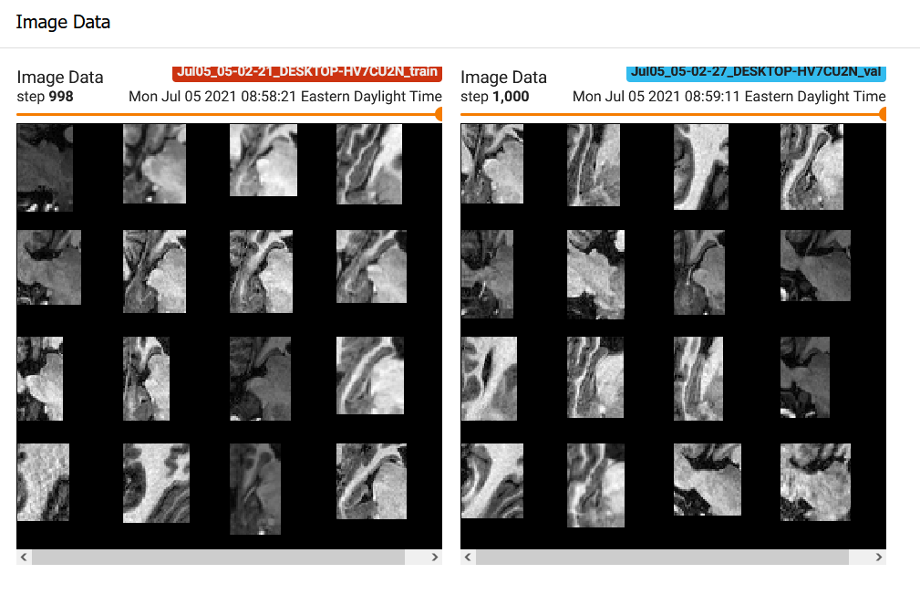

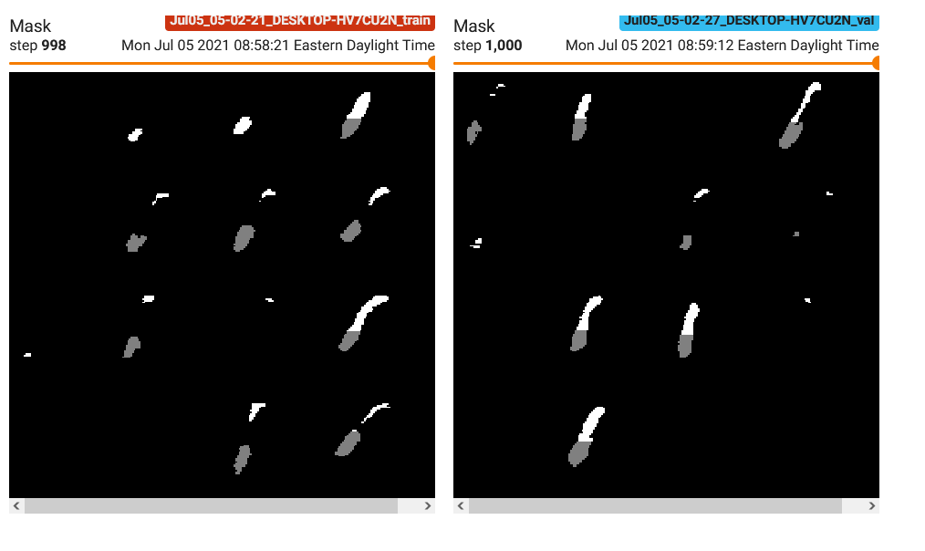

Figure 3: Image data at various steps.

**Part 3: Simulate Integration of Segmentation CNN into DIMSE**

In Section 3, the segmentation CNN from Section 2 will be integrated into a simulated clinical network. This AI product will automatically compute hippocampus volume for brain MRI scans, and provide this information to clinicians in a DICOM report.

[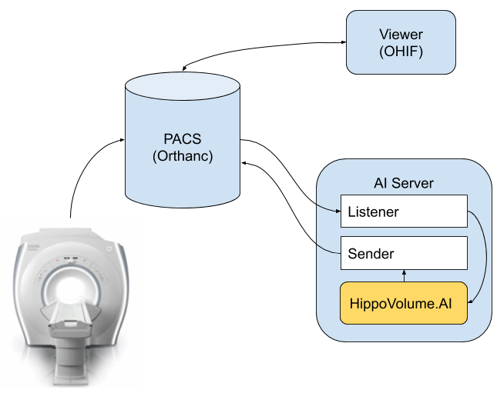](https://github.com/ElliotY-ML/Hippocampus_Segmentation_MRI/blob/master/data/readme.img/network_setup.png)  
**Figure 2.** DIMSE Simulation Setup

| **List** | **Network Object** | **Script to Simulate Network Object** |
| --- | --- | --- |
| 1 | Picture Archiving & Communications System (PACS) server | Orthanc DICOM server |
| 2 | MRI Scanner | section3/src/deploy_scripts/send_volume.sh. It will initiate a file transfer to the Orthanc. |
| 3 | Viewer System | OHIF Viewer [2]. It connects to the Orthanc server using DicomWeb and is serving a web application on port 3000. |
| 4 | AI Server containing Segmentation software | (1) section3/src/deploy_scripts/start_listener.sh. It will copy everything it receives into a folder specified in the script. (2) AIandHealthcare/udacity/Hippocampus/inference/UNetInferenceAgent.py is the Hippocampus Segmentation CNN software. |
|  |  |  |

1. The PACS server is central to clinical settings. It receives & archives all medical images and allows connected computers to request & send image files.

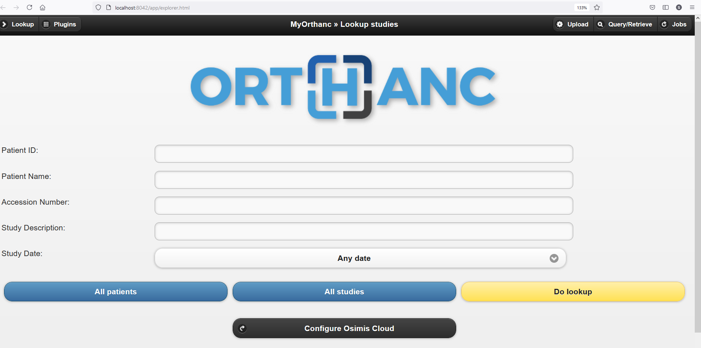

1. The MRI Scanner will send entire studies to the Picture Archiving and Communication System (PACS) Orthanc server after completing a scan. The script will simulate the archive transfer.
2. The Viewer system represents workstations that clinicians use to retrieve and view studies from PACS. The OHIF is viewer is software for viewing medical studies. It is connecting to the Orthanc server using DicomWeb and is serving a web application on port 3000.

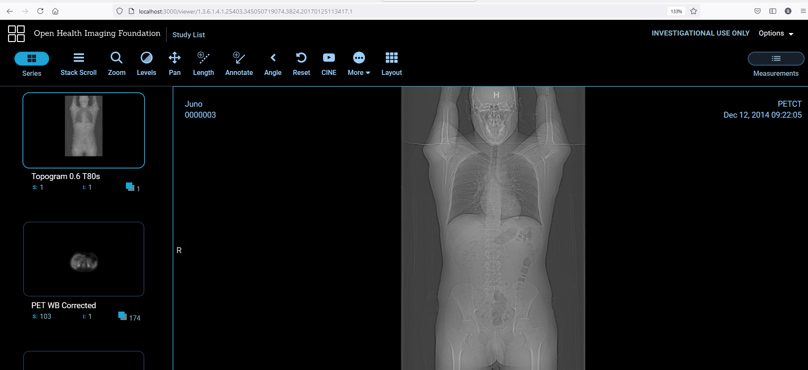

1. An AI server is responsible for listening to PACS ports for incoming MRI studies. When it detects that an MRI study is sent, the AI server will request a copy from the PACS server. Once the MRI study is received on the AI server, the brain MRI scan will be processed by segmentation software and the hippocampus volume will be calculated from the determined hippocampus mask.

Inputs:

* A file transfer of a Brain MRI scan.
* Model : AIandHealthcare/udacity/Hippocampus/Section3/model.pth

Outputs:

* A DICOM Report displaying Total Hippocampal Volume, Anterior Hippocampal Volume, Posterior Hippocampal Volume, and Axial views (head to toe direction) at three depths.

*Please note the Section 1 and Section 2 are merged and is a common folder and section 3 is separate. This worked better when I was working in my PC.*