# Beehive Monitor User Manual

By Seth Worthylake

This User Manual will help you setup, operate, and understand the Beehive monitor. This Beehive Monitor was built in 2020-2021 and installed in 2021. If you are operating on it and have any questions, please contact the listed technician.

Table of Contents

Beehive Monitor User Manual 1

Installation Instructions 2

Setting Up Bluetooth 4

Operating Instructions 6

Images 7

Importing Data into Excel 9

Theory of Operation 10

Hardware Components 11

Operating Conditions & Ranges 11

Warnings & Cautions 12

Solar Extension 12

Contact 12

# Installation Instructions

WARNING, read all installation instructions before attempting installation.

1. Lift the beehive up enough that the monitor can be slide underneath.
2. Place the monitor underneath the monitor with the side of the load cell shown in Figure 1 facing down. Make sure each point of the load cell sensor is level and is the four points that the monitor sits on.

Figure 1

1. Place the battery module near the Beehive monitor in a place where it is covered from rain.
2. Place the external temperature sensor outside and insert the internal temperature sensor and humidity sensor through the Beehive entrance and place them in between.
3. Then place the Beehive atop the monitor. Being careful to have the connection cord for the monitors Arduino exposed so that a laptop can connect to it.
4. Ensure the Beehive monitors Arduino is displaying its running light and that the system can actually turn on. This will look like a green light blinking on the faceplate every 30 minutes to an hour.
5. Hook a laptop with Arduino software on it. The software should come already programmed to have the monitor zeroed out. If you would like to Zero out other components please contact a technician listed.
6. Then run the standard operation Arduino program on the beehive monitor while maintaining a direct connection between the laptop and the monitor. This code is provided at the end of the document. When you open the Arduino file it will look like figure 2.

Figure 2

1. Press the arrow button while having a connection from the Blue connection cable that connects from a USB port on your laptop to the Arduino Microcontroller. The arrow is seen in figure 3.

Figure 3

1. Select the Serial Monitor on the left side to check on how the program is doing. As seen in figure 4

Figure 4

1. Then Wait until the output window outputs these 3 lines, as seen in figure 5. If it does not, please email the technician with the output from the output window.

Figure 5

1. Disconnect the laptop and ensure the weatherization capsule is secure.

*If you do not have any of the programs mentioned, please email [sethworthylake@gmail.com](mailto:sethworthylake@gmail.com)*

# Setting Up Bluetooth

While near the monitor open your Windows laptop settings, then to Bluetooth & other devices. Select add a device. As seen in figure 2

Figure 6

Then select Bluetooth, you should see a device named H-C 2020-06-1. Pair to it when a password is required enter 1234 or 0000

Once connected go to the More Bluetooth Options on the right side. Then select COM Ports and select Add.

Figure 7

Then select Outgoing and find the H-C-2010-06-01 and then select it and hit Ok. The menu should look like figure 4.

Figure 8

Then go back to the More Bluetooth Options page and note which COM port is used for the Outgoing direction. You will use it when running the BeeHive_Data_Client.exe program on your laptop that communicates with the Monitors Bluetooth. When you go to run the program make sure your Bluetooth is on and you are connected to the Bluetooth monitor.

# Operating Instructions

Check and ensure the monitor reading light is going off every 30 minutes to an hour. If that is not happening check to make sure the Arduino heartbeat light is on. If the light is not on or the reading light is not going off, then please email the technician.

*Read the Setting Up Bluetooth section and make sure everything is working before continuing.*

Ensure that The Monitor’s send light turns on once the button is pressed. Then using the Bluetooth Connection executable connect to the Bluetooth and it will return a comma delimited text file that will be located in the folder where the Bluetooth Connection executable is located. The file will be named like so.

DAYOFTHEWEEK_MONTH_DAY#_HOUR;MINUTE;SECOND_YEAR.txt

Example Fri_Mar_12_13;38;17_2021.txt

If you haven’t pressed the button it will output this.

If the system ever dies and you need to extract the data, open up the Tupper wear container that has the Arduino and circuitry in it. Then extract the SD card by clicking it out, as Show in this diagram.

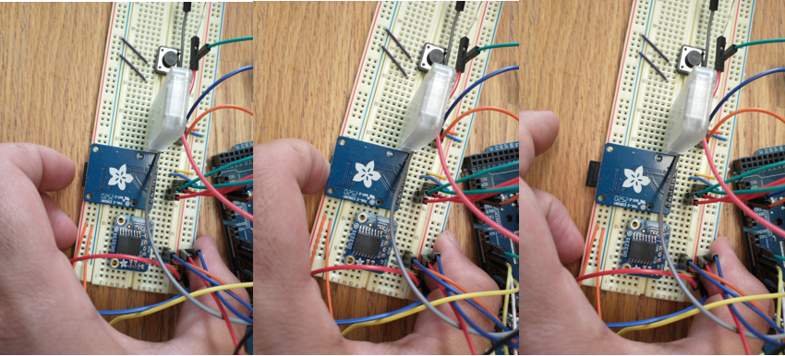

*Make sure to put the SD card into the system before continuing as that is were the data is saved*

# Images

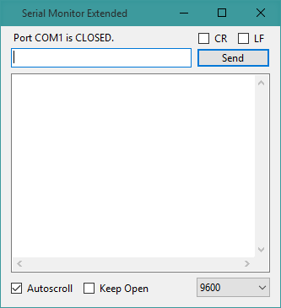

Output window I

Bluetooth Executable 1

Data Output 1

Monitor 1

# Importing Data into Excel

Go into your Excel file and go to Data. Then to Get Data -> From File -> From Txt/Csv. Then select your file.

Ensure the data looks how you want then select load.

Your data should then be formatted as so.

# Theory of Operation

The Monitor will spend most of its time in low power mode. It will wait until either the button to request a send is pressed or the timer goes off. If the system wakes up from the timer, then it will turn the Read LED On and then read data from all the sensors then it will write that data to the SD card. Then it will turn the Read LED Off and go back to sleep. If the system wakes up from the button it will turn the Send LED On. It will wait for the user to run the BeeHive_Data_Client.exe so it can establish a connection then send the data on the SD card. If the user doesn’t run the BeeHive_Data_Client.exe within 2 minutes it will just stop and turn the Send LED off and go back to sleep.

# Hardware Components

HX711 Load Cell Sensors x4

DHT11 Humiture Sensor x1

DS18B20 Waterproof Temperature Sensor x2

HC-05 Bluetooth Module x1

MicroSD card breakout board+ x1

5mm Led x2

Button x1

ExpertPower 12 Volt 12 Ah Rechargeable Battery with F2 Terminals || EXP12120 x1

# Operating Conditions & Ranges

HX711 Load Cell Single

Max Weight: 50kg, 110.2 lbs.

HX711 Load Cell All four in Wheatstone configuration

Max Weight: 50kg * 4 = 200kg, 440.9 lbs.

DHT11 Humiture Sensor

Min Temperature: -55°C

Max Temperature: 125°C

Humidity Accuracy: ±5％

Temperature Accuracy: ±2°C

DS18B20 Waterproof Temperature Sensor

Min Temperature: -55°C

Max Temperature: 125°C

±0.5°C Accuracy from -10°C to +85°C

HC-05 Bluetooth Module

Min Temperature: -20 °C

Max Temperature: 75°C

*MINIMIZE EXPOSURE TO HUMIDITY*

MicroSD card breakout board+

Min Temperature: -25°C

Max Temperature: 85°C

*MINIMIZE EXPOSURE TO HUMIDITY*

ExpertPower 12 Volt 12 Ah Rechargeable Battery with F2 Terminals || EXP12120

Temperature will affect capacity, can be found in Specification Sheet.

Battery Capacity: 12000 Milliampere Hour (mAh)

*MINIMIZE EXPOSURE TO RAIN*

# Warnings & Cautions

This monitor is designed to work with Honeybees. To ensure your safety and the Bee’s safety please wear a Bee suit and operate slowly and carefully. If you are allergic to Bee stings, please operate with an EpiPen pen or someone who can drive you to a nearby emergency room.

# Solar Extension

Solar Component : Topsolar Solar Panel Kit 30W

Operating Guide: There is a charger controller that controls the power going to the Monitor from the battery and the power that is coming from the solar panel. If there are any issues with this component please research the Topsolar Solar Panel Kits Documentation.

# Contact

Technician – Seth Worthylake, Email: [sethworthylake@gmail.com](mailto:sethworthylake@gmail.com)

https://github.com/sethWorthylake/BeeBoxPublic