A Formal Account of Procedural Knowledge in Moral Reasoning

Seth Kurtenbach

1 Introduction
John F. Horty’s Agency and Deontic Logic presents a multi-modal logic meant to capture an agent’s moral reasoning. This paper identifies two problems with Horty’s system, and proposes a solution to each. The first problem with Horty’s system is that it allows an agent to control her moral obligations by ignoring certain possible actions. The second problem is that Horty’s system fails to account for an agent’s uncertainty when reasoning about outcomes that are historically settled, unbeknownst to the agent. I argue that the addition of a knowledge operator provides plausible solutions to both problems with Horty’s system.
In the next section, I present the basics of Horty’s system, so that I can explain its problems, and then my solution.

2.1 Action
Horty’s logic aims to capture how an agent properly reasons about her moral decisions about what action to perform. He follows Brian Chellas and Nuel Belnap in adopting STIT logic to represent action. I’ll present an illustrative example, then briefly explain STIT logic.

Consider a quarterback in American football. When the quarterback throws the ball to his wide receiver in the end-zone, he tries to score a touchdown. Intuitively, he cannot, simply by throwing the ball, see to it that his team scores a touchdown. Thus, if he throws the ball at moment-history pair m1/h1, then he constrains the possible histories to those in which the ball is thrown. However, it is possible that the wide receiver drop the ball, so the quarterback, in throwing the ball, does not see to it that the team scores a touchdown. Let A be the proposition that that ball is thrown, and B be the proposition that the team scores a touchdown. Then, the model looks like:
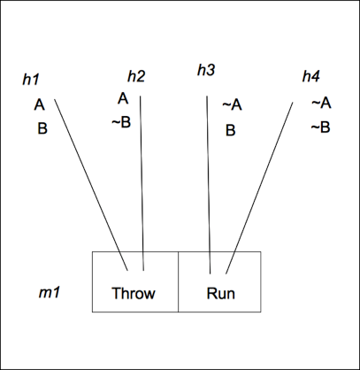
Figure1: m1/h1⊨ [αSTIT]A; m1/h3 ⊨ [αSTIT]~A. m1/h1 ⊨ [αSTIT]B; m1/h3 ⊨ [αSTIT]B.

If the quarterback chooses to throw the ball, he sees to it that A, that the ball is thrown. Every possible history branching out of his choice cell “Throw” is one at which A is true. However, B, that the team scores a touchdown, is not true at every possible history branching out of “Throw”. In h1, the wide receiver catches the ball in the end-zone, thereby scoring a touchdown, and B is true. However, in h2, the wide receiver does not catch the ball in the end-zone, so a touchdown is not scored, and B is false. So, the quarterback, in throwing the ball, does not see to it that a touchdown is scored, but he does see to it that the ball is thrown.
The system represents an action's possible consequences by visualizing the possible timelines branching out from the moment of action. In Horty's system, each possible timeline, including the actual one, is called a history. A history is a total-ordering of moments. Moments may belong to multiple histories. On the branching time model, there are vast numbers of possible histories that spread into the future. An agent’s action is a choice that constrains or limits the possible histories.
When an agent constrains the possible histories in such a way that, no matter which possible history becomes actual, proposition A is true, then she sees to it that A. In this way, an agent's action is a function operating on a set of histories at a moment, constraining them into subsets. An action is picked out by the propositions it guarantees true. The formula expressing the proposition that agent α sees to it that A is:
[αSTIT]A.
Think of it as a special kind of modal ☐ operator. Instead of truth in all possible worlds, [αSTIT] is truth in all possible histories that result from making a choice. The definition of ☐ in alethic modal logic refers to truth in all possible worlds. Possible worlds are those that are related in some specified sense. In the STIT logic I use, histories indexed to moments are the relata, rather than worlds, and R_{A} is the relevant relation among them. The relation R_{A} denotes the equivalence class of histories that share membership in a choice cell. Of the many histories branching from her choice cell, she cannot control which particular one will become actual. For a history to share a choice cell with another history is to be “action related.” Formally, the [αSTIT] operator is defined:
Definition 1: At a moment-history pair m, h ⊨ [αSTIT]A iff for all h', where h R_{A} h', m,h' ⊨ A.
STIT formulas are evaluated at moments indexed to a history. When an agent selects a choice cell available to her, she constrains the future to an action related equivalence class of histories. However, an agent reasons not only about what she in fact does, but also about what she is able to do. I turn next to Horty’s treatment of an agent’s ability.

2.2 Ability
The discussion so far has presented only Horty's analysis of an agent's action. His system goes beyond this to account for an agent's abilities to act. To do so, he introduces the historical possibility operator. An agent is able to see to it that A when she has a choice cell available to her at a moment such that all histories in that choice cell make A true. We represent this formally as:

Definition 2: A moment m ⊨ ♢[αSTIT]A iff there is some choice Q available to α at m such that m/h ⊨ A, for all h ∈ Q.
Returning to our quarterback example in Figure 1, we see that the model makes false ♢[αSTIT]B at m1, where α is the quarterback, and B is still the proposition that the team scores a touchdown. That is, the quarterback cannot see to it that the team scores - he lacks the ability to do so at m1. I’ve just explained how Horty’s system models an agent’s ability. Next I describe the relation between an agent’s available choices and her obligations. After that, I point out the flaws in Horty’s system.

2.3 Moral Obligation and Field of Concern
In order to incorporate moral obligation, Horty adds a valuation function V that maps moral values onto histories. In Figure 1 above, suppose the value V(h1) = V(h2) = 1, while V(h3) = V(h4) = 0. Horty assumes a form of consequentialism called dominance act utilitarianism, which holds that an agent is obligated to choose an action that is not dominated by any other action. An action is dominated by another iff all of former’s possible histories are less than or equal to The agent ought to see to it that A.
The choice cells considered at a moment determine the agent's moral obligations. She is to choose the most valuable of the available options. However, in order to make this aspect of his framework more realistic, Horty imposes a limit on the number of options an agent considers: the field of concern. Intuitively, the field of concern captures the ‘region’ of the possible future with which the agent is actively concerned. This is to prevent the agent from worrying about possible histories she has no intention of realizing. For example, it is possible for me to board a plane and arrive in Amsterdam within the next two days. Should my field of concern account for this possibility? Horty thinks not, because I have no intention of ever realizing this history. So, a model of my moral decision-making excludes this possibility from my field of concern. Once the field of concern is determined, the agent’s obligations can be determined: the agent is obligated to realize the most valuable history in her field of concern. This concludes my discussion of Horty’s system. I turn now to the first problem of Horty’s system, that it needs some principled way to determine the field of concern.

2.4 Problem 1: The Agent Controls Her Obligations
This section will highlight an undesirable feature of Horty's system. I will then suggest how the undesirable feature can be fixed, and Horty’s system enriched.
We can illustrate the problem by interpreting the model as the following case. An agent has $10 more than she had expected, and is deciding what to do with it. While deliberating, she is watching television, and a commercial comes on advertising a well-reputed charity. The charity makes very efficient use of its donations, and saves many lives annually. The commercial makes the agent feel guilty. She must decide whether to donate $10 dollars she doesn't need, or change the channel and feel less guilty. In her deliberations, if she ignores the possibility of donating it to charity, then the choice cell Donate is no longer included in the model. She no longer has any intention of realizing the history, so there’s no need to include it in her field of concern. This leaves only the choice cell Change, for 'change the channel,' with a value of 1. This becomes the most morally valuable choice in virtue of being the only choice considered. However, it seems like she should not be able to ignore the possibility of donating to the efficient charity. Horty's system provides no method for insisting that she consider the better possibility, and according to Horty's system, the agent acted morally.
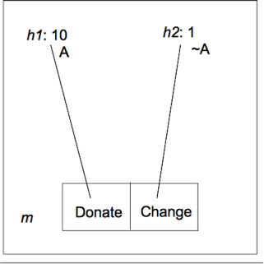
Figure2: Obligations determined by the field of concern.
In Figure 2, the model consists of two histories, h1 and h2 running through a moment m. If the field of concern contains both histories, then the agent should see to it that A holds, since the history at which A holds has greater value than that at which ~A holds. Let A be the proposition that the charity receives ten additional dollars.
As things stand, an agent can control what her moral obligations are merely by ignoring potential future moments. For many, this is not an accurate picture of morality. It grants too much control to the agent over what is morally permissible. We must develop a principled way of determining the agent’s field of concern. With a principled way of determining the agent's field of concern, we move closer to a realistic and expressively powerful formal analysis of agency. I show that an agent’s procedural knowledge at a moment is a plausible candidate to solve this problem, as well as the next, which I turn to now.

2.5 Problem 2: Historically Impossible but Epistemically Possible Outcomes
A second problem with Horty’s system is that it cannot distinguish between epistemic possibility and historical possibility. Horty's system treats an agent's options solely as a function of historical possibility. If a choice cell has only histories satisfying A, then the agent’s options include the choice to see to it that A. Typically, however, an agent must make a decision when she is ignorant about some historically settled fact. So, even though she has a choice available to see to it that A, she may consider it possible that ~A will result from the choice, so she may not know that she can see to it that A. In this situation, Horty's system will deny that there is any uncertainty about the choice to see to it that A, when in fact there is. Take for example Mine Shaft, a case from Derek Parfit's new book (2011).
In Mine Shaft, 100 miners are trapped in either shaft A or shaft B. We do not know which. We may close one of three floodgates, gate 1, gate 2, or gate 3. If we close gate 1, and the miners are in shaft A, we save all 100 miners, none otherwise. If we close gate 2, and the miners are in shaft B, we save all 100 miners, none otherwise. If we close gate 3, we will save exactly 90 miners, and 10 will die, no matter which shaft they are in. We may model the problem as the following decision matrix:

“Mine Shaft” | In Shaft A | In Shaft B
Close Gate 1 | save 100 | save 0
Close Gate 2 | save 0 | save 100
Close Gate 3 | save 90 | save 90

Whichever shaft the miners are trapped in, it is a settled historical fact. However, it is crucial that the agent's uncertainty regarding this fact be represented when formalizing the problem in a logical system. As it stands, Horty's system cannot represent this decision problem. The divergence of histories from choice cells is a function of historical possibility, not of epistemic possibility. Horty’s system trivializes the decision problem. Horty's system, in modeling the decision, loses the problematic feature, namely the agent's epistemic possibilities. If we suppose that the miners are in shaft A, Horty's system represents the problem as follows.

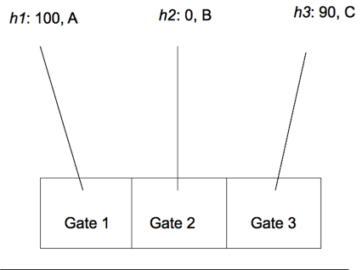
Figure3: If the miners are trapped in shaft A, then it is historically settled which shaft they are in. The agent should see to it that Gate 1 is open.

The same problem occurs if the miners are in shaft B. Thus, Horty's system does not provide for a formal solution to the decision problem, because it mischaracterizes it. The source of the problem is the agent's epistemic uncertainty about the miners' location, so Horty's system will be enriched if it can account for an agent's epistemic uncertainty. I turn now propose a way for the agent's procedural knowledge to solve both problems for Horty's system.

3.1 Informal Account of the Solution
I propose that if an agent knows how to do something at a moment, then that choice is in her field of concern. I work out the formal details of this proposal in the next section. For now, I provide an informal account of how procedural knowledge solves the two problems facing Horty's system.
The first problem facing Horty's system was that the agent had too much control over her obligations. By ignoring certain possibilities, she could manipulate her obligations in an unacceptable way. For example, I can make it my moral obligation to lay on the couch all day by ignoring all of the other actions available to me that would produce better outcomes. By letting an agent's procedural knowledge determine the field of concern, it becomes possible to explain why an agent cannot simply ignore actions with better outcomes in order to permissibly avoid doing them. When deciding what I should do, I cannot simply ignore an option that I know how to do. I do know how to donate ten dollars to a responsible charity, so that action should be within my field of concern. On a consequentialist account, I should donate ten dollars to charity rather than lie on the couch, etc, provided there are no other actions I know how to do at this moment that would produce outcomes at least as valuable. This is a principled way to determine an agent's field of concern, and it is intuitively satisfying.
Incorporating an agent's procedural knowledge also allows Horty's system to model problems like Parfit's Mine Shafts, where an agent considers some outcomes to be epistemically possible though they are not historically possible. These types of moral decision-making problems are common, because we often have imperfect information about the moral situations facing us. So, Horty's system becomes more realistic as a model of moral decision-making.
In Mine Shafts, the agent must make a decision under uncertainty about the past. As it stands, Horty's system models only decisions under uncertainty about the future. She doesn't know which shaft the miners were in when the mine collapsed, but it is an historically fixed fact which mine they are in. As the deciding agent, she does not have access to this fact, so she considers more histories to be possible than historically are. If the miners are in Shaft A, then the history in which they are in Shaft B is historically impossible, but epistemically possible. Thus, this case capitalizes on the distinction, and invites the addition of epistemic possibility to a formal system modeling agency.
We know that we can save 100 lives, in the sense that it is historically possible for us to do so. No matter which shaft the miners are in, we have the option of saving all 100 of them. Unfortunately, we do not know how to save all 100 lives. Equivalently, we cannot knowingly save 100 lives. `Knowingly doing' concerns a qualification on action (a STIT formula), whereas `knowing how' concerns a qualification on an ability. Recall that an ability in STIT logic applies a historical possibility operator to an action, according to Horty. So, `knowingly doing' adds a knowledge operator to an action, while`knowing how' inserts a knowledge operator into an historically possible action.

α Knowingly STIT A: [Kα][αSTIT]A.
α Knows How to STIT A: ♢[Kα][αSTIT]A.

The knowledge operator is defined: m/h ⊨ [K_{i}]A iff for all h', where h R_{K} h', m,h' ⊨ A. The relation R_{K} denotes the epistemic equivalence relation. It denotes the set of moment-history pairs that are epistemically possible for an agent at a moment. For any epistemic equivalence set, the moment is held fixed throughout, and it is only the histories indexed at that moment that change in the relation.
The above formulas are distinct from the formulas [αSTIT]A and ♢[αSTIT]A respectively, which lack a knowledge operator. For the purposes of Mine Shafts, and cases relevantly similar to it, we are concerned with what an agent can knowingly do, rather than with what she merely (historically, perhaps accidentally) can do. It may be that the agent can save 100 lives, but if she cannot knowingly do so, then she is not obligated to do so. In being able to distinguish the types of possibility, Horty's system can now model these moral theories with an adjustment to the obligation operator's semantics.
She ought to knowingly save 100 lives only if she can knowingly save 100 lives. In Mine Shaft, she cannot knowingly save 100 lives, but she can knowingly save 90 lives. She cannot knowingly save more than 90 lives, so she ought to knowingly save 90 lives. Incorporating a knowledge operator in Horty's system allows us to correctly model this result. Not everyone agrees that this is the correct solution to the problem. This dispute is normative, and concerns the correct theory of moral permissibility, which I do not address here.
It may be that more formal work needs to be done to account for all the possible cases turning on the distinction between historical and epistemic possibility. For instance, suppose rather than 90 lives, the agent can knowingly save only 10 lives. It is not clear that the agent ought to knowingly save 10 lives, when there's a subjective chance of saving 100, but also of saving 0. This is a normative question that, once worked out, the enriched system could represent. Adding a knowledge operator allows Horty’s system to model the various normative positions. A further enrichment is to introduce subjective probabilities, but I leave this for future work.

3.2 Formal Account of the Solution
I now present the formal account that solves the two problems I've considered thus far. I turn first to the problem that the agent has too much control over her moral obligations.

3.2.1 Problem 1 Solved
As Horty's system currently stands, it constructs models out of frames of the following type:

Finite Choice Utilitarian STIT Frame: ⟨Tree, <, Agent, Choice, Value⟩.

- Tree is defined as a nonempty set of moments, and < is a transitive, irreflexive, tree-like ordering on Tree. This models the branching nature of the potential futures, according to indeterminism.
- Agent is a nonempty set of agents.
- The Choice function takes an agent and a moment as input and maps onto a partition of H_{m}, which is the set of all the histories that run through moment m, {h : m ∈ h}. A moment m is a member of h when m occurs at some point along h, or equivalently, if h runs through m. A choice cell is a set of histories comprising an equivalence class for the agent's choice at a moment. I denote the equivalence class relation among histories in a choice cell with R, the historical possibility relation. The partition Choice(α,m) is a set of choice cells available to α at m. Each choice cell is a set of historically possible histories.

Formally, the first problem is that the agent controls her moral obligations because she can arbitrarily construct the Finite Choice Utilitarian STIT model by ignoring potential choices. My formal solution defines a new function, K-Choice, that maps an agent and a moment onto a partition of H_{m}. K-Choice represents the agent's procedural knowledge at a moment. For example, if I can knowingly open the door right now, then a formal model of my decision will include a K-Choice cell in which I see to it that the door is open. This represents my knowing how to open the door right now. With my principled solution, knowingly opening the door must be in the model of my deliberation right now.
A procedural knowledge cell is an action that an agent can knowingly do. I use procedural knowledge cells to demarcate the field of concern. Let Field(α,m) be the agent's field of concern at a moment, m. A history running through m is part of the agent's field of concern if it is a member of a K-Choice cell all the members of which satisfy A. All histories of a K-Choice cell at moment m satisfy A iff m ⊨ ♢[Kα][αSTIT]A. This captures all the actions an agent knows how to do at a moment. In order to model an agent’s procedural knowledge at a moment, I propose that models be constructed out of the following frames.

Definition 4: Finite Choice Utilitarian Fielded STIT Frame (Epistemic STIT Frame):
1. ⟨Tree, <, Agent, Choice, K-Choice, Value⟩.
2. Agent α's field of concern at m is the intersection of her K-Choice and Choice cells: Field(α,m) = K-Choice(α,m) ∩ Choice(α,m). Intersecting K-Choice and Choice cells are those that contain exactly the same histories.
3. The partition Field(α,m) is a set of histories that are members of intersecting K-Choice and Choice cells. A Choice cell from Choice(α,m) is a procedural knowledge cell from Field(α,m) iff each cell has all and only the same histories as the other, respectively. If some choice cell Q of a history h, Choice(α,m)(h), satisfies [αSTIT]A, and Q = P for some procedural knowledge cell P of h, K-Choice(α,m)(h), then P of h satisfies [K_{α}] [αSTIT]A.
4. A moment m ⊨ ♢[K_{α}][αSTIT]A iff m/h ⊨ A, for all h ∈ P, where P is some K-Choice cell at m.

In selecting choice cell that is also a procedural knowledge cell, the agent narrows the future to those histories action-related to h, and further, she does so knowingly. If all those action-related histories satisfy A, then all epistemically related histories satisfy A, so she knowingly sees to it that A. The field of concern at a moment consists of all choice cells at that moment that are also procedural knowledge cells. If an agent can knowingly do something, then that action is in her field of concern. This is a principled way of determining an agent's field of concern.
Recall Figure 2, in which an agent must choose between Donate and Change. Prior to my proposed addition, Horty's system does not require the agent to consider the option of donating. Let's assume that in watching the first portion of the commercial, the agent gains the requisite knowledge about how to donate $10. Thus, at the moment of deliberation, a choice cell is available to her that is also a procedural knowledge cell. At moment m, it is possible for her to knowingly donate $10 to a responsible charity. The revised Horty system now requires that she consider this option by including it in her field of concern. I model the revised system in the following way.
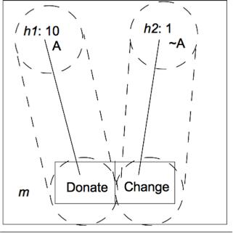
Figure4: The dashed cylinders represent the agent's procedural knowledge cells at a moment. The choice cell is in an agent's field of concern iff it is equivalent to a procedural knowledge cell, i.e., it contains all and only the same histories as some procedural knowledge cell. In Figure 4, both Donate and Change are in the agent's field of concern, because both are equivalent to a corresponding procedural knowledge cell.

It may be helpful to imagine that the agent is standing below the structure, looking forward through the epistemic tunnels. Looking through the Donate tunnel (the procedural knowledge cell for Donate), she `sees' an outcome with a value of 10. Through the Change tunnel, she `sees' an outcome with a value of 1. Thus, she can knowingly realize either history. She is obligated to realize the outcome with a value of 10. This concludes the formal solution I propose to the first problem facing Horty's system. I turn to how my proposal solves the second problem as well.

3.2.2 Problem 2 Solved
In Parfit's Mine Shaft, the agent is able to save 100 lives, but she does not know how. However, she does know how to save 90 lives. With our additional formal tools, we can model this situation, where formerly we could not in Horty's system.
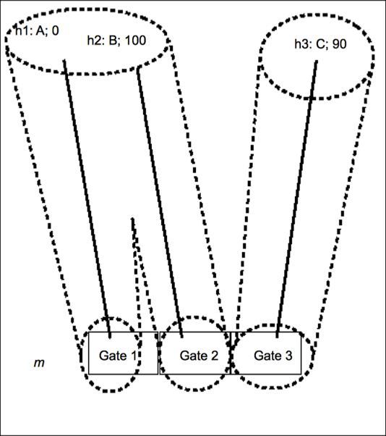
Figure5: Mine Shaft in an Epistemic STIT Model. The outcomes of Gate 1 and Gate 2 are grouped together epistemically, because the agent is uncertain which outcome corresponds to which choice.

Suppose that the miners are in Shaft B. The procedural knowledge cells associated with Gate 1 and Gate 2 share histories h1 and h2. Thus, the agent considers h1 and h2 both to be possible for Gate 1 and Gate 2 alike, even though it is historically settled that Gate 1 results in h1 while Gate 2 results in h2. Because the choice cell Gate 2 is not equivalent to a procedural knowledge cell, it is not in the field of concern: the agent doesn't know how to save 100 lives. One can see that it is not equivalent by indicating which histories it contains, as well as those contained in the closest candidate procedural knowledge cell. Gate 2 = {h2}, while the procedural knowledge cell associated with Gate 2, call it K-Gate 2 = {h1, h2}. Similarly, K-Gate 1 ≠ Gate 1, so she does not know how to see to it that everyone dies, either. Removing these choice cells, and their corresponding histories, from the field of concern, leaves the agent with Gate 3, in which she knowingly saves 90 lives. Of course, a full model of the situation will include in the agent's field of concern every action that she can knowingly do at m. This still leaves the agent with quite a broad field of concern.
The importance of this result is not the normative issue of whether she ought to try and save 100 lives, or settle for the 90. The importance of this result centers on the fact that Horty's system has now gained significant expressive power. It is now able to make distinctions that it previously could not make concerning the difference between epistemically possible outcomes and historically possible outcomes. Determining the field of concern with a knowledge operator allows Horty's system to make such distinctions. If one is unsatisfied with the result that the agent is obligated to save the 90 lives, consider that future work incorporating probabilities will likely account for this. Current restrictions on the field of concern may be relaxed later, once the system is further enriched.

5 Conclusion
I have argued that Horty's logic of moral agency benefits from the addition of an epistemic modality that captures an agent's procedural knowledge. I have shown that formally modeling an agent's procedural knowledge solves two classes of problems for Horty's system.
The first problem stems from the fact that Horty's system, without my additions, lacks a principled means of determining an agent's field of concern. Incorporating an agent's procedural knowledge at a moment provides just such a means, which is intuitively plausible, if not universally agreed upon. With a realistic and plausible means of determining an agent's field of concern, Horty's system becomes more realistically applied to actual moral agents.
The second problem stems from the fact that Horty's system does not distinguish two types of possibility relevant for moral reasoning: historical and epistemic. Derek Parfit's Mine Shaft case illustrates how Horty's system fails to accurately model cases where the two types of possibility come apart. With the addition of an epistemic modality, Horty's system now has no trouble modeling such cases. Further refinement of modeling an agent's procedural knowledge, for example the addition of subjective probability, will allow us even more precision in modeling these cases.
Finally, this paper advances the project of modal logic as it concerns philosophers and computer scientists, who are interested in formally modeling human-like agency. It takes steps toward the development of a full-fledged logic of agency by exploring the interaction of procedural knowledge, action, and historical possibility.

References
Aumann, Robert J. “Interactive epistemology I: Knowledge”, International Journal of Game Theory, 1999, vol. 28, p. 263-300.

Broersen, Jan “Deontic epistemic stit logic distinguishing modes of mens rea”, Journal of Applied Logic, 2011, p. 137-152.

Fagin, Ronald; Halpern, Joseph Y.; Moses, Yoram; Vardi, Moshe Y. Reasoning about
Knowledge. 1995, Cambridge. The MIT press, especially chapter 2.
Hintikka, Jaakko “Individuals, Possible Worlds, and Epistemic Logic,” Nous, 1967, vol. 1, no. 1, p. 33-62.

Horty, John F. Agency and Deontic Logic. 2001, Oxford: Oxford University Press.

Parfit, Derek Climbing the Mountain (working title of On What Matters, 2011), online copy, July 2011.

van Benthem, Johan Modal Logic for Open Minds. 2010, Center for the Study of Language and Information, especially chapter 12.

That is, at moment m1 along history h1.
Horty (2001) p. 146.
Note that the problem is not that Horty’s system delivers an incorrect moral result, but rather that it is unable to accurately model the decision at hand. The correct moral result is a normative question, whereas Horty and I are concerned with the formal representation of moral reasoning, assuming a crude form of consequentialism.
Broersen (2011) p. 144
Horty (2001) p. 19
Broersen (2011), p. 145
This definition of the knowledge operator is consistent with Fagin (1995) chapter 2, van Benthem (2010) chapter 12, Aumann (1999), and Hintikka (1967), where their possible worlds/states correspond to my possible histories running through a moment.
Every K-Choice cell is indexed to an agent and a moment. Members of K-Choice are histories that form an epistemic equivalence class. I denote this epistemic equivalence relation as R_{K}. If h1 R_{K} h2, then h1 and h2 are members of the same procedural knowledge cell.

