Extending the Modal Logic of Best Action to Strategic Form Games
Seth Kurtenbach

Section 1: Introduction

In his article, “Logic in a Social Setting,” Johan van Benthem presents an axiom of a new modal logic of best action that represents reasoning through backward induction. My goal for this paper is to explain the working parts of van Benthem’s axiom, and extend the underlying analytical tools to capture dominance reasoning in strategic form games. In particular, I’ll propose a translation procedure which takes strategic form games and converts them into models appropriate for the modal logic of best action.
My contribution to the field builds on a suggestion van Benthem makes in his 2010 book, Modal Logic for Open Minds. He says, “logics for defining equilibria and studying their properties are a lively research area” (202), and, “We worked with games in extensive form, but similar methods apply to the usual matrix games in strategic form.” He does not elaborate on how the methods apply to strategic forms of games, so I will explore that in this paper.
First I’ll explain the basics of backward induction, and introduce van Benthem’s axiom that represents it, so that I next I can extend the logic to deal with the prisoner’s dilemma.

Section 2: Backward Induction and the Axiom
Backward induction is a method for identifying one’s optimal strategy in a sequential game or decision tree. One begins by looking toward the end of a problem, identifying the best outcome, and working backward toward the beginning to identify the best action at each step, or node. Consider the following game tree.

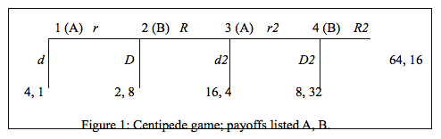

Backward induction provides the solution (dd2, DD2), in which player A chooses d at node 1, and player B chooses D if she gets a turn at node 2. This solution is reached by first examining the payoffs at the end, node 4. The final move is player B’s, and we assume that B is rational. B will select D2, because 32 is greater than 16. Next we move backwards to A’s move at node 3. We assume A knows what B will do at node 4, and that A is rational. A knows her payoffs for choosing r2 are 8, while her payoffs for choosing d2 are 16. Because A is rational, she will choose d2. Moving back again, to node 2, B knows what A will do at node 3, and so B will choose D, because 8 is greater than 4. Finally, at node 1, A knows what B will do at node 2, and being rational, chooses d, because 4 is greater than 2. Thus, the game is solved by backward induction.
Game theorists and decision theorists identify principles of rationality that underlie good decision-making and interactive strategizing. The modal logic of best action formalizes such decision-making and interactive strategizing with modal operators. The formalization process treats game and decision trees as Kripke structures. Each node in the tree is like a world or state, and each strategic movement from one node to the next constitutes a frame relation. Van Benthem identifies an axiom of the new modal logic that corresponds to a principle of rationality satisfied by reasoning through backward induction.
In the Centipede game above, backward induction recommends d to player A, who makes the first move. If player B gets to move, backward induction recommends D. Because an adequate strategy recommends a move for any possible situation, d2 and D2 are also recommended for A and B respectively. Thus, we may label each of those moves with σ, denoting the strategies recommended by backward induction. Figure 1’ illustrates this re-labeling of the backward induction recommended strategies.

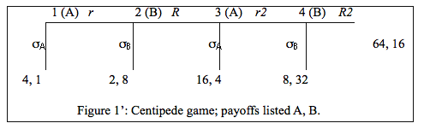

If we take the game tree to be a Kripke structure, then we can treat it as a semantic model for a modal logic of best action. In particular, Figure 1’ satisfies the following axiom of van Benthem’s modal logic of best action. In satisfying the axiom, a player’s choice satisfies the corresponding principle of rationality (below).
VB’s Axiom (VBA): (turn_{i} ∧ 〈σ〉[σ*](end ⊃ p)) ⊃ [move_{i}]〈σ*〉(end ∧ 〈pref_{i}〉p).
The principle of rationality to which VBA corresponds states,
(RAT) No alternative move for the current player i yields outcomes via further
play with σ that are all strictly better for i than all outcomes resulting from
starting at the current move and then playing σ all the way down the tree.
Note that σ denotes the strategy recommended by backward induction. Van Benthem does not go into much detail clarifying the axiom, so I take this task upon myself.
The symbol 〈σ〉 indicates a modal possibility relation, akin to the familiar operator ♢. Where ♢ expresses a possibility relation between worlds, 〈σ〉 expresses a relation between nodes both belonging to the σ strategy set, i.e., the set of strategies recommended by backward induction. Let W be the set of nodes, of which nodes w and u are members. If one can execute strategy σ at node w and in one step arrive at node u, where the proposition p is true at u, then w satisfies 〈σ〉p. Figure 2 illustrates this.

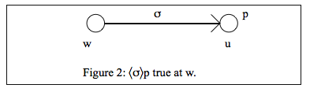

Definition 1 〈σ〉p: A model M and node w∈W satisfy 〈σ〉p iff there exists a node u∈W and wR_{σ}u such that u satisfies p. The notation R_{σ} denotes that w can reach u in one σ move.

Similarly, [σ] is the dual operator of 〈σ〉, defined as ¬〈σ〉¬. Thus, for readers unfamiliar with van Benthem’s notation, VBA should begin to emerge from the fog.
A potentially misleading notation involves the use of *. One might think that 〈σ*〉 indicates a relation between two nodes reachable by executing strategy σ* one time, analogous to the definition of 〈σ〉. However, rather than introducing a new strategy, the * denotes a technical innovation to the logic, compliments of propositional dynamic logic and Kleene’s analysis of programs. In fact, 〈σ*〉p is true at a node w iff there is some node u, and wR_{σ*}u such that u satisfies p. The relation R_{σ*} is the execution of strategy σ some finite, possibly zero, number of times. Similarly, [σ*] is defined as ¬〈σ*〉¬. We might express this in the following way: [σ*]p tells us that all nodes reachable from the current node by some finite iterative execution of strategy σ satisfy the proposition p. If we start at node w and continue to execute σ, we are guaranteed to reach a node at which p is true. For an intuitive grasp of *, consider an analogy in the successor function. Call the successor function s, and we can say that 2 is s-related to 1, or modally, 1 satisfies 〈s〉2. If we continue to execute the successor function, we arrive at 7. Thus, we can say that 1 satisfies 〈s*〉7, because from 1, one can execute the successor function some finite number of times and arrive at 7. However, 1 does not satisfy 〈s〉7, because 7 is not s-reachable in one step. Similarly for 〈σ〉 and 〈σ*〉.
Concerning the distinction between [σ*](end ⊃ p) and 〈σ*〉(end ∧ p), I draw one’s attention to the modal operators, and invite the reader to think of them as quantifiers. Consider the distinction between the symbolic representations of “all nodes satisfy p” and “some node satisfies p” in predicate logic. For the former, we write ∀x(Nx ⊃ Px), and for the latter, we write ∃x(Nx ∧ Px). The analogous translations apply to the modal symbols in VBA. When the axiom reads [σ*](end ⊃ p), it says, “all endnodes reachable by iteratively executing σ (some finite number of times) satisfy p,” and when the axiom reads 〈σ*〉(end ∧ p), it says, “some endnode reachable by iteratively executing σ (some finite number of times) satisfies p.”
Another potential source of confusion concerns the [move_{i}] operator. One might think that it represents player i’s enacting a move, or executing a move. If so, then it would be a new kind of operator. However, rather than indicating a totally new modal operator, [move_{i}] is just ☐ ranging over all nodes reachable (in one move) by player i from the current node. It is just like [σ], but with a more inclusive relation among nodes. We know this, because van Benthem tells us, “strategies then become binary subrelations of the total move relation...” (Forthcoming, 2) Because 〈σ〉 relates the current node to some node reachable by strategy σ, and σ is a sub-relation of the total move relation, then 〈move_{i}〉 relates the current node to some node reachable by any move available to player i. Just as before, [move_{i}] is defined as ¬〈move_{i}〉¬.
The final piece of the notational puzzle concerns 〈pref_{i}〉p. Intuitively, this operator states that there is some node that the player prefers to her current node, and p is true at the preferred node. The notion of preference requires a precise definition, as it involves the rankings or orderings of outcomes. In his 2010 book, “Modal Logic for Open Minds,” van Benthem construes this operator as 〈<〉p. The < indicates that the value of the current node is less than or equal to a node at which p is true.
Definition 2 〈pref_{i}〉p: A model M and a node w∈W satisfy 〈pref_{i}〉p iff there is some node u∈W such that w ≤_{i} u, where u satisfies p.
Thus, the axiom states: if at a node w it is player i’s turn and in one σ step i can reach a node u such that every node σ-reachable in some finite number of steps yields an endnode at which p is true, then for all the possible (including non-σ) moves that i can make at w, from each resulting node i can play σ some finite number of times and reach an endnode to which she prefers a node at which p is true.
So, at w, there is a strategy σ available to i. She can execute that strategy, and from the resulting node, continue to execute σ a finite number of times until she reaches an endnode, call it z, at which p is true. Now, had she executed any non-σ move at w and then continued to play σ all the way to another endnode, call it y, she would have preferred z to y. This corresponds exactly with RAT.
This concludes my explanation of the axiom. I turn to the project of extending the modal logic of best action to the prisoner’s dilemma, and simultaneous-move games in strategic form more broadly. I do so by translating strategic-forms of games into tree-like structures, which in turn can be treated as Kripke structures for the new logic.

Section 3: A Translation Procedure for Strategic Form Games
The goal of this section is to present explicitly the reasoning that leads to the solution (down, right), and then translate this reasoning into the language of modal logic of best action. To do so, we must figure out a way to represent the above game in a tree-like way, with nodes and move relations.
First, I’ll explain the difference between strategic form and extensive form. Strategic form games are simultaneous move games. This means that the players do not alternate turns in moving toward a solution, as they do in Centipede, a sequential-move game. For this reason, a player cannot anticipate how a player will react to certain moves. An immediate difference to note between the strategic form and extensive form games concerns the absence of anything resembling a Kripke structure in the representation of the former. The lines and nodes in extensive form games are convenient for transitioning into modal logic, as they clearly resemble Kripke structures. This is why the strategic form of games does not translate as simply into a model of the new logic. As a first step of translating dominance reasoning about strategic form games into the modal logic of best action, I will borrow some modeling techniques from John F. Horty (2001).
A familiar simultaneous-move game is the prisoner’s dilemma, presented in strategic form as a matrix with payoff cells marking the intersections of players’ moves. I have chosen to analyze the prisoner’s dilemma because it shares some properties with Centipede. For example, both games’ solutions are counter-intuitive to someone unfamiliar with game theory. Also, both games’ solutions are not Pareto optimal; that is, there are outcomes in which both players do better that are not Nash equilibria. After analyzing the rationality underlying the prisoner’s dilemma, I will apply a translation procedure so that the new logic can represent the reasoning. In particular, I represent the method of dominance reasoning, which is the method used to solve the prisoner’s dilemma.

Figure 3. Prisoner’s Dilemma
A \ B | left | right
up | 4, 4 | 0, 5
down | 5, 0 | 1, 1

Rather than adopting the method of backward induction, players will assume that the other player, in virtue of her being rational, will first check for a dominant strategy. A strategy is dominant when it yields better results than an alternative strategy no matter what the other player does. It guarantees to be the best response to the other player’s move. In some more complicated strategic form games dominance reasoning may not deliver a unique solution, but it does for the prisoner’s dilemma, which is why I’ve chosen it for analysis.
Player A will reason as follows:
- If player B chooses left, player A does best to choose down.
- If player B chooses right, player A does best to choose down.
- This information is sufficient for A to choose down. It does not matter to A whether B is rational, or whether B knows 1 and 2. All A need know are B’s preferences, her own, and the game structure.

I propose the following translation procedure to convert strategic form simultaneous move games into tree-like structures.
- Convert the matrix to a Horty-style model of collective action.
- Decompose the model into each agent’s decision tree.
- Recombine each decision tree as a new structure, composed only of nodes and move relations.
I will now demonstrate how the translation procedure works by converting the strategic form of the prisoner’s dilemma into a form amenable to modal analysis. Figure 3, below, is the result of converting the strategic form a the prisoner’s dilemma into a Horty-style model of collective action, completing step 1 in the translation procedure. The structure has both tree-like elements and matrix-like elements.
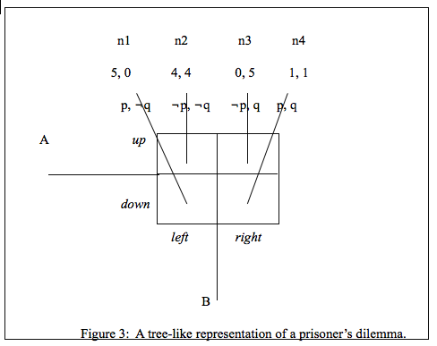

Consider the structure from A’s position first (See Figure 4). Think of A’s position before deciding as n0, with four unique lines emerging from it. Available to A are two moves, each with two lines. A chooses the move, either up or down, but does not determine which unique node results. In this way, the move relations are non-deterministic. Figures 4 and 5 decompose the Horty-style model into each agent’s individual decision tree, completing step 2 of the procedure.
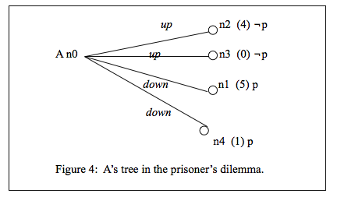

Now consider the structure from B’s position (Figure 5, below). Prior to her decision, B is at node n’. Node n’ can reach four nodes, but has two non-deterministic relations between itself and the four nodes, just as with A’s position at n0.

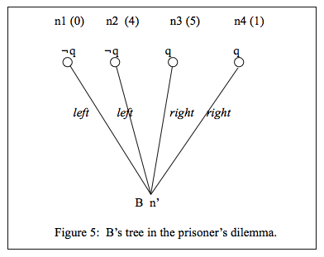

At n0, nodes n2 and n3 are up-reachable, and at each ¬p is true. We can express this modally as such: [up_{A}]¬p; this states, “for all nodes up-reachable from n0, ¬p is true.” Likewise at n0 we have [down_{A}]p. For B, at n’, we have [left_{B}]¬q and [right_{B}]q.
Now, it is easy to incorporate the modal operator 〈 pref_{i}〉p. For example, n’ satisfies [left]〈 pref_{B}〉q. This says that for all nodes left-reachable from n’, B prefers some node at which q is true. Suppose B chooses left and arrives at n1. Then, at n1, there is some node B prefers at which q is true, namely n4 or n3. Suppose B chooses left and arrives at n2. Then, there is some node B prefers at which q is true, namely n3. Similarly for A’s choices, we have at n0
[up]〈 pref_{A}〉p. Suppose A chooses up and arrives at n2. Then, there is some node A prefers at which p is true, namely n1. Suppose A chooses up and arrives at n3. Then, there is some node A prefers at which p is true, namely n1 or n4. The beginnings of an axiom of dominance reasoning are beginning to form. Clearly, the above formulae rule out up and left as potential moves, because there are nodes preferable to the nodes that result. If there are nodes preferable to the nodes that result, then the choices that lead to the resulting nodes are dominated. Rational agents do not make dominated choices. By eliminating up and left, the only possible solution is (down, right). This iterated removal of dominated strategies is dominance reasoning.
If we incorporate the structures from Figures 4 and 5 into one structure with 6 nodes, we have a model of the prisoner’s dilemma that is amenable to modal analysis. Figure 6 below is such a model, composed only of nodes and move relations among agents. It combines the elements of Figures 4 and 5 into a single model of the prisoner’s dilemma modeled by the game matrix in Figure 3. Its construction completes step 3 of the translation procedure.

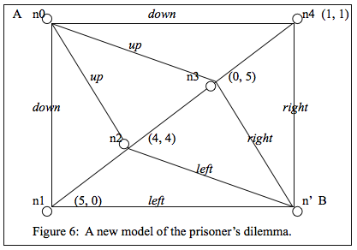

If we name the dominated strategy δ, then in figure 6 we can replace ‘up’ and ‘left’ with ‘δ_{A}’ and ‘δ_{B}’ respectively. Also, we will name the dominant strategy Δ, then we’ll replace ‘down’ and ‘right’ with Δ_{A} and Δ_{B} respectively. Now, the model satisfies the following axiom:
Dominance Axiom: [Δ_{i}]p ⊃ [δ_{i}]〈pref_{i}〉p
This tells us if all nodes reachable by the dominant strategy satisfy p, then for all nodes reachable by the dominated strategy, there will exist a preferable node at which p is true. This axiom will be true of every strategic form simultaneous-move game whose unique Nash equilibrium is established through iterated removal of dominated strategies, i.e., dominance reasoning.
Proof. By contrapositive. Suppose ¬[δ_{i}]〈pref_{i}〉p. Then, by the definition of [δ_{i}] as the dual operator of 〈δ_{i}〉, it follows that 〈δ_{i}〉¬〈pref_{i}〉p. Thus, there is a node, n, reachable by strategy δ_{i}, such that no preferable nodes satisfy p. If no preferable nodes satisfy p, then there are no nodes m such that n < m and m satisfies p. That is, n is not dominated by any nodes m, where p is true at m. But if n is not dominated by any nodes m, then there is no strategy Δ_{i} such that all reachable nodes satisfy p and at least one reachable node dominates n. Then, it is not the case that [Δ_{i}]p. Thus, ¬[δ_{i}]〈pref_{i}〉p ⊃ ¬[Δ_{i}]p, and by contraposition, [Δ_{i}]p ⊃ [δ_{i}]〈pref_{i}〉p.
This axiom will apply to all simultaneous move games with a unique Nash equilibrium determined by dominance reasoning. Simultaneous move games are often best represented in strategic form. I have thereby extended van Benthem’s modal logic of best action to account for dominance reasoning in strategic forms of simultaneous-move games.
I suspect that the Dominance Axiom is deducible from VBA, as dominance reasoning is a weaker version of the iterated deletion of dominated strategies that we see in backward induction. Future work might show that the Dominance Axiom is merely a theorem of the modal logic of best action, after more progress has been made in the logic’s formal proof theory.

Conclusion
This paper makes two main contributions to the modal logic of best action. First, I explain the notation of van Benthem’s axiom in great detail, shedding light on the new logic’s working parts. I consider this a significant contribution, because to the untrained reader, the axiom is difficult to comprehend, and thus, so is the logic itself. Second, having made sense of the axiom and the logic, I propose a translation procedure to convert strategic form games into forms amenable to modal analysis. I show how this works by translating the strategic form of the prisoner’s dilemma into a new model, and then apply van Benthem’s new logic. This allows me to present an axiom in the new logic that characterizes successful dominance reasoning.

References
- van Benthem, Johan, “Logic in a Social Setting,” Episteme (Forthcoming).
- Blackburn, Patrick, et al, “Modal Logic,” Cambridge University Press, (2001).
- Horty, John F., “Agency and Deontic Logic,” Oxford University Press, (2001).
- Kleene, Stephen, "On notation for ordinal numbers," The Journal of Symbolic Logic, 3 (1938), 150-155.

van Benthem, Johan, “Logic in a Social Setting,” Episteme (Forthcoming).
Where p is true at the endnodes for 1 and 3.
Johan van Benthem (Forthcoming, 4)
A recent discussion of propositional dynamic logic using * can be found in Blackburn, Patrick, et al, “Modal Logic,” Cambridge University Press, (2001), p. 13. For the original discussion, see Kleene, Stephen, "On notation for ordinal numbers," The Journal of Symbolic Logic, 3 (1938), 150-155.
I’ve omitted discussion of 〈pref_{i}〉p here for simplicity.
van Benthem, Johan, “Modal Logic for Open Minds,” CSLI publications, (2010), p. 189.
Sequential-move games may be represented in strategic form if the players are uncertain about what the other agent has done.
John F. Horty, “Agency and Deontic Logic,” Oxford University Press, (2001), pp. 30, 62, 83.
I limit my analysis to the one-shot prisoner’s dilemma, in which players should defect. Opportunities for cooperation arise in repeated prisoner’s dilemmas.
Blackburn et al, (2001), p. 4.

