Assignment 4: Implement a Filter
Seth Ahrenbach

Description: In this assignment, I use data from A3-MeasurementData.bin to implement a filter, estimating 3D coordinates as measured by the sensor.

Deliverables:

1. First observation mean vector z and sqrt of its covariance R.

z1 = [ 12.7785
130.0927
23.5293]

sqrtm(R) = [ .87112 .38768 .30142
.38768 1.17254 .68910
.30142 .68910 1.56022 ]

However, in initializing my filter, I used the following initial input:

z0 = [0
0
0]

sqrtm(R) = [ 10^5 0 0
0 10^5 0
0 0 10^5 ]
in order to represent an initial state of complete uncertainty.

2. Final mean x and sqrt of covariance matrix P.

x = [ 12.896
130.398
23.495 ]

sqrtm(P) = [.0027547 .0012260 .000953160
.001226 .0037079 .0021791
.00095316 .0021791 .0049339]
3. Three plots showing innovations in x,y,z with sqrts of respective invariances.
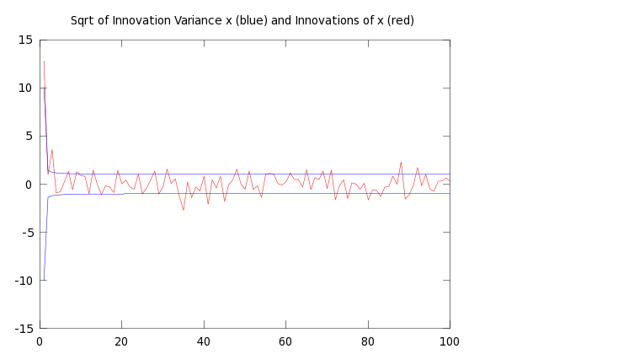

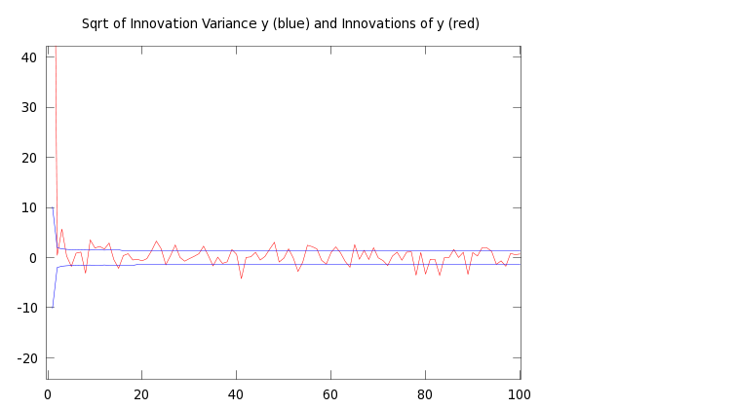

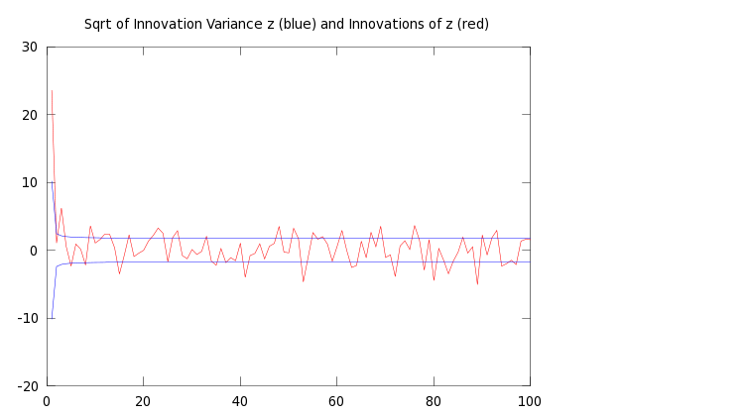
4. Plot of Expected distance (blue) vs Euclidean distance (red)
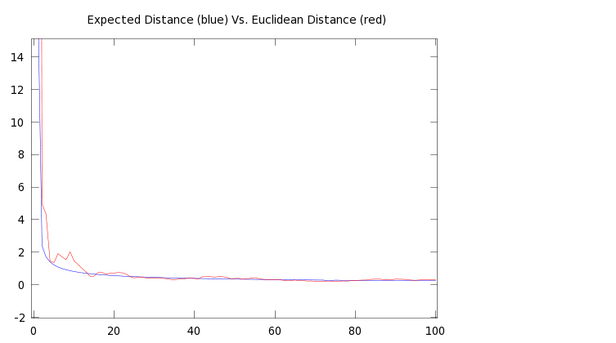

Code
# Assignment 4: Implement a filter to process 3D sensor observations.
# Seth Kurtenbach

actual = [12.9; 130.4; 23.5];

R = [1,1,1;
1,2,2;
1,2,3];

fm = fopen("A3-MeasurementData(1).bin");

meas = fread(fm, [3, 100000], "float");

## Initialized Estimate (x, P) ##
x = [0;0;0];

P = [10^10,0,0;
0,10^10,0;
0,0,10^10];

for i = 1:100000
z = [meas(1,i);meas(2,i);meas(3,i)];
S = P + R;
W = P * inv(S);

innovX(i) = z(1) – x(1);
innVarX(i) = sqrt(S(1,1));
innVarXmin(i) = -(innVarX(i));

innovY(i) = z(2) - x(2);
innVarY(i) = sqrt(S(2,2));
innVarYmin(i) = - (innVarY(i));

innovZ(i) = z(3) - x(3);
innVarZ(i) = sqrt(S(3,3));
innVarZmin(i) = - (innVarZ(i));

euc(i) = norm(x - actual, 2);
expDist(i) = sqrt(sum(eig(P)));

P = P - (W * S * W');
x = x + (W * (z - x));

end

